https://kubernetes.io/docs/tutorials/hello-minikube/
Step 1 in minikube start for installation instructions.
Installation
Start your cluster
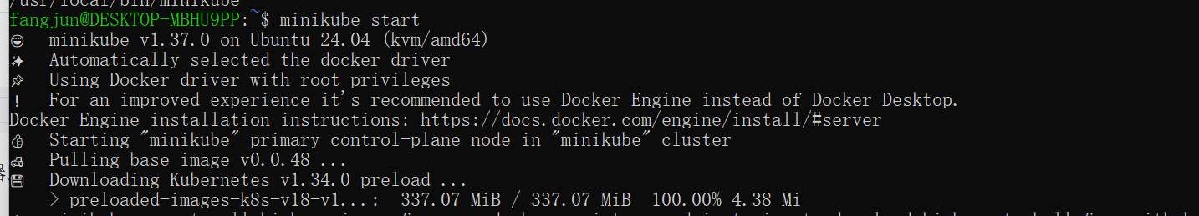
Interact with your cluster
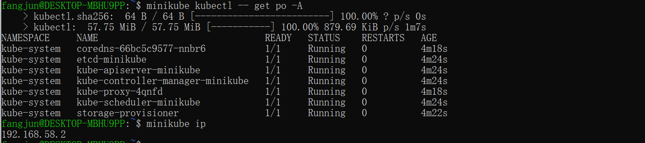
Deploy applications
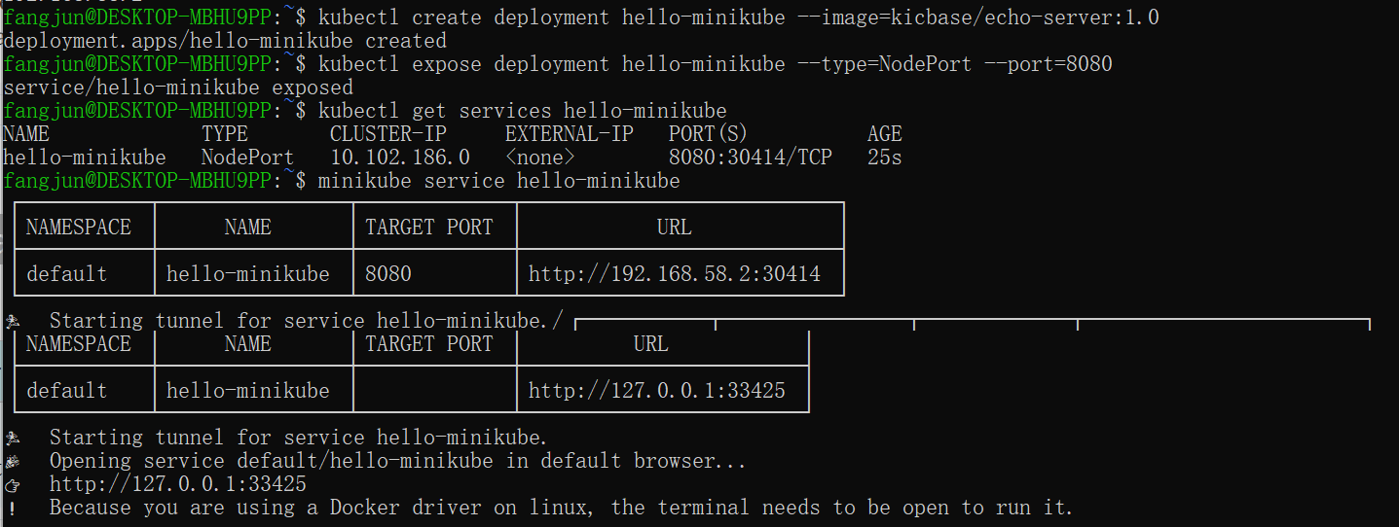
My application is now available at http://localhost:7080/.
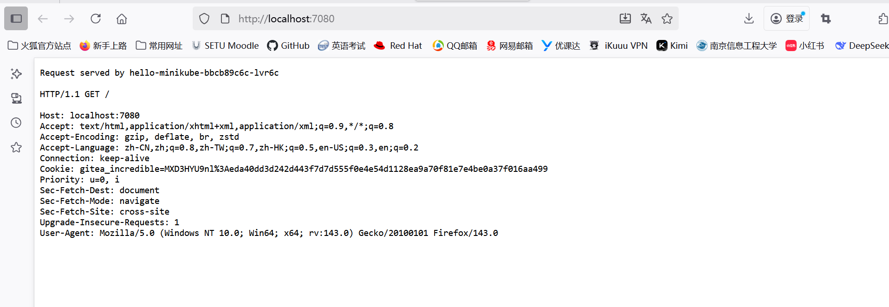
Step 2 Create a minikube cluster
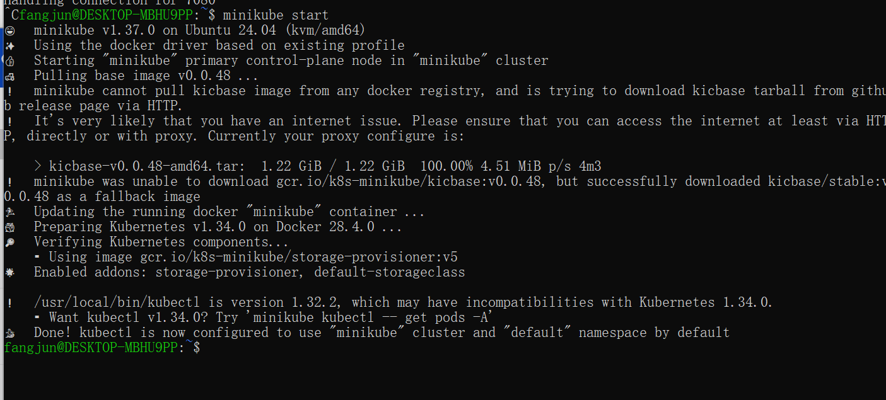
Step 3 Open the Dashboard
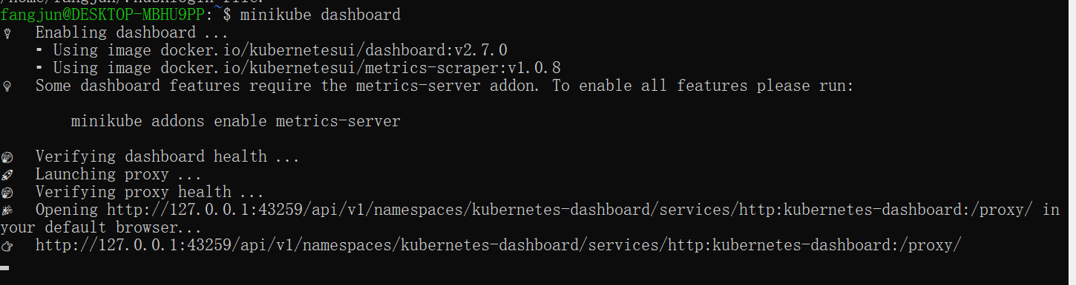
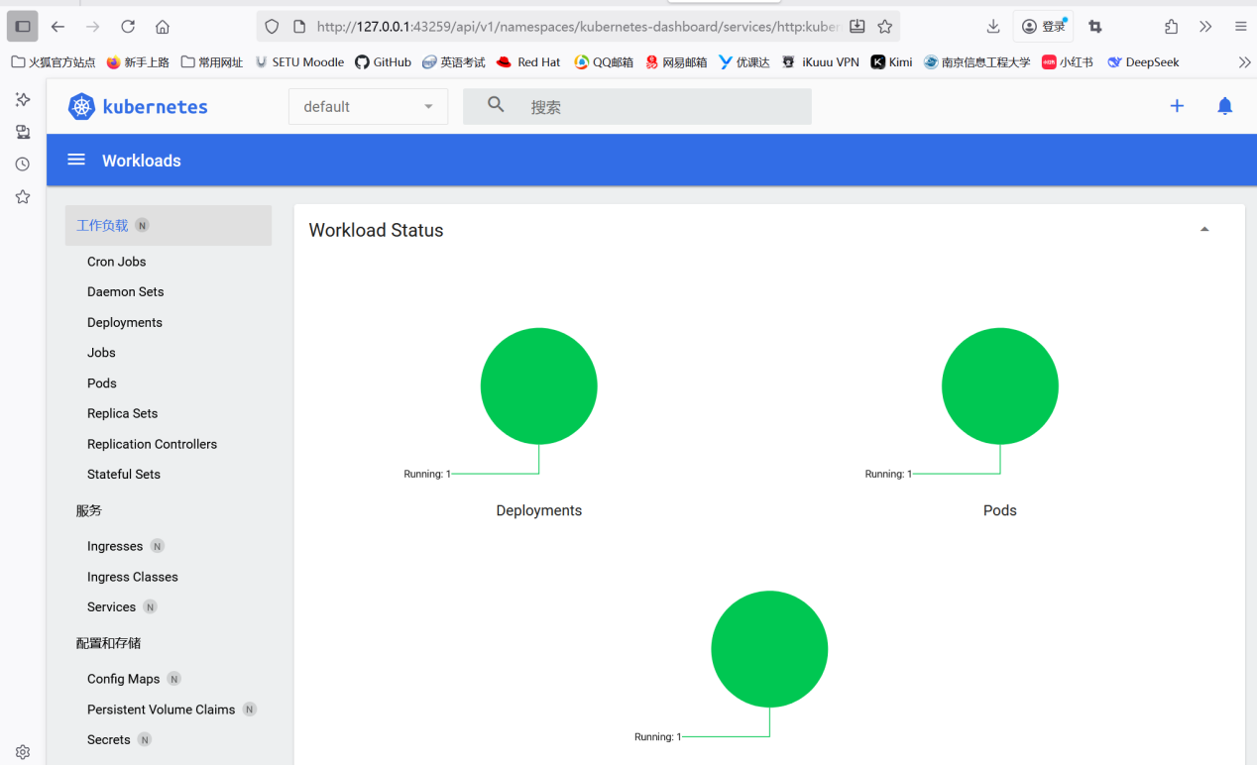
Step 4 Create a Deployment
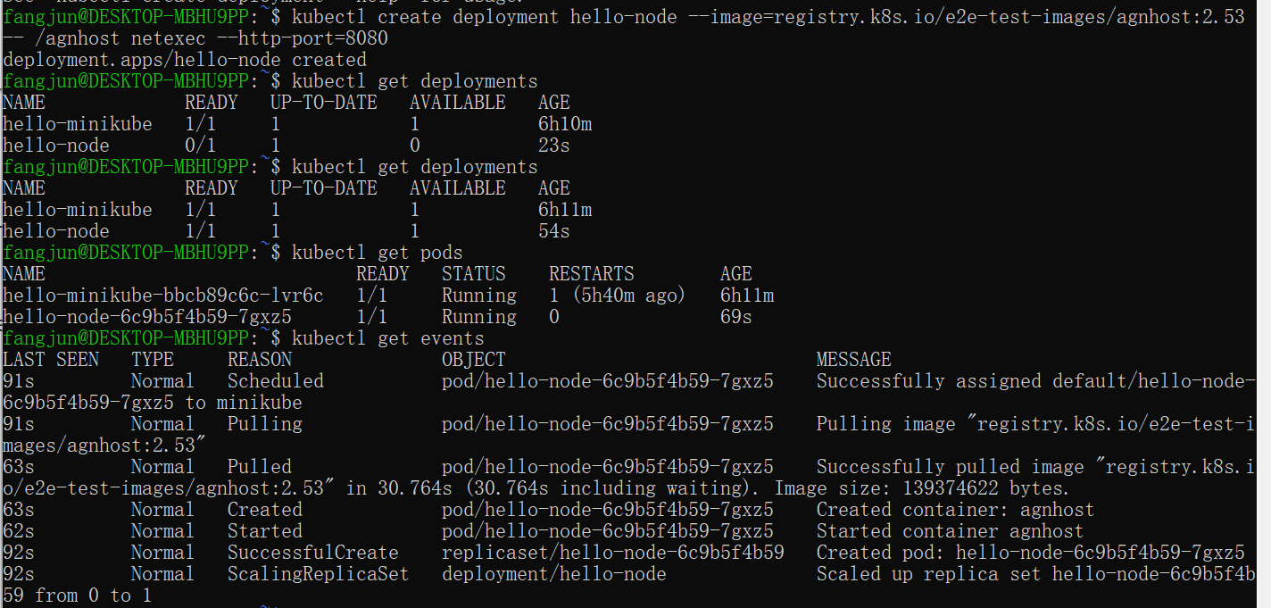
Step 5 Create a Service
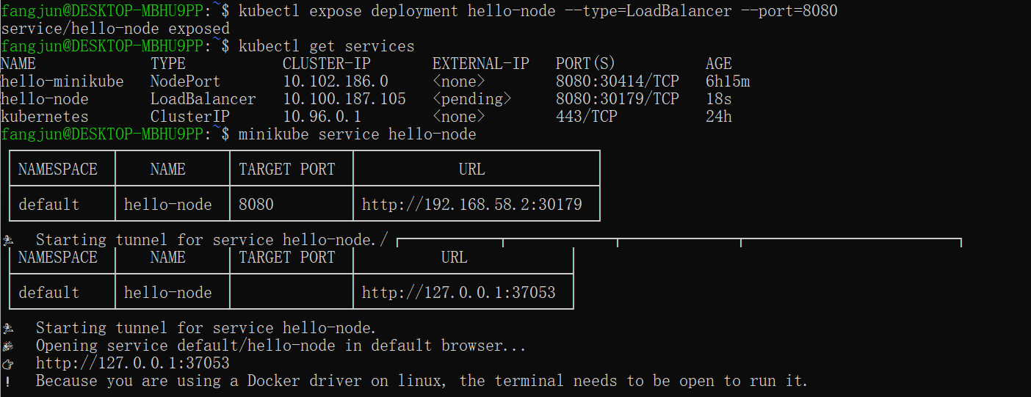
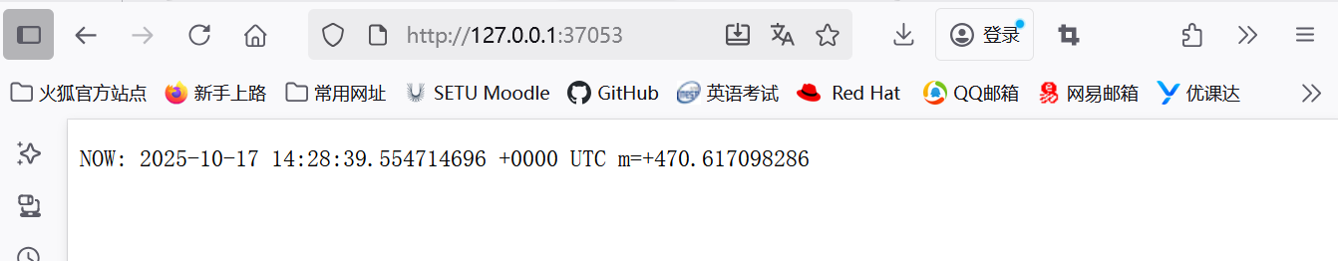
Step 6 Enable addons
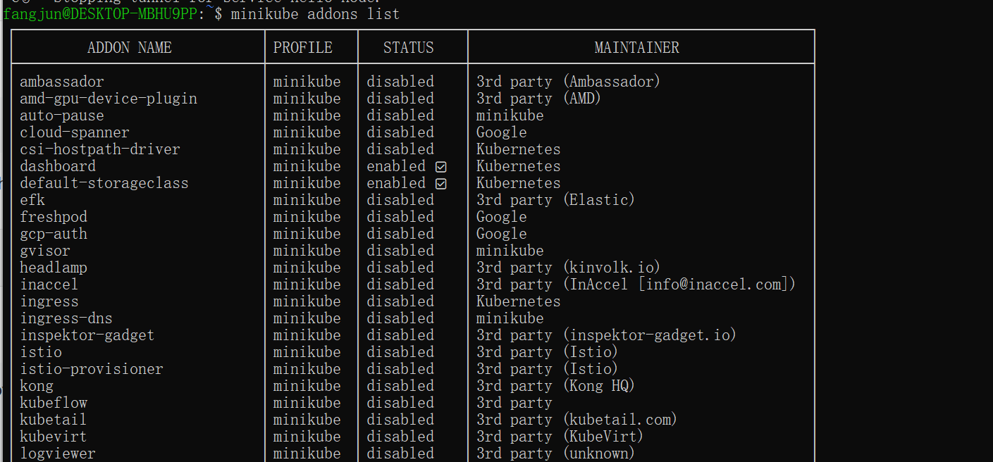
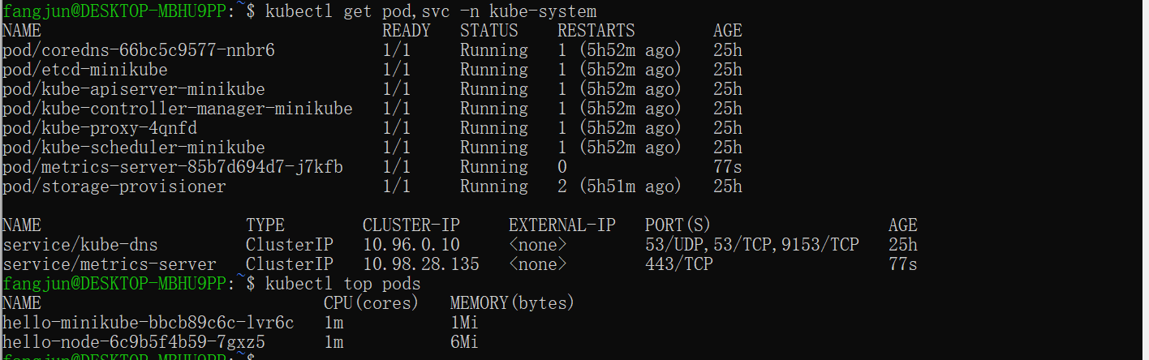
https://kubernetes.io/docs/tutorials/kubernetes-basics/deploy-app/deploy-intro/
A Deployment is responsible for creating and updating instances of your application.
Deploy an app
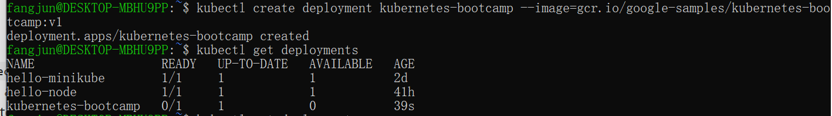
View the app
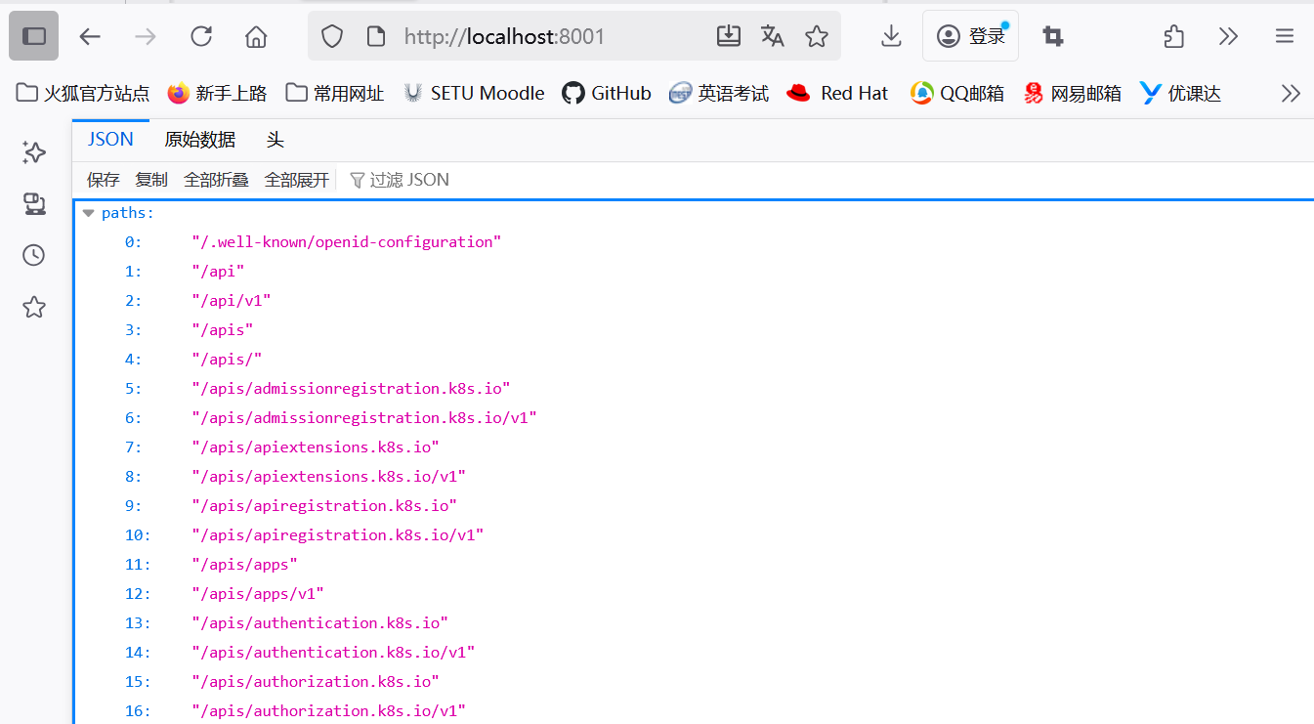
query the version directly through the API
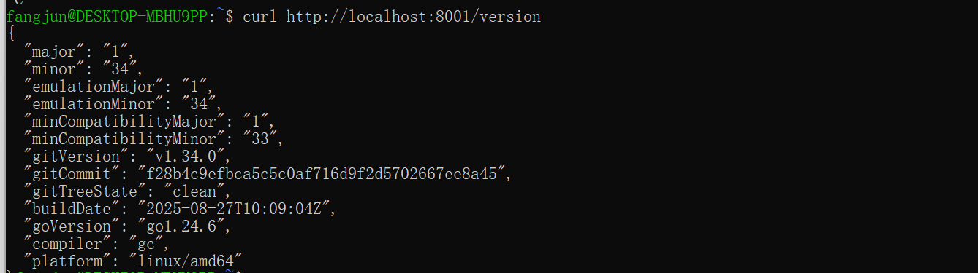
The API server will automatically create an endpoint for each pod, based on the pod name, that is also accessible through the proxy.
get the Pod name, store it in the environment variable POD_NAME.
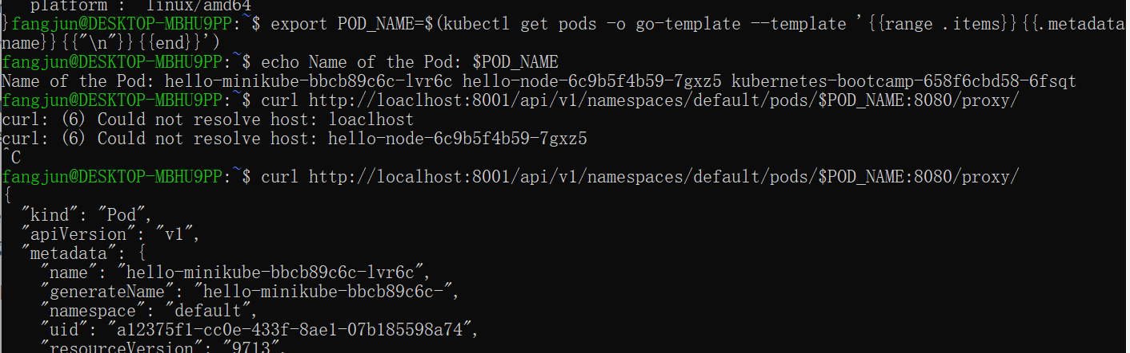
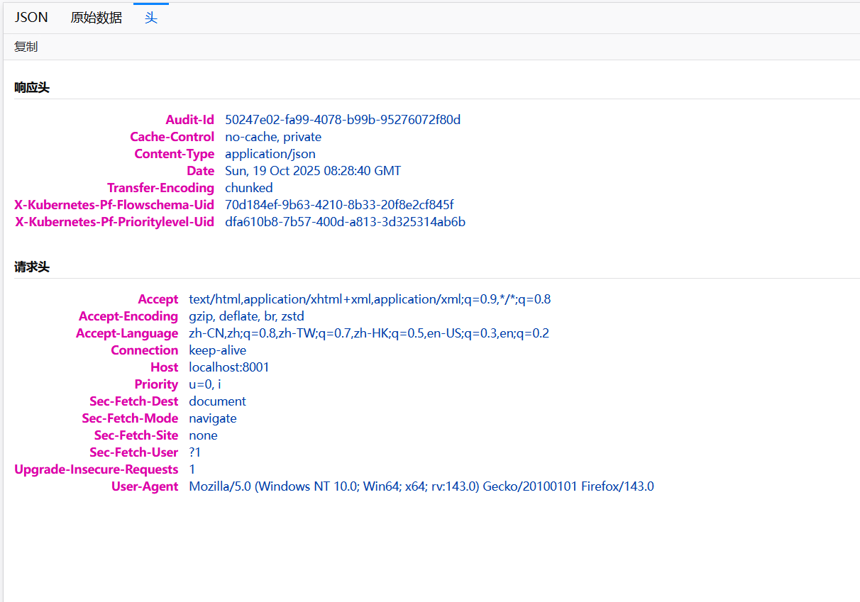
https://kubernetes.io/docs/tutorials/kubernetes-basics/explore/explore-intro/
A Pod is a group of one or more application containers (such as Docker) and includes shared storage (volumes), IP address and information about how to run them.
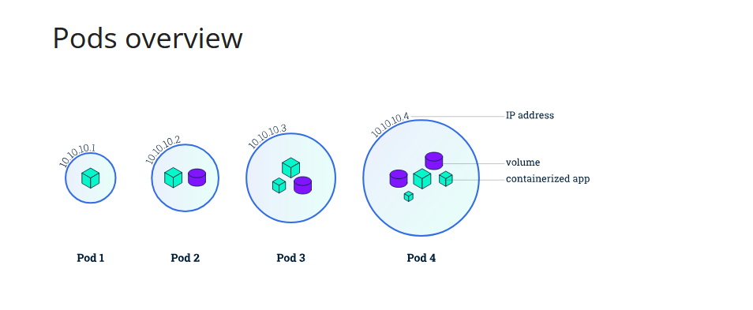
A Pod always runs on a Node. A Node is a worker machine in Kubernetes and may be either a virtual or a physical machine, depending on the cluster. Each Node is managed by the control plane.
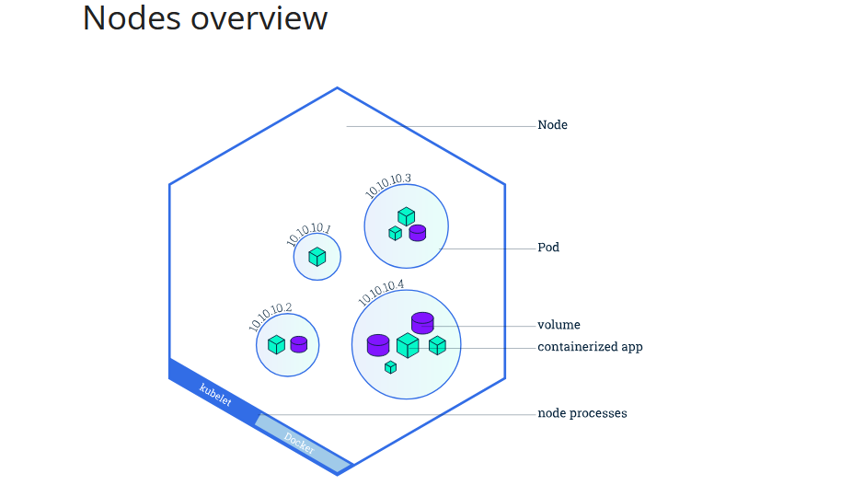
Executing commands on the container
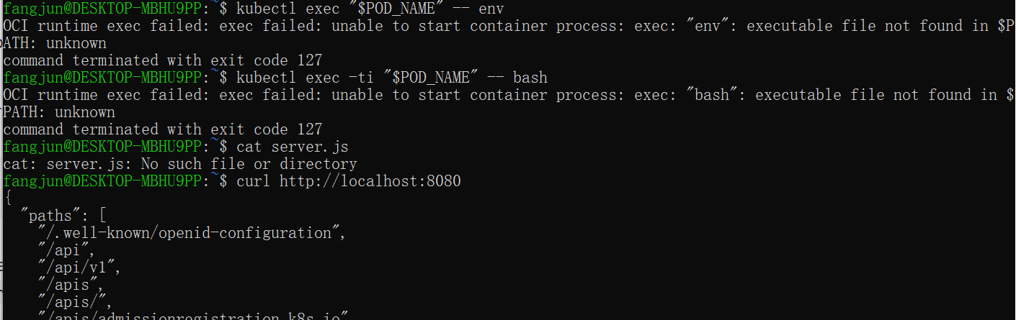
https://kubernetes.io/docs/tutorials/kubernetes-basics/expose/expose-intro/
A Kubernetes Service is an abstraction layer which defines a logical set of Pods and enables external traffic exposure, load balancing and service discovery for those Pods.
Let’s verify that our application is running. We’ll use the kubectl getcommand and look for existing Pods:
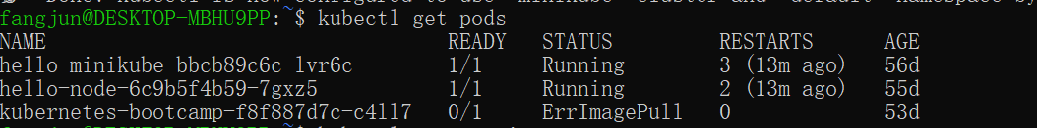
Next, let’s list the current Services from our cluster:
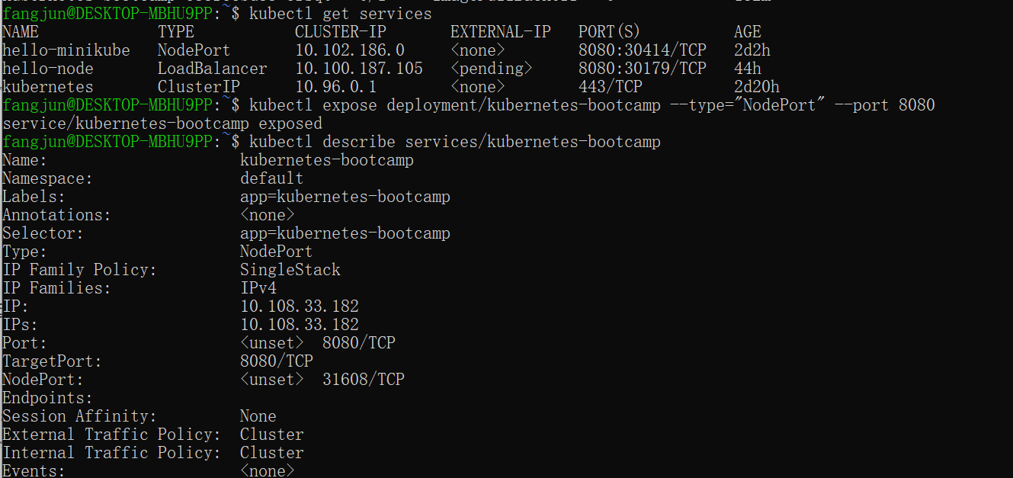
Create an environment variable called NODE_PORT that has the value of the Node port assigned:
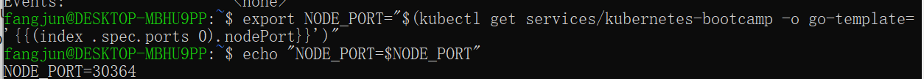
Because I’m running minikube with Docker Desktop as the container driver, a minikube tunnel is needed. This is because containers inside Docker Desktop are isolated from your host computer.
In a separate terminal window, execute:
The Deployment created automatically a label for our Pod. With the describe deployment subcommand you can see the name (the key) of that label:
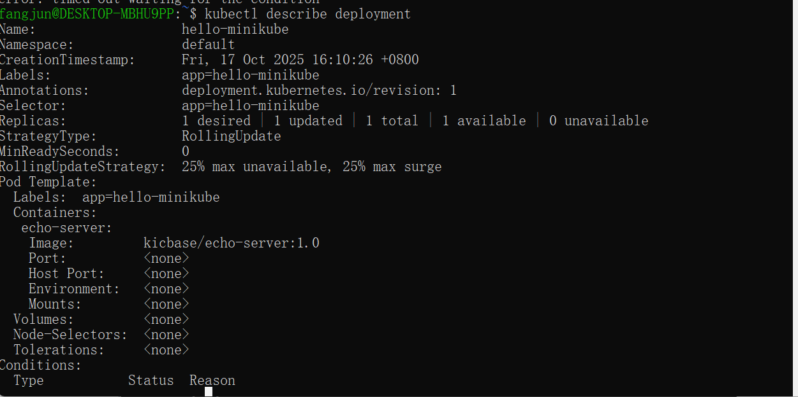
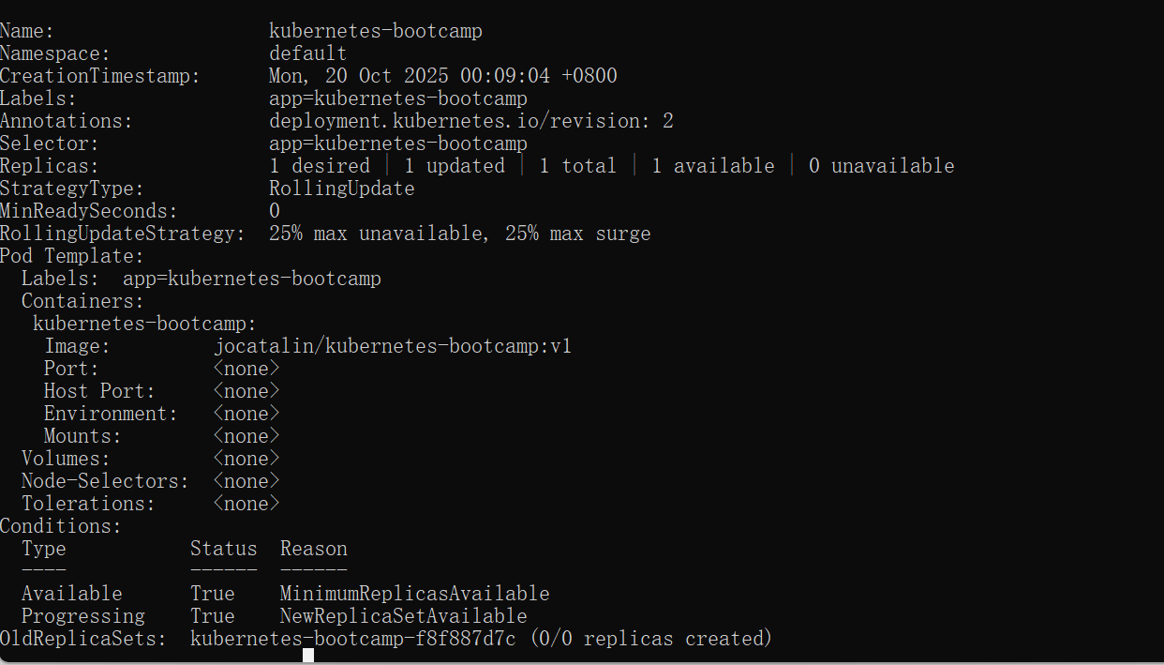
Let’s use this label to query our list of Pods. We’ll use the kubectl get pods command with -l as a parameter, followed by the label values:
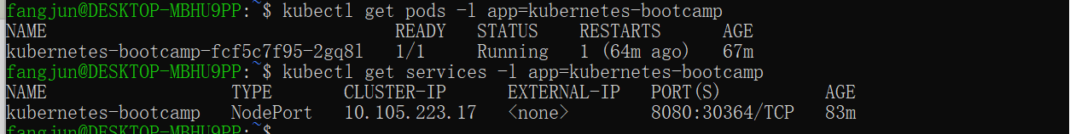
Get the name of the Pod and store it in the POD_NAME environment variable:
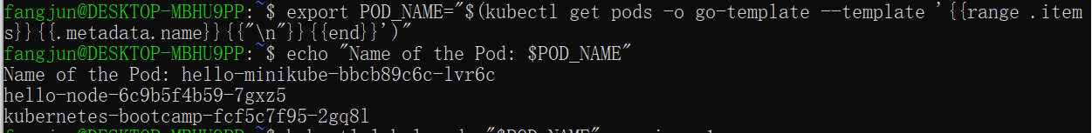
To apply a new label we use the label subcommand followed by the object type, object name and the new label:
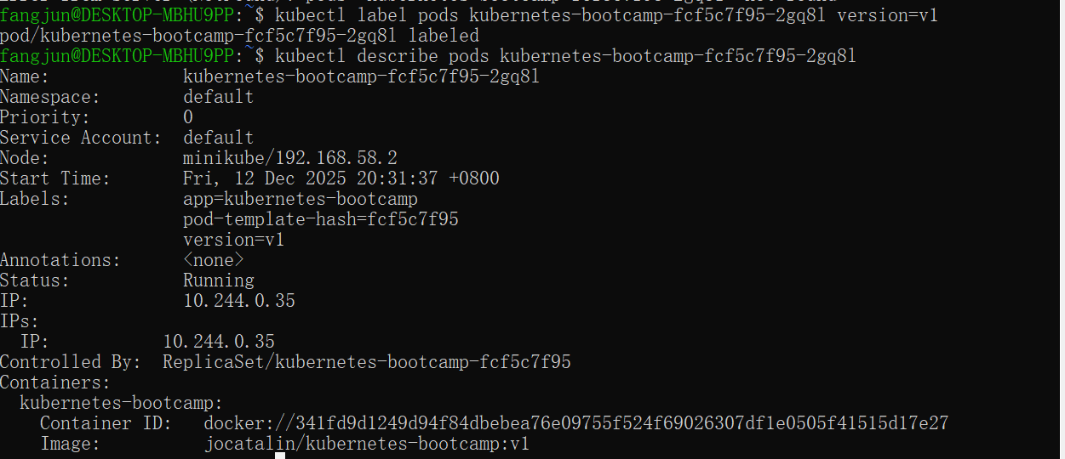
We see here that the label is attached now to our Pod. And we can query now the list of pods using the new label:
To delete Services you can use the delete service subcommand. Labels can be used also here:
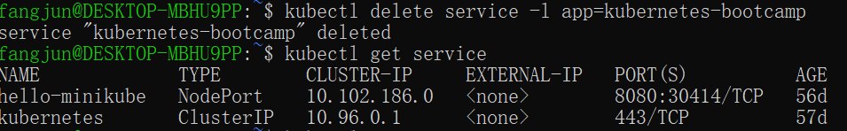

https://kubernetes.io/docs/tutorials/kubernetes-basics/scale/scale-intro/
Scaling out a Deployment will ensure new Pods are created and scheduled to Nodes with available resources. Scaling will increase the number of Pods to the new desired state. Kubernetes also supports autoscaling of Pods, but it is outside of the scope of this tutorial. Scaling to zero is also possible, and it will terminate all Pods of the specified Deployment.
To list your Deployments, use the get deployments subcommand:
To see the ReplicaSet created by the Deployment, run:
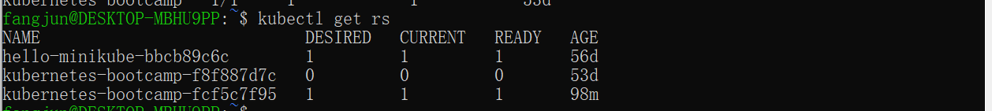
Next, let’s scale the Deployment to 4 replicas. We’ll use the kubectl scalecommand, followed by the Deployment type, name and desired number of instances:
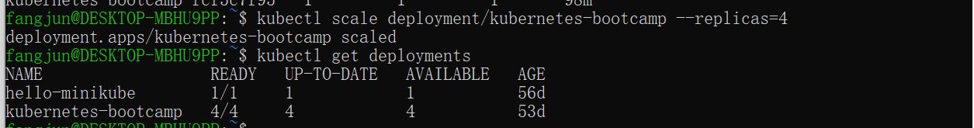
Let's check that the Service is load-balancing the traffic. To find out the exposed IP and Port we can use describe service as we learned in the previous part of the tutorial:
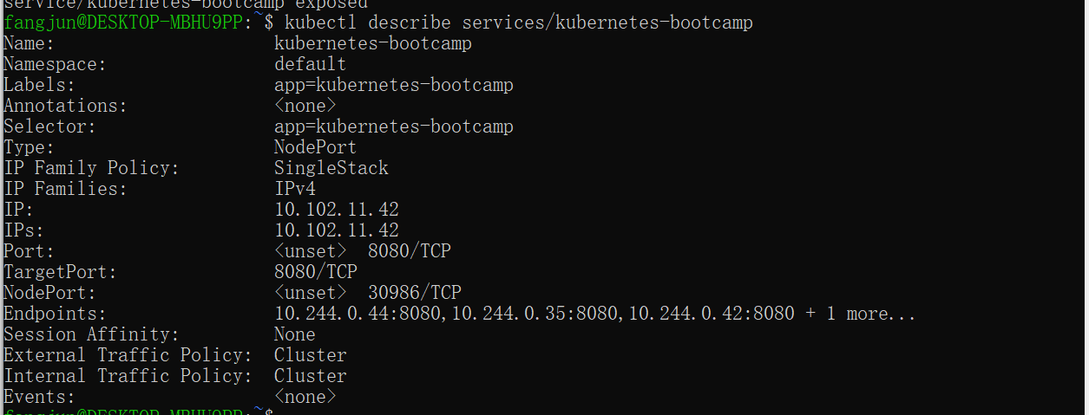
To scale down the Deployment to 2 replicas, run again the scalesubcommand:
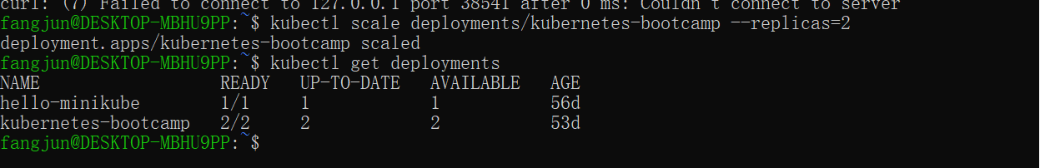
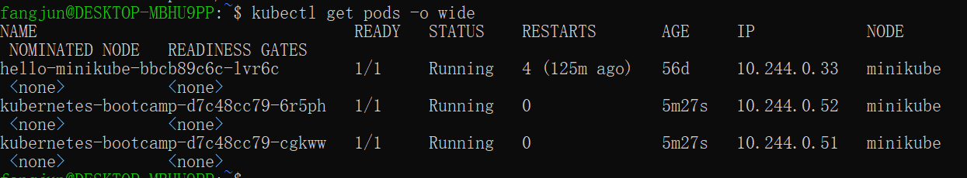

https://kubernetes.io/docs/tutorials/kubernetes-basics/update/update-intro/
Rolling updates allow the following actions:
• Promote an application from one environment to another (via container image updates)
• Rollback to previous versions
• Continuous Integration and Continuous Delivery of applications with zero downtime
To list your Deployments, run the get deployments subcommand:
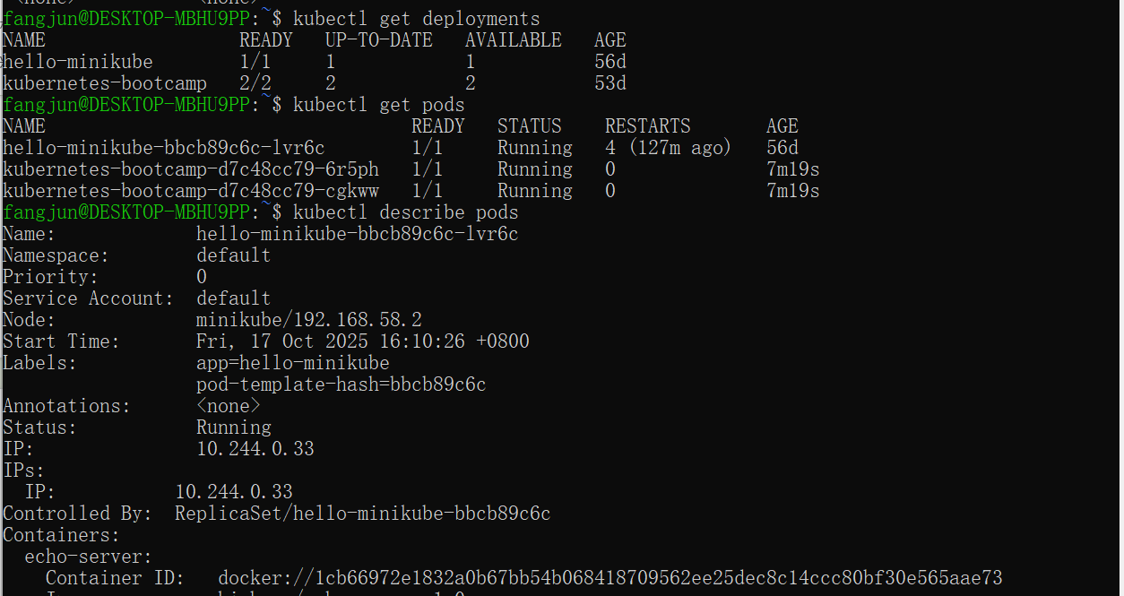
To update the image of the application to version 2, use the set imagesubcommand, followed by the deployment name and the new image version:
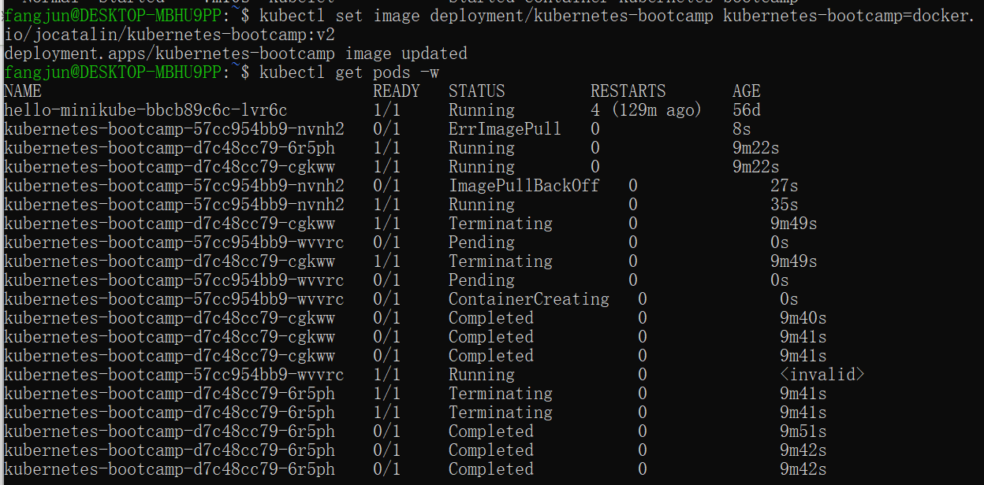
You can also confirm the update by running the rollout statussubcommand:
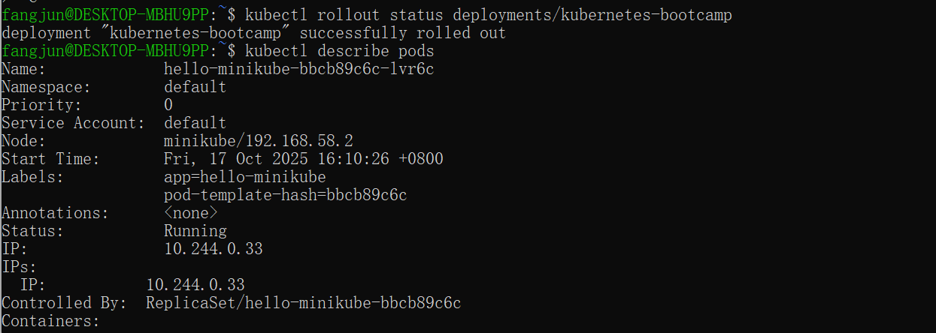
Let’s perform another update, and try to deploy an image tagged with v10:
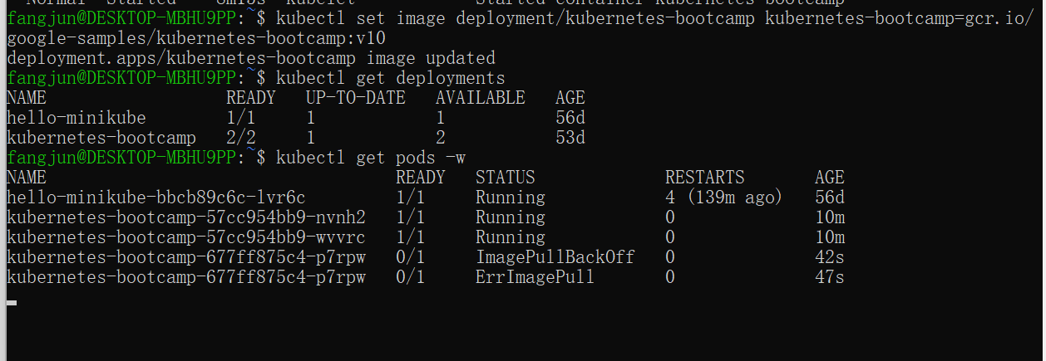
Notice that some of the Pods have a status of ImagePullBackOff.
To get more insight into the problem, run the describe podssubcommand:
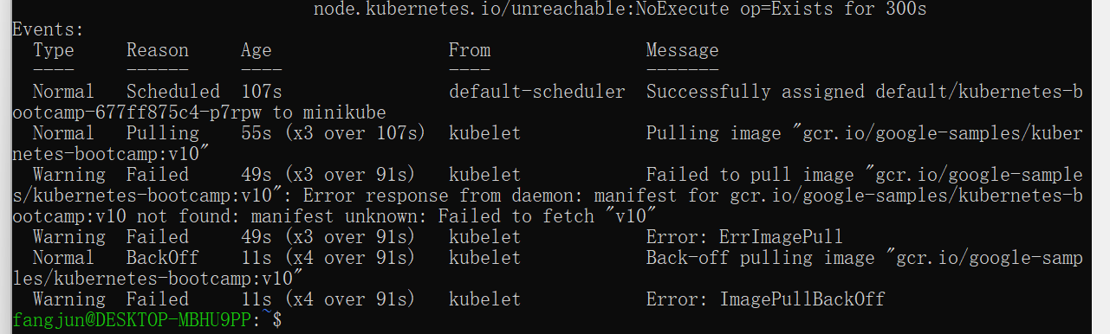
To roll back the deployment to your last working version, use the rollout undo subcommand:
