This lab exercise will give you hands-on experience with Knative for
building, deploying, and managing serverless, cloud-native applications on Kubernetes.

Please follow the instructions here:
The lab environment:
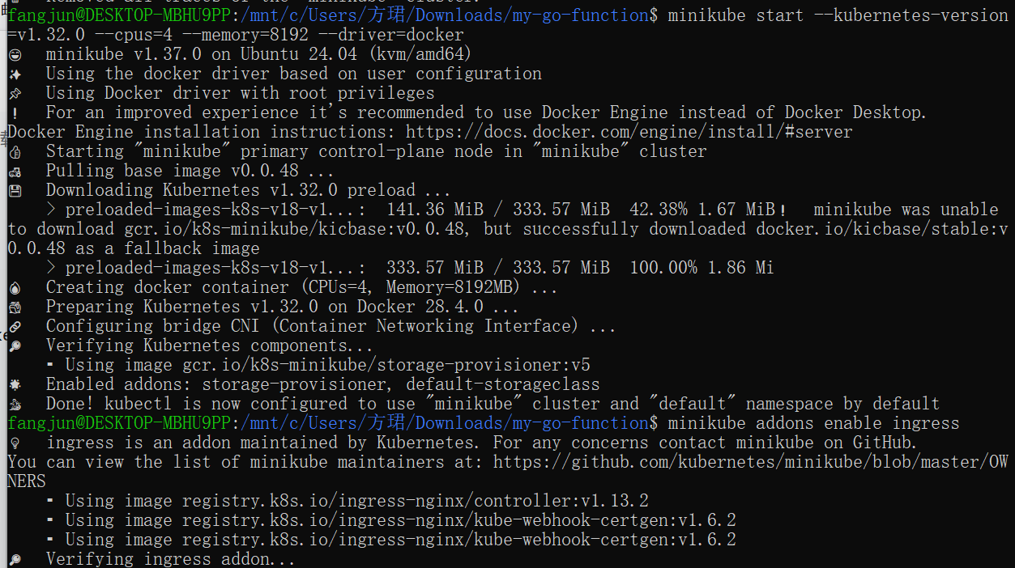
Install the Knative CLI
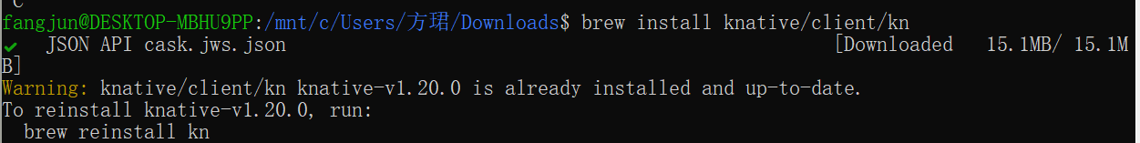
Install the Knative quickstart plugin
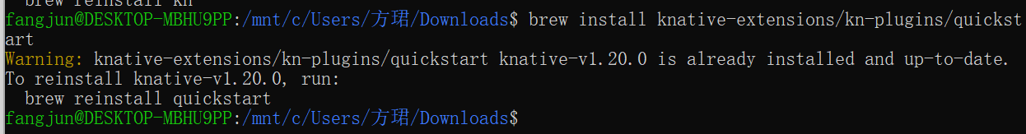
Knative Serving Installation
Knative Serving was installed using the official YAML manifests.
The Serving CRDs and core components were applied successfully.
Istio was used as the networking layer for Knative Serving.
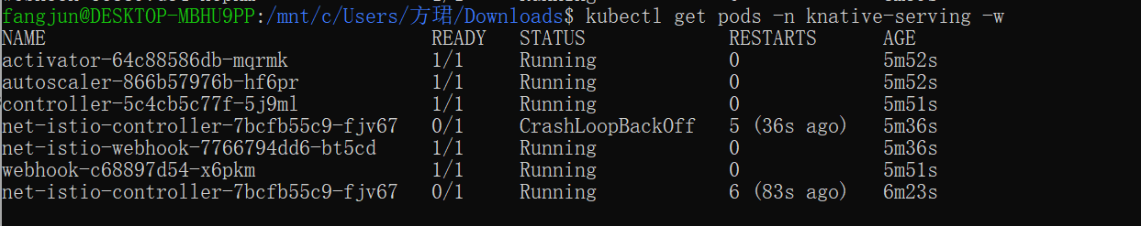
Knative Eventing Installation
Knative Eventing was installed using the official YAML manifests.
All Eventing components were successfully deployed and running.
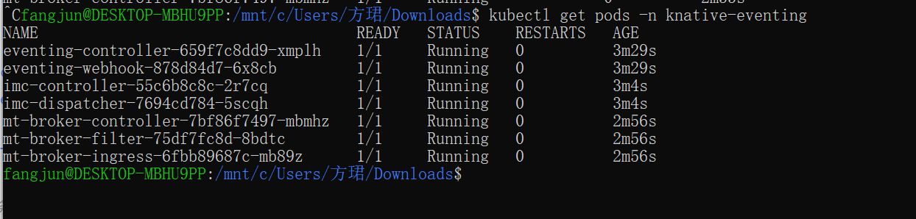
Run the Knative quickstart plugin:
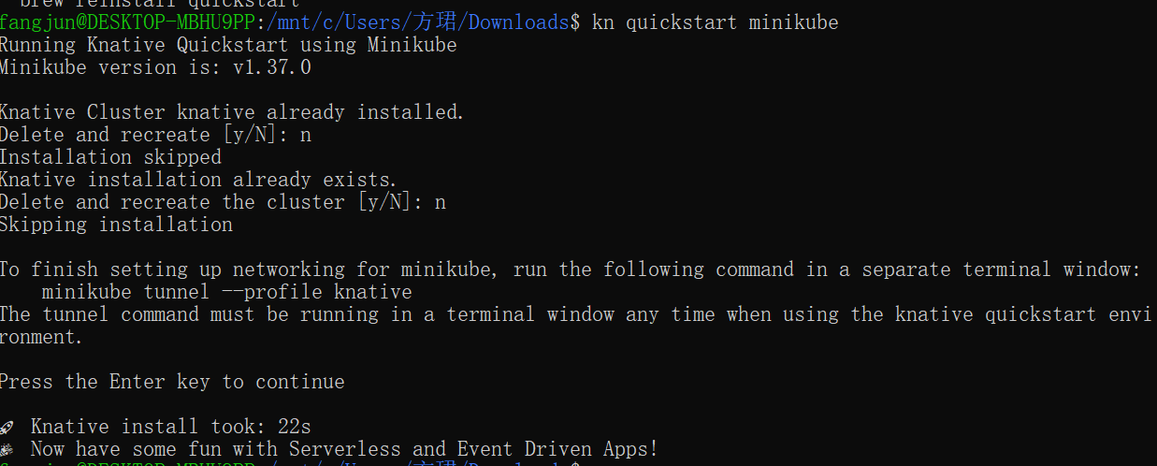
The output of the previous command asked you to run minikube tunnel. Run the following command to start the process in a secondary terminal window, then return to the primary window and press enter to continue:
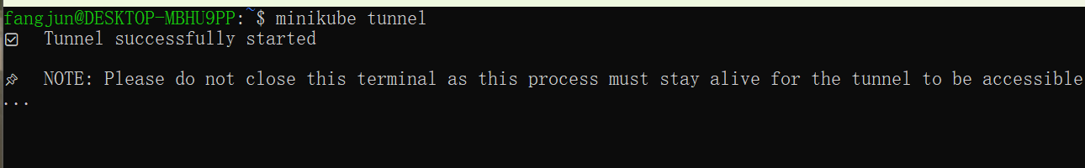
The tunnel must continue to run in a terminal window any time you are using your Knative quickstart environment.

[Knative Functions]
https://knative.dev/docs/getting-started/about-knative-functions/
Installing the func CLI
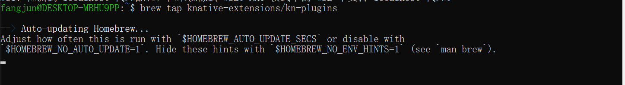

Installing the kn func CLI plugin
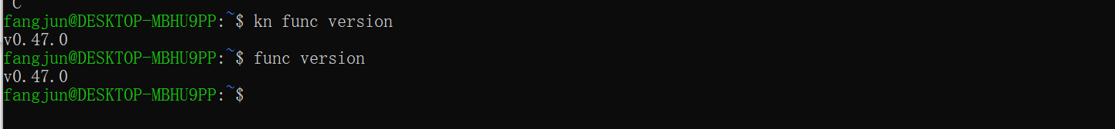
Creating a function

Running a function
The run command builds an image for your function if required, and runs this image locally, instead of deploying it on a cluster.
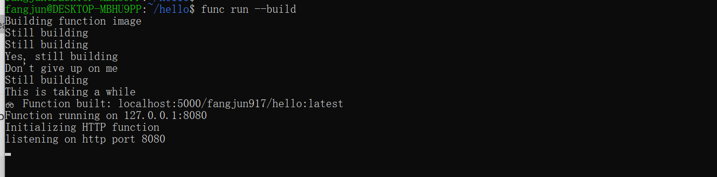
You can verify that your function has been successfully run by using the invoke command and observing the output:
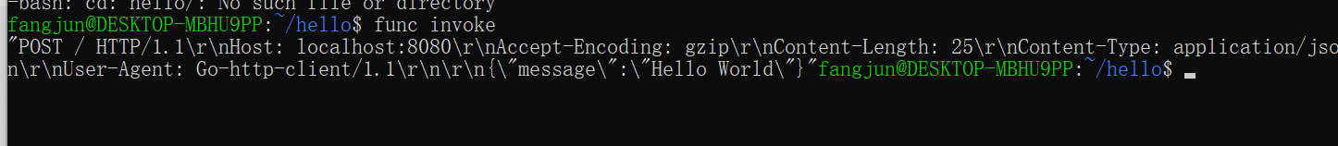
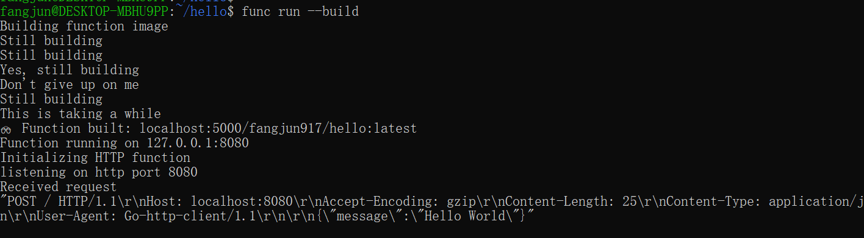

Comments: 1. Use local registry; 2. Skip the "Deploying a function" part

[Knative Serving]
https://knative.dev/docs/getting-started/first-service/
Pull and Tag the Image for Local Registry
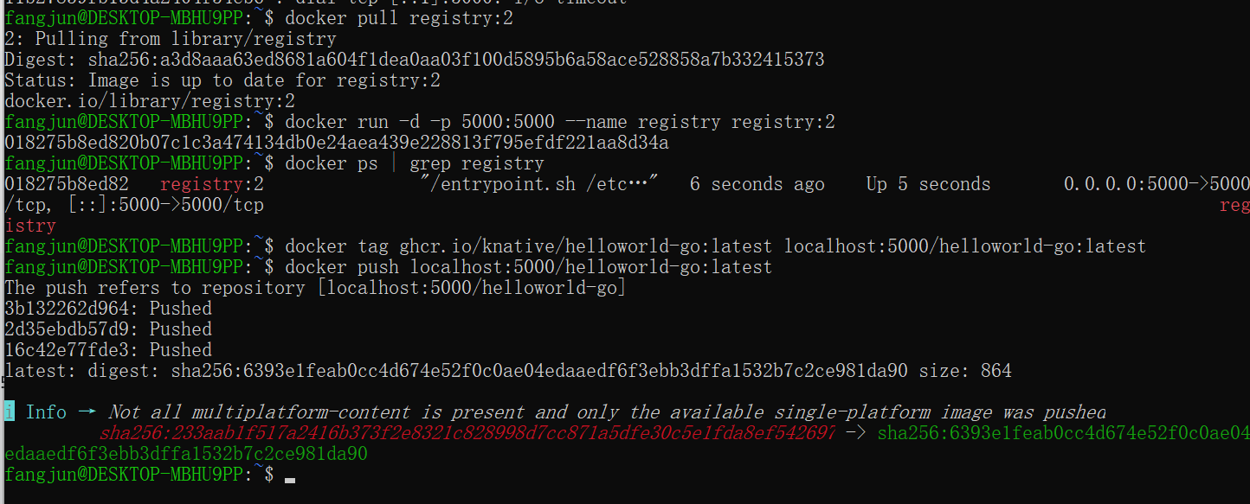
Deploying a Knative Service
In this tutorial, you will deploy a "Hello world" Knative Service that accepts the environment variable TARGET and prints Hello ${TARGET}!.
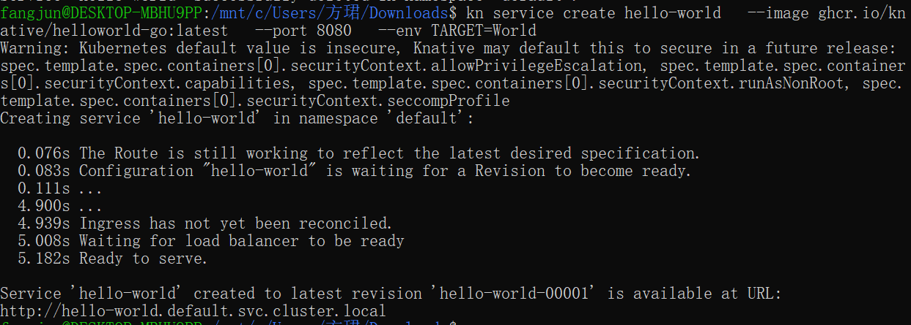
List your Knative Service
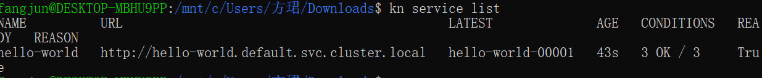
Access your Knative Service
Observe autoscaling
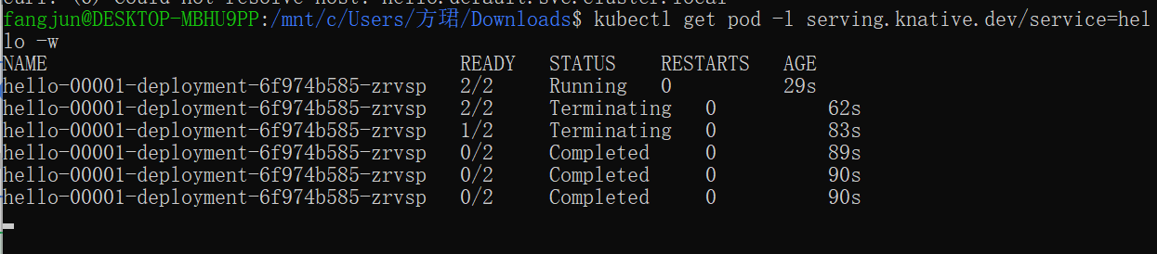

Traffic splitting
Creating a new Revision
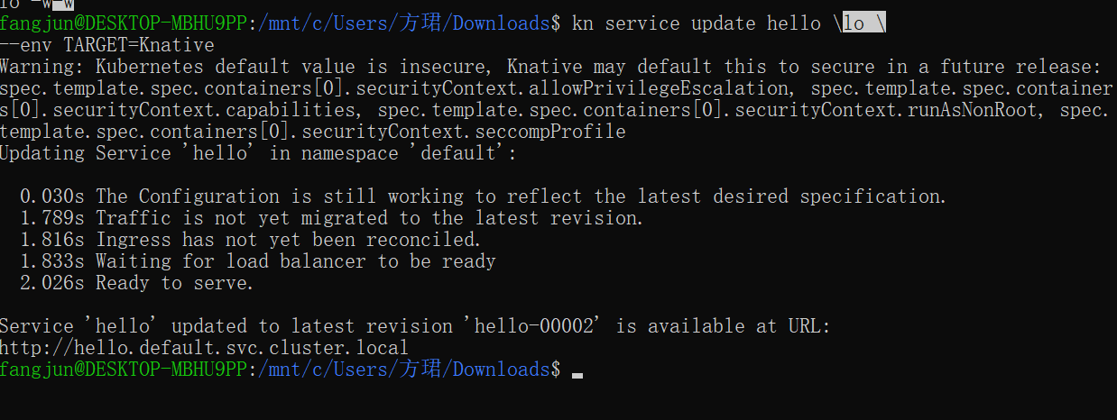
Accessing the new Revision
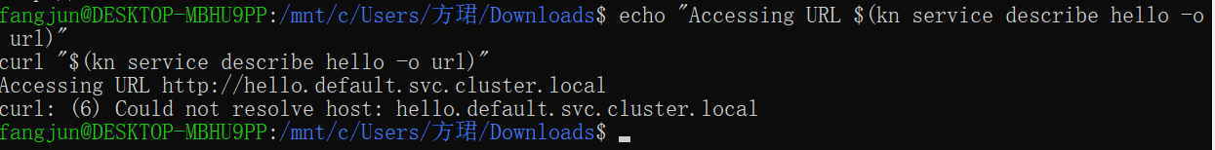
View existing Revisions
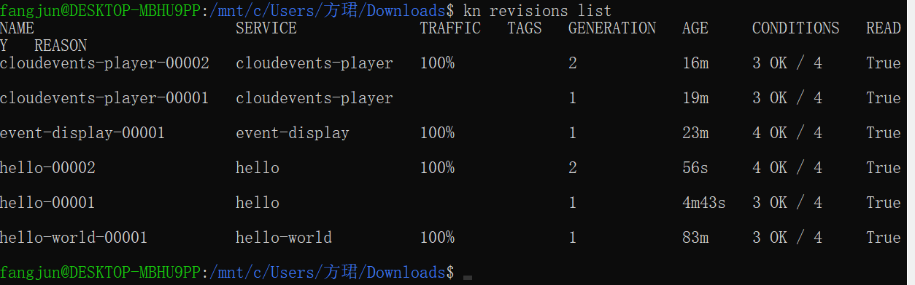
Splitting traffic between Revisions
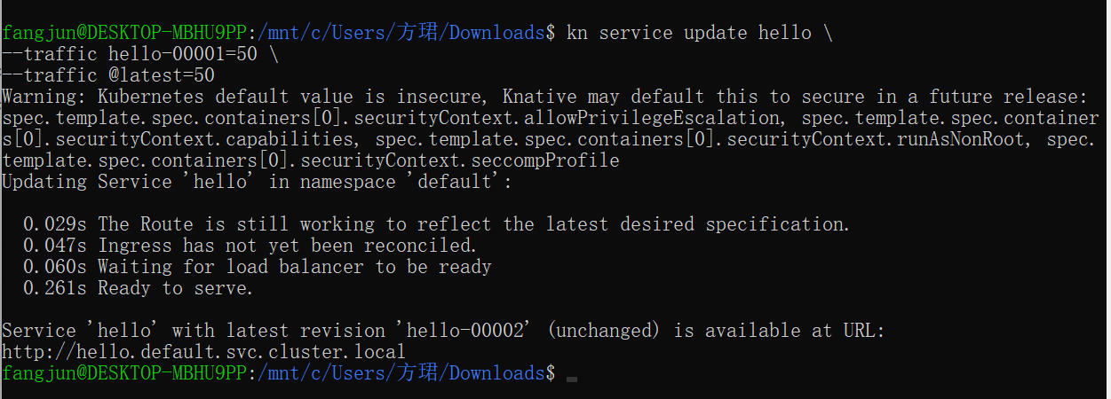
Verify the traffic split
To verify that the traffic split has configured correctly, list the Revisions again by running the command:
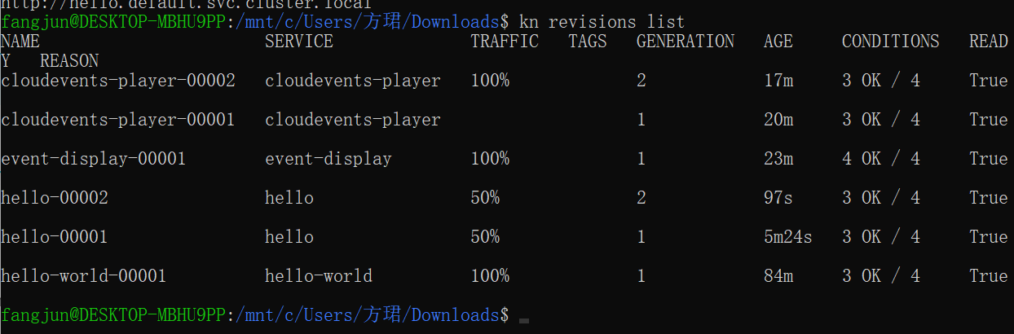

[Knative Eventing]
https://knative.dev/docs/getting-started/getting-started-eventing/
Knative Eventing provides you with helpful tools that can be used to create event-driven applications, by easily attaching event sources, triggers, and other options to your Knative Services.
Event-driven applications are designed to detect events as they occur, and process these events by using user-defined, event-handling procedures.
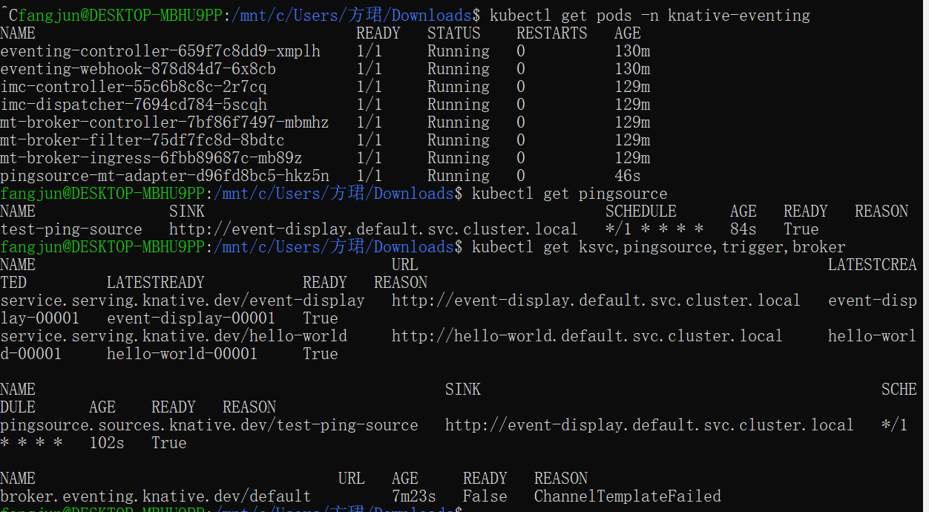
Sources, Brokers, and Triggers
Verify that the Broker is installed by running the following command:
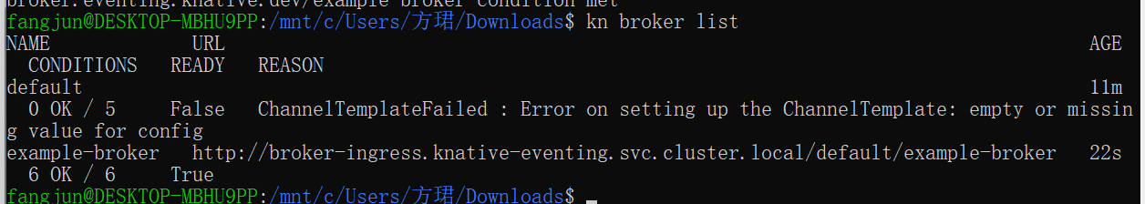

Using a Knative Service as a source
Create the CloudEvents Player Service:
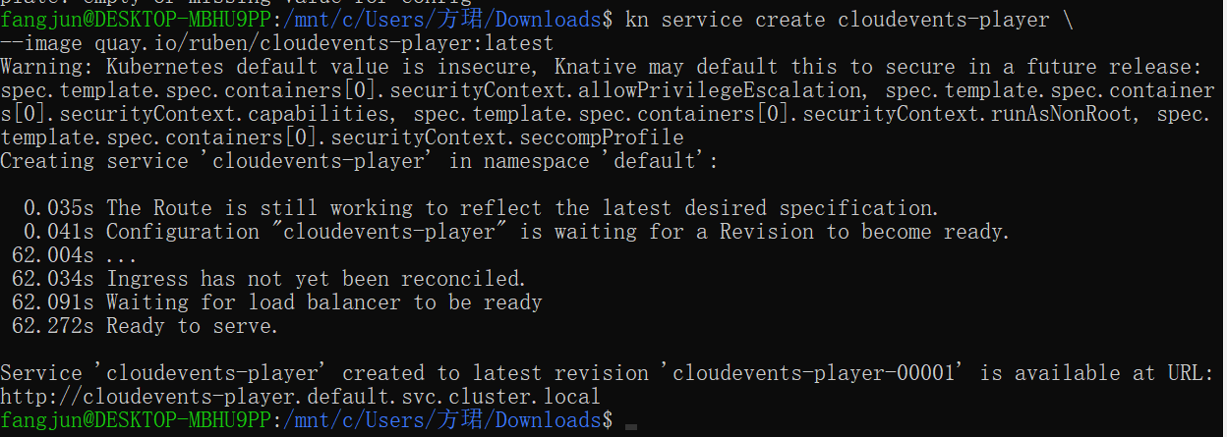
The service is now running but it doesn't know where the broker is so let's create a SinkBinding between the service and the broker.
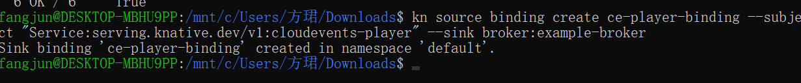
Examining the CloudEvents Player

Using Triggers and sinks
Create a Trigger that listens for CloudEvents from the event source and places them into the sink, which is also the CloudEvents Player app.
