This lab exercise will give you hands-on experience with Istio's traffic management capabilities. For example, you can demonstrate how the traffic shifting can be used to manage deployments and migrations of service versions in a microservices architecture.

For the following four topics, please follow the instructions here:

https://istio.io/latest/docs/tasks/traffic-management/traffic-shifting/
1.Istio APIs
Apply weight-based routing
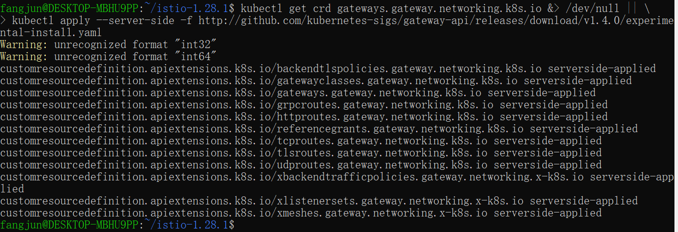
Apply weight-based routing
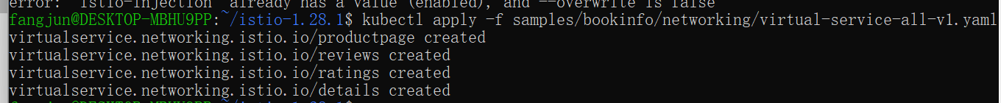
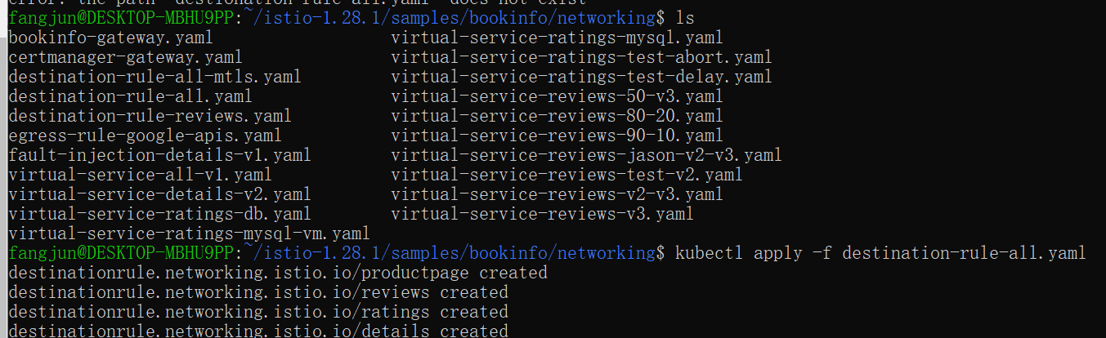
Transfer 50% of the traffic from reviews:v1 to reviews:v3 with the following command:
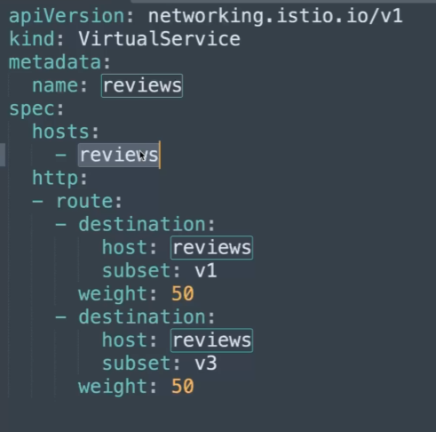
Wait a few seconds for the new rules to propagate and then confirm the rule was replaced:
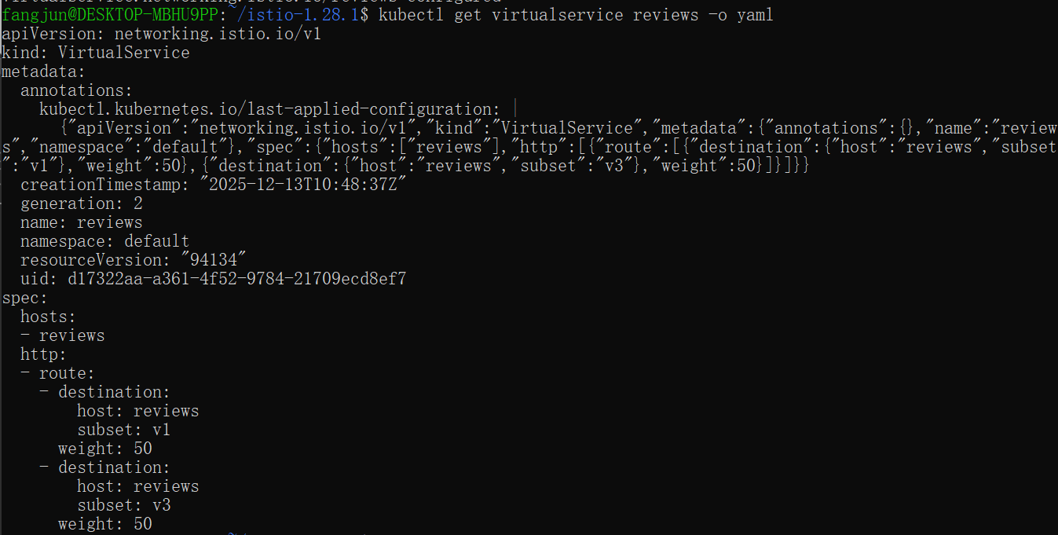
Assuming you decide that the reviews:v3 microservice is stable, you can route 100% of the traffic to reviews:v3 by applying this virtual service:
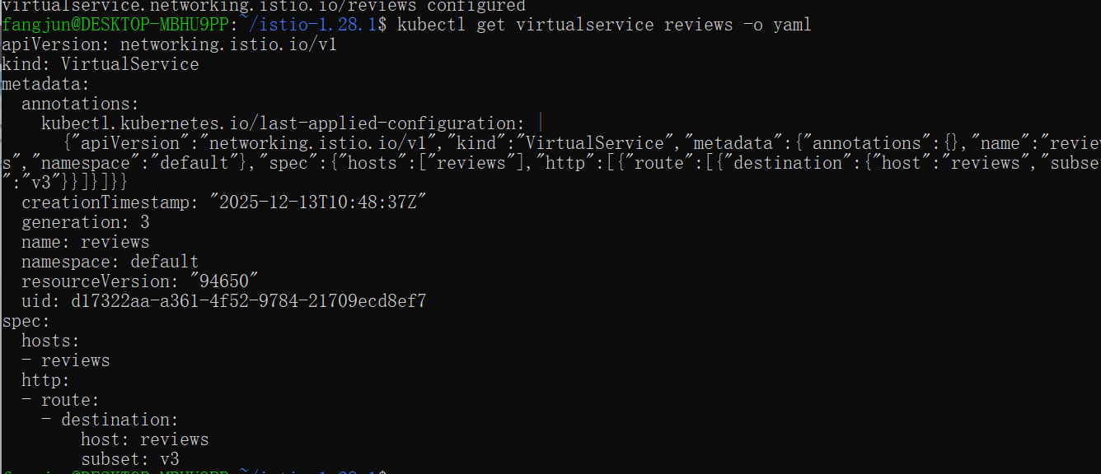

- Gateway API
Apply weight-based routing
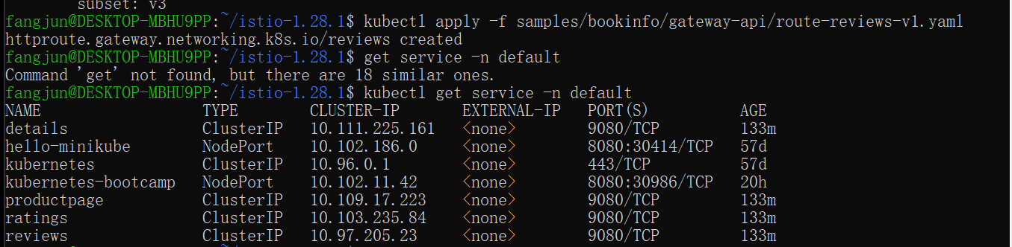
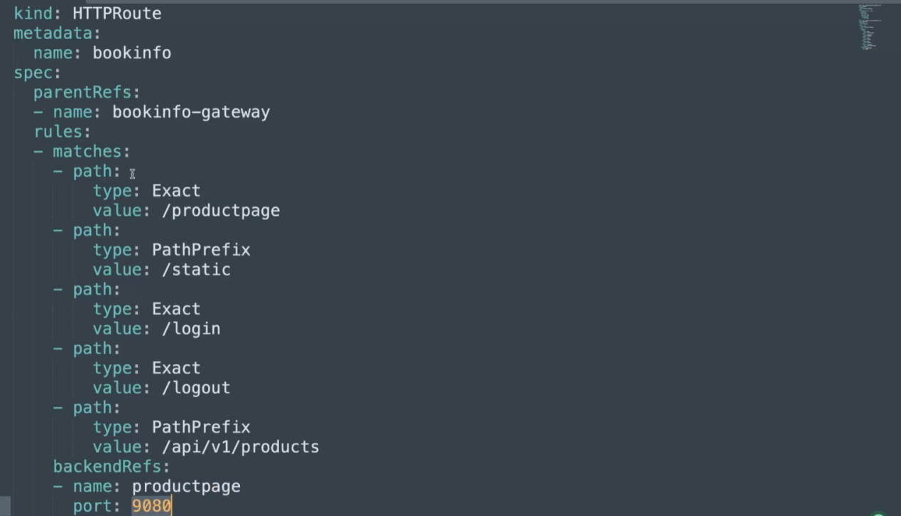
We can see the port 9080
Wait a few seconds for the new rules to propagate and then confirm the rule was replaced:
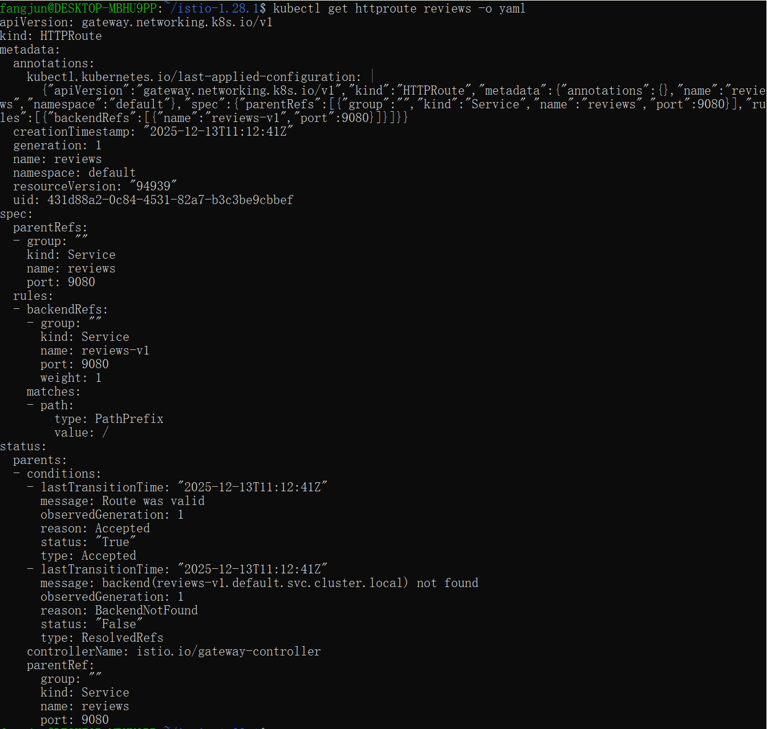
Assuming you decide that the reviews:v3 microservice is stable, you can route 100% of the traffic to reviews:v3 by applying this virtual service:
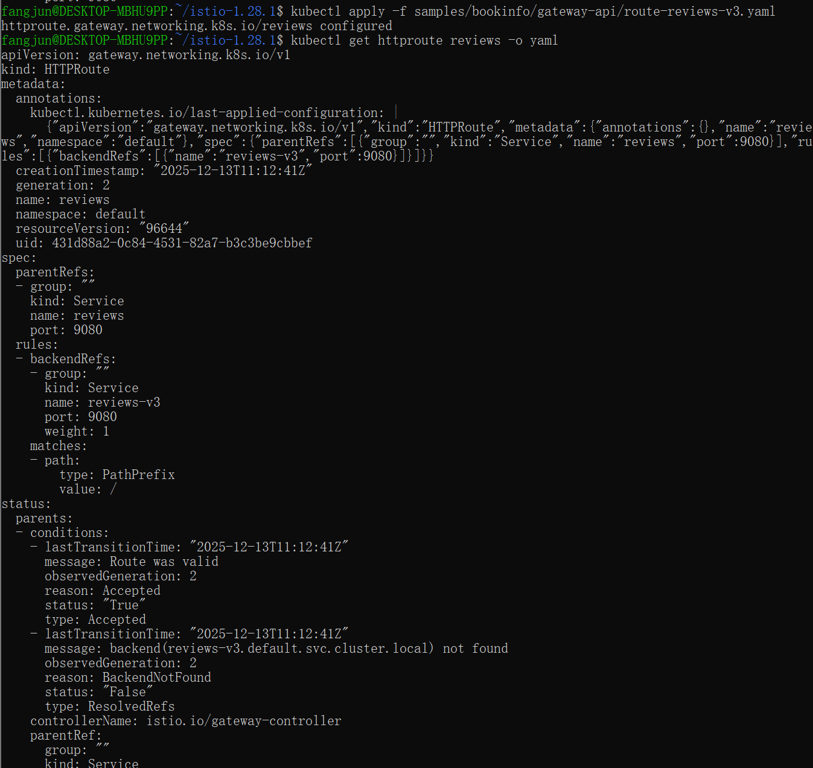

https://istio.io/latest/docs/tasks/traffic-management/request-routing/
1.Istio APIs
Run the following command to create the route rules:
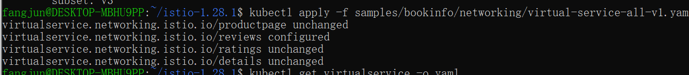
Display the defined routes with the following command:
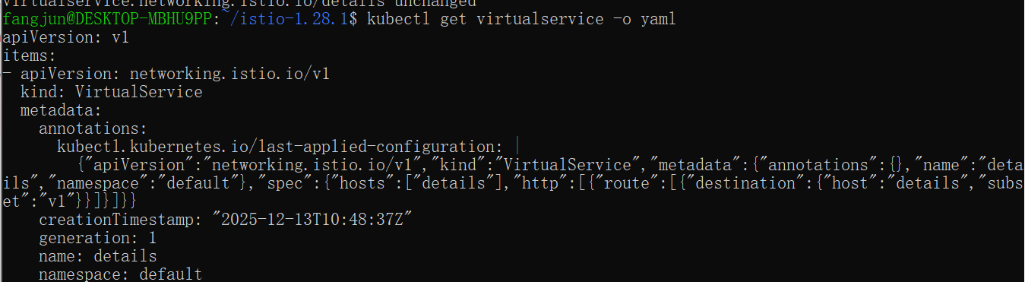
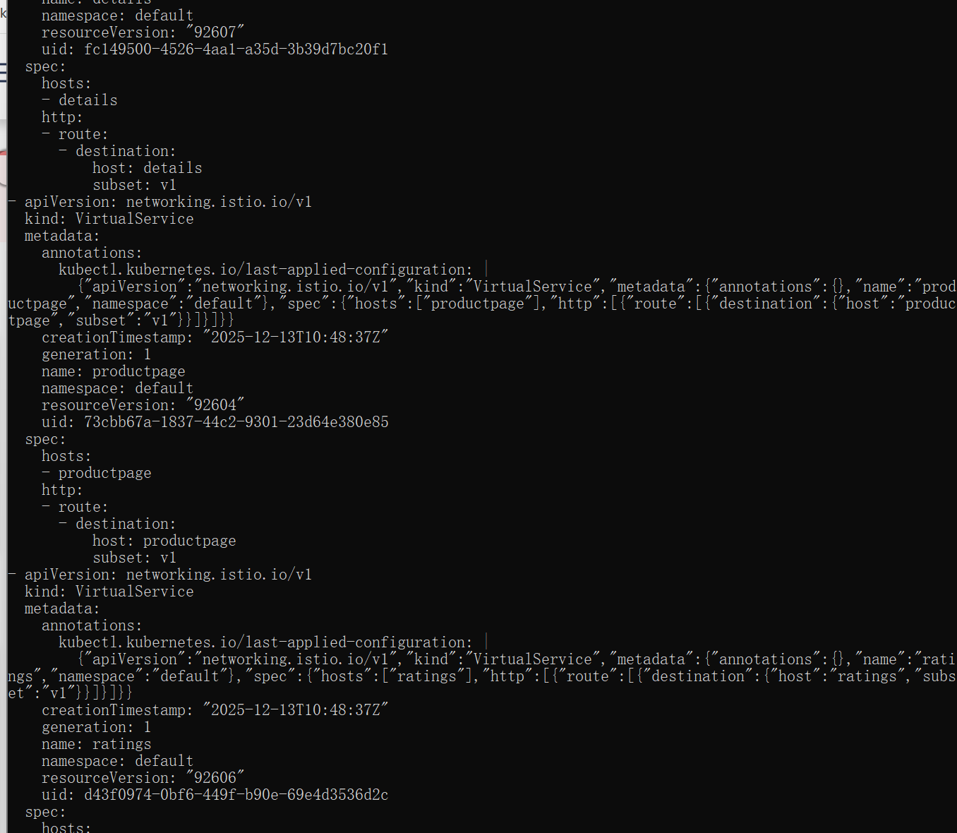
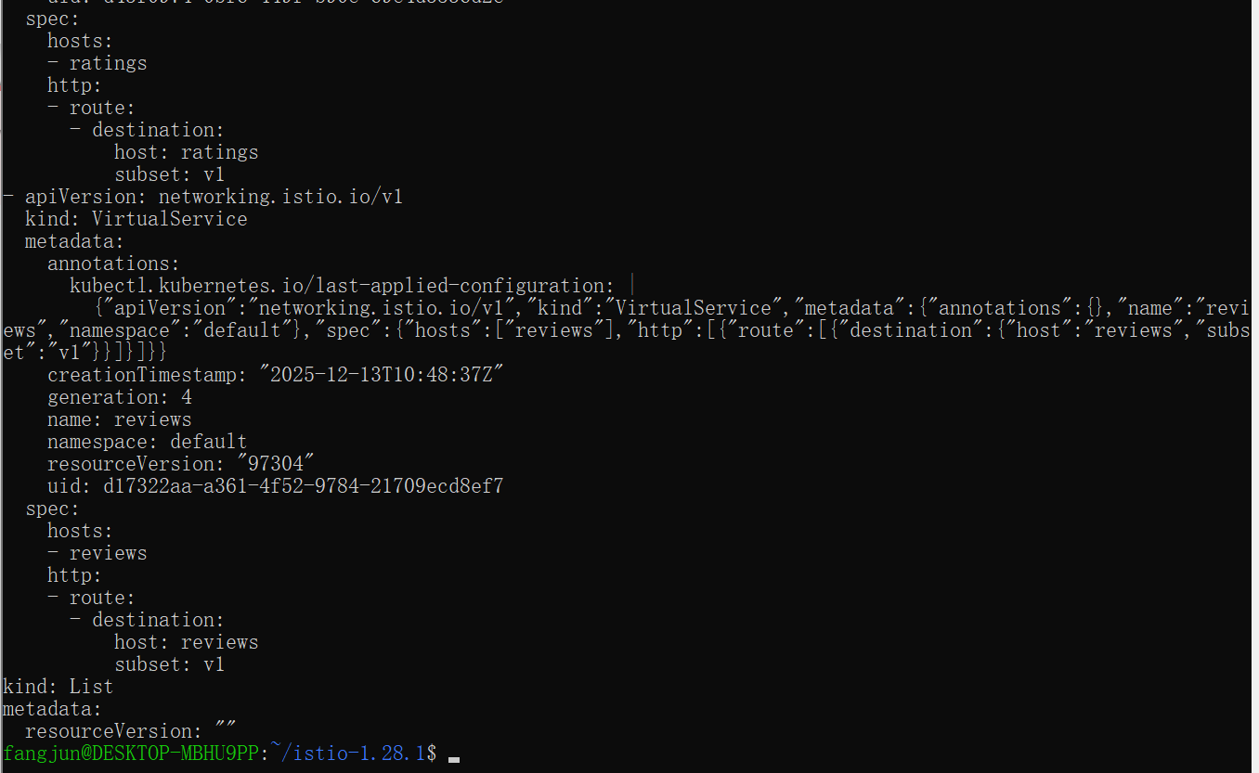
You can also display the corresponding subset definitions with the following command:
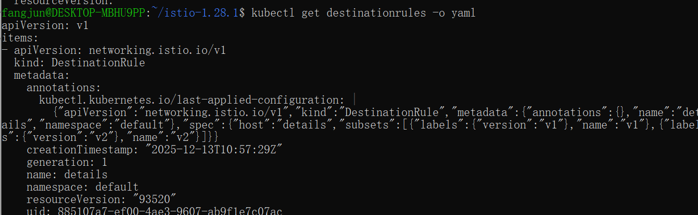
Route based on user identity
Run the following command to enable user-based routing:
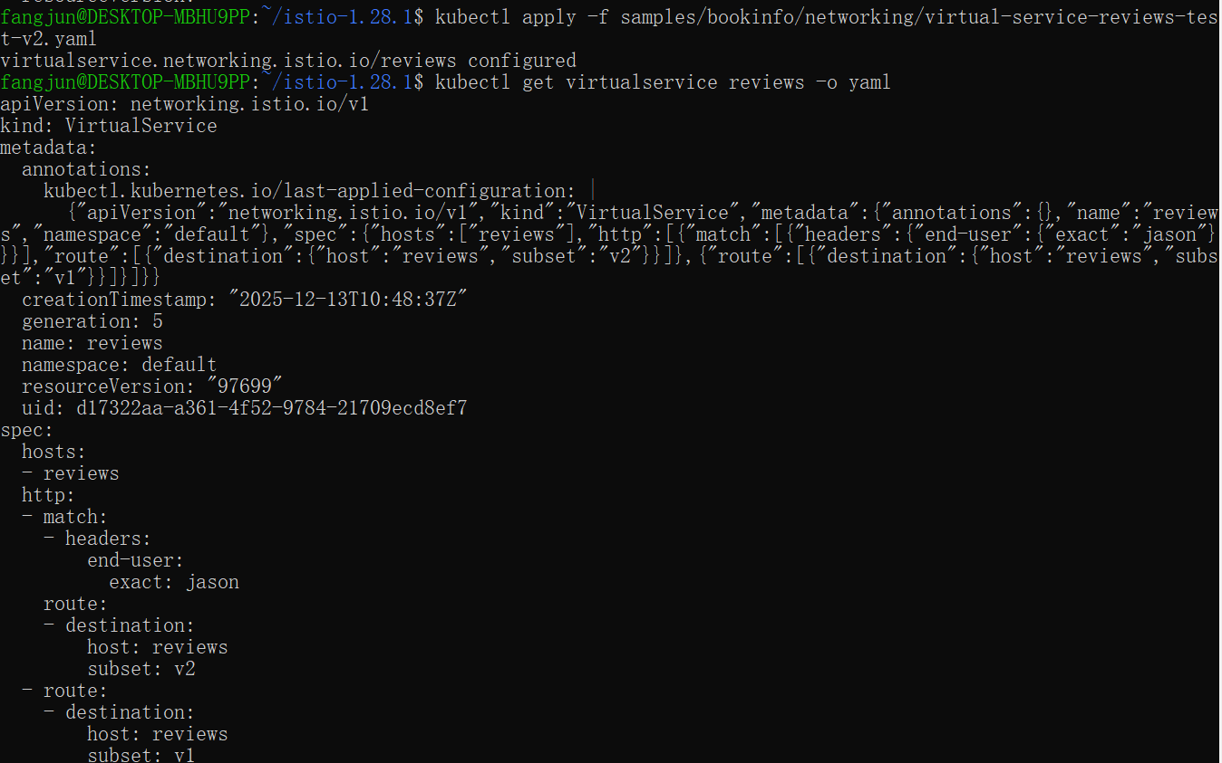
2.Gateway API
Run the following command to create the route rules:
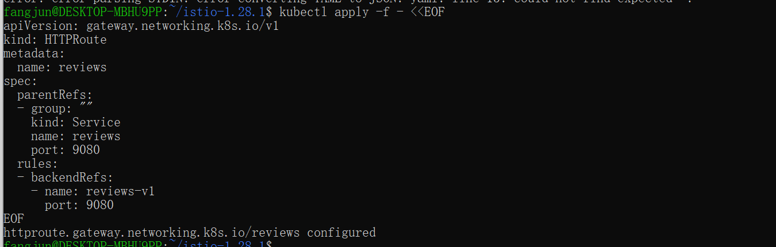
Display the defined routes with the following command:
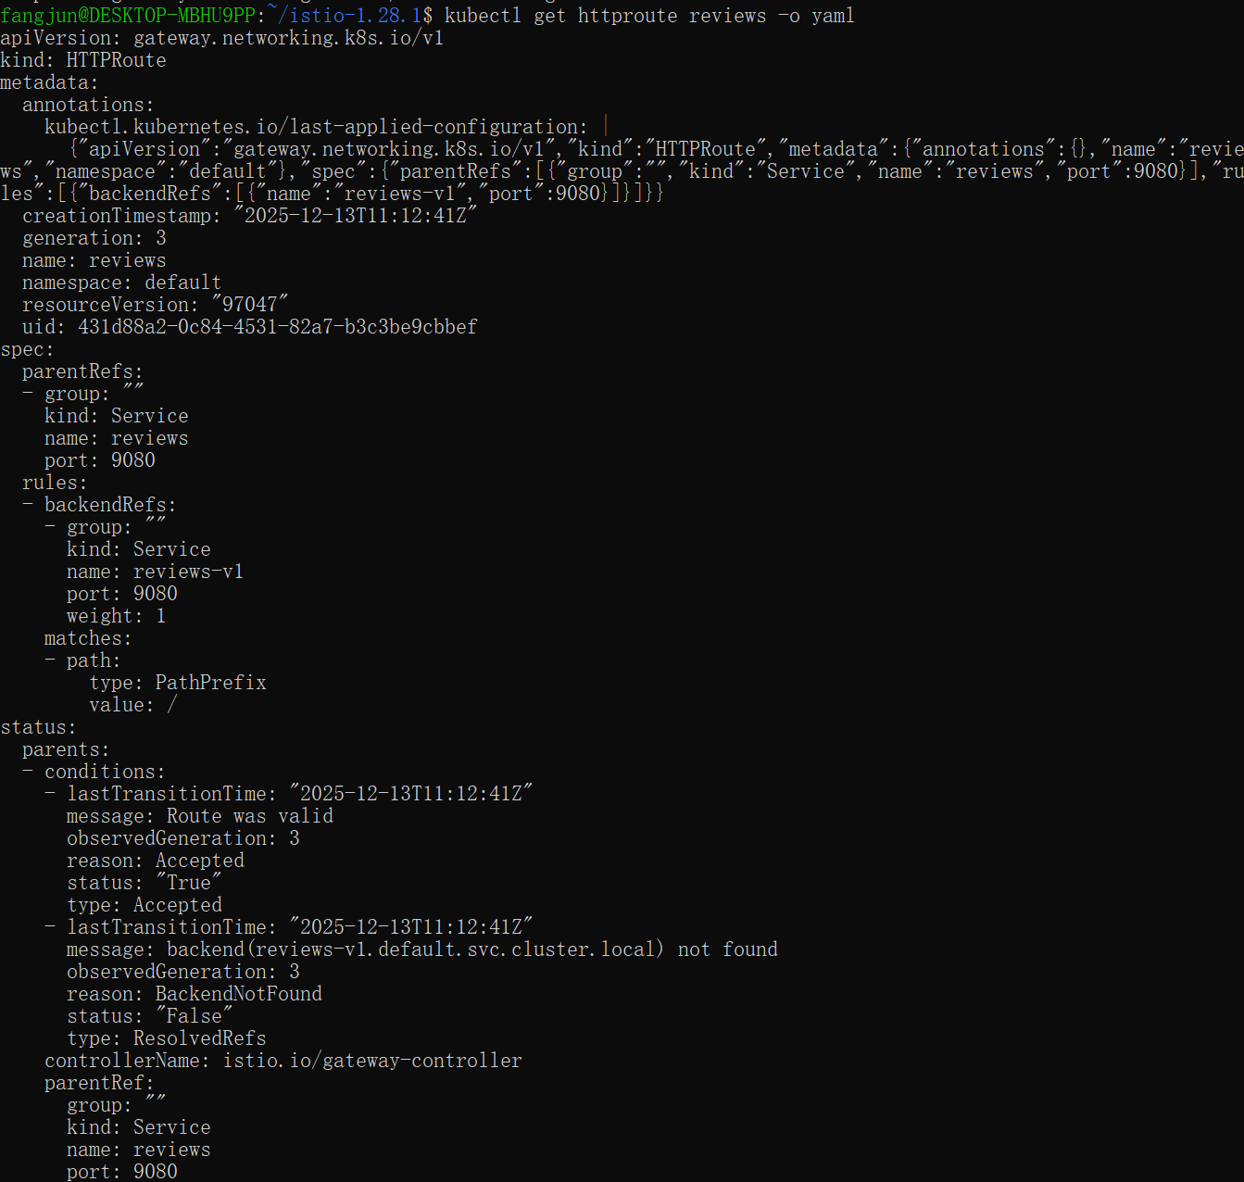

Route based on user identity
Run the following command to enable user-based routing:
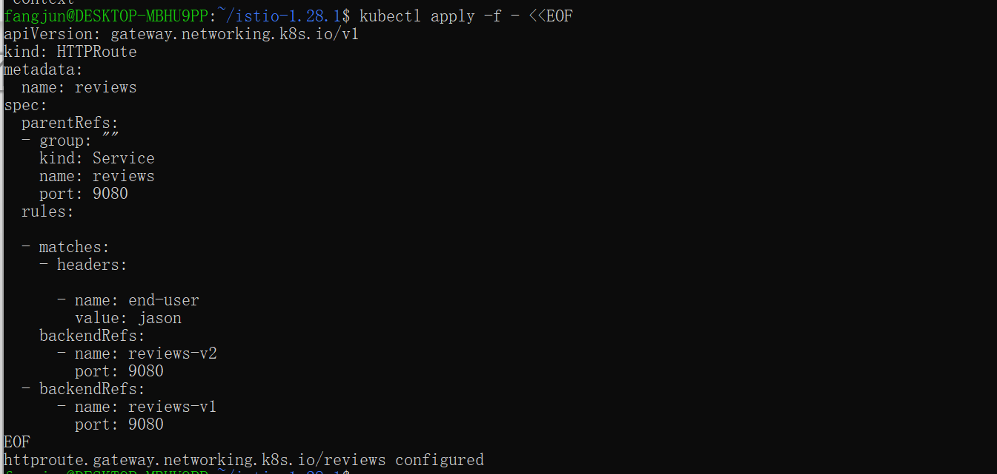

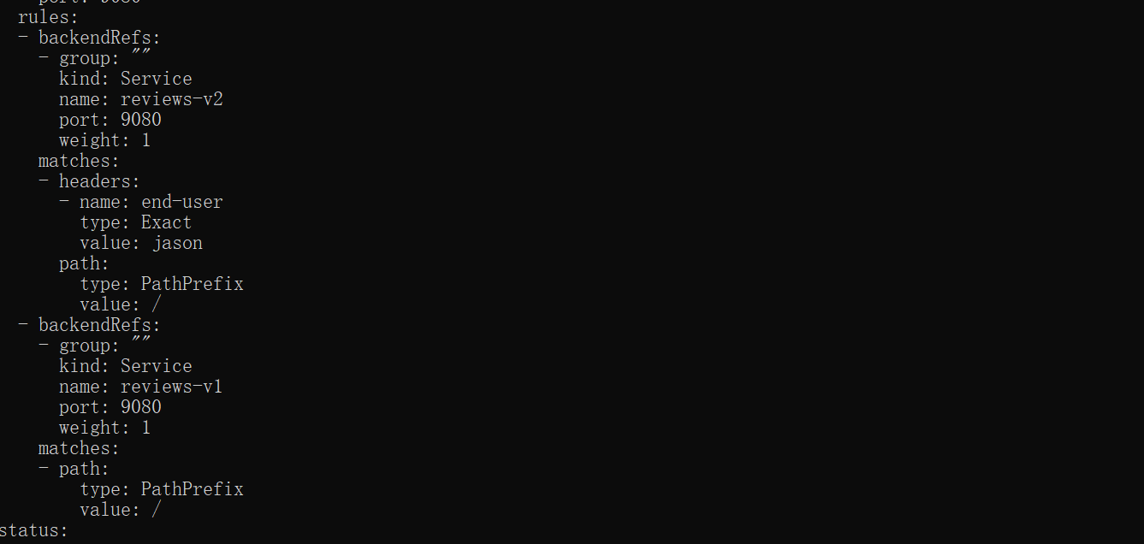
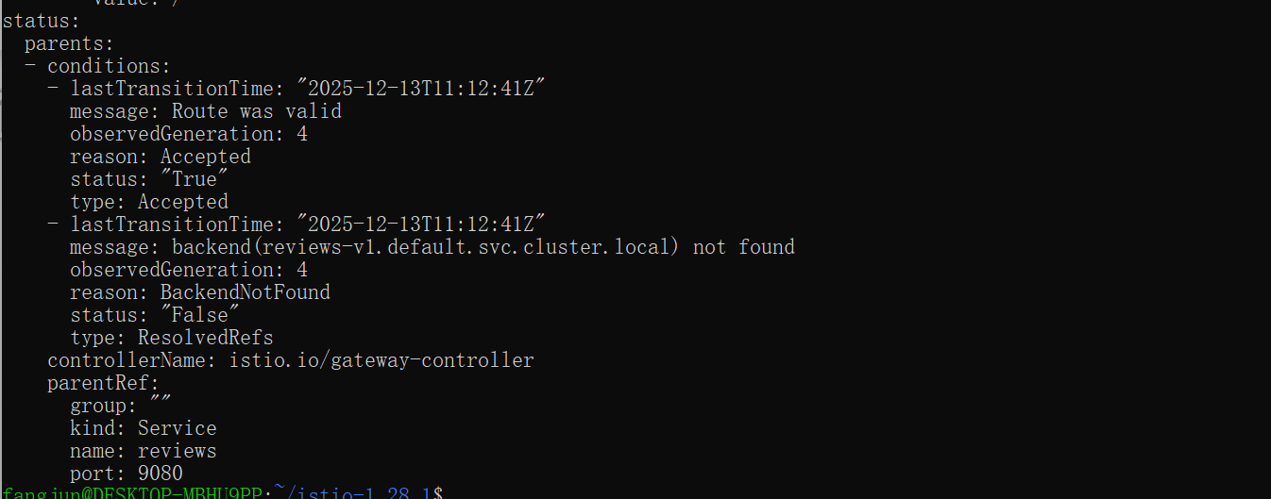

https://istio.io/latest/docs/tasks/traffic-management/fault-injection/
Apply application version routing by either performing the request routing task or by running the following commands:
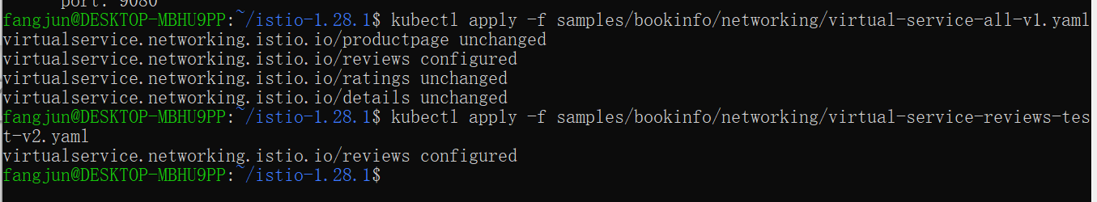
Create a fault injection rule to delay traffic coming from the test user jason.
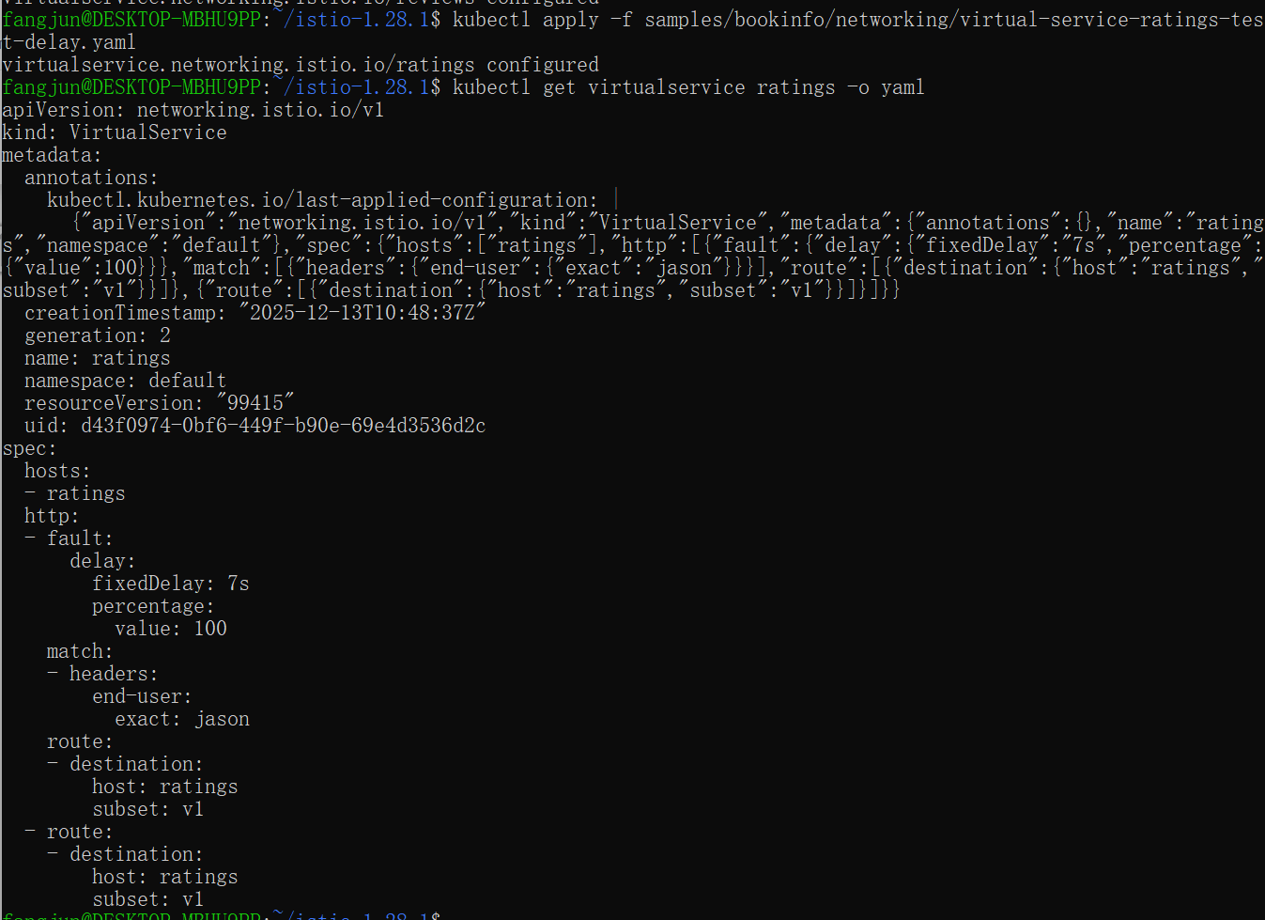
Testing the delay configuration
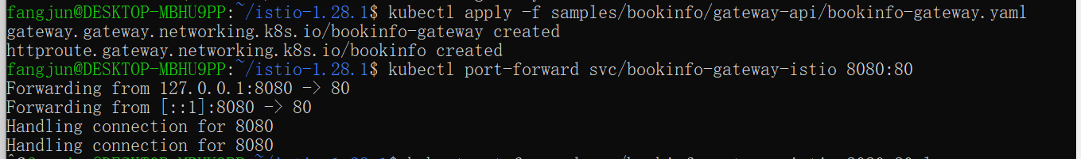

Understanding what happened
You’ve found a bug. There are hard-coded timeouts in the microservices that have caused the reviewsservice to fail.
As expected, the 7s delay you introduced doesn’t affect the reviews service because the timeout between the reviews and ratings service is hard-coded at 10s. However, there is also a hard-coded timeout between the productpage and the reviews service, coded as 3s + 1 retry for 6s total. As a result, the productpage call to reviews times out prematurely and throws an error after 6s.
Bugs like this can occur in typical enterprise applications where different teams develop different microservices independently. Istio’s fault injection rules help you identify such anomalies without impacting end users.

Fixing the bug
You would normally fix the problem by:
1. Either increasing the productpage to reviews service timeout or decreasing the reviews to ratingstimeout
2. Stopping and restarting the fixed microservice
3. Confirming that the /productpage web page returns its response without any errors.
However, you already have a fix running in v3 of the reviews service. The reviews:v3 service reduces the reviews to ratings timeout from 10s to 2.5s so that it is compatible with (less than) the timeout of the downstream productpage requests.
If you migrate all traffic to reviews:v3 as described in the traffic shifting task, you can then try to change the delay rule to any amount less than 2.5s, for example 2s, and confirm that the end-to-end flow continues without any errors.
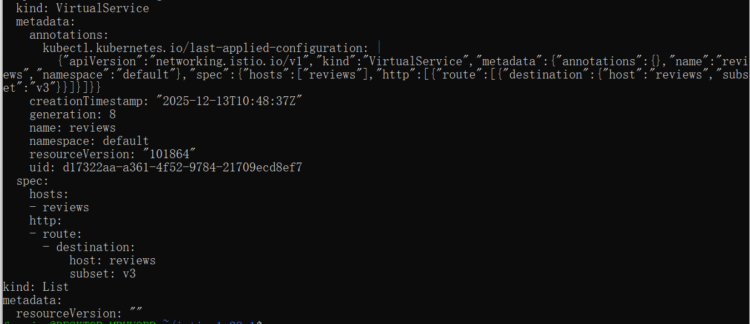
Injecting an HTTP abort fault
Create a fault injection rule to send an HTTP abort for user jason:
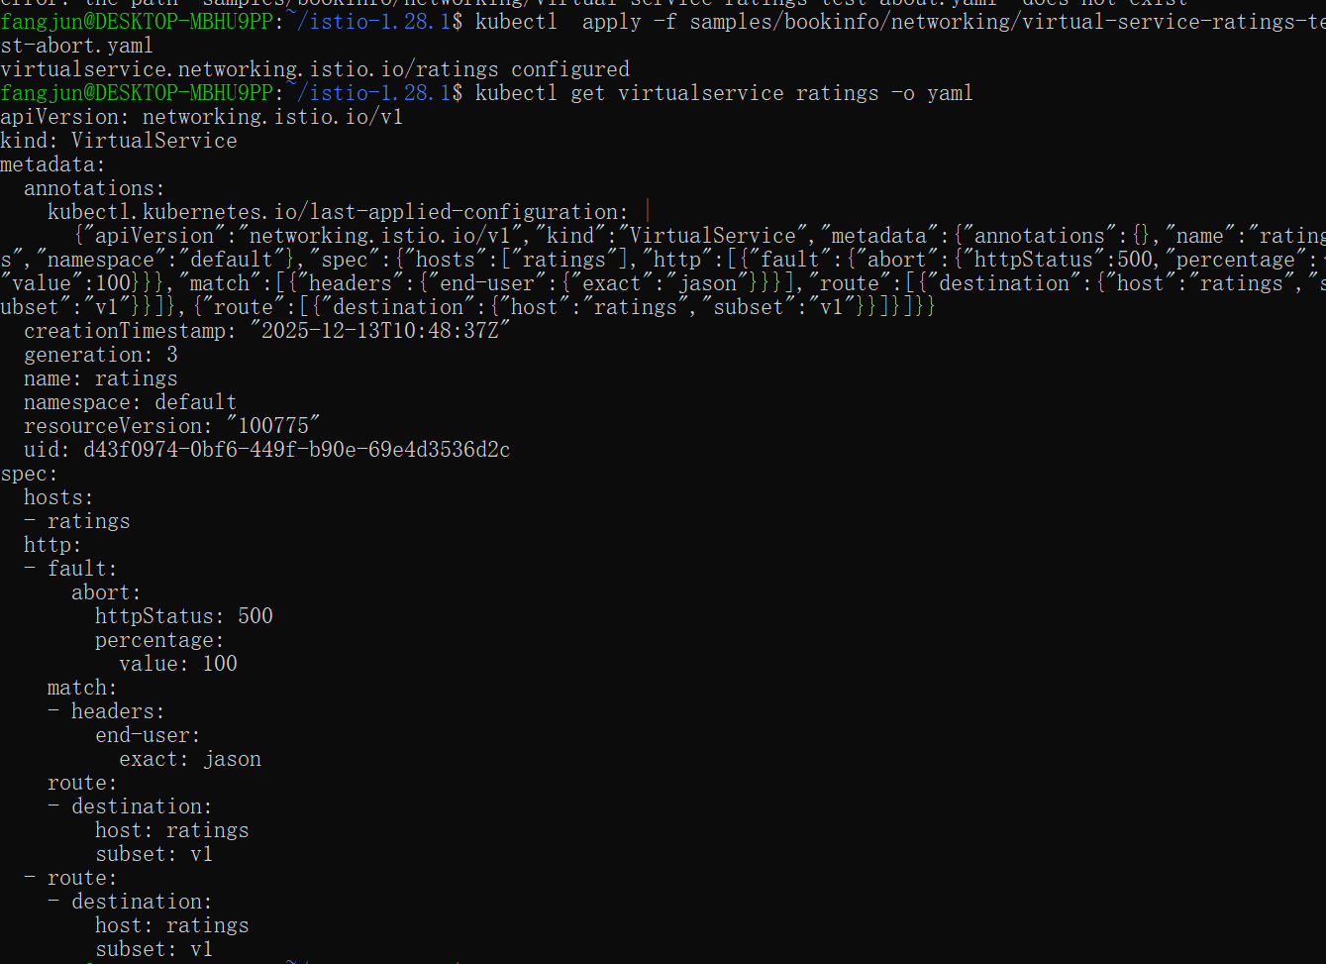
Testing the abort configuration
Open the Bookinfo web application in your browser.
2. On the /productpage, log in as user jason.
If the rule propagated successfully to all pods, the page loads immediately and the Ratings service is currently unavailable message appears.
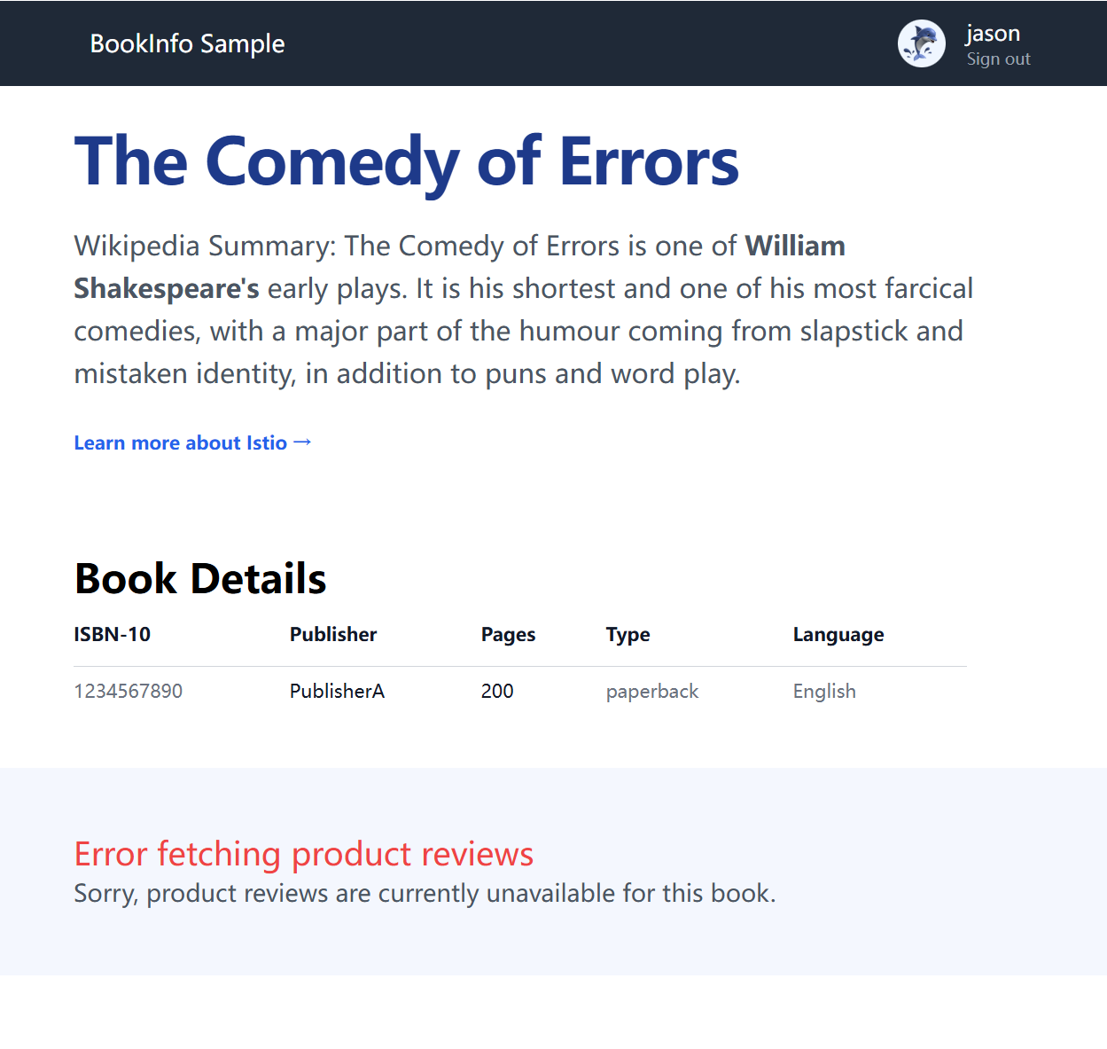
If you log out from user jason or open the Bookinfo application in an anonymous window (or in another browser), you will see that /productpage still calls reviews:v1 (which does not call ratings at all) for everybody but jason. Therefore you will not see any error message.
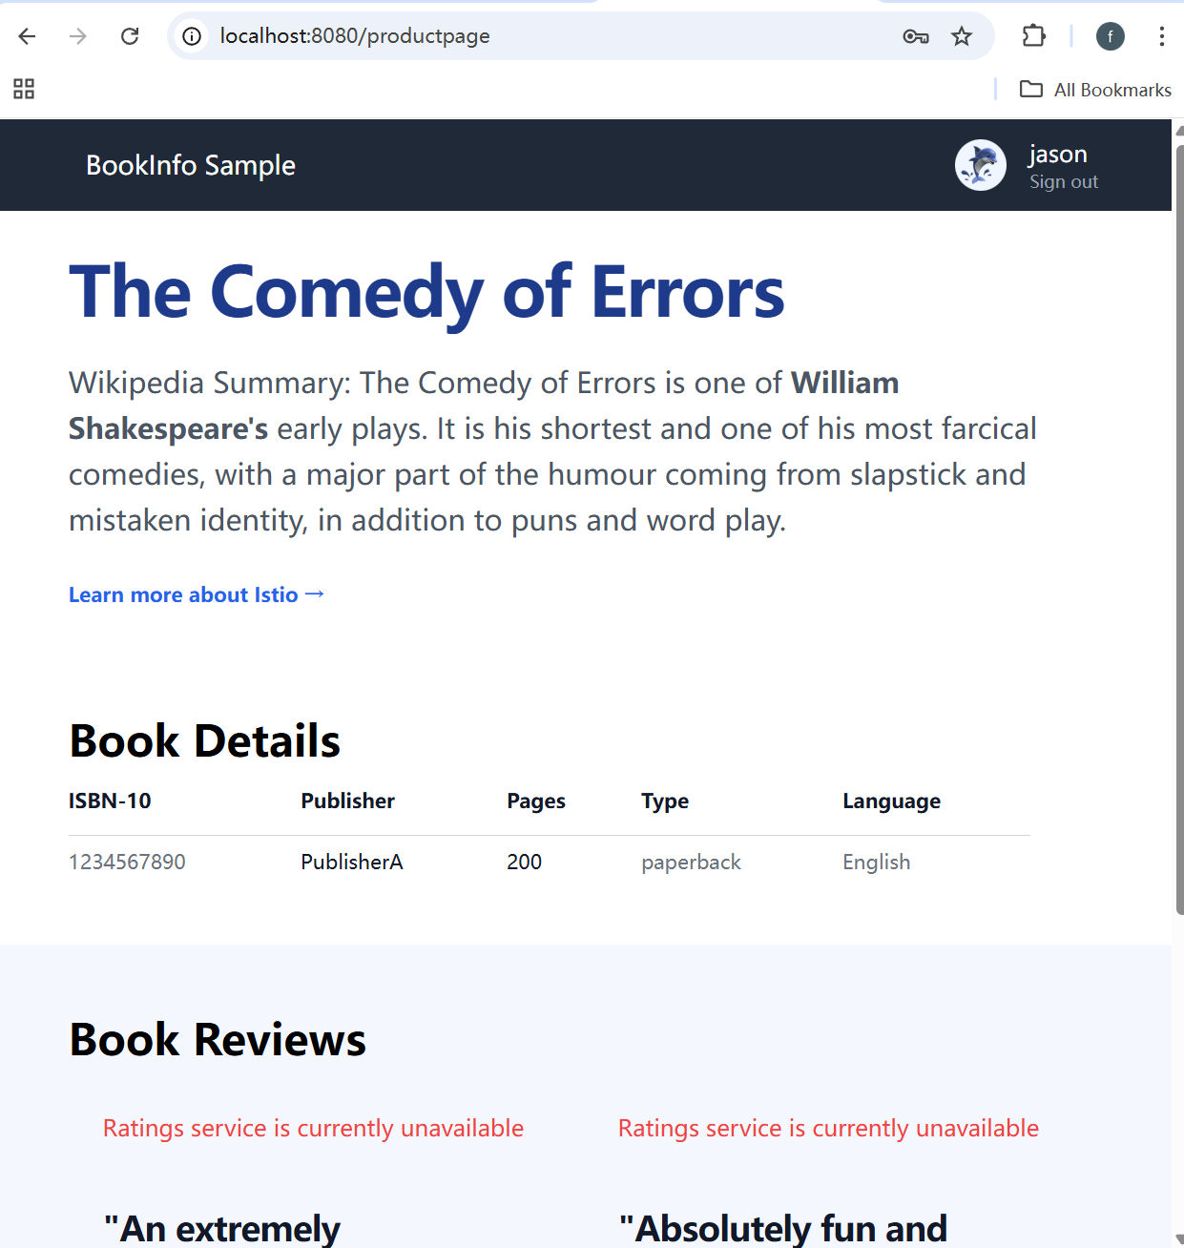

https://istio.io/latest/docs/tasks/traffic-management/circuit-breaking/
Setup Istio by following the instructions in the Installation guide.

Configuring the circuit breaker
Create a destination rule to apply circuit breaking settings when calling the httpbin service:

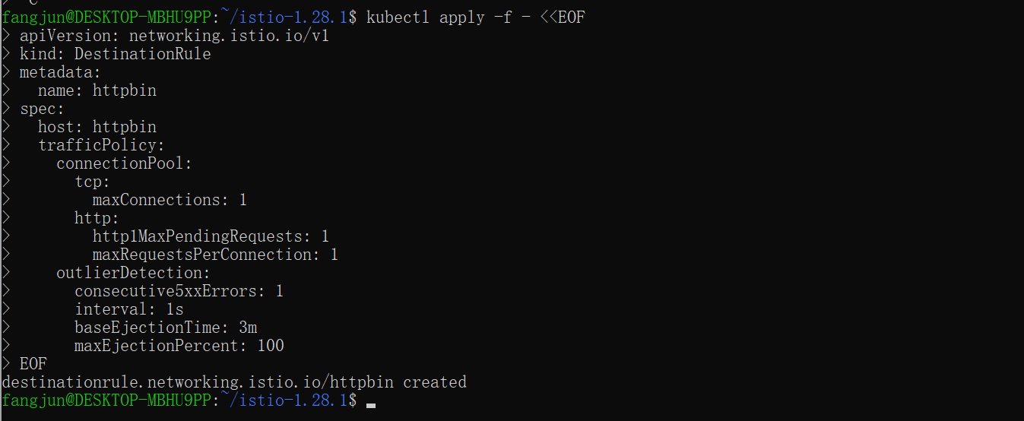

Verify the destination rule was created correctly:
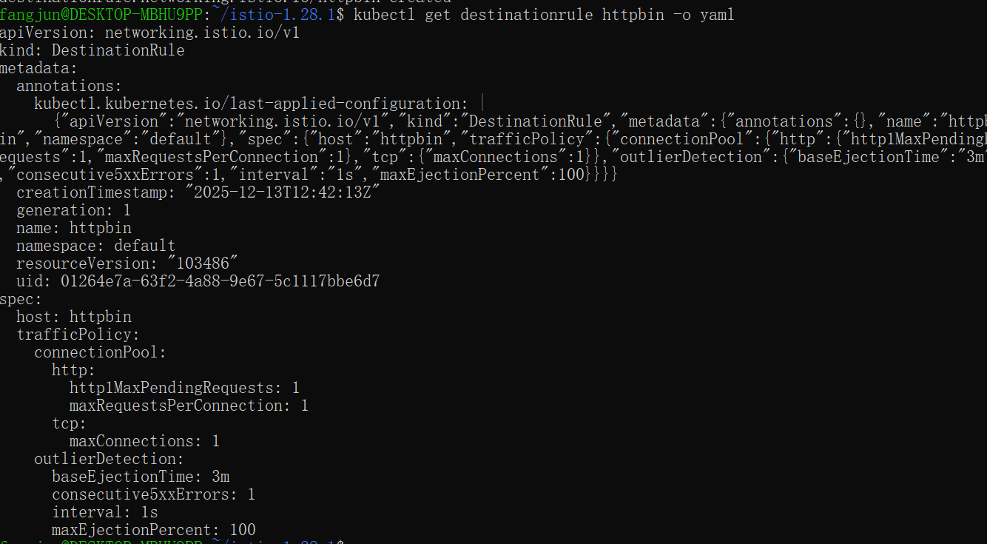

Adding a client
Create a client to send traffic to the httpbin service. The client is a simple load-testing client called fortio. Fortio lets you control the number of connections, concurrency, and delays for outgoing HTTP calls. You will use this client to “trip” the circuit breaker policies you set in the DestinationRule.
Inject the client with the Istio sidecar proxy so network interactions are governed by Istio.
If you have enabled automatic sidecar injection, deploy the fortio service:
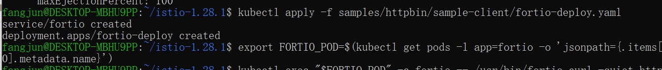
Log in to the client pod and use the fortio tool to call httpbin. Pass in curl to indicate that you just want to make one call:
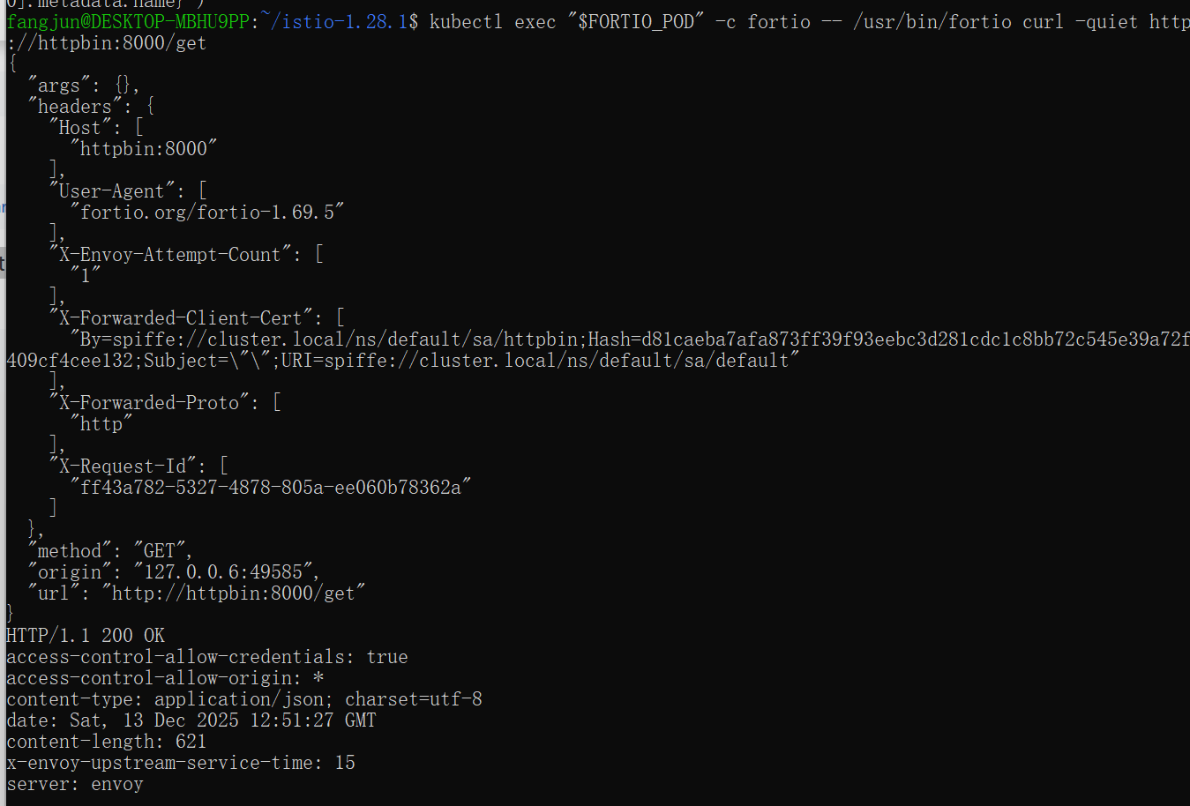

Tripping the circuit breaker
In the DestinationRule settings, you specified maxConnections: 1 and http1MaxPendingRequests: 1. These rules indicate that if you exceed more than one connection and request concurrently, you should see some failures when the istio-proxy opens the circuit for further requests and connections.
Call the service with two concurrent connections (-c 2) and send 20 requests (-n 20):
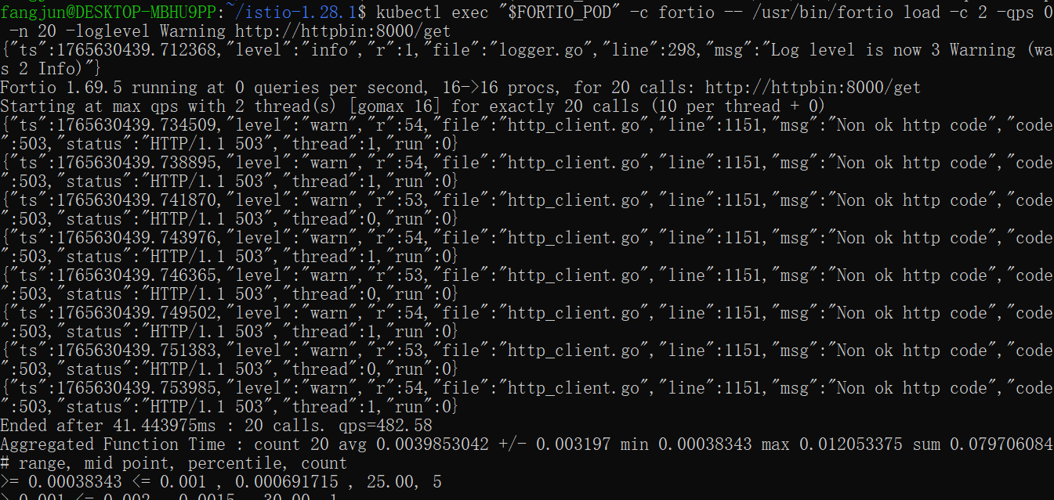
It’s interesting to see that almost all requests made it through! The istio-proxy does allow for some leeway.
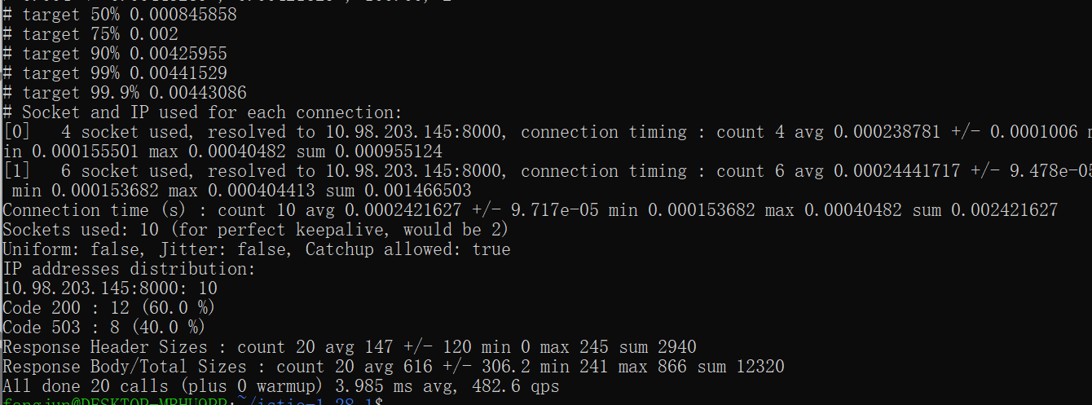
Bring the number of concurrent connections up to 3:
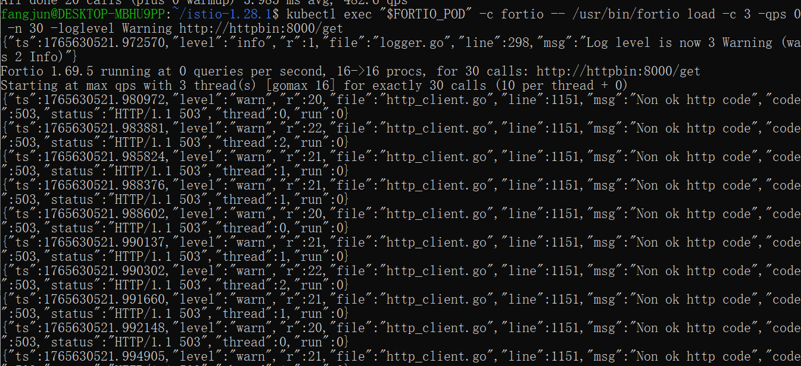
Now you start to see the expected circuit breaking behavior. Only 36.7% of the requests succeeded and the rest were trapped by circuit breaking:
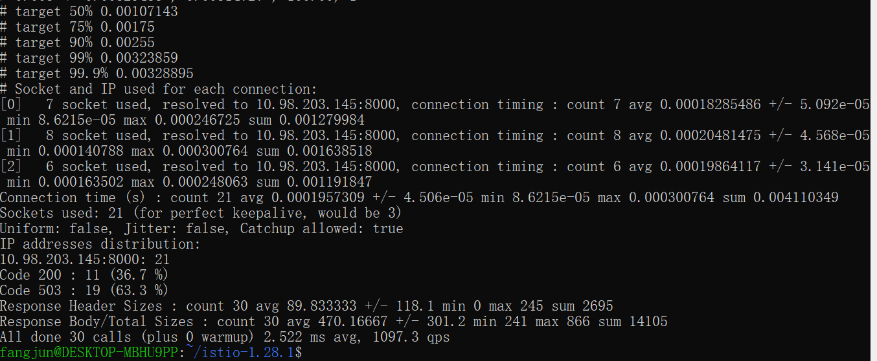
Query the istio-proxy stats to see more:
