https://istio.io/latest/docs/setup/getting-started/
Download Istio：
Go to the Istio release page to download the installation file for your OS, or download and extract the latest release automatically (Linux or macOS):
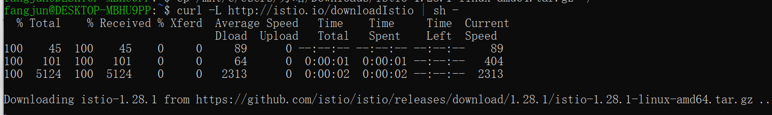
Move to the Istio package directory. For example, if the package is istio-1.28.1:
Add the istioctl client to your path (Linux or macOS):

Install Istio：
Install Istio using the demo profile, without any gateways:
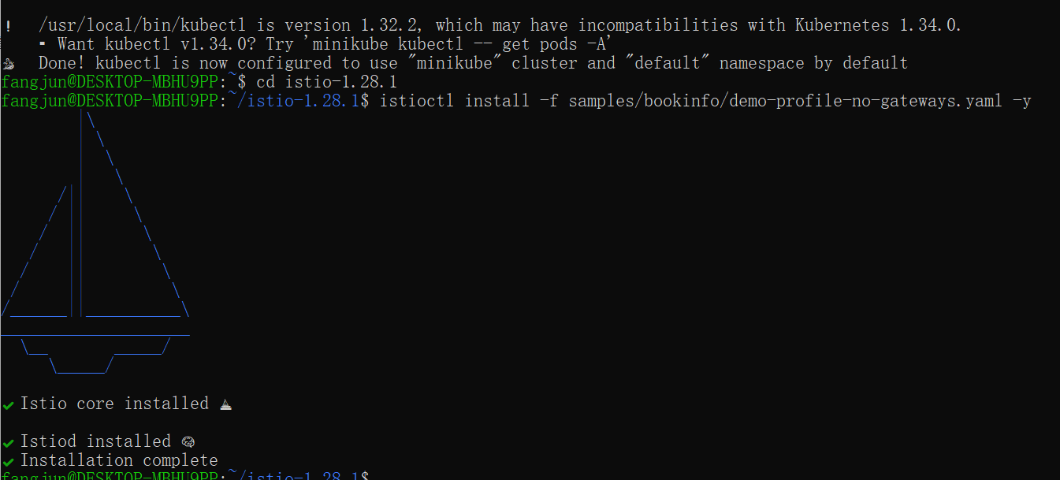
Add a namespace label to instruct Istio to automatically inject Envoy sidecar proxies when you deploy your application later:

Install the Kubernetes Gateway API CRDs
The Kubernetes Gateway API CRDs do not come installed by default on most Kubernetes clusters, so make sure they are installed before using the Gateway API.
- Install the Gateway API CRDs, if they are not already present:
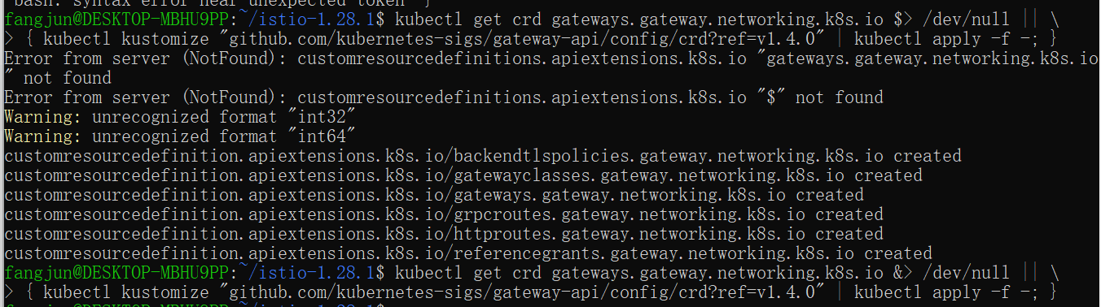

Deploy the sample application
Deploy the Bookinfo sample application:
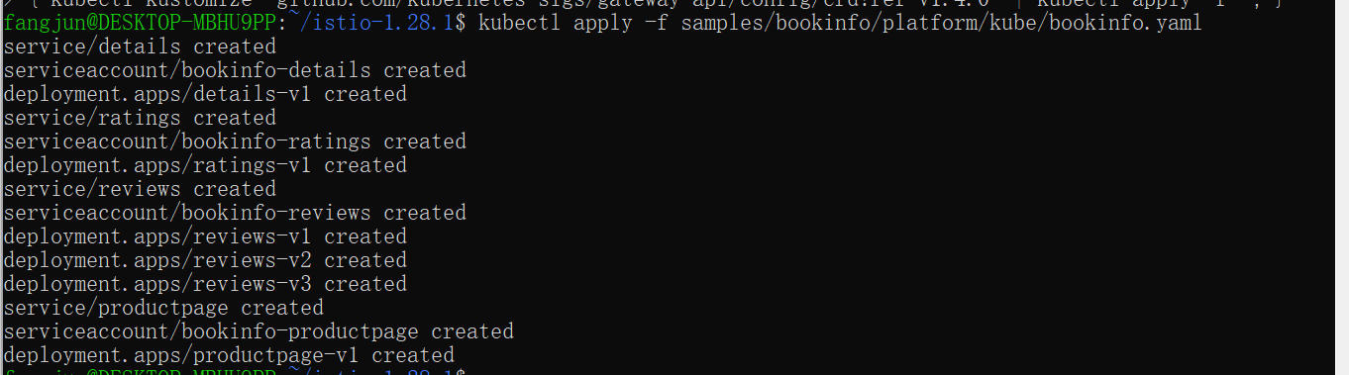
The application will start. As each pod becomes ready, the Istio sidecar will be deployed along with it.
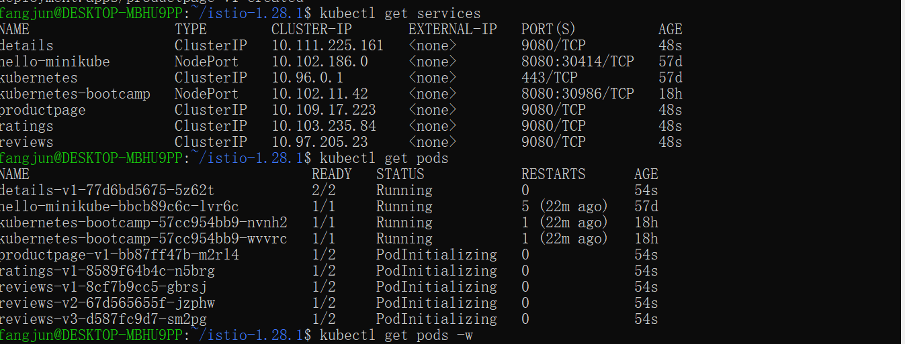
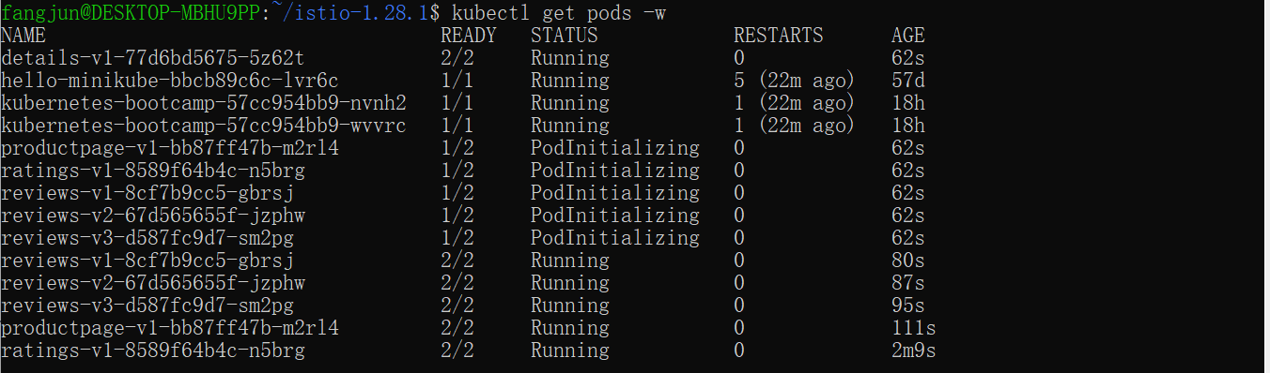
Validate that the app is running inside the cluster by checking for the page title in the response:

Open the application to outside traffic
The Bookinfo application is deployed, but not accessible from the outside. To make it accessible, you need to create an ingress gateway, which maps a path to a route at the edge of your mesh.
Create a Kubernetes Gateway for the Bookinfo application:
Change the service type to ClusterIP by annotating the gateway:
To check the status of the gateway, run

Access the application
You will connect to the Bookinfo productpage service through the gateway you just provisioned. To access the gateway, you need to use the kubectl port-forward command:
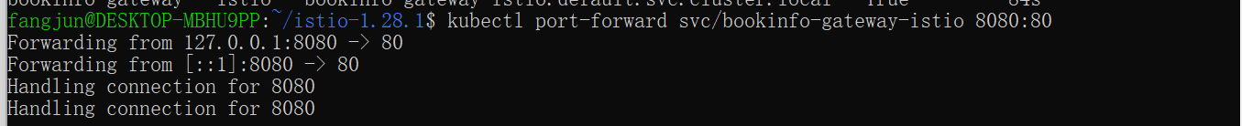
Open browser and navigate to http://localhost:8080/productpage to view the Bookinfo application.
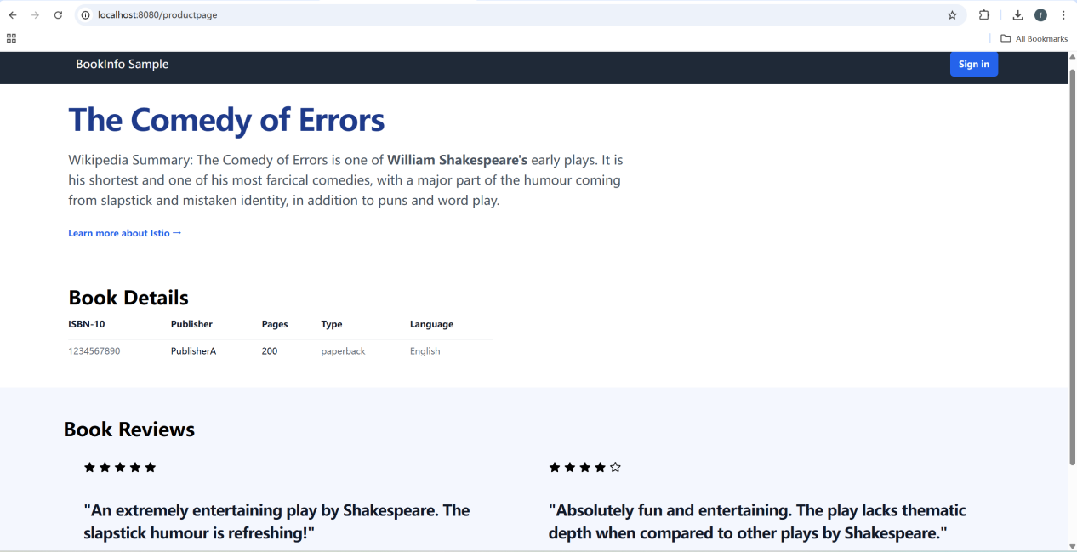

View the dashboard
Install Kiali and the other addons and wait for them to be deployed.
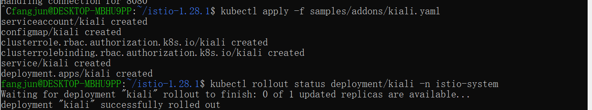
Access the Kiali dashboard.
In the left navigation menu, select Graph and in the Namespace drop down, select default.
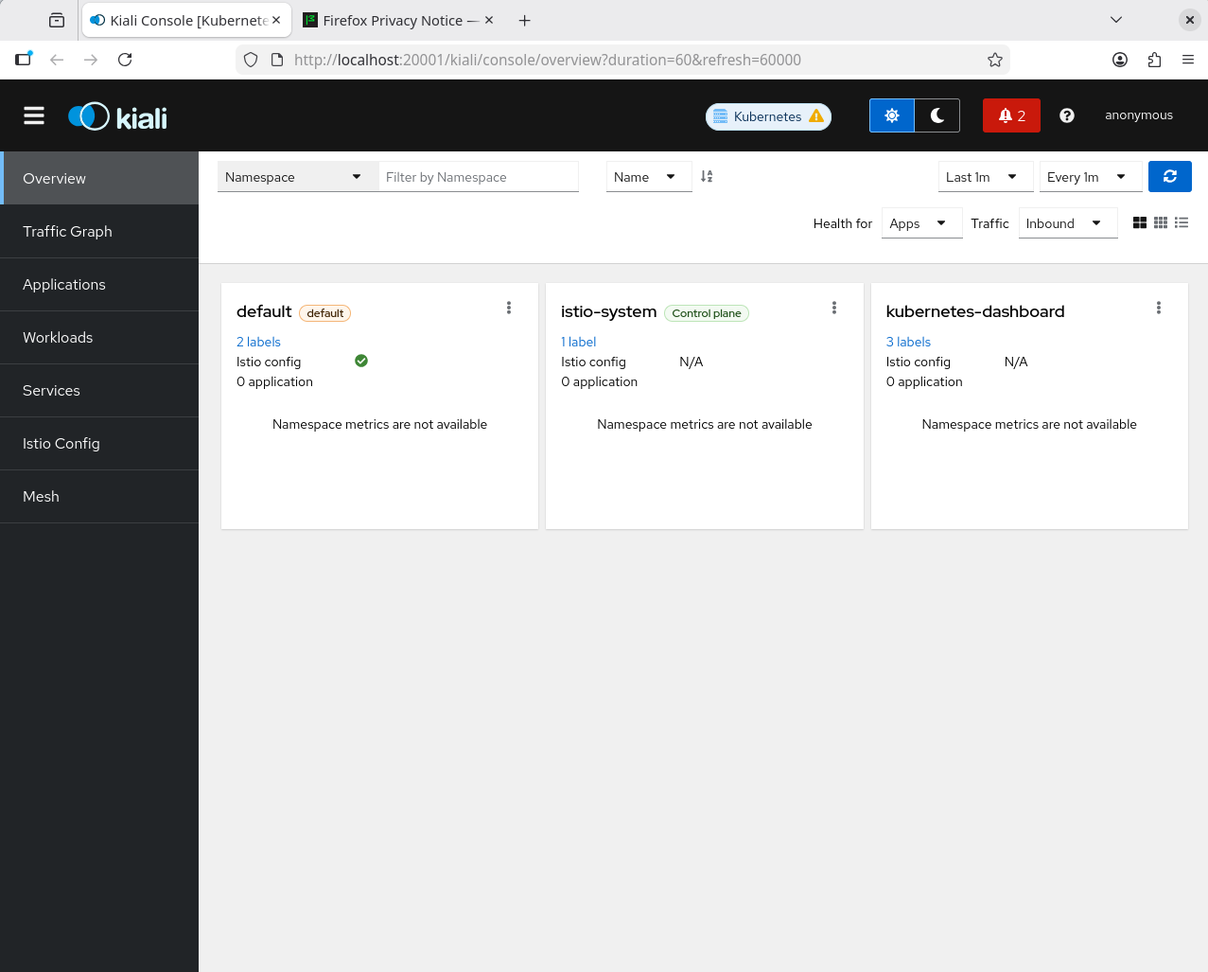

Uninstall
The Istio uninstall deletes the RBAC permissions and all resources hierarchically under the istio-systemnamespace. It is safe to ignore errors for non-existent resources because they may have been deleted hierarchically.
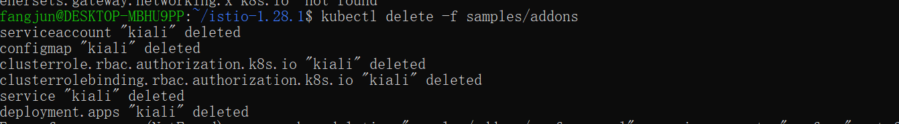
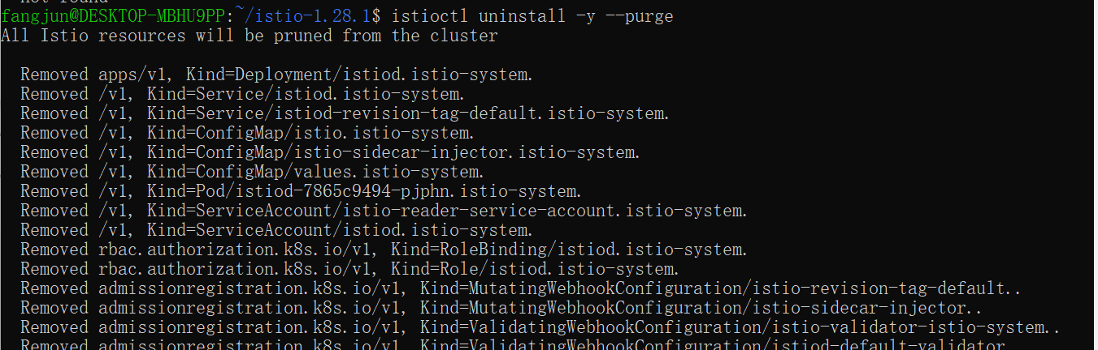

The istio-system namespace is not removed by default. If no longer needed, use the following command to remove it:

