Deploying a Predictive Model with KServe on Minikube

- Install and configure KServe on a local Kubernetes cluster (Minikube)
Make sure you have the following tools installed:
• kubectl - The Kubernetes command-line tool
• helm - for installing KServe and other Kubernetes operators
• curl - for the quickstart script and for testing API endpoints (installed by default on most systems)
Ensure Minikube is installed and start a cluster with sufficient resources.
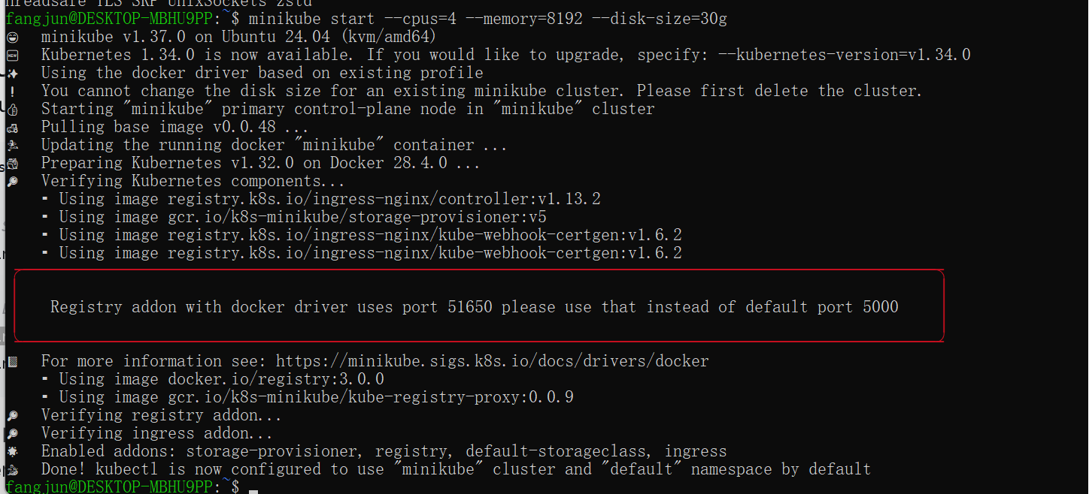
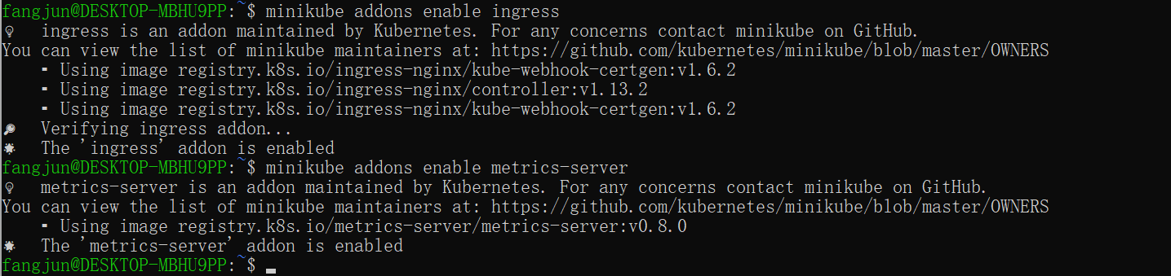
Install Helm
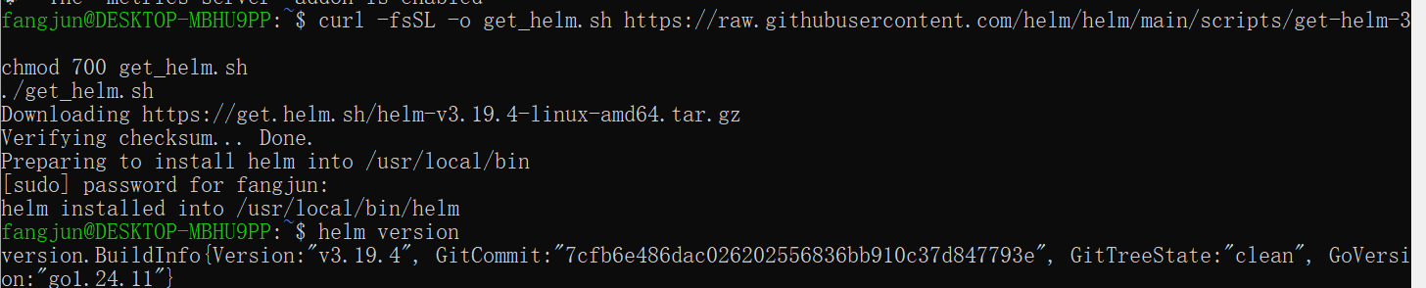
Install KServe CRDs
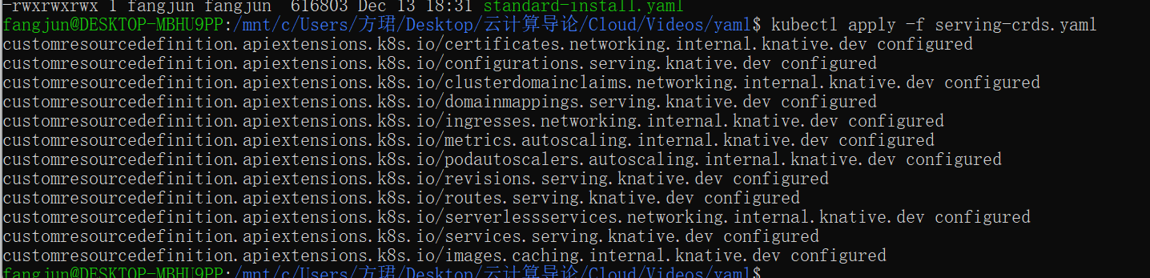
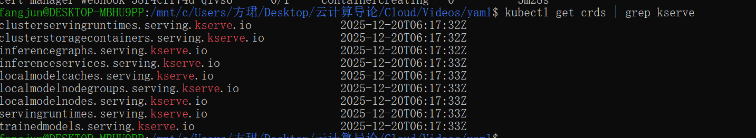
Install cert-manager (local YAML)
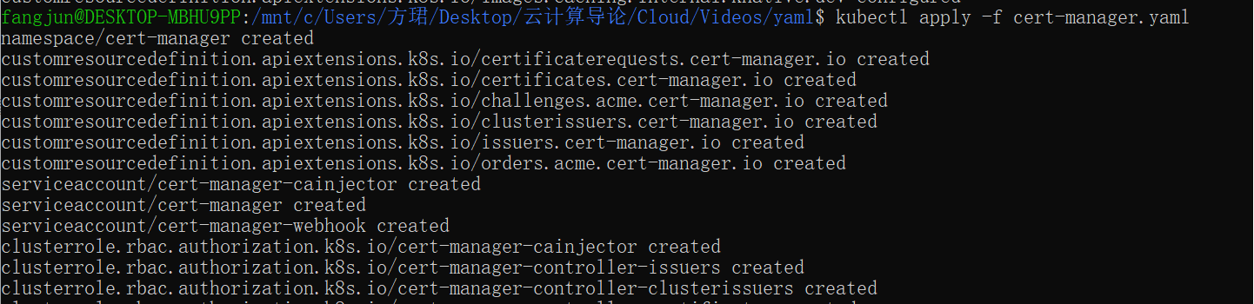
All cert-manager pods must be Running
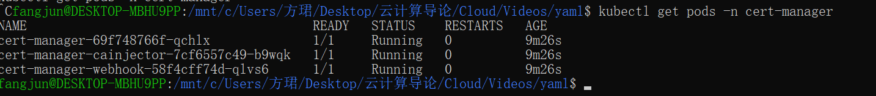
Install KServe Core Components
kubectl apply --server-side -f kserve.yaml
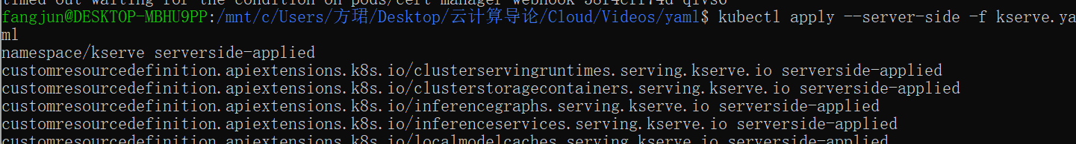
kubectl apply --server-side -f kserve-cluster-resources.yaml
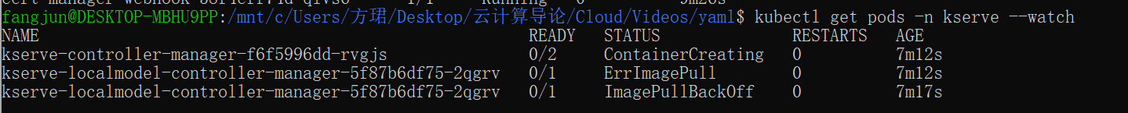
Debugging Controller CrashLoopBackOff
"error": "invalid deployment mode. Supported modes are Serverless, RawDeployment, ModelMesh"
Fix：kubectl patch configmap/inferenceservice-config -n kserve \
--type=strategic \
-p '{"data":{"deploy":"{\"defaultDeploymentMode\":\"RawDeployment\"}"}}'

2. Deploy a predictive model using a KServe InferenceService
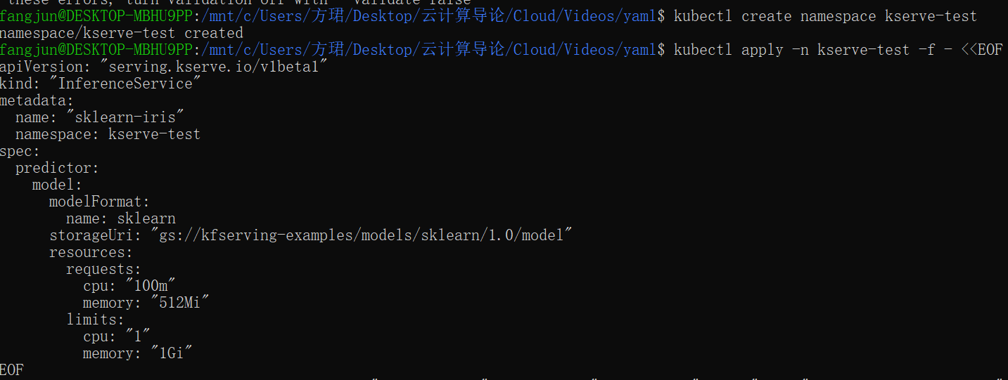
3.Monitor the status of the service and debug common issues
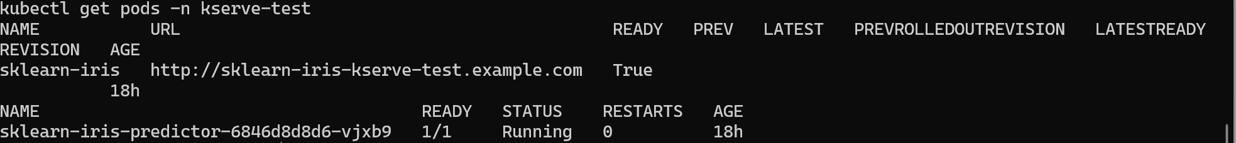
- Find out how to reach the InferenceService from outside the cluster.
5. Send inference requests and interpret results
Prepare input
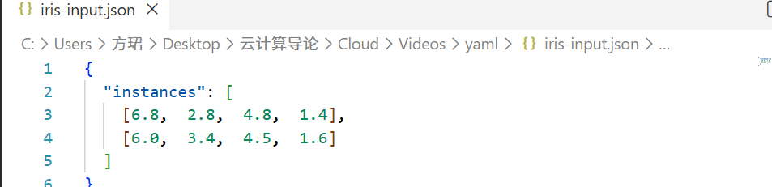
Related links:
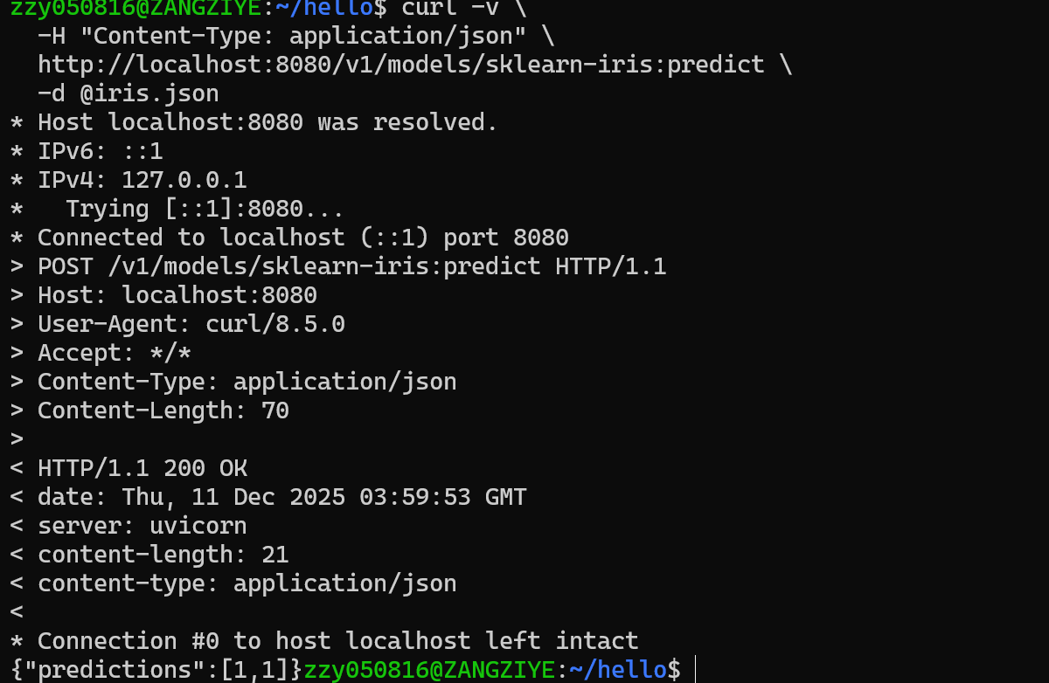
https://kserve.github.io/website/docs/getting-started/quickstart-guide
https://kserve.github.io/website/docs/getting-started/predictive-first-isvc
https://futurelei.com/KServe.mov

