\*\*1. Check if your processor supports Intel/AMD virtualization technology. Enable Intel virtualization technology in BIOS if possible.\*\*

Open Task Manager (Ctrl+Shift+Esc), go to the "Performance" tab, and look for "Virtualization" at the bottom. It says "Enabled" :

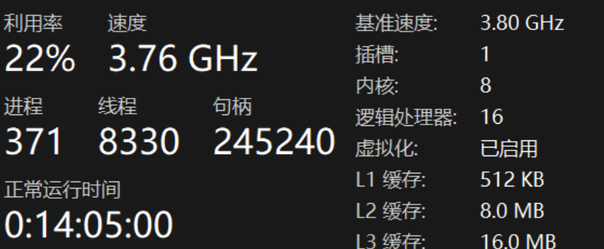Enable in BIOS/UEFI:

Restart your computer.

As it boots, press the key to enter BIOS/UEFI setup (common keys: Del, F2, F10, Esc).

Navigate to the configuration tabs (often called "Advanced," "CPU Configuration," or "Security").

Look for an option named Intel Virtualization Technology (VT-x), AMD-V, SVM Mode, or simply "Virtualization."

Set the option to Enabled.

Save and Exit the BIOS/UEFI (usually F10).

\*\*2. The cloud is almost everywhere in our lives now. What do you think are the fundamental reasons behind its success? Name three pros and three cons of cloud.\*\*

Fundamental Reasons for Success:

The cloud's success is driven by its shift from a Capital Expenditure (CapEx) model (buying expensive hardware) to an Operational Expenditure (OpEx) model (paying only for what you use). This democratizes access to immense computing power, allowing startups and large enterprises alike to innovate and scale rapidly without massive upfront investment.

Three Pros:

Cost Efficiency: Eliminates the capital expense of buying and maintaining physical hardware and datacenters. You pay on a subscription or pay-as-you-go basis.

Scalability and Elasticity: Resources can be scaled up or down instantly to meet demand ("right-sizing"), ensuring performance during peaks and cost savings during lulls.

Reliability and Disaster Recovery: Cloud providers offer data replication across multiple geographically redundant sites, making backup, recovery, and business continuity easier and more affordable.

Three Cons:

Potential for Unexpected Costs: Without careful management and governance, resource sprawl and idle resources can lead to surprisingly high bills ("bill shock").

Security and Compliance Concerns: Storing sensitive data on third-party systems requires trust and a shared responsibility model. Ensuring compliance with industry regulations can be complex.

Vendor Lock-in and Limited Control: Migrating services and data from one cloud provider to another can be difficult and expensive due to proprietary technologies. Users also have less control over the underlying infrastructure.

\*\*3. What is the primary function of a hypervisor in virtualization?\*\*

The primary function of a hypervisor (or Virtual Machine Monitor - VMM) is to create, run, and manage virtual machines (VMs). It acts as a layer of software that abstracts the physical hardware (CPU, memory, storage, networking) and allocates these resources to one or more guest operating systems.

\*\*4. What is a virtual machine (VM)?\*\*

A Virtual Machine (VM) is a software-based emulation of a physical computer. It runs its own operating system (the guest OS) and applications as if it were a physical machine, but it shares the resources of the underlying host machine, which is managed by a hypervisor.

\*\*5. What are the benefits of using virtual machines?\*\*

Server Consolidation: Run multiple VMs on a single physical server, drastically improving hardware utilization.

Isolation: VMs are isolated from each other and the host. A crash or security breach in one VM does not affect the others.

Portability: VMs are encapsulated into files, making them easy to move, copy, and back up.

Legacy Application Support: Run older operating systems and applications on modern hardware.

Development and Testing: Create isolated, disposable environments for testing software, updates, or configurations without risk to the production environment.

\*\*6. List five use cases of virtual machines.\*\*

Data Center Consolidation: Combining multiple underutilized physical servers into VMs on a fewer number of powerful hosts.

Development and Sandboxing: Creating safe, isolated environments to develop and test new code or malware analysis.

Disaster Recovery: Easily backing up and replicating entire systems (as VM files) to a remote site for quick recovery.

Running Incompatible Software: Using a VM to run an application that only works on an older version of an OS (e.g., Windows XP).

Desktop Virtualization (VDI): Hosting desktop operating systems (like Windows 10) on a central server that users can access remotely from thin clients.

\*\*7. In virtualization, what is the guest operating system?\*\*( b ）

\*\*a) The main operating system running on the physical machine\*\*

\*\*b) The operating system installed on a virtual machine\*\*

\*\*c) The operating system running on a remote server\*\*

\*\*d) The operating system running on a mobile device\*\*

\*\*8. What does virtual machine isolation mean?\*\*（ c ）

\*\*a) Virtual machines can communicate directly with the physical hardware.\*\*

\*\*b) Virtual machines share the same resources and cannot be isolated.\*\*

\*\*c) Virtual machines run independently and are isolated from each other and the host system.\*\*

\*\*d) Virtual machines can only be accessed locally.\*\*

\*\*9. What is the benefit of virtual machine portability?\*\*( c )

\*\*a) It allows virtual machines to communicate with each other easily.\*\*

\*\*b) It ensures faster boot times for virtual machines.\*\*

\*\*c) It allows virtual machines to be moved between different physical machines with compatible hypervisors.\*\*

\*\*d) It reduces the need for hardware virtualization.\*\*

\*\*10. What is the purpose of cloning a virtual machine?\*\*

The purpose of cloning a virtual machine is to quickly create an exact duplicate of an existing VM, including its OS, installed applications, and current state. This is extremely useful for:

Rapidly deploying multiple identical systems (e.g., for a cluster of web servers).

Creating a perfect backup copy before making risky changes.

Reproducing a specific environment for testing and debugging.