This project will help you:

1. Learn the fundamentals of web publishing.

2. Gain hands-on experience with GitHub as a version control and hosting platform.

3. Build a professional online presence that can be used as your portfolio, résumé site, or personal blog.

Learning Objectives

By completing this project, you will:

1. Understand what a static website is and how it differs from dynamic websites.

2. Use GitHub Pages as a PaaS solution for hosting static content.

3. Learn how to create, manage, and publish a GitHub repository for web hosting.

4. Customize and design your own personal website using HTML, CSS, and optional templates.

5. Develop professional digital literacy skills relevant to modern software development.

Requirements

1. Create a GitHub account.

2. Set up a new repository named username.github.io, where username is your GitHub username.

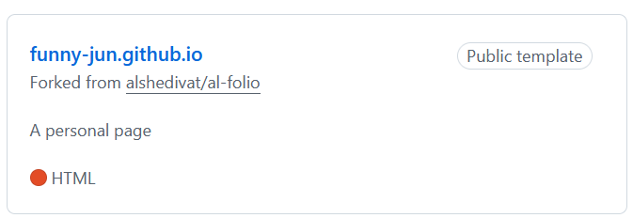

3. Add at least a home page to give a brief introduction of yourself.

4. Optional: Customize the layout and style using HTML and CSS by using Jekyll themes or other templates.

5. Publish the website and verify that it is accessible at https://username.github.io.

Deliverables

1. A live, functional website hosted on GitHub Pages.

2. The GitHub repository containing your website’s source code.

Evaluation Criteria

Your project will be graded on the following:

1. Successful deployment on GitHub Pages (website accessible online).

https://funny-jun.github.io/

2. Completeness of required home page.

3. Creativity and personalization of design.

4. Correct use of GitHub for version control and publishing.

Step 1：

I choose a Jekyll Template on the github,and than fork to my main branch, rename to the funny-jun.github.io



Step 2:

Then, set the github page, use the url: <https://funny-jun.github.io/> as page domain:

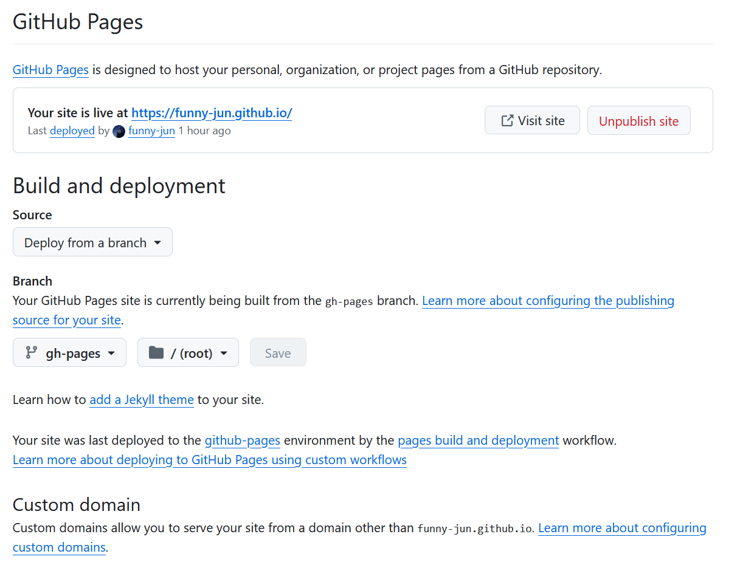

Step 3:

Add at least a home page to give a brief introduction of yourself:

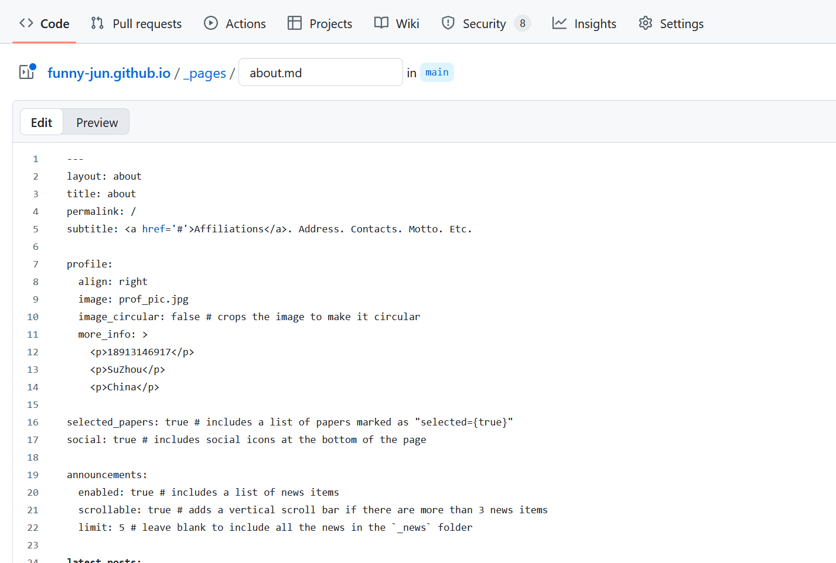

Step 4:

Publish the website and verify that it is accessible at https://funny-jun.github.io.

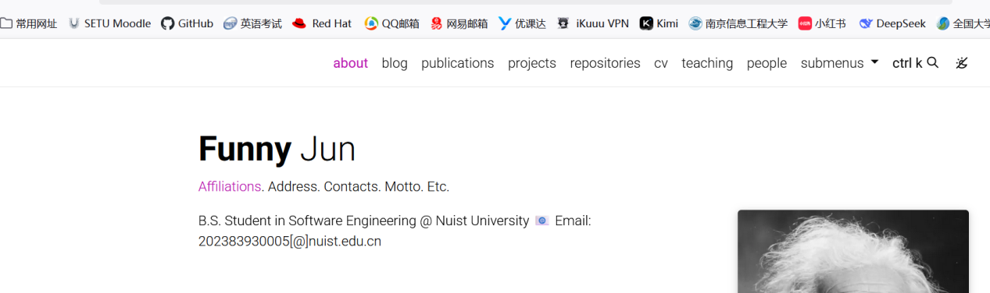

Step 5:

Add this link to my github overview page

