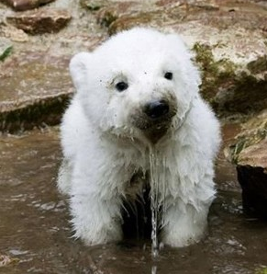

Funny Bear

Contact

**Skype:**

live:.cid.27c190e61ce5620

**Email:**

Funnybear0718@gmail.com

Languages

English – A1

Hobbies

* Writing
* Sketching
* Photography
* Design
* Reading
* Coding

Summary

Senior Full Stack Developer specializing in front-end and back-end development. Experienced with all stages of the development cycle for dynamic web & mobile & desktop projects. Strong background in project management and customer relations. Top Skill – Laravel, ASP.NET, nodeJS, Django, ReactJS, AngularJS, VueJS, Python, .NET, AI

Skill Highlights

|  |  |
| --- | --- |
| * Project management * Strong decision maker * Complex problem solver | * Creative design * Innovative * Service-focused |

Experience

**Senior Full Stack Developer** – 01/2012 to Current

**Luna Web Development**, New York

* Cooperate with designers to create clean interfaces and simple, intuitive interactions and experiences.
* Develop project concepts and maintain optimal workflow.
* Work with senior developer to manage large, complex design projects for corporate clients.
* Complete detailed programming and development tasks for front end public and internal websites as well as challenging back-end server code.
* Carry out quality assurance tests to discover errors and optimize usability.

Education

Bachelor of Science: **I.T Software Programming , Business Administration** - 2018

**Moscow University**, Russia