**Name: Ashish Mukherjee**

**Class: LY CSE NS –‘A’**

**Roll No: 2193060**

**Subject: NML**

**Assignment 10**

**Objective**: Analyze network using Solarwinds network performance monitor.

# Theory:

SolarWinds is one of the world’s leading producers of IT management software. SolarWinds Network Performance Monitor (NPM) is one of its key products. This system focuses on monitoring the health of the devices connected to a network. The hardware that SolarWinds NPM keeps an eye on includes network equipment, such as routers and switches; endpoint devices, including terminals, desktop PCs, and mobile devices; and office equipment, such as printers. The constant monitoring process gathers metrics that serve troubleshooting tasks.

The NPM includes a dashboard with comprehensive controls that can help you customize your views of network data and also filter the events that are reported by the system. This is a very flexible system that is suitable for any size of network. The NPM is a standalone package.

**NETWORK PERFORMANCE MONITOR AT A GLANCE:**

* Speed troubleshooting, increase service levels, and reduce downtime with multivendor network monitoring
* Measure the health of the logical network in addition to the physical network with Cisco® ACI and Azure VNet gateway support
* Simplify the management of complex network devices by monitoring the right information for each device’s unique role in the network with Network Insight™ features
* Critical path hop-by-hop analysis for on-premises, hybrid, and cloud services
* Cross-stack network data correlation for acceleration of problem identification with the PerfStack™ dashboard
* Improve operational efficiency with out-of-the-box dashboards, alerts, and reports

# Procedure:

* Discovery is a term used to describe the process to identify network elements.
* Before you discover your network, go through the Discovery checklist.
  + If the Discovery Wizard does not start automatically after configuration, click Settings

> Network Discovery.

* + Click Add New Discovery, and then click Start.
  + On the Network panel, if this is your first discovery, add a limited number of IP addresses.
* If the Agents panel appears, you enabled the Quality

of Experience (QoE) agent during installation. The QoE agent monitors packet-level traffic. If there are any nodes using agents, select the Check all existing

nodes check box.

* On the Virtualization panel, to discover VMware vCenter or ESX hosts on your network:
  + Check Poll for VMware, and click Add vCenter or ESX Credential.
  + Select <New credential> and provide required information.
* On the SNMP panel:
  + If all devices on your network require only the default SNMPv1 and SNMPv2 public and private community stings, click Next.
  + If any device on your network uses a community string other than public or private, or if you want to use an SNMPv3 credential, click Add

Credential and provide the required information.

* On the Windows panel, to discover WMI or RPC-enabled Windows devices, click Add New Credential and provide the required information.
* On the Monitoring Settings panel, SolarWinds recommends manually setting up monitoring the first

time you run discovery. This allows you to review the list of discovered objects and select the ones you

want to monitor.

* On the Discovery Settings panel, click Next.
* Accept the default frequency and run the discovery immediately
* Discovery can take anywhere from a few minutes to a

few hours, depending on the number of network elements the system discovers.

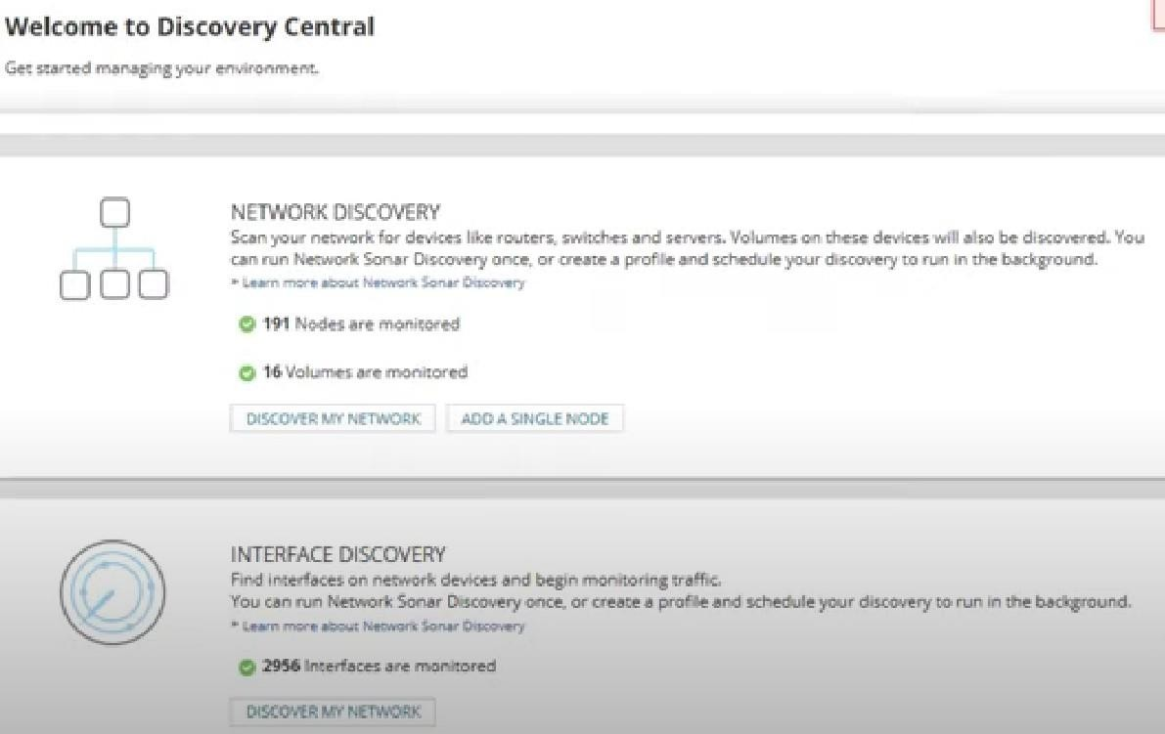

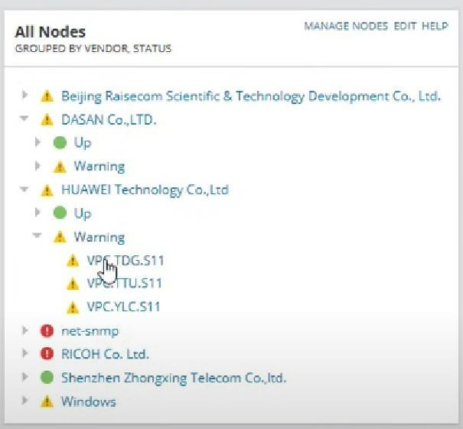

**Conclusion:** Network was successfully analyzed using solarwinds network performance monitor.