**Name: Ashish Mukherjee**

**Class: LY CSE NS –‘A’**

**Roll No: 2193060**

**Subject: NML**

**Assignment 11**

**Objective**: Use Paessler prtg network monitor for monitoring and managing network nodes.

# Theory:

PRTG (Paessler Router Traffic Grapher until version 7) is an agentless network monitoring software from Paessler AG. Several software versions are combined under the umbrella term Paessler PRTG. It can monitor and classify system conditions like bandwidth usage or uptime and collect statistics from miscellaneous hosts such as switches, routers, servers and other devices and applications.

The first version of PRTG was released on 29 May 2003 by the German company Paessler GmbH (now: Paessler AG), which was founded by Dirk Paessler in 2001.

Paessler PRTG has an auto-discovery mode that scans predefined areas of an enterprise network and creates a device list from this data. In the next step, further information on the detected devices can be retrieved using various communication protocols. Typical protocols are ICMP, SNMP, WMI, NetFlow, jFlow, sFlow, but also communication via DCOM or the RESTful API is possible.

# Procedure:

* Install the software. You can also access it from the web as it is an agentless monitoring solution.
* PRTG obtains monitoring data from target devices in the following ways:
  + Polls or queries sensor data: PRTG actively gathers data from a device in regular intervals. This includes, for example, device status, resource usage, and performance metrics. Most sensors use this method. PRTG can also consume and collect sensor data based on interfaces with, for example, HTTP or HTTPS requests, port checks, email checks, File Transfer Protocol (FTP) downloads, and database requests.
  + Listens for or receives sensor data: PRTG passively receives data from a device or application. This includes, for example, unexpected events, Syslogs and Simple Network Management Protocol (SNMP) traps, detailed data flow (bandwidth monitoring), and event log messages.
* You need to take care of 3 things:
  + What to monitor?
  + What credentials do you need?
  + What notification methods to set up?

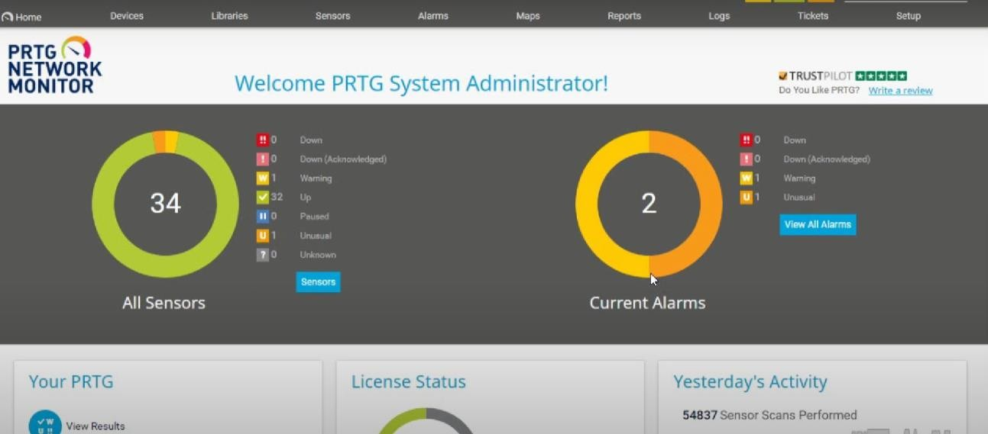

**Conclusion:** Network was monitored successfully using PRTG.