***ASSIGNMENT 1***

***NAME: Ashish Mukherjee***

***ROLL NO.: 2193060***

***CLASS:LY NS***

**ASSIGNMENT - 1**

**AIM** – Create a terminal network and list architecture.

**THEORY-**

**TERMINAL NETWORK**

TELNET is an abbreviation for Terminal Network. It is essentially a TCP/IP protocol used for virtual terminal services, and it was primarily proposed by the International Organization for Standardization (ISO).

It is a client/server application software that may be used for a variety of purposes.

This software allows the connection to the distant system to be established in such a way that the local system begins to appear as a terminal at the remote system.

It is a TCP/IP standard that is used for virtual terminal service.

In layman’s terms, TELNET allows the user to connect to a distant computer. After signing in, the user can utilise the remote computer’s services and then transmit the results back to the local computer.

TELNET was primarily created during a period when most operating systems operated in a time-sharing environment. A big computer may also handle numerous users in this sort of setting. Interaction between the computer and the user is often accomplished through the use of a terminal (It is a combination of keyboard, mouse, and monitor).

TELNET makes use of a single TCP/IP connection.

**WORKING-**

**Step 1** – Implementing Switches and couple of end devices i.e PCs in CISCO Packet Tracer.

**Step 2** – Connect all the PCs to switch through Fastethenet cable.

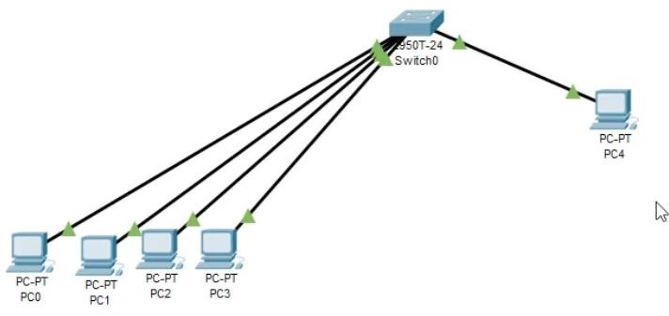

Figure-1 Telnet Architecture

**Step 3** – Open switch and go to the CLI of switch (same commands for routers too.)

Switch> Switch>enable

Switch#configure terminal

Enter configuration commands, one per line. End with CNTL/Z. Switch(config)#interface vlan 1

Switch(config-if)#ip address 192.168.10.100 255.255.255.0 (Management ip address) Switch(config-if)#no shutdown

Switch(config-if)#

%LINK-5-CHANGED: Interface Vlan1, changed state to up

%LINEPROTO-5-UPDOWN: Line protocol on Interface Vlan1, changed state to up

Switch(config-if)#exit

Switch(config)#line vty 0 15 (line configuration mode giving telnet access within virtual terminal) Switch(config-line)#password telnet@123

Switch(config-line)#login (whenever we connect telnet it will ask for password) Switch(config-line)#exit

Switch(config)#exit Switch#

%SYS-5-CONFIG_I: Configured from console by console

(Saving file to startup-config)

Switch#copy running-config startup-config Destination filename [startup-config]?

Building configuration... [OK]

Switch#configure terminal

Enter configuration commands, one per line. End with CNTL/Z. Switch(config)#enable password admin@1234 (Adding switch password) Switch(config)#exit

Switch#

%SYS-5-CONFIG_I: Configured from console by console

Switch#copy running-config startup-config Destination filename [startup-config]?

Building configuration... [OK]

Switch#

**Step 4** – Provide ip addresses to PCs

**Step 5 –** Go to PC from which you want to manage.

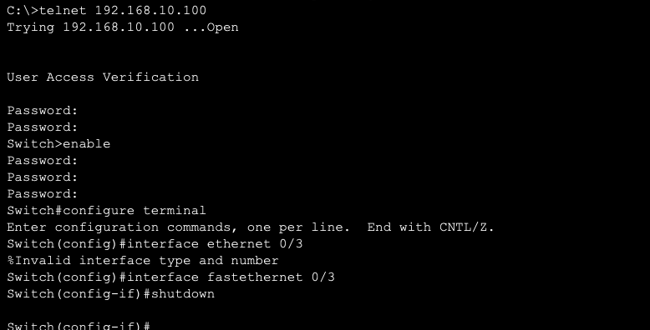

1. Enter Command Prompt of the PC.

telnet 192.168.10.100 (administrator ip address)

1. Enter telnet Password 3.Enter Switch command enable

4.Enter the Password 5.Go to configure terminal configure terminal interface fastethernet 0/3

shutdown. (link getting down) no shutdown (enabled again)

Figure- 2: Accessing Telnet Communication using PC4

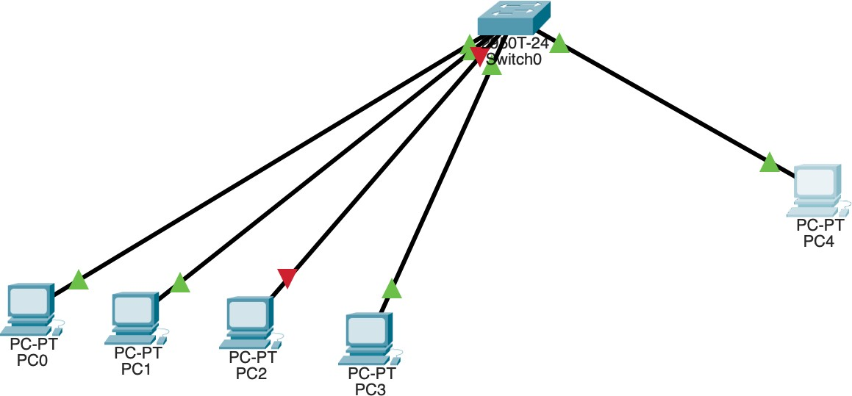

# Drawbacks of Telnet:

Figure- 3: Shutdown of PC2 Remotely

Username and password will be visible in network as clear text because telnet communication uses clear text mode.

By using wireshark by anyone in the network sniff the packets over the network and get the passwords and commands used.So now everyone uses SSH.

# Conclusion -

Using cisco packet tracer and forming a network, using switches and PCs. We were able to remotely access different PCs connected to the switch using telnet communication, through command prompt of any one of the PC.