 GNS3 Installation on Linux

# [Installation from packages](https://docs.gns3.com/1QXVIihk7dsOL7Xr7Bmz4zRzTsJ02wklfImGuHwTlaA4/" \l "h.guunih5nikle)

## [Ubuntu-based distributions (64-bit only)](https://docs.gns3.com/1QXVIihk7dsOL7Xr7Bmz4zRzTsJ02wklfImGuHwTlaA4/" \l "h.l56h7z55hmxm)

This instructions are for Ubuntu and all distributions based on it like Linux Mint.

sudo add-apt-repository ppa:gns3/ppa  
sudo apt-get update  
sudo apt-get install gns3-gui

If_you_want_IOU_support

sudo dpkg --add-architecture i386  
sudo apt-get update  
sudo apt-get install gns3-iou

If_you_want_Docker_support

Remove any old versions:  
sudo apt-get remove docker docker-engine docker.io  
  
Install these packages, if not already present:  
sudo apt-get install \  
    apt-transport-https \  
    ca-certificates \  
    curl \  
    software-properties-common  
Import the official Docker GPG key:  
curl -fsSL https://download.docker.com/linux/ubuntu/gpg | sudo apt-key add -  
Setup the Docker repo:  
sudo add-apt-repository \  
   "deb [arch=amd64] https://download.docker.com/linux/ubuntu \  
   $(lsb_release -cs) \  
   stable"  
*NOTE* There currently isn’t a package for Ubuntu 18.04 in the stable release channel, but there is in the edge channel.   
Update the metadata:  
sudo apt-get update  
Install Docker:  
sudo apt-get install docker-ce  
Finally, add your user to the docker group, and restart your user session  
sudo usermod -a -G docker username  
NOTE_1 If you encounter any permission errors when trying to run GNS3, DynaMIPS devices, Wireshark, or Qemu VMs, ensure your user belongs to the following groups:  
  
ubridge libvirt kvm wireshark   
  
You can see which groups your user belongs to, by simply typing “groups” in a command terminal. If your user account is missing from one or more of these groups, user the usermod command listed above to add them. Be sure to log out and back in to restart your user session  
  
NOTE_2 If running Ubuntu in VMware with Qemu v2.8 or greater, there is an issue with VMs hanging. There’s a workaround posted at the bottom of this document.   
  
Debian-based distributions (64-bit only)

### For Debian Jessie

Add the following lines to your */etc/apt/sources.list*:

deb <http://ppa.launchpad.net/gns3/ppa/ubuntu> trusty main  
deb-src <http://ppa.launchpad.net/gns3/ppa/ubuntu> trusty main

### For Debian Stretch

Add the following lines to your /etc/apt/sources.list:

deb <http://ppa.launchpad.net/gns3/ppa/ubuntu> xenial main  
deb-src <http://ppa.launchpad.net/gns3/ppa/ubuntu> xenial main

Finally,_run_the_following_commands_in_a_terminal

sudo apt-get install dirmngr  
sudo apt-key adv --keyserver keyserver.ubuntu.com --recv-keys F88F6D313016330404F710FC9A2FD067A2E3EF7B  
sudo apt-get update  
sudo apt-get install gns3-gui

For Docker support (Jessie and newer)

Uninstall older versions:  
sudo apt-get remove docker docker-engine docker.io  
Install these dependencies, if not already present:  
sudo apt-get install  apt-transport-https ca-certificates \  
     curl gnupg2 software-properties-common telnet  
  
Import the official Docker GPG key:  
curl -fsSL https://download.docker.com/linux/$(. /etc/os-release; echo "$ID")/gpg | sudo apt-key add -  
  
Set up the repository:  
sudo add-apt-repository \  
   "deb [arch=amd64] https://download.docker.com/linux/$(. /etc/os-release; echo "$ID") \  
   $(lsb_release -cs) \  
   stable"  
  
Install docker:  
sudo apt-get update  
sudo apt-get install docker-ce  
  
If any permissions errors are encountered, ensure your user belongs to the following groups:  
ubridge docker wireshark   
  
If your user doesn’t belong to any of the above groups, use the following command to add it to them:  
  
sudo usermod -a -G group username  
  
Log out and back in to restart your user session  
  
*NOTE* If running Debian in VMware with Qemu v2.8 or greater, there is an issue with VMs hanging. There’s a workaround posted at the bottom of this document.

## [Arch Linux](https://docs.gns3.com/1QXVIihk7dsOL7Xr7Bmz4zRzTsJ02wklfImGuHwTlaA4/" \l "h.1hhytqqu5gdw)

Note that this package is maintained by a third-party.

Run the following commands in a terminal:

yaourt -S gns3-gui gns3-server

## [Fedora](https://docs.gns3.com/1QXVIihk7dsOL7Xr7Bmz4zRzTsJ02wklfImGuHwTlaA4/" \l "h.odi1imgo08q0)

Note that this package is maintained by a third-party.

Starting with Fedora 24 packages are available in official repositories.

dnf install gns3-server gns3-gui wireshark wireshark-qt

WARNING21/12/16 the installation is broken: <https://bugzilla.redhat.com/show_bug.cgi?id=1406711>

WARNINGWayland in Fedora 25 seem to be not

For_QEMU/KVM_guests

dnf install qemu-kvm qemu-system-x86

For_Dynamips_emulation,_packages_are_still_under_review,_however_you_can_use_this_copr_repository

dnf copr enable athmane/gns3-extra  
dnf install vpcs dynamips

For_Docker_support

Uninstall previous versions:

sudo dnf remove docker \  
                 docker-client \  
                 docker-client-latest \  
                 docker-common \  
                 docker-latest \  
                 docker-latest-logrotate \  
                 docker-logrotate \  
                 docker-selinux \  
                 docker-engine-selinux \  
                 docker-engine  
  
Set up the repository -   
sudo dnf -y install dnf-plugins-core  
sudo dnf config-manager \  
   --add-repo \  
   https://download.docker.com/linux/fedora/docker-ce.repo  
*NOTE* There currently is NOT a release in the stable channel, so you’ll need to use the edge channel for now:  
  
sudo dnf config-manager --set-enabled docker-ce-edge  
Install Docker -   
  
sudo dnf install docker-ce  
*NOTE* there currently appears to be an issue with docker containers from the GNS3 Marketplace (even after adding your user account to the docker group). Will update this doc accordingly.

For IOU support with Fedora

<https://gns3.com/discussions/use-iou-images-in-64-bit-linux>

## [Gentoo](https://docs.gns3.com/1QXVIihk7dsOL7Xr7Bmz4zRzTsJ02wklfImGuHwTlaA4/" \l "h.ox524mh7gb6w)

Note that this package is maintained by a third-party.

Run the following commands in a terminal:

emerge --ask net-misc/gns3-gui  
  
  
  
*NOTE*  
Kernel support for KVM and virtio recommended (required for certain Qemu VMs)

## [Sabayon](https://docs.gns3.com/1QXVIihk7dsOL7Xr7Bmz4zRzTsJ02wklfImGuHwTlaA4/" \l "h.ii2ork3do31c)

Note that this package is maintained by a third-party.

Run the following commands in a terminal:

equo i net-misc/gns3-gui net-misc/gns3-converter net-misc/gns3-server  
  
*NOTE*  The available packages are very out-of-date.   
Kernel support for KVM and virtio recommended (required for certain Qemu VMs)  
Docker does not seem to work properly with the packages provided via Entropy.

## [Alpine Linux](https://docs.gns3.com/1QXVIihk7dsOL7Xr7Bmz4zRzTsJ02wklfImGuHwTlaA4/" \l "h.984tjfap61y4)

Note that this package is maintained by a third-party.

GNS3 is in testing repository of "edge" version.

apk update && apk add gns3-gui gns3-server

## [OpenSuse](https://docs.gns3.com/1QXVIihk7dsOL7Xr7Bmz4zRzTsJ02wklfImGuHwTlaA4/" \l "h.lysobww90547)

Note that this package is maintained by a third-party.

<http://software.opensuse.org/download.html?project=home%3ADremor%3Agns3&package=gns3-gui>

# [Installation from source](https://docs.gns3.com/1QXVIihk7dsOL7Xr7Bmz4zRzTsJ02wklfImGuHwTlaA4/" \l "h.gxybzkr97f48)

## [Source archive](https://docs.gns3.com/1QXVIihk7dsOL7Xr7Bmz4zRzTsJ02wklfImGuHwTlaA4/" \l "h.6yspix1x0j7q)

The GNS3 source archive can be downloaded from [here](https://github.com/GNS3/gns3-gui/releases)

Qemu is not provided you need to install it by hand.

## [Installation from PyPi](https://docs.gns3.com/1QXVIihk7dsOL7Xr7Bmz4zRzTsJ02wklfImGuHwTlaA4/" \l "h.xo8m7q5xitv6)

PyPi is the python package index. A repository for pure python package.

pip3 install gns3-gui  
pip3 install gns3-server

You will also need to install all the dependencies by hand (qemu, iouyap, ubridge, dynamips...).

If you are running Linux in VMware, have Qemu 2.8 or higher installed, and require non-ide HDD types (like virtio or sata) for a Qemu VM, the workaround for to prevent them from hanging is to edit the properties of the necessary VM by clicking Edit->Preferences->Qemu VMs->*[VM name]*->Edit, and then select the Advanced settings tab.  Append “-machine type=pc-1.0” to the options line, as shown here:

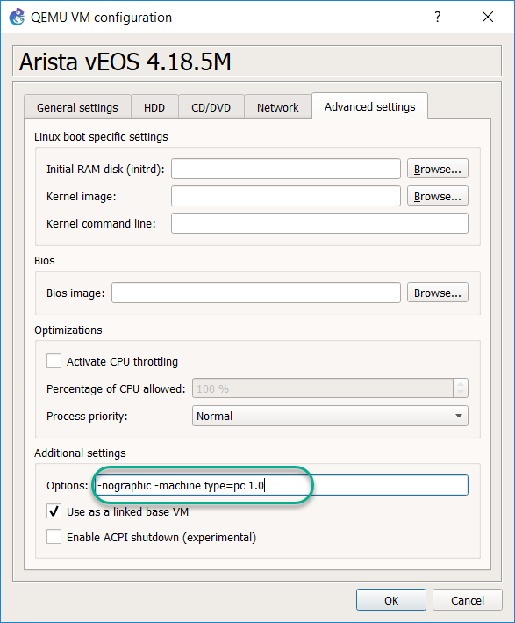

This workaround is NOT required if you are running Linux natively on your PC.

(credit for this workaround goes to Bernhard Ehlers)

# [Next step](https://docs.gns3.com/1QXVIihk7dsOL7Xr7Bmz4zRzTsJ02wklfImGuHwTlaA4/" \l "h.p47zrfwvkq8n)

You need now to follow the setup wizard:

[The setup wizard](https://docs.gns3.com/1yL-p0vPROWPTkQqkEzL2IaDu7iYW-PUzpFamnksHH98/index.html)