Validation System Documentation

Student Name: FUNWI CHECY

Student Number: 1195270

College Name: GAUTENG CITY COLLEGE

Lecturer: MR OWANI

Date: 22 SEPTEMBER 2026

Table of Contents
3. Introduction 3
4. System Design 3
6. Validation Checks 5
7. Testing 7
8. Code 9
9. GitHub Repository 12
10. Conclusion 13
11. References 14

3. Introduction

The Validation System is a Java Swing desktop application developed to capture and validate user information through a graphical user interface. The system is designed to ensure that information entered by a user is complete and follows the required validation rules before it is accepted.

The application includes fields for name and surname, ID or student number, age or date of birth, gender, contact number, and email address. Each field has appropriate validation checks to identify missing, incorrectly formatted, or invalid information.

The main purpose of the system is to demonstrate the practical use of Java programming, Java Swing components, event handling, input validation, and user feedback. When invalid information is entered, the application provides feedback to the user so that the information can be corrected. When all required information passes validation, the system provides confirmation that the validation has been completed successfully.

4. System Design
  - 4.1 Planned Layout and Design

Before development began, the Validation System was planned as a simple form-based desktop application. The main design objective was to create an interface that would be easy for a user to understand and operate.

The form was designed with clearly labelled input fields so that users could identify the type of information required. Different Swing components were selected according to the type of information being captured.

Text fields were used for information such as names, identification numbers, contact numbers, and email addresses. Selection controls were used for gender so that the user could choose an appropriate option.

The interface also uses visual elements such as icons and a consistent colour scheme to improve the appearance of the application. Validation feedback was designed to be clear so that users could identify incorrect information and make corrections.
The design focused on:
Simplicity
Clear labels
Easy navigation
Consistent layout
User-friendly feedback
Appropriate use of colours
Appropriate use of icons
Easy identification of invalid information

  - 4.2 Interface Design

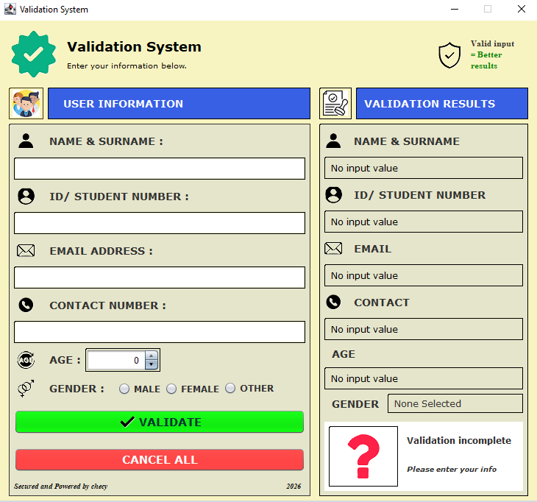
Figure 1: Validation System user interface
Figure 1 shows the main interface of the Validation System. The interface contains the required input fields and controls used to capture and validate user information.

5. Fields
The Validation System captures the following information.

Field | Purpose
Name and Surname | Captures the user's first name and surname.
ID / Student Number | Captures the user's identification or student number.
Age / Date of Birth | Captures the user's age or date-of-birth information.
Gender | Captures the gender selected by the user.
Contact Number | Captures the user's contact or mobile number.
Email Address | Captures the user's email address.

Each field has a specific purpose and is validated according to the type of information it is expected to contain.

6. Validation Checks
The Validation System applies different validation checks depending on the field.
  - 6.1 Name and Surname
The name and surname fields are checked to ensure that the required information has been entered.
The checks include:
Presence: The field must not be empty.
Type/characters: The input should contain appropriate name characters.
Length: The input should not be unreasonably short or long.
These checks are appropriate because a name field should contain actual name information rather than being left blank or containing inappropriate characters.

  - 6.2 ID / Student Number
The ID or student number field is checked to ensure that an appropriate identification value has been entered.
The checks include:
Presence: The field cannot be empty.
Type: The input must contain the expected type of characters.
Length: The value must follow the expected length.
Format: The value must follow the required identification format.

These checks help prevent incomplete or incorrectly formatted identification information from being accepted.

  - 6.3 Age / Date of Birth
The age or date-of-birth field is checked to ensure that the entered information represents a valid value.
The checks include:
Presence: The field cannot be empty.
Type: The value must be a valid number or date, depending on the implementation.
Range: The value must fall within an appropriate range.
These checks are appropriate because an age cannot be negative or outside a reasonable human age range, while a date of birth must represent a valid date.

  - 6.4 Gender
The gender field requires the user to select an available option.
The main check is:
Presence/selection: An option must be selected.
This validation is appropriate because the system requires the user to provide a gender selection before the form can be considered complete.

  - 6.5 Contact Number
The contact number field is checked to ensure that a valid contact number is entered.
The checks include:
Presence: The field cannot be empty.
Type: The input must contain appropriate numeric/contact characters.
Length: The number must have an appropriate number of digits.
Format: Invalid characters or an invalid structure should be rejected.
These checks help prevent incomplete or incorrectly formatted contact information.

  - 6.6 Email Address
The email field is checked to ensure that the entered value follows the expected email format.
The checks include:
Presence: The field cannot be empty.
Format: The email must follow a recognizable email structure.
Type/characters: The input must contain appropriate email characters.
For example, an email normally contains an @ symbol and a domain.
These checks help prevent obviously invalid email addresses from being accepted.

7. Testing
Testing was performed by entering both invalid and valid information into the application.
The purpose of testing was to determine whether the application correctly identifies invalid input and accepts information that satisfies the validation rules.

  - 7.1 Before Testing — Invalid Data
This section provides evidence that the validation checks work correctly.

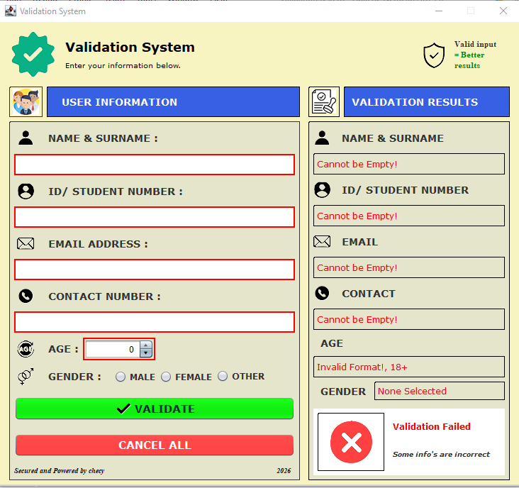
Figure 2: Empty input error

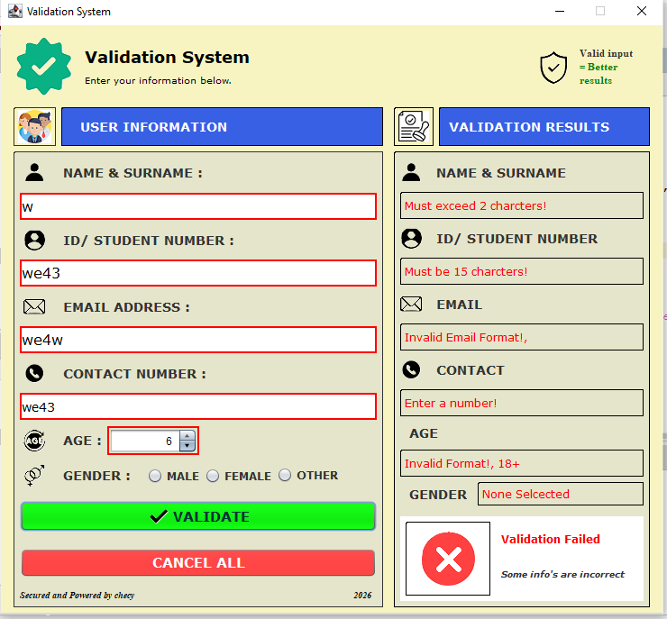
Figure 3: Invalid input error

  - 7.2 After Testing — Valid Data
After testing invalid information, valid information was entered into the same fields.
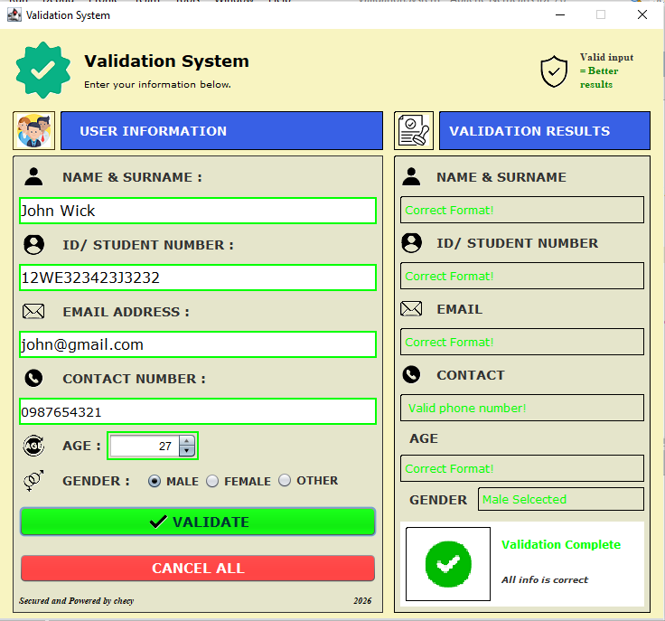
Figure 14: Completed form with all input passing validation

The screenshot demonstrates the final state of the application when all required information has been entered correctly. The system accepts the information and displays the appropriate successful validation feedback.

8. Code
This section contains selected key sections of the source code rather than the entire Java file. Each section demonstrates an important part of the validation process.
  - 8.1 Retrieving User Input
For example:
String uname = name.getText().trim();
String sname = surname.getText().trim();
String number = contatc.getText().trim();
String uemail = email.getText().trim();

Explanation:
This section retrieves the information entered by the user from the form. The getText() method obtains the text from the relevant Swing component, while trim() removes unnecessary spaces at the beginning and end of the input.

  - 8.2 Checking for Empty Fields
Example:

if (uname.isEmpty()) {
name.setText(“cannot be empty!”);
name.setForeground(Color.red);
Border border = BorderFactory.createLineBorder(Color.red, 2)
name.setBorder(border);
allValid = false;
}else{
--- Line of code ---
}

Explanation:
This validation checks whether the name field is empty. If no name has been entered, a message is displayed to the user and the validation process stops until the problem is corrected.

  - 8.3 Email Validation
For example:
if (uemail.matches("^[A-Za-z0-9+_.-]+@[A-Za-z0-9.-]+$")) {
email1.setText(“Correct Format”);
email1.setForeground(Color.green);
Border border = BorderFactory.createLineBorder(Color.green, 2)
email1.setBorder(border);

}else{
email1.setText(“Invalid format!”);
email1.setForeground(Color.red);
Border border = BorderFactory.createLineBorder(Color.red, 2)
email1.setBorder(border);
allValid = false;

}

Explanation:

This section uses a regular expression to check whether the entered email follows the expected format. If the input does not match the required pattern, the system displays an error message.

  - 8.4 Successful Validation
For example:
if (allValid) {
cmsg.setText(“Validation Complete”);
email1.setForeground(Color.green);
cmsg1.setText(“All info are correct”);
image1.setIcon{
new ImageIcon{
getClass().getResources(“checkfian1.png”)
}
};

}else{
cmsg.setText(“Validation Failed”);
email1.setForeground(Color.red);
cmsg1.setText(“some info are incorrect”);
image1.setIcon{
new ImageIcon{
getClass().getResources(“delete.png”)
}
};

}

Explanation:
This message is displayed after the required validation checks have been successfully completed. It informs the user that the information has passed the validation process.

9. GitHub Repository
The source code for the Validation System is available on GitHub.
GitHub Repository:
https://github.com/funwi6191/ValidationSystem
The repository contains the Java source code, NetBeans project files, images, README documentation, and other project files required for the application.
Cloning the Repository
A marker can clone the project by opening a terminal and running:
git clone https://github.com/funwi6191/ValidationSystem.git
After cloning the repository, the project can be opened in NetBeans.

The marker can then:
Open NetBeans.
Open the cloned ValidationSystem project.
Allow NetBeans to load the project.
Build the project.
Run the application.
The project is maintained using Git version control, with the main branch containing the current version of the project.

10. Conclusion
The Validation System project provided practical experience in developing a Java Swing desktop application and implementing input validation.
One of the main challenges during development was ensuring that different types of information were validated using appropriate rules. Different fields require different checks. For example, an email address requires format validation, while an age requires a valid numerical value and an appropriate range.
Testing both invalid and valid information helped verify that the application responds appropriately to different types of input. Error messages provide feedback when information does not meet the required conditions, while successful validation confirms when the required information has been entered correctly.
Through this project, I improved my understanding of Java Swing, graphical user interface development, event handling, conditional statements, string handling, input validation, error handling, and Git/GitHub version control.
The project also demonstrated the importance of designing an application with usability in mind. Clear labels, appropriate controls, visual elements, and understandable feedback make the system easier for users to operate.
Overall, the Validation System demonstrates my practical ability to design, develop, test, document, and manage a Java desktop application.

11. References
FlatIcon for icons. Available at flaticon.com
Oracle. Creating a GUI With Swing. Available at:
Oracle Swing Tutorial
Apache NetBeans. Apache NetBeans Documentation. Available at:
Apache NetBeans
GitHub. GitHub Documentation. Available at:
GitHub Docs

