What do you need ?
To be able to communicate with a Black Box unit through a computer, you would need a serial cable. The so called RS232 protocol makes use of a COM port, hooked up over the serial connection.
(On unix based systems this would be something like /dev/ttyS0)

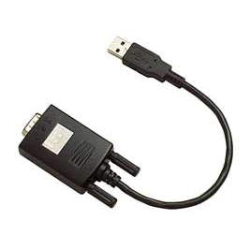
Modern systems
USB ⬄ Serial
In some cases, when the host system no longer has a physical COM port, an USB to serial converter is used.
(With Linux you would get something resembling: /dev/ttyUSB0)

The interface:
Over the command prompt you can send out commands by means of a PHP script.
This way you can use the following features:
You can:
- Create the MySQL database and tables
- Scan for units
- Read data from the PDUs and have this stored in the database
- Check whether all units are still present on the bus
- Read the current status of the outlets
- Switch outlets on or off
- Reset the Kwh meters to 0

Windows clients
A limitation is known with windows based systems.
The COM port is blocked from reading by default.
This way, reading data would be impossible.
This also goes for USB connected serial cables.
The solution for this little annoyance lays in the Tools folder on the CD.
There you will find the “Unblock.exe” program which is able to unblock COM1 by default or any other COM port when given the correct parameter command over the command prompt.
e.g. c:\location\of\unblock>unblock.exe COM2
This would put COM port 2 in an unblocked status as long as the PC stays booted up.

There is just one thing which a user needs to know, that is his or her correct com port.
By following the next steps an user should be able to find his or her COM port in windows based systems.
In the control panel you open “System”.
In the screen that opens you click on the TAB “Hardware”.
In the TAB screen there is a button called “Device manager” click this.
In the following screen click the “+” in front of the next image

- In the underlying example you see a serial port connected over a USB converter cable.
The desired COM there would be COM5
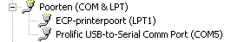

Once you know the needed COM port you can use the unblock program as described above.

