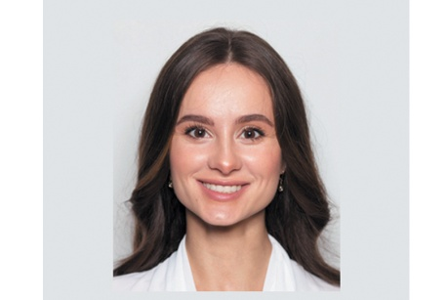Toshisangla

H.NO 125,Shitikolak Ward,Tuli

Mokochung ,Nagaland – 798618

+91-9612689711

[Toshisangla@gmail.com](mailto:Toshisangla@gmail.com)

**CAREER OBJECTIVE**

*Dynamic Digital Margeting Manager with over five years of experience in leading successful marketing campaigns. Looking to leverage proven skills in content management and data analytics to drive forward the marketing strategies at XYZ Corporation* .

**PERSONAL INFORMATION**

Name : Toshisangla

Fathers Name : Masamongba

Date of Birth : March 27 2003

Sex : Female

Mobile Number : 9612689711

E–Mail [Toshisangla@gmail.com](mailto:Toshisangla@gmail.com)

Nationality : Indian

**EDUCATION**

HSLC NBSE (2019)

HSSLC NBSE (2021)

**CERTIFICATION COURSES**

Course in CAA ( Computer Application Associate) from NIELIT

**LANGUAGES**

Ao , English and Hindi

**STRENGTH**

Honest,Hardworking and good at solving problems.

**DECLARATION**

I hereby declare that the above information given above is true and correct to the best of my knowledge.