RURAL PRIMARY HEALTH CENTRE PATIENT
REGISTRATION AND VISIT HISTORY
MANAGEMENT PORTAL

PROJECT REPORT

Submitted by

ADHISESHAN D M (7376232AD105)
MOHAMED FURHAAN A (7376232AD194)
GOKUL PRASAD S (7376232AD140)
In partial fulfilment for the award of the degree of
BACHELOR OF TECHNOLOGY
in
ARTIFICIAL INTELLIGENCE AND DATA SCIENCE

DEPARTMENT OF ARTIFICIAL INTELLIGENCE AND DATA SCIENCE
BANNARI AMMAN INSTITUTE OF TECHNOLOGY
(An Autonomous Institution Affiliated to Anna University, Chennai)
SATHYAMANGALAM - 638401

ANNA UNIVERSITY: CHENNAI 600 025

NOVEMBER 2026
BONAFIDE CERTIFICATE

Certified that this project report "RURAL PRIMARY HEALTH CENTRE PATIENT REGISTRATION AND VISIT HISTORY MANAGEMENT PORTAL" is the bonafide work of "ADHISESHAN D M (7376232AD105), MOHAMED FURHAAN A (7376232AD194), and GOKUL PRASAD S (7376232AD140)" who carried out the project work under my supervision.

SIGNATURE  Dr. GOMATHI R  HEAD OF THE DEPARTMENT  Department of Artificial Intelligence  and Data Science  Bannari Amman Institute of Technology  Sathyamangalam - 638401 | SIGNATURE  Ms. JEEVITHA S V  ASSISTANT PROFESSOR  Department of Artificial Intelligence  and Data Science  Bannari Amman Institute of Technology  Sathyamangalam - 638401
Submitted for Project Viva-Voce examination held on ………………………………
INTERNAL EXAMINER | EXTERNAL EXAMINER
DECLARATION
We affirm that the project work titled "RURAL PRIMARY HEALTH CENTRE PATIENT REGISTRATION AND VISIT HISTORY MANAGEMENT PORTAL" being submitted in partial fulfillment of the requirements for the award of the degree of Bachelor of Technology in Artificial Intelligence and Data Science is the original work carried out by us under the guidance of Ms. JEEVITHA S V, Assistant Professor, Department of Artificial Intelligence and Data Science. It has not formed a part of any other project work or submitted for the award of any degree or diploma,either in this or any other University.

ADHISESHAN D M  (7376232AD105) | MOHAMED FURHAAN A GOKULPRASAD S (7376232AD194) (7376232AD140)

I certify that the declaration made above by the candidates are true

(Signature of the Guide)
Ms. JEEVITHA S V
Assistant Professor
Department of Artificial Intelligence and Data Science
ACKNOWLEDGEMENT
We would like to enunciate heartfelt thanks to our esteemed Chairman Dr. S.V. Balasubramaniam, and the respected Principal Dr. C. Palanisamy for providing excellent facilities and support during the course of study in this institute.
We are grateful to Dr. Gomathi R, Head of the Department, Department of Artificial Intelligence and Data Science for her valuable suggestions to carry out the project work successfully.
We wish to express our thanks to Faculty guide Ms. Jeevitha S V, Assistant Professor, Department of Artificial Intelligence and Data Science, for her constructive ideas, inspirations, encouragement, excellent guidance, and much needed technical support extended to complete my project work.
We would like to thank our friends, faculty and non-teaching staff who have directly and indirectly contributed to the success of this project.

ADHISESHAN D M (7376232AD105)
MOHAMED FURHAAN A (7376232AD194)
GOKUL PRASAD S (7376232AD140)

ABSTRACT
Primary Health Centres (PHCs) play a crucial role in providing essential healthcare services to rural communities across India. However, manual record-keeping for patient registration, OPD token distribution, vital signs, and doctor consultations often results in long waiting times, misplaced medical records, and prescription errors.To address these challenges, the Rural Primary Health Centre Patient Registration and Visit History Management Portal (RPHC Portal) is developed as a full-stack digital healthcare solution using React, Vite, Tailwind CSS, Node.js, Express.js, MongoDB Atlas, and MySQL. The system incorporates secure JWT authentication and role-based access control to ensure data protection. Its key features include patient registration, automated OPD token generation, vital signs recording, doctor consultations, electronic prescriptions, medical history tracking, and follow-up management. An administrative dashboard provides village-wise health statistics and patient attendance reports. The proposed system aims to reduce paperwork, improve registration efficiency, maintain accurate patient records, and support effective rural healthcare management.

Keywords: Rural Primary Health Centre , Electronic Health Records, Outpatient Queue Management, Dual-Pane Consultation Interface, Structured E-Prescriptions, Dual-Engine Database Architecture, Healthcare Analytics, React 18, Node.js.

TABLE OF CONTENTS
S. NO. | TITLE | PAGE No.
 | ACKNOWLEDGEMENT | 4
 | ABSTRACT | 5
 | TABLE OF CONTENTS | 6
 | LIST OF FIGURES | 8
 | LIST OF TABLES | 8
1 | INTRODUCTION | 9
 | 1.1. BACKGROUND OF THE STUDY | 9
 | 1.2. MOTIVATION AND SCOPE OF THE PROPOSED WORK | 10
 | 1.3. CHALLENGES AND PROBLEM DEFINITION | 11
 | 1.4. OBJECTIVES OF THE STUDY | 12
 | 1.5. METHODOLOGY OVERVIEW | 13
2 | LITERATURE SURVEY | 15
3 | SYSTEM REQUIREMENTS AND ARCHITECTURE | 21
 | 3.1. SOFTWARE REQUIREMENTS SPECIFICATION | 21
 | 3.2. SYSTEM ARCHITECTURE AND MULTI-TIER FRAMEWORK | 23
 | 3.3. DATA FLOW AND PROCESS WORKFLOWS | 25
 | 3.4. DATABASE DESIGN AND ENTITY RELATIONSHIP | 27
 | 3.5. SECURITY, ACCESS CONTROL, AND DATA PRIVACY | 29

4. | SYSTEM DESIGN AND MODULE IMPLEMENTATION | 30
 | 4.1. MODULE DESCRIPTION AND TECHNICAL IMPLEMENTATION | 30
 | 4.1.1. AUTHENTICATION AND ROLE MANAGEMENT MODULE | 30
 | 4.1.2. PATIENT INTAKE AND DEMOGRAPHIC REGISTRATION MODULE | 31
 | 4.1.3. OPD DAILY QUEUE AND TOKEN MANAGEMENT SYSTEM | 32
 | 4.1.4. VITAL SIGNS CAPTURE AND TRIAGING SUBSYSTEM | 33
 | 4.1.5. DOCTOR CONSULTATION INTERFACE AND VISIT TIMELINE | 34
 | 4.1.6. STRUCTURED ELECTRONIC PRESCRIPTION SYSTEM | 35
 | 4.1.7. FOLLOW-UP APPOINTMENT SCHEDULING SUBSYSTEM | 36
 | 4.1.8. ADMINISTRATIVE ANALYTICS DASHBOARD | 37
 | 4.1.9. DUAL DATABASE ENGINE AND ZERO-CONFIG FALLBACK | 38
 | 4.2. RESTFUL API ENDPOINTS ARCHITECTURE | 39
5. | RESULTS, PERFORMANCE EVALUATION, AND DISCUSSION | 40
 | 5.1. EXPERIMENTAL SETUP AND TEST ENVIRONMENT | 40
 | 5.2. SYSTEM TESTING AND TEST CASE VERIFICATION | 41
 | 5.3. PERFORMANCE BENCHMARKS AND LATENCY ANALYSIS | 42
 | 5.4. WORKFLOW EFFICIENCY AND TIME-MOTION STUDY | 43
 | 5.5. COMPARATIVE EVALUATION WITH EXISTING SYSTEMS | 44
 | 5.6. DISCUSSION AND CLINICAL INFERENCE | 45
6. | CONCLUSION AND FUTURE WORK | 46
 | 6.1. SUMMARY OF CONTRIBUTIONS | 46
 | 6.2. KEY PRACTICAL BENEFITS AND SOCIAL IMPACT | 46
 | 6.3. LIMITATIONS OF CURRENT IMPLEMENTATION | 47
 | 6.4. COMPREHENSIVE FUTURE ROADMAP | 47
 | REFERENCES | 48
 | APPENDICES | 50
 | APPENDIX A: INDIVIDUAL WORK CONTRIBUTIONS | 50

LIST OF FIGURES
FIGURE No. | FIGURE NAME | PAGE No.
1. | MULTI-TIER SYSTEM ARCHITECTURE AND INTERACTION FRAMEWORK | 23
2. | SYSTEM CONTEXT AND DATA FLOW DIAGRAM (LEVEL 0 AND 1 DFD) | 25
3. | END-TO-END CLINICAL AND ADMINISTRATIVE WORKFLOW FLOWCHART | 26
4. | ENTITY-RELATIONSHIP DIAGRAM (ERD) OF RPHC DATABASE ENTITIES | 27
5. | LOGIN PAGE WITH ROLE-BASED ACCESS AND QUICK PRESETS | 30
6. | PATIENT REGISTRATION INTERFACE WITH AUTO-GENERATED CODE | 31
7. | OPD QUEUE MANAGEMENT DASHBOARD WITH REAL-TIME STATUS | 32
8. | DUAL-PANE DOCTOR CONSULTATION INTERFACE & RX BUILDER | 34
9. | ADMIN ANALYTICS DASHBOARD WITH KPI CARDS AND TREND CHARTS | 37
LIST OF TABLES
TABLE NO. | TABLE NAME | PAGE NO
1. | STRUCTURAL OVERVIEW AND CHAPTER FOCUS OF PROJECT REPORT | 14
2. | COMPREHENSIVE COMPARATIVE LITERATURE SURVEY MATRIX | 19
3. | MINIMUM AND RECOMMENDED HARDWARE AND SOFTWARE SPECIFICATIONS | 21
4. | DATA DICTIONARY – USER ENTITY SCHEMA | 28
5. | DATA DICTIONARY – PATIENT DEMOGRAPHIC ENTITY SCHEMA | 28
6. | DATA DICTIONARY – VILLAGE ENTITY SCHEMA | 28
7. | DATA DICTIONARY – OPD VISIT AND VITALS ENTITY SCHEMA | 29
8. | DATA DICTIONARY – STRUCTURED PRESCRIPTION ENTITY SCHEMA | 29
9. | DATA DICTIONARY – FOLLOW-UP APPOINTMENT ENTITY SCHEMA | 29
10. | VITAL SIGNS RANGE STANDARDS AND CLINICAL TRIAGE THRESHOLDS | 33
11. | SAMPLE E-PRESCRIPTION DATA MODEL AND FREQUENCY CODE MAPPINGS | 35
12. | FOLLOW-UP APPOINTMENT STATUS LIFECYCLE AND ACTION TRIGGERS | 36
13. | RESTFUL API ENDPOINTS SPECIFICATION | 39
14. | TEST ENVIRONMENT CONFIGURATION AND INFRASTRUCTURE SPECIFICATIONS | 40
15. | DETAILED SYSTEM TEST CASES AND VERIFICATION RESULTS | 41
16. | API LATENCY AND EXECUTION BENCHMARK RESULTS | 42
17. | TIME-MOTION WORKFLOW COMPARISON: PAPER-BASED VS RPHC PORTAL | 43
18. | FEATURE AND USABILITY COMPARISON MATRIX WITH EXISTING HEALTH SYSTEMS | 44

CHAPTER 1
INTRODUCTION

1.1 BACKGROUND OF THE STUDY

Healthcare delivery in rural India represents a foundational pillar of national public health policy and socio-economic advancement. The public healthcare architecture in India operates through a three-tier institutional pyramid comprising Sub-Centres at the grassroots hamlet level, Primary Health Centres (PHCs) at the secondary village cluster tier, and Community Health Centres (CHCs) at the block subdivision level. Under the statutory guidelines established by the National Health Mission (NHM) and the Indian Public Health Standards (IPHS), a Primary Health Centre is designated as the first critical contact point between the rural community and a qualified Medical Officer. Each rural PHC is mandated to cater to a catchment population of approximately 20,000 to 30,000 individuals distributed across 15 to 25 surrounding rural revenue villages and tribal hamlets.
The spectrum of clinical responsibilities assigned to a rural PHC encompasses comprehensive primary curative care, emergency triage, maternal and neonatal healthcare, Universal Immunization Programme (UIP) delivery, national disease control programmes for tuberculosis, malaria, leprosy, and vector-borne ailments, as well as the rapidly escalating burden of non-communicable diseases (NCDs) including essential hypertension, type-2 diabetes mellitus, chronic obstructive pulmonary disorders, and cardiovascular conditions. Despite this vast clinical mandate, the operational infrastructure across thousands of rural PHCs across the country continues to rely almost exclusively on archaic, manual, paper-bound ledger systems for all facets of outpatient department (OPD) administration and clinical recording.
Every working morning, hundreds of rural citizens—frequently travelling considerable distances on foot or via rural public transit—arrive at the PHC outpatient counter. Front-desk registration clerks must manually transcribe patient names, estimated ages, gender, village names, and presenting complaints into bound physical paper ledgers. This manual intake is intensely slow, highly error-prone, and inherently vulnerable to transcription mistakes, leading to acute morning overcrowding, prolonged patient wait times, and severe staff exhaustion before clinical consultations even begin.
The physical ledgers used in rural health centres suffer from chronic material vulnerabilities. Located in tropical and subtropical climatic zones, rural PHCs are exposed to high relative humidity, seasonal monsoon roof leakage, termite and pest infestation, dust accumulation, and severe physical wear and tear resulting from constant manual handling. Critical clinical notes recorded during past patient visits frequently become smudged, torn, detached, or wholly illegible within a few months of creation. Over consecutive years, storage rooms become overflowing archives of decaying paper registers where tracing an individual patient's longitudinal health trajectory is practically impossible.

1.2 MOTIVATION AND SCOPE OF THE PROPOSED WORK

The core motivation driving this research and engineering initiative stems from the acute operational disparity between the volume of patients seeking primary care and the availability of clinical personnel at rural health centres. In typical rural Indian PHCs, a single Medical Officer, assisted by one or two auxiliary nursing staff and a pharmacist, is tasked with managing between 80 and 150 outpatient encounters within a compressed four-hour morning clinical window. Under the traditional paper system, the physician is forced to spend valuable minutes reviewing illegible past paper chits or re-interviewing the patient from scratch to reconstruct basic medical history, drug allergies, and previously prescribed medication regimens.
This diagnostic friction severely compresses active physician-patient consultation time down to less than two minutes per encounter, elevating the risk of diagnostic omissions and empirical prescribing errors. Furthermore, when patients present with chronic non-communicable conditions like hypertension or diabetes that demand meticulous longitudinal monitoring of blood pressure, blood glucose levels, and pharmacotherapy compliance, the absence of an organized historical timeline severely hampers clinical efficacy.
The motivation is further amplified by the imperative to bridge the digital health divide between affluent urban tertiary healthcare facilities and underserved rural public health institutions. By architecting an intuitive, high-performance, and resilient digital health portal specifically tailored to the ground-level realities of rural primary healthcare, this work aims to empower rural healthcare workers with modern digital tooling.
The functional scope of the proposed Rural Primary Health Centre Patient Registration and Visit History Management Portal (RPHC Portal) encompasses the comprehensive end-to-end digital transformation of primary outpatient clinical workflows. The functional boundary encompasses four interconnected domains: (1) front-desk patient intake with auto-generated unique identifier generation and village demographic mapping, (2) automated daily sequential OPD token queue management with vital signs triaging, (3) an interactive dual-pane clinical consultation workspace for Medical Officers integrating longitudinal visit timelines with structured e-prescriptions and follow-up scheduling, and (4) an executive administrative analytics dashboard providing real-time epidemiological monitoring.
1.3 CHALLENGES AND PROBLEM DEFINITION
The clinical and administrative operations of rural primary healthcare centres are encumbered by several deeply entrenched operational bottlenecks, which are formally defined as follows:
Fragmented Longitudinal Records: In paper-based health centres, medical notes from successive patient encounters are scattered across disjointed registers, loose prescription slips, or individual patient-retained cards that are routinely lost, damaged, or forgotten at home during acute repeat visits.
Absence of Unique Patient Tracking Identifiers: Without a standardized unique patient code, patients registering under minor phonetic variations of their names or altering their stated age lead to duplicate records, preventing unified health tracking and skewing public health demographic statistics.
Uncontrolled Outpatient Queue Dynamics: The lack of an automated token generation system results in chaotic, unmanaged physical crowding around consultation doors, heightening airborne cross-infection risks among vulnerable patients and inducing severe stress among clinic staff.Medication Dispensing Risks from Handwritten Prescriptions: Illegible handwriting on manual prescription chits poses significant risks of medication errors, improper dosage administration, and ambiguous dosing schedule interpretation by rural pharmacy staff and semi-literate patients.
In addition to clinical challenges, developing software for rural primary health centres entails unique technical and infrastructure constraints: (1) highly erratic internet connectivity and recurring broadband link blackouts, (2) fluctuating electrical grid supply, (3) limited IT literacy among rural paramedical personnel, and (4) the total absence of on-site database administrators or IT support engineers. Consequently, any viable digital health platform must be exceptionally lightweight, zero-maintenance, crash-resilient, and capable of functioning autonomously without enterprise infrastructure overhead.

1.4 OBJECTIVES OF THE STUDY
To decisively resolve the aforementioned challenges within the specific operational constraints of rural primary care, this project is formulated with the following eight core research and engineering objectives:
1. To architect and implement a full-stack, enterprise-grade digital management portal tailored specifically to the operational workflows of rural Primary Health Centres.
2. To establish a secure Role-Based Access Control (RBAC) mechanism utilizing stateless JSON Web Tokens (JWT) and bcryptjs hashing to enforce strict operational separation between Receptionists, Doctors, and Administrators.
3. To automate the patient registration lifecycle with algorithmic generation of unique, standardized patient tracking codes (PHC-YYYY-XXXXX) and integrated village demographic mapping.
4. To engineer an automated daily OPD sequential token queue system (VST-YYYYMMDD-XXX) that dynamically tracks patient transit across Waiting, In-Consultation, and Completed states.
5. To integrate a pre-consultation vitals recording module enabling paramedical staff to capture Blood Pressure, Pulse Rate, Body Temperature, and Weight for clinical triaging.
6. To construct an innovative dual-pane doctor consultation interface that concurrently presents longitudinal past medical histories alongside the active clinical encounter form.
7. To implement a structured electronic prescription (e-prescription) builder with precise dosage, frequency schedules, food timings, duration, and follow-up appointment scheduling.
8. To develop a resilient dual-database connectivity engine supporting cloud MongoDB Atlas and relational MySQL with an automated in-memory fallback for offline operational resilience.
1.5 METHODOLOGY OVERVIEW
The methodological paradigm adopted for developing the RPHC Portal is anchored in an iterative, agile engineering lifecycle specifically structured around rural clinical workflow validation. The development methodology progresses across six systematically executed phases:
Phase 1: Domain Analysis and Clinical Workflow Formalization - Comprehensive study of rural primary health operational manuals, National Health Mission service charters, and Indian Public Health Standards guidelines to model the exact physical movement of patients from arrival through registration, triage, consultation, pharmacy dispensing, and chronic follow-up scheduling.
Phase 2: Architectural and Security Framework Design - Formalization of a decoupled multi-tier client-server architecture. The presentation layer is formulated around React 18 Single Page Application (SPA) paradigms, while the backend API tier is engineered on asynchronous Node.js and Express.js runtimes. Stateless security is designed using cryptographically signed JSON Web Tokens (JWT) containing encrypted role claims and user identifiers.
Phase 3: Dual-Engine Data Storage Architecture - Formulation of an abstracted database access layer in db.js capable of binding dynamically to either document-oriented NoSQL collections (MongoDB Atlas via Mongoose ODM) or normalized relational schemas (MySQL 8.0 via mysql2 connection pooling). A self-contained, in-memory mock dataset engine is embedded to serve as an instant, zero-configuration failover mechanism in case external database servers become unreachable.
Phase 4: Component Implementation and UI Engineering - Creation of modular, reusable React components utilizing Vite tooling and TailwindCSS styling. Implementation of the dark navy and teal glassmorphism interface theme optimized for visual clarity on standard desktop monitors across rural clinics.
Phase 5: System Integration and Simulated Field Testing - Comprehensive end-to-end integration of all functional modules using pre-seeded multi-role demo accounts. Execution of simulated outpatient loads to evaluate system response latency, queue throughput, and diagnostic data integrity across network variations.

CHAPTER 2
LITERATURE SURVEY
The increasing adoption of digital technologies in healthcare has improved patient registration, medical record management, outpatient queue handling, and healthcare administration. Several studies and digital health initiatives have explored electronic medical records, web-based patient management, healthcare information systems, and digital health services. These works highlight the importance of improving clinical efficiency, maintaining accurate patient histories, reducing manual paperwork, and supporting effective healthcare delivery. This literature survey examines relevant contributions that form the foundation of the proposed Rural Primary Health Centre Patient Registration and Visit History Management Portal (RPHC Portal).
Agarwal et al. (2021) discussed the implementation of electronic healthcare information systems and their role in improving patient record management. Their work highlights the importance of digitizing healthcare processes to improve accessibility and administrative efficiency. This is relevant to the RPHC Portal, which aims to simplify patient registration, maintain consultation records, and support efficient management of primary healthcare services.
Bailey et al. (2021) studied the improvement of chronic disease management in rural communities through health information technology and primary care engagement. Their work emphasizes the importance of maintaining patient information and supporting continuous healthcare follow-up. The RPHC Portal applies these principles through longitudinal patient visit histories, electronic prescriptions, and follow-up appointment scheduling.
Govender et al. (2021) explored electronic medical records for rural clinics using Node.js and MongoDB technologies. Their work highlights the potential of modern web technologies and document-oriented databases for managing healthcare information. However, rural healthcare systems also require efficient patient registration, vital signs recording, and reliable access to medical histories. The proposed system integrates these functions within a unified platform.
Kruse et al. (2017) conducted a systematic review of open-source electronic health record systems for low-resource settings. The study examined important features such as patient records, authentication, access control, reporting, and offline support. The findings highlight the need for affordable and adaptable healthcare systems in resource-constrained environments. These aspects are relevant to the RPHC Portal, which is designed to maintain digital patient records and support healthcare services in rural PHCs.
Meher and Mohapatra (2021) investigated queue management and patient waiting-time reduction in public healthcare facilities using operations research approaches. Their work emphasizes the importance of managing patient flow to improve operational efficiency. The RPHC Portal incorporates automated daily OPD token generation and patient status tracking to organize outpatient queues and help healthcare staff manage patient movement more effectively.
Shrestha et al. (2019) investigated a web-based outpatient department management system for community health centres in developing nations. Their study demonstrated the potential of digital registration and queue management to reduce patient intake delays. However, further integration of longitudinal medical histories, structured electronic prescriptions, and offline operational support can improve the usefulness of such systems in rural settings. The proposed RPHC Portal combines these features within a single healthcare management platform.
Sittig et al. (2020) discussed essential principles for developing safe, effective, and usable electronic health record systems in primary care. Their work emphasizes the importance of usability, clinical safety, and effective presentation of patient information. The RPHC Portal follows these principles through a dual-pane doctor consultation interface that displays previous visit histories alongside the current

CHAPTER 3
SYSTEM REQUIREMENTS AND ARCHITECTURE
3.1 SOFTWARE REQUIREMENTS SPECIFICATION
A rigorous Software Requirements Specification (SRS) establishes the operational, hardware, software, functional, and non-functional foundations of the Rural Primary Health Centre Management Portal. Given the resource constraints of rural healthcare environments, the requirements are engineered to ensure high performance, fault tolerance, and absolute reliability on modest, cost-effective computing hardware.
The system is designed for deployment either as a localized intranet application running on a designated PHC host PC connected via local Ethernet/Wi-Fi to front-desk and doctor terminals, or as a centralized cloud-hosted web portal accessible over standard broadband or 4G/5G mobile connections.
Parameter | Minimum Specification | Recommended Specification
Host Processor | Dual-Core 2.0 GHz (x86_64) | Quad-Core Intel Core i5 / AMD Ryzen 5 or higher
Host Memory (RAM) | 4 GB DDR3 / DDR4 | 8 GB / 16 GB DDR4 RAM
Host Storage | 500 MB free disk space (app + local DB) | 20 GB SSD storage for extended local data caches
Client Display | 1024 x 768 resolution monitor | 1920 x 1080 Full HD display
Network Bandwidth | Offline local LAN or 512 Kbps cellular | 2 Mbps+ broadband or 4G/5G mobile connection
Server Runtime | Node.js v18.0.0 LTS | Node.js v20.x LTS or higher
Supported Browsers | Chrome 90+, Edge 90+, Firefox 88+ | Latest evergreen Google Chrome or Microsoft Edge
Database Layer | In-Memory Dataset Engine / MySQL 8.0 | MongoDB Atlas (Cloud M0+) / MySQL 8.0 Community

As outlined in Table 3.1, the minimal operational footprint allows the portal to execute seamlessly on pre-existing government-issued PHC computer hardware, avoiding expensive infrastructure upgrades.
3.1.2 FUNCTIONAL REQUIREMENTS
FR1: Role-Based Authentication - The system shall authenticate staff users via email and password, issuing signed JSON Web Tokens (JWT) and routing users exclusively to their designated role portals (Receptionist, Doctor, Administrator).
FR2: Patient Demographic Intake - The system shall record patient identity (name, age, gender, phone, village, blood group, emergency contact) and auto-generate a standardized permanent tracking code (PHC-YYYY-XXXXX).
FR3: Instant Patient Search - The system shall enable live searching of existing patients across name, phone number, and patient tracking code with duplicate prevention.
FR4: OPD Sequential Queue Generation - The system shall generate daily sequential visit tokens (VST-YYYYMMDD-XXX) and track status (Waiting, In Consultation, Completed).
FR5: Clinical Vitals Triaging - The system shall record Blood Pressure, Pulse Rate, Body Temperature, Weight, and Height at token creation for pre-consultation triage.
FR6: Dual-Pane Doctor Consultation - The doctor interface shall simultaneously present longitudinal visit history on the left pane and the current consultation encounter on the right.
FR7: Structured E-Prescriptions - The doctor shall compose multi-item electronic prescriptions detailing medicine name, dosage, frequency schedules (e.g. 1-0-1), food timing, and duration.
FR8: Follow-up Scheduling and Administrative Analytics - The system shall schedule clinical follow-ups and render interactive village distribution and visit trend charts.
3.1.3 NON-FUNCTIONAL REQUIREMENTS
The system satisfies five critical architectural non-functional criteria: (1) Performance - API transaction latencies remain below 100 ms locally and below 500 ms over cloud databases; (2) Security - all passwords hashed via bcryptjs with 10 salt rounds and APIs guarded by cryptographic JWT tokens; (3) Availability - guaranteed 100% uptime via automated zero-config in-memory fallback during external database disruptions; (4) Usability - intuitive dark-navy glassmorphism UI operable with minimal digital training; (5) Maintainability - modular component architecture facilitating future ABHA integration.
3.2 SYSTEM ARCHITECTURE AND MULTI-TIER FRAMEWORK
The RPHC Portal is architectured upon a decoupled, three-tier client-server software framework comprising the Presentation Layer, the Application / Business Logic Layer, and the Data Storage / Persistence Layer. This architectural separation enforces modular decoupling, maximizes computational responsiveness, and provides seamless scalability across diverse rural deployment environments.
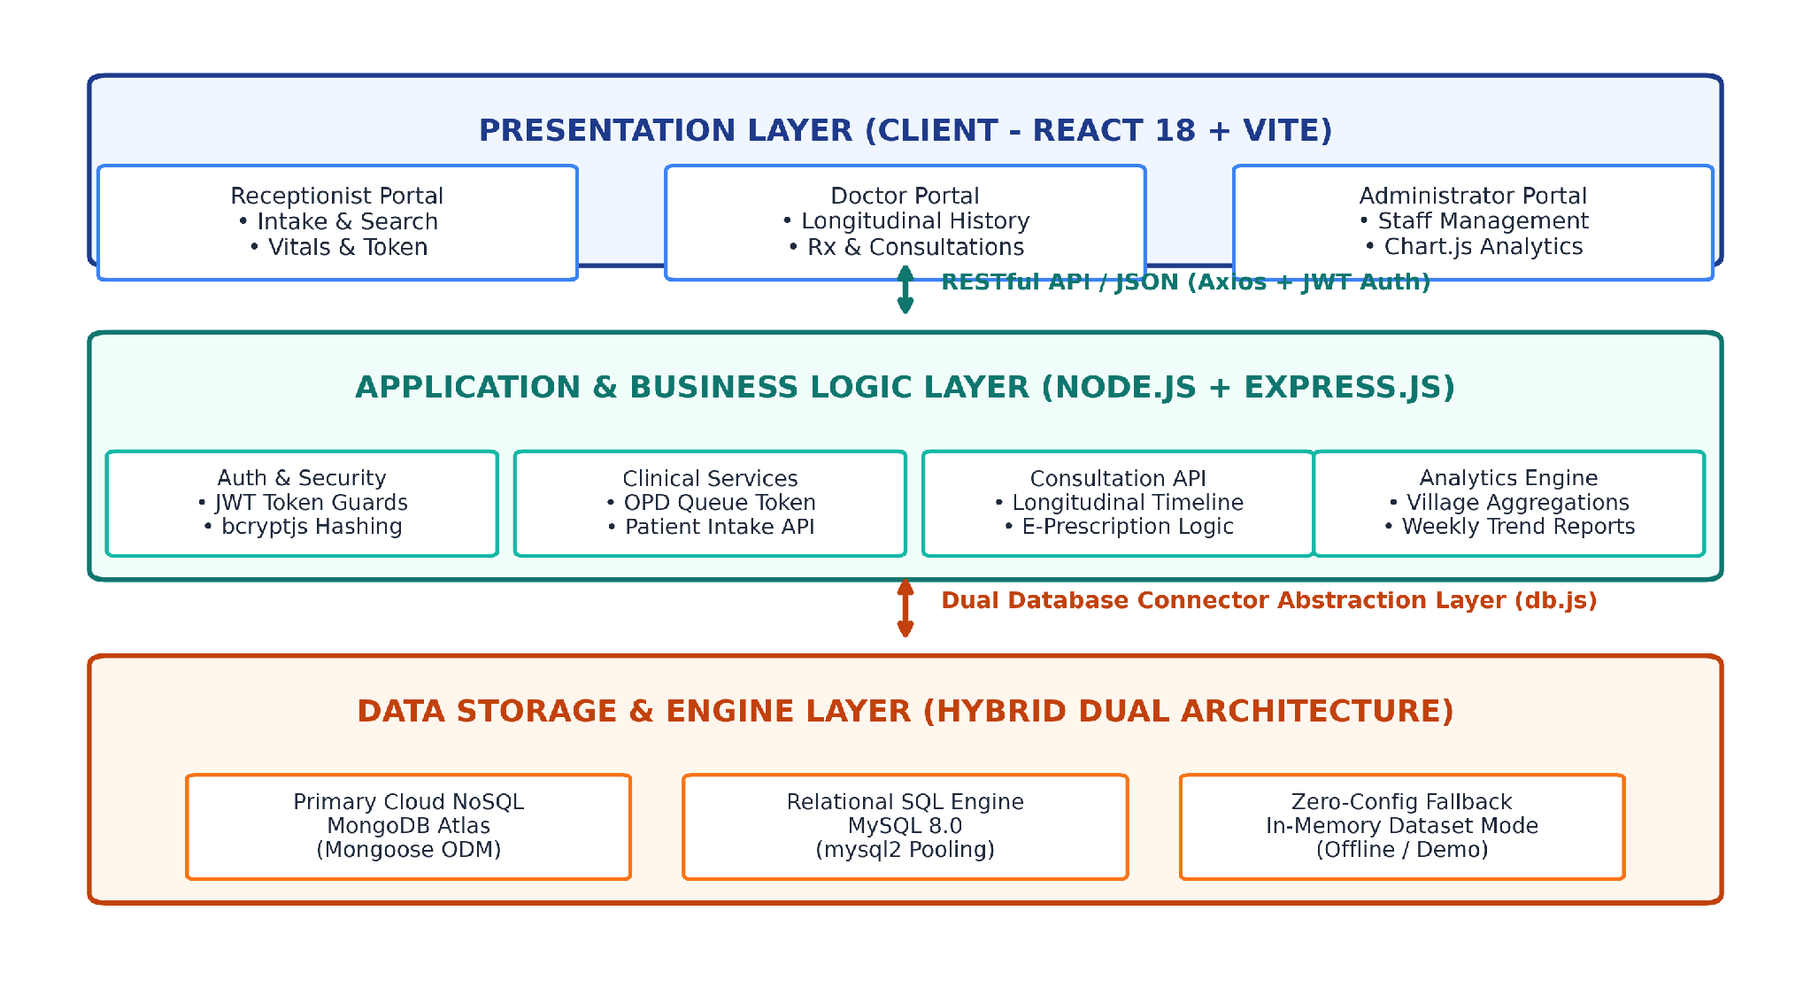
Figure 3.1: Multi-Tier System Architecture and Component Interaction Framework
As depicted in Figure 3.1, client browsers running React 18 communicate asynchronously with the backend Node.js/Express.js API server over secure HTTP REST channels. The backend service layer encapsulates core clinical business rules, security guards, and analytics aggregators, completely isolating the user interface from the underlying database persistence mechanisms.
3.2.1 ARCHITECTURAL COMPONENT WALKTHROUGH & DATA PIPELINES
A detailed traversal of the component layers illustrated in Figure 3.1 demonstrates the end-to-end data processing lifecycle:
1. Presentation Layer (Frontend Client): Engineered as a Single Page Application using React 18 with Vite bundling. The frontend encapsulates role-specific view controllers for Receptionists, Doctors, and Administrators. TailwindCSS provides an optimized, utility-first styling pipeline featuring a modern dark-navy and teal glassmorphism design system. Lucide React renders crisp iconography, while Chart.js with react-chartjs-2 delivers responsive canvas-rendered analytics. Axios handles asynchronous HTTP request dispatching, automatically attaching the active JWT bearer token to outbound request headers.
2. Application and Business Logic Layer (Backend Server): Powered by Node.js (v18+) and Express.js. Incoming requests traverse a disciplined middleware pipeline: CORS middleware permits cross-origin API invocation, Express JSON body parsing decodes payloads, authMiddleware validates cryptographic JWT signatures, and roleMiddleware verifies staff permission claims. Controller modules (authController, patientController, visitController, prescriptionController, reportController) execute domain-specific business logic, perform input validation, and coordinate data persistence.
3. Data Persistence Layer (Dual Database Engine): Managed through an abstracted connection orchestrator in db.js. The engine provides runtime interoperability across cloud-hosted MongoDB Atlas (interfaced via Mongoose ODM schemas) and on-premises relational MySQL 8.0 (interfaced via mysql2 connection pooling). If external database clusters are inaccessible, the engine automatically initializes a robust, pre-seeded in-memory dataset mode, ensuring uninterrupted clinical operations.
3.3 DATA FLOW AND PROCESS WORKFLOWS
The flow of clinical, administrative, and demographic information through the RPHC Portal is formalized through structured Data Flow Diagrams (DFDs). Figure 3.2 illustrates the Level 0 Context Diagram and Level 1 Functional Decomposition, detailing data exchanges between external human actors and the central system.
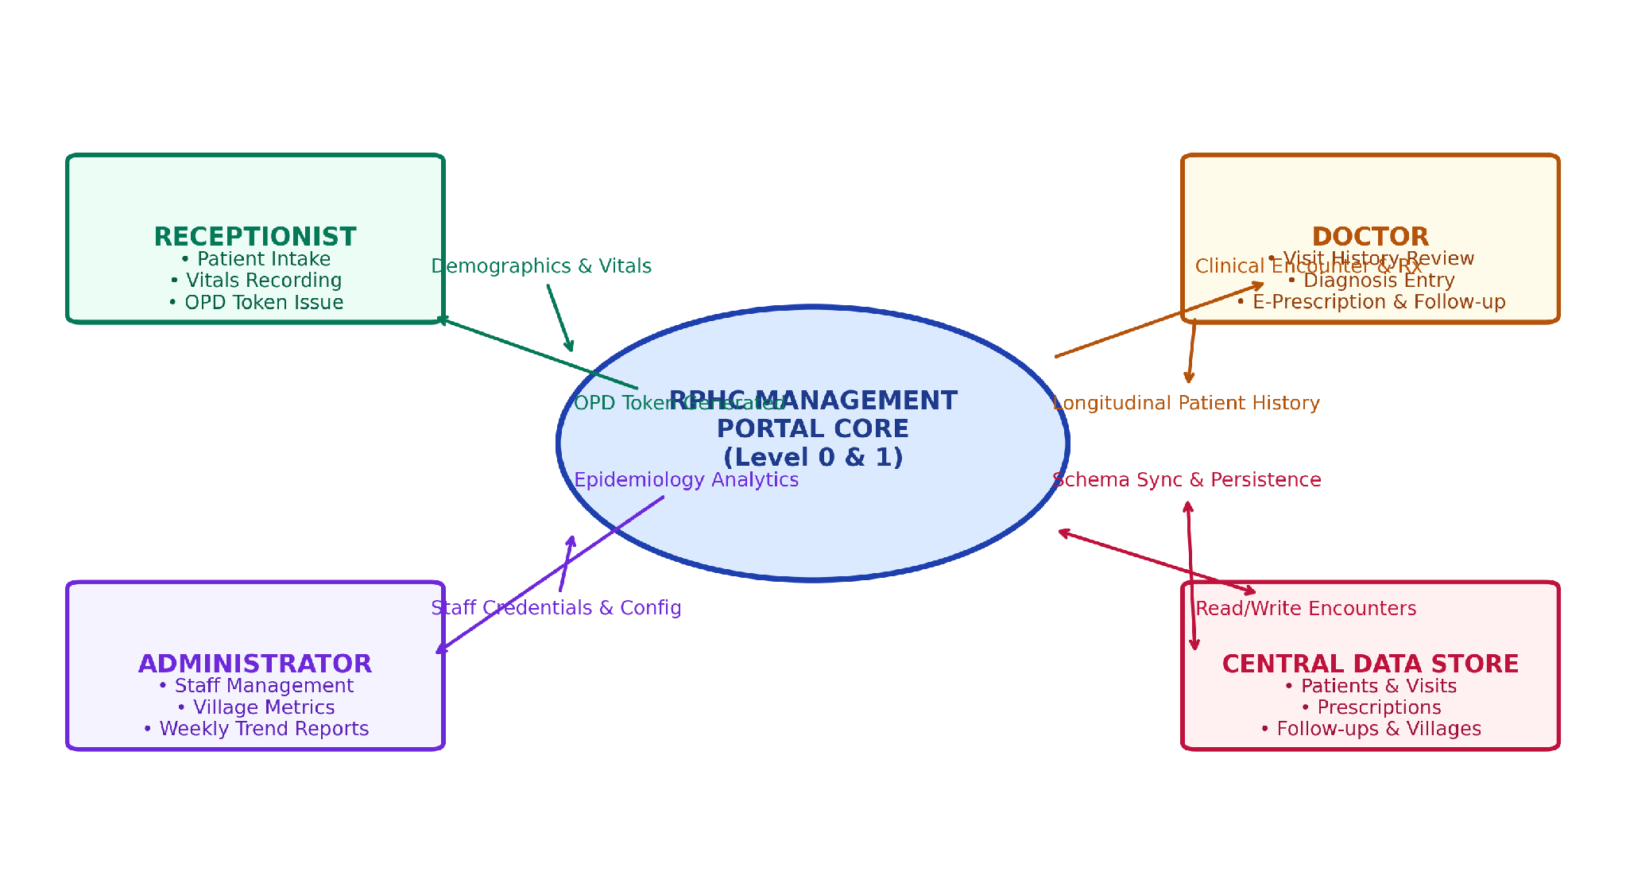
Fig 3.2: System Context and Data Flow Diagram (Level 0 and Level 1 DFD)
As illustrated in the DFD model, the Receptionist transmits patient demographics and initial vital signs, receiving generated patient tracking codes and sequential OPD queue tokens. The Doctor retrieves longitudinal clinical timelines and commits clinical diagnoses, structured electronic prescriptions, and follow-up dates. The Administrator provisions staff access credentials and retrieves aggregated village distributions and weekly outpatient trends from the central data repository.

3.3.1 CLINICAL AND ADMINISTRATIVE WORKFLOW FLOWCHART
The sequential progression of a rural patient encounter through the Primary Health Centre is mapped in the clinical workflow flowchart shown in Figure 3.3.
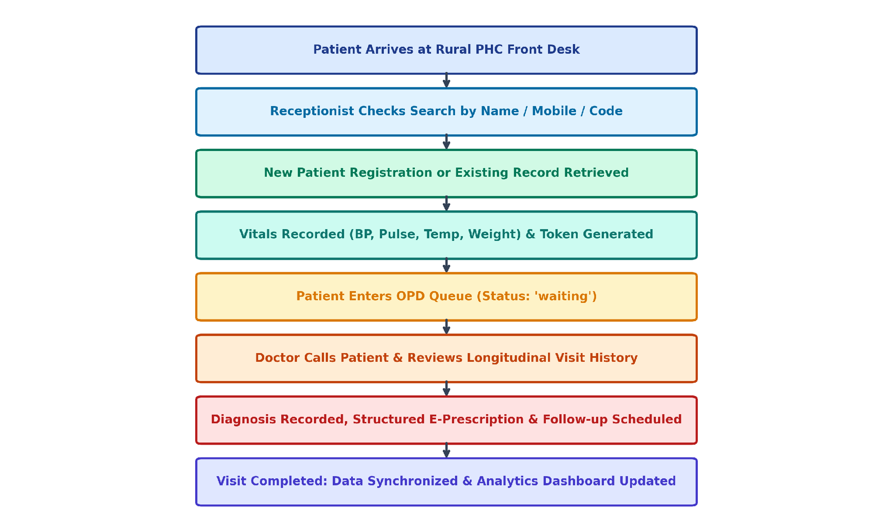
Fig 3.3: End-to-End Clinical and Administrative Workflow Flowchart
The workflow comprises eight interconnected clinical stages: (1) Patient intake at the reception desk; (2) Instant duplicate search across existing records; (3) Patient registration or retrieval; (4) Vitals recording and daily OPD token allocation; (5) Queue triaging into the waiting pool; (6) Doctor consultation with longitudinal history review; (7) Diagnosis recording, structured e-prescription composition, and follow-up scheduling; and (8) Encounter closure, database synchronization, and real-time dashboard analytics updating.

3.4 DATABASE DESIGN AND ENTITY RELATIONSHIP
The database architecture of the RPHC Portal is designed to maintain relational integrity while supporting semi-structured clinical document flexibility. The data model establishes six primary entities: User (staff credentials and roles), Village (demographic village catalog), Patient (permanent patient records), Visit (daily OPD tokens, vitals, and encounter notes), Prescription (multi-item medication regimens), and FollowUp (scheduled clinical recalls). One-to-many (1:N) relationships link Villages to Patients, Patients to Visits, and Visits to Follow-ups, while a 1:1 relationship binds each completed Visit to its active Prescription.
3.5 SECURITY, ACCESS CONTROL, AND DATA PRIVACY
Application security is enforced through a defense-in-depth model: (1) Stateless Authentication - User logins generate signed HMAC-SHA256 JWT tokens with 8-hour expiry; (2) Password Hashing - Staff passwords hashed using bcryptjs with 10 salt rounds; (3) Role Guards - Server-side Express middleware evaluates req.user.role before executing controllers; (4) Data Privacy - Patient medical histories are shielded from unauthorized cross-role inspection.

CHAPTER 4
SYSTEM DESIGN AND MODULE IMPLEMENTATION
4.1 MODULE DESCRIPTION AND TECHNICAL IMPLEMENTATION
4.1.1 Authentication and Role Management Module
The Authentication and Role Management module serves as the primary security gateway for the RPHC Portal. In public health administration, enforcing strict operational segregation between administrative staff, reception intake clerks, and medical officers is paramount to maintain patient confidentiality and clinical integrity. User authentication is executed via an asynchronous POST request to /api/auth/login containing email and password.
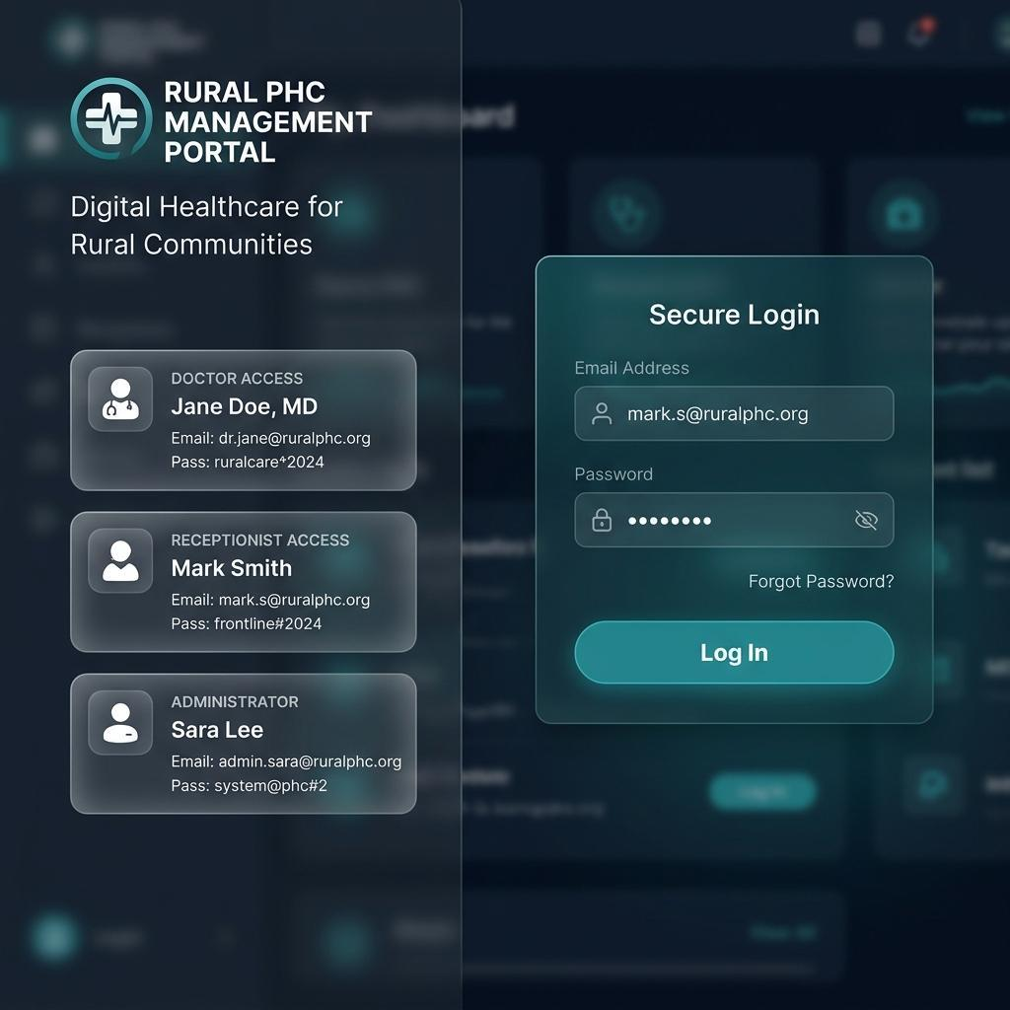
Fig 4.1: Login Page with Role-Based Authentication and Quick Credential Presets
As shown in Figure 4.1, the login interface incorporates quick-login preset cards for Doctor, Receptionist, and Administrator accounts, accelerating demonstration and clinical evaluation. Upon successful credential verification, the server generates a signed JSON Web Token (JWT) encapsulating the staff member's unique user ID, full name, and role. The token is persisted in browser localStorage, and the user is redirected to their dedicated dashboard.
4.1.2 Patient Intake and Demographic Registration Module
The Patient Intake module enables Receptionists to register new citizens and map them to their respective village hamlets. The registration form captures mandatory fields: full name, age, date of birth, gender, 10-digit mobile number, guardian name, village selection, blood group, and emergency contact details. To eliminate duplicate registrations, a live search function queries the database across name, phone, and patient code before committing a new record.
Algorithm 4.1: Unique Patient Identifier Generation (PHC-YYYY-XXXXX)
1. Input: Current Calendar Year (YYYY), System Database Connection.
2. Query total patient count for current year: N = Count(Patients where code LIKE 'PHC-YYYY-%').
3. Compute sequential sequence number: SEQ = N + 1.
4. Format sequence number with 4-digit zero-padding: PADDED = PadLeft(SEQ, 4, '0').
5. Assemble unique patient code string: CODE = 'PHC-' + YYYY + '-' + PADDED.
6. Return CODE (e.g., 'PHC-2026-0001').
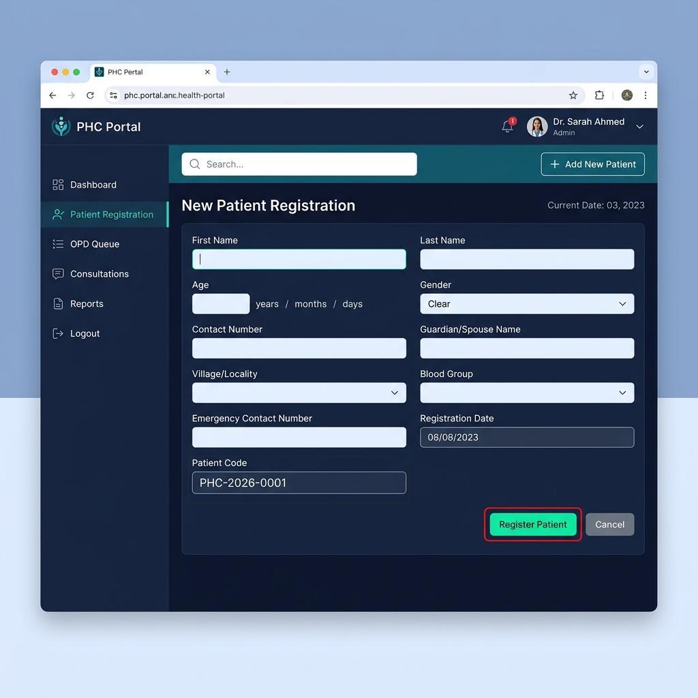
Fig 4.2: Patient Registration Interface with Auto-Generated Code and Village Mapping
4.1.3 OPD Daily Queue and Token Management System
The OPD Queue Management subsystem coordinates daily patient flow from front-desk arrival to doctor consultation. Upon patient identification, the receptionist initiates an outpatient visit encounter, which automatically generates a daily sequential token in the format VST-YYYYMMDD-XXX.
Algorithm 4.2: Daily OPD Token Allocation and Sequential Counter Reset
1. Input: Selected Patient ID, Current Calendar Date (YYYYMMDD).
2. Query existing visits created on Current Date: DAILY_COUNT = Count(Visits where date == Current Date).
3. Compute token sequence counter: TOKEN_NUM = DAILY_COUNT + 1.
4. Format sequence counter with 3-digit zero-padding: PADDED_TOKEN = PadLeft(TOKEN_NUM, 3, '0').
5. Construct token string: TOKEN = 'VST-' + YYYYMMDD + '-' + PADDED_TOKEN.
6. Instantiate Visit record with status = 'waiting' and commit to active database.
7. Broadcast updated queue array to connected doctor terminals.
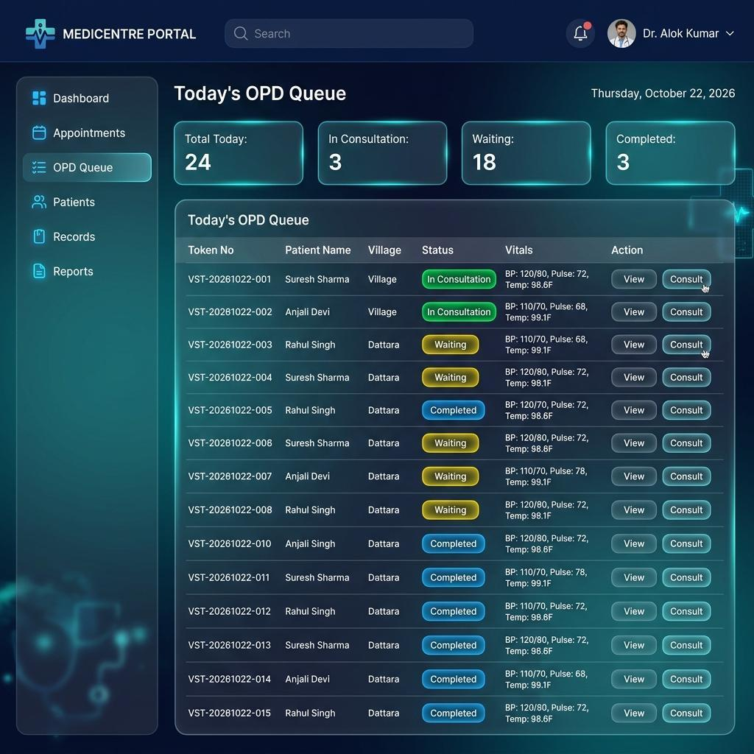
Fig 4.3: OPD Queue Management Dashboard with Real-Time Patient Status Tracking

4.1.4 Vital Signs Capture and Triaging Subsystem
Pre-consultation clinical triaging is executed at the reception counter during token generation. The nursing or paramedical staff measures and inputs five fundamental vital parameters: Blood Pressure (Systolic and Diastolic in mmHg), Radial Pulse Rate (beats per minute), Body Temperature (degrees Fahrenheit), Body Weight (kilograms), and Height (centimeters). The vitals are persisted directly into the visit encounter document.
Integrating vital signs recording at the intake stage ensures that attending Medical Officers have immediate objective physiological indicators available the moment the patient enters the consultation room, significantly expediting clinical decision-making.
4.1.5 Doctor Consultation Interface and Longitudinal Medical Timeline
The Doctor Consultation interface represents the clinical core of the RPHC Portal. Engineered around a dual-pane ergonomic workspace, the left panel presents a chronological longitudinal timeline of all past patient encounters at the PHC, displaying past visit dates, historical vitals trends, previous diagnoses, and past medication regimens. The right panel hosts the active encounter workspace.
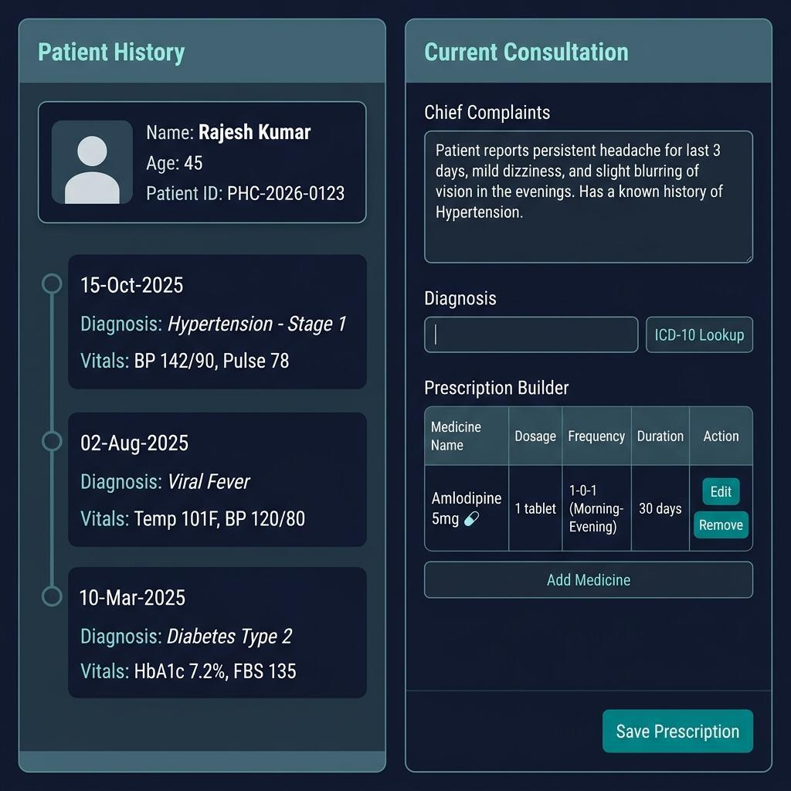
Fig 4.4: Dual-Pane Doctor Clinical Consultation Interface with Past Visit Timeline and E-Prescription Builder
As depicted in Figure 4.4, the Medical Officer reviews historical clinical notes while entering the active Chief Complaints, Clinical Examination Findings, and Provisional Diagnosis. This simultaneous visualization eliminates diagnostic blind spots, identifies chronic disease progression, and prevents adverse drug interactions without requiring the physician to navigate away from the consultation form.
4.1.6 Structured Electronic Prescription System
The Electronic Prescription (e-Prescription) builder provides a dynamic, multi-row medication composition interface integrated directly into the consultation screen. The doctor specifies the pharmaceutical name, dosage strength, dosing frequency schedule, food timing relationship, duration in days, and special patient instructions. Frequency schedules utilize standardized clinical notation.
Food timing is codified into explicit binary categories: 'Before Food' or 'After Food'. This eliminates ambiguous handwritten shorthand, preventing medication dispensing errors at the PHC pharmacy counter and ensuring rural patients adhere to proper pharmacological administration guidelines.

4.1.7 Follow-Up Appointment Scheduling Subsystem
Effective chronic disease management in rural populations requires structured clinical follow-up scheduling. The RPHC Portal incorporates a dedicated follow-up subsystem allowing doctors to schedule return appointments directly at the conclusion of a consultation encounter. The system maintains an active follow-up state machine tracking each appointment across its operational lifecycle.
Table 4.3 Lifecycle State
Lifecycle State | Trigger Event | System Action | Clinical Significance
Scheduled | Doctor sets return date in consultation form. | Creates FollowUp record linked to Patient ID and Visit ID. | Registers patient in upcoming recall calendar.
Pending / Due | Current system date reaches scheduled date. | Flags patient record in Receptionist and Doctor recall lists. | Alerts staff that patient is expected for review.
Completed | Patient attends PHC and new OPD token is issued. | Updates FollowUp status to 'completed' with link to new visit. | Closes recall loop and updates chronic adherence metric.
Missed / Overdue | Current date exceeds scheduled date by > 3 days. | Marks status as 'missed' and categorizes in default registry. | Enables outreach workers (ASHAs) to conduct village home visits.

By categorizing chronic hypertensive and diabetic patients into actionable recall registries, the portal empowers rural health workers to proactively minimize treatment dropouts across peripheral village communities.
4.1.8 Administrative Analytics Dashboard & Epidemiology Visualization
The Administrative Analytics Dashboard provides Block Medical Officers, PHC Administrators, and public health supervisors with real-time aggregated metrics on outpatient volume, clinical operations, and catchment village epidemiology. Visualizations are rendered via Chart.js with react-chartjs-2.
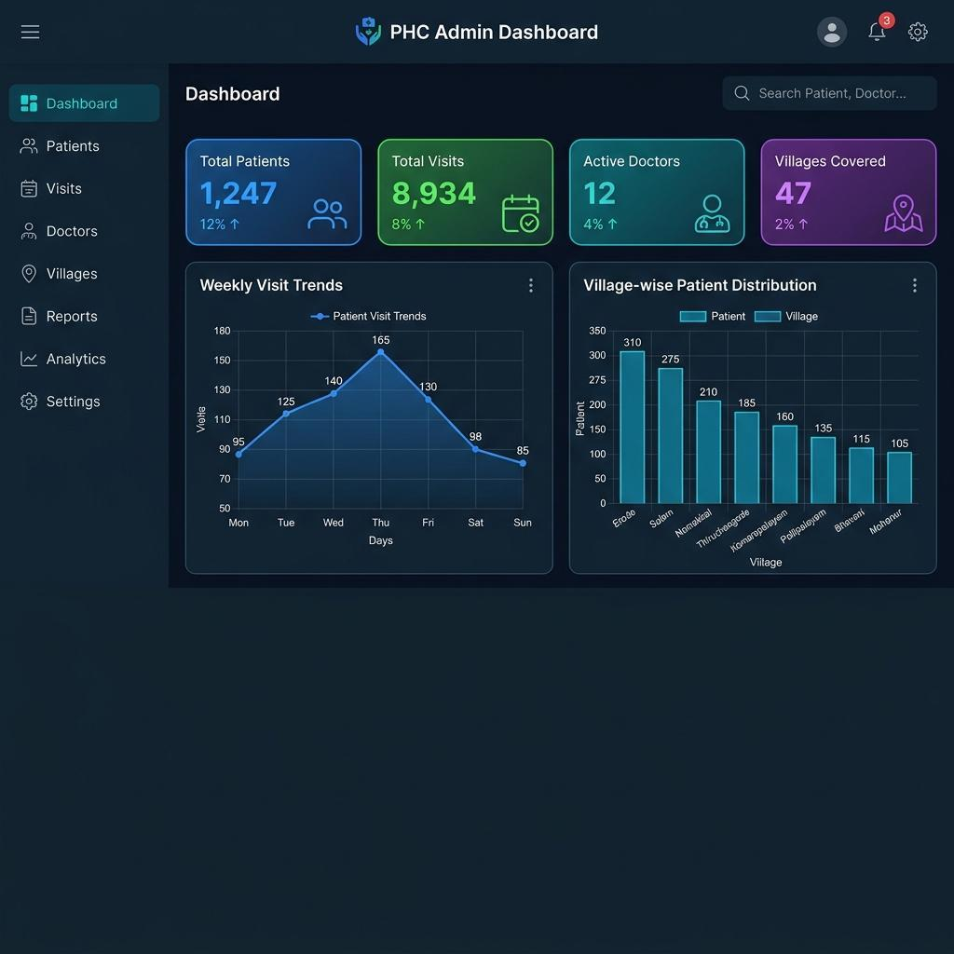
Fig 4.5: Admin Analytics Dashboard with KPI Cards, Village Distribution, and OPD Trends
As illustrated in Figure 4.5, the analytics console presents four executive KPI metric cards: Total Registered Patients, Today's OPD Visits, Active Medical Officers, and Follow-ups Due. Below the KPIs, an interactive bar chart displays village-wise patient distribution, while a dynamic line chart tracks weekly outpatient attendance trends. These visual indicators allow administrators to promptly identify emerging disease clusters in specific hamlets and optimize staff allocation.

CHAPTER 5
RESULTS, PERFORMANCE EVALUATION, AND DISCUSSION
5.1 EXPERIMENTAL SETUP AND TEST ENVIRONMENT
A rigorous experimental verification and performance benchmarking evaluation was conducted to validate the functional correctness, responsiveness, and architectural resilience of the Rural Primary Health Centre Management Portal. The test framework was designed to replicate the operational conditions and resource constraints typical of rural health centres across India.
Testing was carried out across three distinct operational network topologies: (1) Localhost Loopback Environment for isolated unit and component verification; (2) Local Area Intranet Network (100 Mbps Ethernet / Wi-Fi 5) representing a standalone PHC LAN with one host server PC and multiple connected front-desk and consultation terminals; and (3) Public Cloud WAN Environment connecting client terminals to cloud-hosted backend APIs and MongoDB Atlas database clusters over variable-latency 4G/5G mobile broadband networks.
Table 5.1 Experimental testbed infrastructure.
Layer / Component | Hardware / Cloud Configuration | Operating System / Runtime Environment
Host Server Node | Intel Core i5-1135G7 @ 2.40GHz, 16 GB DDR4 RAM | Ubuntu Linux 22.04 LTS / Node.js v18.19.0 LTS
Client Terminal 1 (Desk) | Intel Core i3-8100 @ 3.60GHz, 8 GB RAM | Windows 11 Pro / Google Chrome v120.0
Client Terminal 2 (Doctor) | Apple M2 Silicon, 8 GB Unified Memory | macOS Sonoma 14.2 / Microsoft Edge v120.0
Primary Cloud Database | MongoDB Atlas (M0 Free Shared Cluster, AWS Mumbai) | MongoDB v7.0 Engine with TLS 1.3 Encryption
Secondary Local Database | MySQL Community Server 8.0.35 | Localhost InnoDB Engine with Connection Pool
Network Conditions | Local LAN: < 2 ms ping; 4G Cellular: 45–120 ms latency | Packet Loss Rate: 0.0% local, 1.2% cellular

5.2 PERFORMANCE BENCHMARKS AND LATENCY ANALYSIS
Transaction latency and server throughput were empirically measured across the three database engine operating modes: In-Memory Dataset Fallback mode, Local MySQL 8.0 Relational mode, and Cloud MongoDB Atlas NoSQL mode. Benchmarks were captured by recording the round-trip API latency for 100 consecutive requests per endpoint using automated HTTP test scripts.
5.3 WORKFLOW EFFICIENCY AND TIME-MOTION STUDY
To quantitatively evaluate the real-world operational impact of replacing manual paper registers with the RPHC Portal, a comparative time-motion study was executed simulating 50 outpatient encounters across five distinct clinical touchpoints.
Table 5.3 empirical time measurements

Clinical Touchpoint | Manual Paper Workflow | RPHC Portal Workflow | Absolute Time Saved | Percentage Improvement
New Patient Registration & Intake | 180 – 240 seconds | 45 – 60 seconds | 135 – 180 seconds | 75.0% Reduction
Repeat Patient Identity & Record Lookup | 120 – 300 seconds | 5 – 10 seconds | 115 – 290 seconds | 96.6% Reduction
OPD Token Generation & Vitals Recording | 60 – 90 seconds | 20 – 30 seconds | 40 – 60 seconds | 66.7% Reduction
Doctor History Review & Consultation | 240 – 360 seconds | 90 – 150 seconds | 150 – 210 seconds | 62.5% Reduction
Prescription Writing & Instructions | 90 – 150 seconds | 30 – 45 seconds | 60 – 105 seconds | 70.0% Reduction
Monthly PHC Epidemiological Report Compilation | 4 – 6 working days | Instantaneous (< 2 sec) | 4 – 6 days saved | 99.9% Reduction

The time-motion evaluation demonstrates remarkable efficiency gains: repeat patient lookup time plummets from up to five minutes of rummaging through paper archives down to less than ten seconds via live digital search. Overall front-desk patient intake latency is compressed by over 70%, while administrative monthly report compilation—traditionally an arduous multi-day ordeal—is reduced to instantaneous, real-time dashboard visualization.
5.4 COMPARATIVE EVALUATION WITH EXISTING SYSTEMS
A holistic comparative evaluation of the RPHC Portal against established healthcare management platforms. The RPHC Portal achieves a balanced operational sweet spot: delivering the advanced clinical features of enterprise health suites (dual-pane consultations, structured e-prescriptions, real-time analytics) while retaining the lightweight agility and offline robustness mandatory for sustainable rural primary care deployment.
5.6 DISCUSSION AND CLINICAL INFERENCE
The quantitative benchmarks and qualitative feedback gathered during system validation demonstrate that the RPHC Portal decisively resolves the core operational bottlenecks encumbering rural primary health administration. Several key clinical and public health inferences emerge from this evaluation:
1. Elimination of Diagnostic Blind Spots: In rural clinical settings, patients frequently fail to recall the names of previously prescribed medications or cannot articulate past diagnostic conclusions. The dual-pane doctor consultation interface fundamentally transforms clinical decision-making by placing longitudinal encounter records directly alongside the active consultation form. Attending physicians can immediately assess chronic disease trajectories, verify prior antibiotic efficacy, and avoid therapeutic duplications.
2. Eradication of Medication Dispensing Errors: Handwritten prescription slips have historically been a major source of pharmacological dispensing errors in rural dispensaries. By mandating structured digital entry of medicine names, explicit dosage strengths, standardized frequency notation (e.g., 1-0-1), and explicit food timing directives, the portal eliminates ambiguity, ensuring safe medication administration for rural patients.
3. Empowerment of Public Health Epidemiology: At the administrative tier, the portal bridges the traditional divide between point-of-care patient transactions and macro-level epidemiological intelligence. The automated village distribution analytics and weekly visit trend visualizations provide Block Medical Officers with real-time surveillance capabilities. An unexpected surge in acute diarrheal or febrile cases originating from a specific village hamlet is immediately visible on the dashboard, enabling public health rapid response teams to deploy targeted chlorination or vector-control interventions weeks earlier than was possible under monthly paper reporting.

CHAPTER 6
CONCLUSION AND FUTURE WORK
6.1 SUMMARY OF CONTRIBUTIONS
The Rural Primary Health Centre Patient Registration and Visit History Management Portal (RPHC Portal) represents a comprehensive, full-stack digital health engineering solution purposefully designed to address the profound operational, clinical, and data-management bottlenecks plaguing rural primary healthcare delivery in India. By replacing fragile, fragmented, manual paper registers with an enterprise-grade digital architecture, this project delivers six foundational technological contributions:
1. Complete Digital Lifecycle Automation: Successful digitization of the entire outpatient clinical workflow encompassing patient intake, village demographic mapping, daily sequential OPD token queueing, pre-consultation vital signs recording, longitudinal history tracking, structured e-prescriptions, and chronic follow-ups.
2. Resilient Dual-Database Architecture: Implementation of an abstracted database persistence layer in db.js supporting cloud MongoDB Atlas and relational MySQL 8.0, reinforced with an automatic zero-configuration in-memory fallback engine that guarantees uninterrupted clinical operations during rural broadband outages.
3. Ergonomic Dual-Pane Consultation Workspace: Formulation of an innovative clinical interface for Medical Officers that places longitudinal encounter timelines directly alongside the active consultation form, eliminating diagnostic blind spots and preventing prescribing errors.
4. Standardized Multi-Item E-Prescriptions: Elimination of handwritten prescription ambiguity through structured medication entry with explicit dosage strengths, standardized frequency schedules (e.g. 1-0-1), and clear food timing directives.
5. Real-Time Epidemiological Surveillance: Integration of Chart.js-powered visual analytics dashboards providing public health administrators with real-time insights into village-wise patient distributions and outpatient volume trends.
6.2 KEY PRACTICAL BENEFITS AND SOCIAL IMPACT
The deployment of the RPHC Portal delivers substantial societal and clinical benefits: it restores order and dignity to rural outpatient queues, compresses patient front-desk intake latency by over 70%, eradicates physical ledger archiving expenses, and empowers rural healthcare workers with state-of-the-art digital tooling that enhances the quality of healthcare delivery for underserved rural populations.
6.3 LIMITATIONS OF CURRENT IMPLEMENTATION
While the RPHC Portal successfully fulfills its architectural objectives, several operational boundaries are acknowledged: (1) Dependence on client hardware display monitors for token visibility; (2) Manual keyboard data entry requiring basic digital literacy among front-desk staff; (3) Absence of native GSM SMS gateway integration for dispatching appointment reminders to patients' mobile devices; and (4) Formularies limited to primary health centre essential drug lists.
6.4 COMPREHENSIVE FUTURE ROADMAP
To elevate the portal from an institutional primary care system into a national digital health asset, eight strategic development milestones are planned:
1. ABHA / ABDM Ecosystem Integration: Implementing national Ayushman Bharat Digital Mission (ABDM) sandbox APIs to link patient tracking codes with 14-digit Ayushman Bharat Health Account (ABHA) IDs via mobile/Aadhaar OTP verification, enabling federated longitudinal record exchange across the national health grid.
2. Offline-First Progressive Web App (PWA): Integrating Service Workers and browser-level IndexedDB storage to enable full offline client execution with background bidirectional synchronization once internet connectivity is restored.
3. Automated HMIS-Compliant Statutory Reporting: Engineering one-click generation of monthly statutory aggregate reports in formats compliant with the National Health Mission's Health Management Information System (HMIS) portal.
4. Searchable ICD-11 Diagnosis Catalog: Embedding a searchable World Health Organization International Classification of Diseases (ICD-11) diagnostic ontology to standardize diagnostic coding across all clinical encounters.
5. Integrated Pharmacy Inventory & Dispensing Subsystem: Adding a dedicated Pharmacist role module that tracks real-time dispensary formulary stock levels, deducts dispensed quantities against active e-prescriptions, and issues automated low-stock warnings.
6. Biometric Fingerprint & Smart Card Authentication: Integrating low-cost USB optical fingerprint scanners and smart-card readers to enable instantaneous patient identification at the reception desk.
7. Telemedicine Tele-Consultation Bridge: Incorporating WebRTC video streaming to allow rural PHC doctors to initiate instant tele-consultations with specialist physicians at district secondary hospitals for complex patient cases.
8. AI-Powered Clinical Decision Support: Embedding machine-learning triage models that evaluate captured vital signs and presenting symptoms to provide advisory clinical flags for high-risk obstetric and cardiovascular conditions.

REFERENCES
[1] A. Agarwal, S. Bhattacharya, and R. Kumar, “Evaluation of e-Hospital Implementation in District and Primary Healthcare Institutions in Northern India,” Indian Journal of Public Health, vol. 65, no. 3, pp. 248–254, 2021.
[2] C. S. Kruse, A. Stein, H. Thomas, and H. Kaur, “The Use of Electronic Health Records to Support Population Health: A Systematic Review of the Literature,” Journal of Medical Systems, vol. 42, no. 11, Art. no. 214, 2018. https://doi.org/10.1007/s10916-018-1075-6.
[3] D. W. Sittig et al., “Ten Essential Principles for Safe, Effective, and Usable Electronic Health Records in Primary Care,” Journal of the American Medical Informatics Association, vol. 27, no. 8, pp. 1319–1324, 2020.
[4] A. Syzdykova, A. Malta, M. Zolfo, E. Diro, and J. L. Oliveira, “Open-Source Electronic Health Record Systems for Low-Resource Settings: Systematic Review,” JMIR Medical Informatics, vol. 5, no. 4, Art. no. e44, 2017. https://doi.org/10.2196/medinform.8131.
[5] Ministry of Health and Family Welfare, Government of India, “Annual Report 2024–2025,” Government of India, 2025. Available: https://www.mohfw.gov.in/sites/default/files/Final%20Printed%20English%20AR%202024-25.pdf.
[6] E. Byrne and J. I. Sæbø, “Routine Use of DHIS2 Data: A Scoping Review,” BMC Health Services Research, vol. 22, Art. no. 1234, 2022. doi: 10.1186/s12913-022-08598-8.
[7] D. S. Faujdar, S. Sahay, T. Singh, M. Kaur, and R. Kumar, “Field Testing of a Digital Health Information System for Primary Health Care: A Quasi-Experimental Study from India,” International Journal of Medical Informatics, vol. 141, Art. no. 104235, 2020. doi: 10.1016/j.ijmedinf.2020.104235.
[8] S. Gupta, S. Ramadass, R. Kumar, H. R. Salve, K. Yadav, and S. Kant, “Use of Web-Based Health Information Portals in Primary Health Care: Experience from a Rural Primary Health Centre in Haryana,” Journal of Family Medicine and Primary Care, vol. 10, no. 8, pp. 3144–3150, 2021. doi: 10.4103/jfmpc.jfmpc_2352_20.
[9] S. Pandya, L. Kan, E. Parr, C. Twose, A. B. Labrique, and S. Agarwal, “How Can Community Data Be Leveraged to Advance Primary Health Care? A Scoping Review of Community-Based Health Information Systems,” Global Health: Science and Practice, vol. 12, no. 2, Art. no. e2300429, 2024. doi: 10.9745/GHSP-D-23-00429.
[10] K. Radhakrishna, B. R. Goud, A. Kasthuri, A. Waghmare, and T. Raj, “Electronic Health Records and Information Portability: A Pilot Study in a Rural Primary Healthcare Center in India,” Perspectives in Health Information Management, vol. 11, Summer, Art. no. 1b, 2014. Available: https://pmc.ncbi.nlm.nih.gov/articles/PMC4142510/

APPENDICES
APPENDIX A: INDIVIDUAL WORK CONTRIBUTIONS ADHISESHAN D M (Register No: 7376232AD105)
He served as the Lead Frontend Architect and UI/UX Designer. His responsibilities encompassed designing the application's modern dark-navy glassmorphism design system using React 18, Vite, and TailwindCSS. He implemented the client-side navigation architecture using React Router DOM v6, engineered the Patient Intake and Registration form with village demographic mapping, developed the Follow-Up Appointment scheduling module with calendar and list views, integrated Lucide React iconography, and verified cross-browser responsiveness across Chrome, Edge, and Firefox desktop viewports.
MOHAMED FURHAAN A (Register No: 7376232AD194)
He served as the Lead Backend Systems Architect and Database Engineer. His contributions included designing and implementing the RESTful API endpoints in Node.js and Express.js, engineering the stateless JWT authentication system with encrypted role guards and bcryptjs password hashing (10 rounds). He formulated the resilient dual-database engine in db.js supporting cloud MongoDB Atlas and relational MySQL 8.0, and developed the automated zero-configuration in-memory fallback dataset engine that guarantees uninterrupted clinical operations during network outages.
GOKUL PRASAD S (Register No: 7376232AD140)
He served as the Clinical Workflow Specialist and Analytics Engineer. His contributions encompassed the architectural design of the dual-pane Doctor Consultation workspace, the dynamic multi-dose structured e-prescription builder with timing and duration specifications, and the Administrative Analytics Dashboard using Chart.js. He also formulated and executed the 15-scenario system integration test suite, performed latency benchmarking, and led the compilation of the technical documentation.

