CDS528 GROUP PROJECT

SafeVendor
A trust-minimized token sale with direct 2-of-3 treasury settlement
Repository: https://github.com/furina0508x-glitch/safevendor-cds528

1,000,000 | 2 of 3 | 0.0001 ETH | 17
fixed SVT supply | treasury approvals | price per SVT | automated tests

Item | Submission information
Course | CDS528 Blockchain DeFi Smart Contract Development
Group | [Group Name and ID]
Members | [Add all member names]
Network | Ethereum Sepolia, chain ID 11155111
Submission | 18 November 2026

SafeVendor addresses a concrete token-sale custody problem: buyers must currently trust a seller or operator to hold sale proceeds and later honor withdrawals. The design removes that trust window by sending ETH directly to a fixed-owner multisig treasury in the same transaction that delivers the token. The deployed system is test-only, publicly verified, and fully documented for reproduction.

1. Problem Statement

1.1 Context and users
The primary users are small project teams or DAOs that want a simple fixed-price token sale, and buyers who want assurance that sale proceeds do not remain under one person's control. The secondary user is the three-person treasury group responsible for spending proceeds after the sale.
A conventional custody flow asks buyers to send ETH to a seller-controlled address, after which the seller promises to transfer the funds into a shared account. The buyer cannot enforce that later step. A database can record the promise, but it cannot make the subsequent transfer non-discretionary.

1.2 Problem statement
How can a fixed-price ERC-20 sale guarantee that every successful purchase settles into shared custody without allowing a seller, deployer, or single treasury member to redirect or withdraw the proceeds unilaterally?

1.3 Why a smart contract
- Settlement is atomic: the payment, treasury deposit, and token delivery either all succeed or all revert.
- The 2-of-3 threshold is enforced by code rather than by an off-chain policy.
- Token supply, price, owners, and threshold are publicly inspectable and cannot be silently changed after deployment.
- Buyers can verify the deployed bytecode and contract state on Etherscan.

1.4 Goals and scope
Goal | Success condition
Direct settlement | Every successful buy sends ETH to Treasury with no seller withdrawal path.
Shared control | Two distinct owners must confirm before any Treasury transfer executes.
Safe failure | Wrong payment, insufficient inventory, and failed transfers revert.
Reproducibility | A new user can install, test, deploy, and verify from the README.

1.5 Constraints and assumptions
- Sepolia only; all assets are test assets with no monetary value.
- Fixed supply of one million SVT; there is no post-deployment mint.
- Three fixed treasury owners and a threshold of two.
- No proxy, upgrade path, pause switch, or owner replacement.
- The sale price does not follow a market oracle; it is a teaching mechanism.

2. Solution Design

2.1 Architecture and roles
SafeVendor separates three responsibilities. The token contract owns only the fixed supply. The vendor owns the sale rule and inventory. The treasury owns shared custody and transaction approval. No contract can upgrade or replace another contract after deployment.
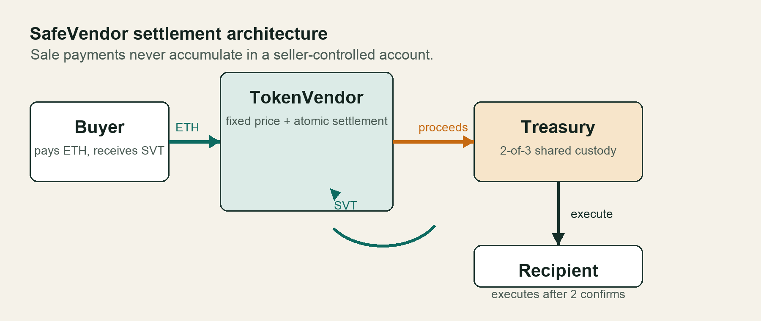
Figure 1. Sale payments settle directly in the multisig treasury.
Actor | On-chain capability | Trust boundary
Buyer | Calls buyTokens with ETH and a minimum SVT output. | Does not need to trust a seller address with custody.
Treasury owner | Submits, confirms, and executes proposals when threshold is met. | One owner is insufficient; two can collude.
Seller | Supplies token inventory; has no vendor withdrawal function. | Cannot retrieve sale ETH from the vendor.
Frontend | Reads state and prepares wallet transactions. | Cannot bypass contract access control.

2.2 Mechanism and token rationale
ERC-20 is appropriate because the sale needs a fungible unit that any wallet can hold and transfer. SafeVendorToken uses OpenZeppelin ERC20 and mints the entire one-million-token supply once. It deliberately omits owner-only mint and burn functions, preventing post-sale supply dilution.
The vendor stores the token address, treasury address, and price as immutable values. A fixed price is feasible for this teaching scope and avoids oracle complexity. The design's distinctive property is not a new token standard. It is the settlement combination: a familiar vendor pattern whose proceeds flow into a multisig that no single operator controls.

2.3 Key process flows
Purchase flow | Treasury flow
1. Buyer sends ETH and minTokensOut. | 1. Owner submits a recipient, value, and calldata.
2. Vendor quotes the fixed-price token amount. | 2. Submission records the first owner confirmation.
3. Vendor checks inventory and slippage. | 3. A different owner confirms the proposal.
4. Vendor sends net ETH to Treasury. | 4. Execution requires confirmation count >= 2.
5. Vendor transfers SVT and emits an event. | 5. Executed is set before the external call.

2.4 On-chain and off-chain partition
Trust-critical state and value transfer stay on-chain: balances, ownership, confirmations, execution state, and ETH movement. The optional Vite frontend stays off-chain because it only reads chain state and prepares signed transactions. There is no server-side custodian or backend signing key.

3. Implementation

3.1 Core mechanisms
Mechanism | Implementation | Why it matters
Fixed supply | One constructor mint; immutable maxSupply. | No post-deployment dilution.
Fixed price | Math.mulDiv converts ETH amount to token units; minimum output protects the buyer. | Deterministic sale terms.
Direct settlement | Checked native call forwards net ETH to Treasury before token delivery. | No seller custody window.
2-of-3 execution | Per-owner confirmation mapping and immutable threshold. | One owner cannot move funds.
Replay protection | Executed state is set before the external call. | A transaction cannot execute twice.
Reentrancy protection | CEI plus OpenZeppelin ReentrancyGuard. | External calls cannot re-enter value paths.

3.2 Events and access control
Token and vendor behavior uses standard ERC-20 Transfer events and a custom TokensPurchased event with gross payment, net settlement, refund, and token amount. Treasury emits Deposit, TransactionSubmitted, TransactionConfirmed, and TransactionExecuted. The event set is sufficient to reconstruct each purchase and approval sequence from logs.
Treasury submission, confirmation, and execution are guarded by onlyOwner. The owner mapping and fixed owner array are initialized once. The vendor has no privileged withdrawal function, so even the deployer cannot retrieve its sale ETH.

3.3 Gas-awareness and code quality
- Immutable token, treasury, price, threshold, and max supply avoid storage reads.
- The only loop is bounded owner initialization at deployment time.
- Small custom errors replace long revert strings.
- The optimizer is enabled with 200 runs.
- Events expose value-bearing state changes without requiring historical storage.
- Code is split by responsibility and uses OpenZeppelin components rather than reimplementing token, transfer, and reentrancy primitives.

3.4 Frontend integration
The dApp displays live Sepolia state, quotes a purchase, collects wallet signatures, submits treasury proposals, and exposes owner confirm and execute actions. It reads deployment metadata from a generated JSON file, so the interface cannot silently point at a different contract set.
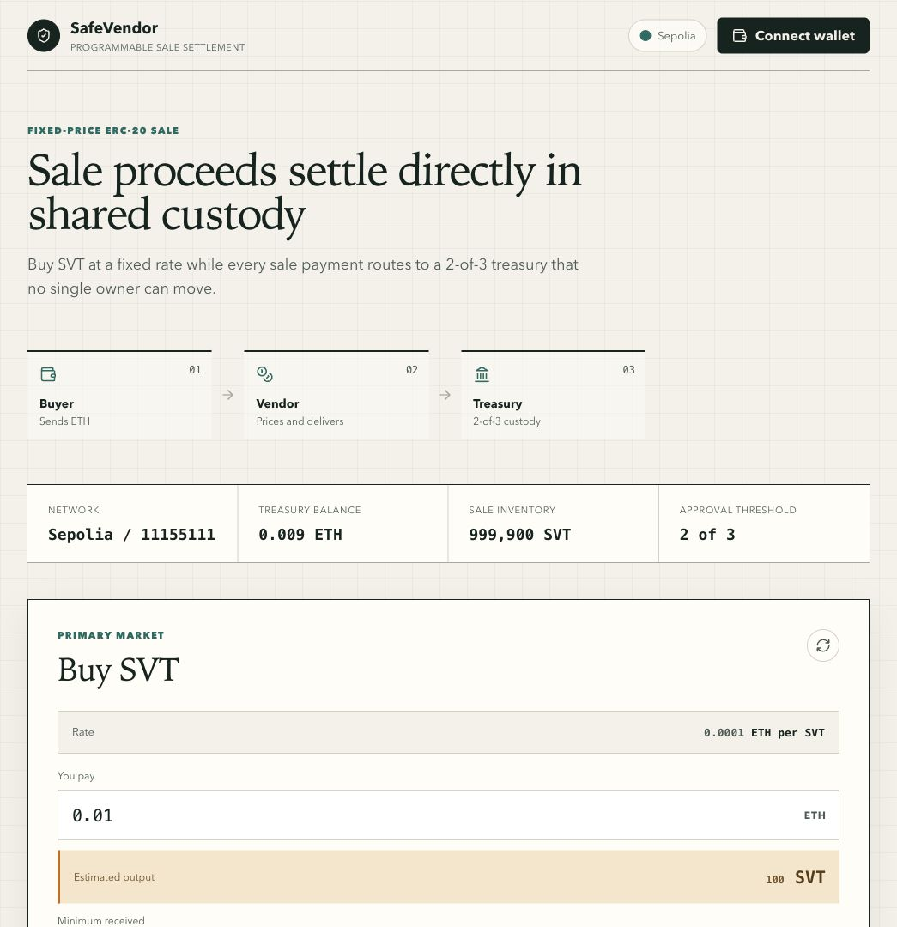
Figure 2. Operational dApp displaying live Sepolia sale and treasury state.

4. Testing and Security

4.1 Verification results
17 | 100% | 100% | 2
tests passing | production line coverage | function coverage | Slither INFO findings

The test suite exercises successful behavior and failure paths, including duplicate confirmation, unauthorized callers, replay, slippage, insufficient inventory, invalid configuration, rounding refunds, and reentrancy. Production contracts have 100 percent statement, function, and line coverage. Aggregate branch coverage is 79.03 percent.

4.2 Static analysis
Slither analyzed 18 compiled contracts with 100 detectors after excluding OpenZeppelin dependencies and the test-only receiver. It reported no High or Medium severity findings. The two project-level findings are informational low-level call findings.
Finding | Location | Decision
Low-level call | MultiSigTreasury.executeTransaction | Required for arbitrary approved calldata and contract wallets; success is checked.
Low-level call | TokenVendor.buyTokens | Required for ETH settlement and refunds; both return flags are checked.

4.3 Top threats and mitigations
Threat | Attack path | Mitigation and residual risk
Single-owner exfiltration | One compromised owner submits and executes a transfer. | 2-of-3 threshold blocks one owner; two colluding owners remain a residual risk.
Reentrancy | Recipient re-enters during ETH delivery. | CEI plus ReentrancyGuard; the reentry test confirms rejection.
Replay | Execute the same approved transfer twice. | Executed is checked and set before the call; replay reverts.
Duplicate approval | One owner confirms repeatedly to reach threshold. | A per-owner, per-transaction confirmation mapping blocks duplicates.
Unauthorized action | Non-owner submits, confirms, or executes. | OnlyOwner on all treasury state changes.
Payment ambiguity | Buyer overpays or price rounding differs. | Minimum output and explicit remainder refund; failed sends revert.

4.4 Economic and compliance risks
- The fixed price is not market-derived and can diverge from any external value.
- Three EOAs create key-management risk; the design assumes independent custody.
- The absence of an upgrade path prevents patching; migration requires redeployment.
- There is no owner-removal mechanism; lost keys reduce availability.
- The project must remain on Sepolia and must not be presented as an investment.
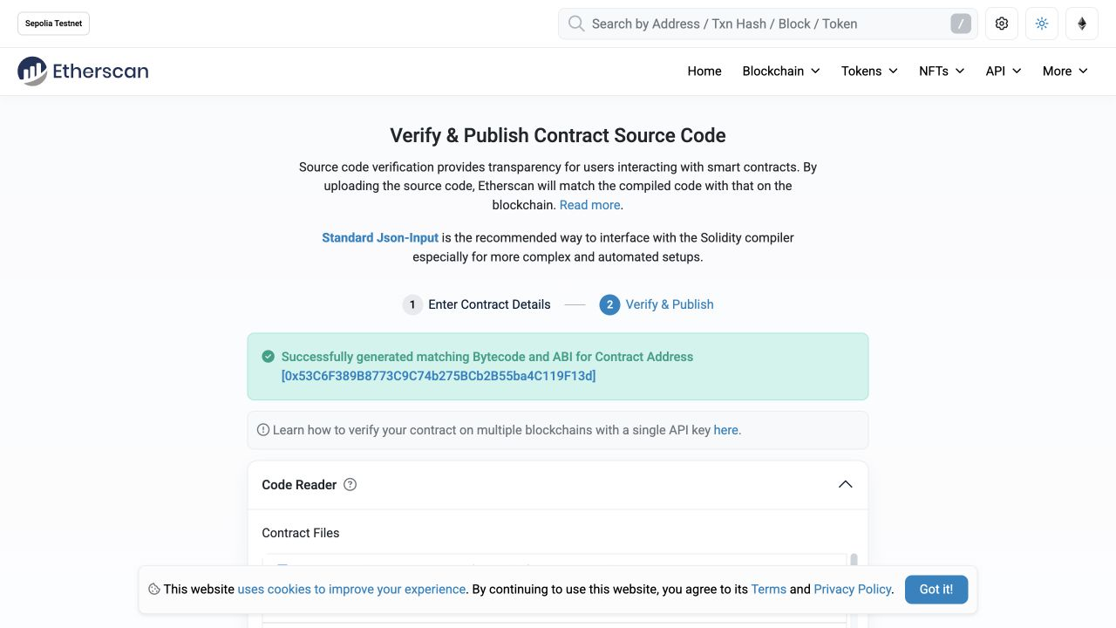
Figure 3. Etherscan reports matching bytecode and ABI for the treasury.

5. Deployment and DevOps

5.1 Live Sepolia deployment
The contracts are deployed on Sepolia and verified on Etherscan with Solidity 0.8.24, optimizer enabled, and 200 runs. Constructor arguments match the live deployment and the source is available through Standard JSON verification.
Contract | Verified Sepolia address
SafeVendorToken | 0x69D7f801AA1EB37321B6F7C1843E380c76C4deeA
MultiSigTreasury | 0x53C6F389B8773C9C74b275BCb2B55ba4C119F13d
TokenVendor | 0x6030d8D8674f96F3e8BF9dCe5AF74b65247d519A

5.2 Reproducible deployment
pnpm deploy validates chain ID 11155111, deploys Token, Treasury, and Vendor in dependency order, transfers the full inventory, and writes addresses, transaction hashes, and constructor data to deployments/sepolia.json. The frontend imports the generated deployment file so UI state and on-chain contracts stay aligned.
Artifact | Purpose
pnpm compile | Compiles Solidity 0.8.24 with optimized settings.
pnpm test | Runs 17 unit and failure-path tests.
pnpm coverage | Writes Istanbul coverage reports.
pnpm deploy | Deploys and records addresses and receipts.
pnpm verify | Verifies constructors through the Etherscan API.
pnpm frontend:build | Creates the production Vite bundle.

5.3 Operational readiness
The contracts deliberately omit pause and upgrade controls. This choice removes a privileged emergency key and prevents an administrator from freezing the sale or replacing the treasury. The trade-off is that a logic defect cannot be patched in place; the team would deploy a new immutable contract set and inform users.
Operationally, two of three owner keys must remain available. Only one may be offline without blocking execution. Two offline or lost keys halt treasury spending, while two compromised keys can collude. These conditions are stated explicitly rather than hidden behind an admin recovery function.

5.4 Live demonstration evidence
Event | Observed result
Buyer purchase | 0.01 ETH paid; 100 SVT received.
Settlement | ETH routed directly to Treasury.
Proposal | Owner 1 submitted and automatically confirmed.
Approval | Owner 2 added the second distinct confirmation.
Execution | 0.001 ETH transferred after the threshold was met.
Post-state | Proposal marked executed; Treasury balance 0.009 ETH.

6. Documentation, Process, and Evaluation

6.1 Repository and documentation
The repository includes source, tests, deployment scripts, a reproducible README, security evidence, a requirements matrix, a demo script, and the optional frontend. The readme identifies exact prerequisites, network, commands, risk controls, and the operational rationale for immutability.
The public GitHub URL is on the cover and at the top of the repository README. The group must confirm instructor and TA read access and add the true group name, group ID, and member names before Moodle submission.

6.2 Rubric coverage
Criterion | Evidence | Risk
R1 Problem Statement | Concrete users, custody pain point, why on-chain, scope and assumptions. | Low
R2 Solution Design | Three-contract architecture, actor table, rationale, purchase and approval flows. | Low
R3 Implementation | Deployed contracts, events, access control, immutable values, frontend. | Low
R4 Testing and Security | 17 tests, full production line coverage, Slither, threat table. | Low
R5 Deployment and DevOps | Three verified Sepolia addresses, reproducible scripts, immutability rationale. | Low
R6 Documentation | README, report, citations, license, AI disclosure. | Medium until group metadata and presenter names are inserted.
R7 Presentation | Editable slide deck, 12-minute flow, four speaker roles, Q&A preparation. | Medium until real member roles are assigned and rehearsed.

6.3 Team process
- Project lead: scope, rubric mapping, submission, and timeline control.
- Smart contract lead: contract design, deployment, verification, and gas review.
- Testing and security analyst: failure-path tests, Slither, assumptions, and Q&A.
- Frontend and integration engineer: Vite + ethers.js workflow in the dApp, wallet flows, and live demonstration.
- All members participate in final rehearsal and answer at least one question.

6.4 Limitations and future work
The current project intentionally favors a small auditable scope. Future work could add an explicit inventory recovery decision, owner rotation with timelocks, proposal cancellation, richer event indexing, fuzz invariants, and a formal threat model for market pricing. Those additions would introduce new trust surfaces and should not be added without matching tests and governance rationale.

7. Conclusion
SafeVendor meets the assignment's central engineering goal. It presents a concrete DeFi custody problem, implements a complete Solidity system, tests failure paths, deploys and verifies on Sepolia, provides a usable frontend, and documents the operational trade-offs. The architecture is deliberately small: three contracts with clear ownership boundaries and no hidden administrator.
The strongest evidence is not a slide claim. It is the live Sepolia state: a buyer received 100 SVT for 0.01 ETH, proceeds entered the treasury, two distinct owners confirmed a transfer, and the treasury executed only after the threshold was met. Etherscan shows the matching source and ABI for all three contracts.
Before submission, the group still needs to attach its real public repository URL and identity metadata. Those administrative fields do not change the technical result, but they are required by D1, D2, R6, and R7.

References
Ethereum Foundation. (2026). Ethereum developer tutorials. https://ethereum.org/developers/tutorials/
Ethereum Foundation. (2026). ERC-20 token standard. https://ethereum.org/developers/docs/standards/tokens/erc-20/
Etherscan. (2026). Ethereum Sepolia block explorer. https://sepolia.etherscan.io/
Nomic Foundation. (2026). Hardhat documentation. https://hardhat.org/docs
OpenZeppelin. (2026). OpenZeppelin Contracts 5.x. https://docs.openzeppelin.com/contracts/5.x/
Solidity Team. (2024). Solidity 0.8.24 documentation. https://docs.soliditylang.org/en/v0.8.24/
Trail of Bits. (2026). Slither static analysis. https://github.com/crytic/slither

Appendix A. Deployment Addresses
Contract | Verified address | Deployment transaction
SafeVendorToken | 0x69D7f801AA1EB37321B6F7C1843E380c76C4deeA | 0x230cc3be5f5ead3886ce1ff5ccdc842cbe4831ce455db8ca9715cca849ab34a7
MultiSigTreasury | 0x53C6F389B8773C9C74b275BCb2B55ba4C119F13d | 0xa1c8b8abc284f6849720e9973048c1ad111610139ccbfcf161af242291dbad4e
TokenVendor | 0x6030d8D8674f96F3e8BF9dCe5AF74b65247d519A | 0xfdf11edf7d8f415c5635191f043155b69b456644599b438b074d50a11dfa8f7e

