CSE437
REAL-TIME SYSTEM ARCHITECTURES
HW1 REPORT

In this micro-controller design, our aim is to keep stable temperature and pressure in a plant. To do that we have two sensor, that read real-life metrics and and send this data to our micro-controller’s ADC ports. These ports called Analog-to-Digital converter and with the help of these conversion, we can digitalize our real-life data. After we obtain real-life data into our micro-controller, we can decide whether we open heater to change temperature or whether we open pump to change pressure.
To read a value from ADC port, we need to trigger that port. There is continuous data flow from sensors so we need to calculate current temperature or pressure in plant by sampling these ports. So, we need to trigger these ports to read values from sensor. These sensor reading work done by two parallel task. These task will be asynchronous tasks. Since we can assume temperature and pressure not affect each other. We don’t need to these tasks to wait each other. Triggering of ADC ports also defines our tasks period. Since we need continuous stabilizing for our plant system, we must read every time we available. Because of that our tasks will be periodic tasks and periods of these task can be defined as, time required to read sensor data + other statements in task + wait for mutex.
Other than these tasks, we need to display current statistics of our system on a display. This is another task. This task work synchronously with other two task. With help of mutexes, we can synchronize access to current temperature and pressure, safely. After we obtain current statistics, we can display these values.
Block diagrams are shown in the following pages.
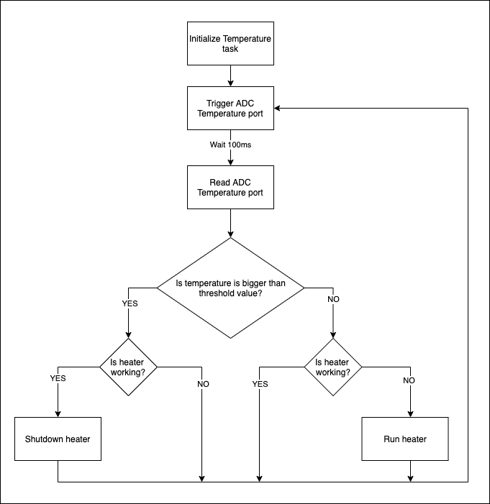Figure 1: Block diagram of Heater Task
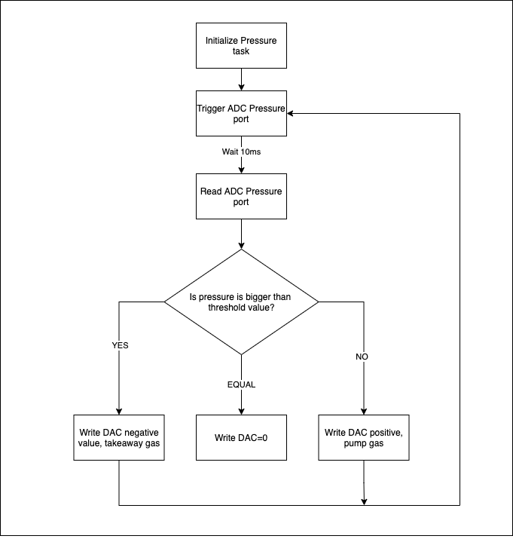Figure 2: Block diagram of Pump Task
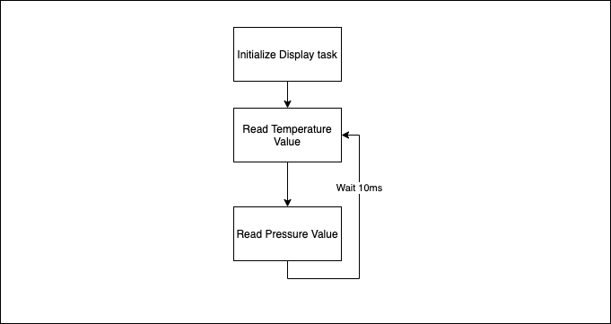Figure 3: Block diagram of Display Task

