|  |  |  |  |
| --- | --- | --- | --- |
| **CS102** | **Fall 2020/21** | Project Group | 2D |
| Instructor: | **Özcan Öztürk** |
| Assistant: | **Assistant's Name** |

~ AFTER DIAGNOSIS ~

G2D

**Berkay Çalmaz**

**Furkan Çalık**

**Bilgehan Sandıkçı**

**Furkan Güzelant**

**Emre Turhan**

|  |
| --- |
| **UI Report Final**  **21November 2020** |

# Introduction

The communication after the first meeting between doctor and patient can be problematic since according to a research 24% of patients leave the first meetings unsatisfied (Kosher, 1976). This is because for doctors, it can be challenging to pursue a patient's status since they cannot really communicate with the patients afterwards. Similarly, patients can’t easily communicate with their doctors when they need to. Therefore this program **can only be used after the meeting with** doctors by patients. In addition, not all people are able to go to hospital frequently. There are some people that are old, disabled or live far away from the hospital. Therefore, they can’t get the necessary information when they need it. As now, there is a global pandemic that affects us, there is a need for a remote and easy connection between doctor and patient.

Therefore, we propose a program that helps to connect patients and doctors after the first treatment. It will help the doctors to make a schedule for themselves and track the status and treatment of the patient. It will also facilitate the process of taking appointments for both doctors and patients. Most importantly, patients will be able to get necessary information from their doctor and inform them in the emergency situation. Patients who are not able to go to the hospital will be able to reach their doctors thanks to this program.

**Sitemap**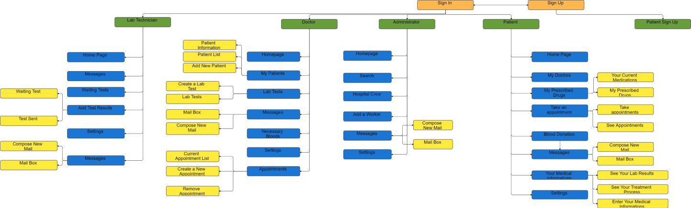

**Login Page**

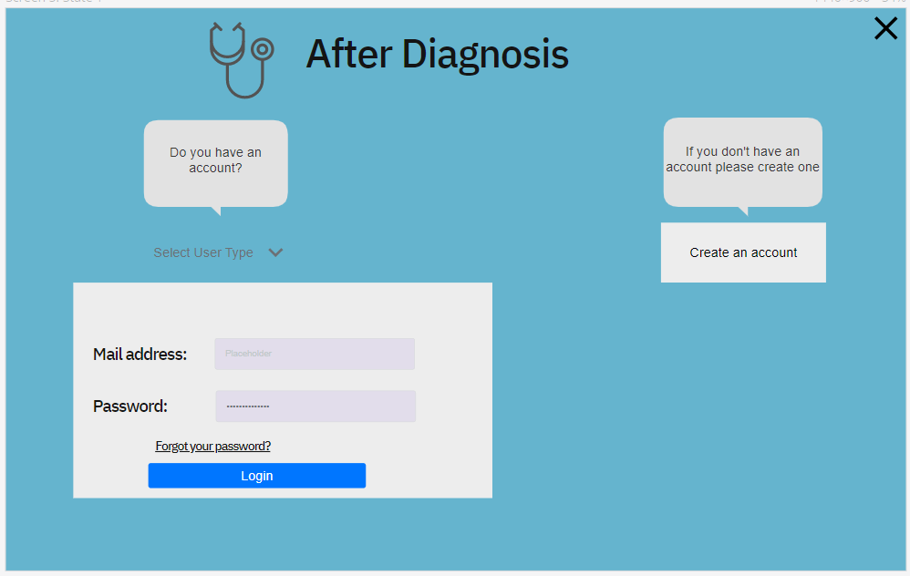

When users enter the application they will see this login page. All users will choose the corresponding user type from the dropdown menu and enter their mail address and password to login to the app. If patients don’t have an account they will click the “Create an account” and go to sign up page.

**Sign Up Page**

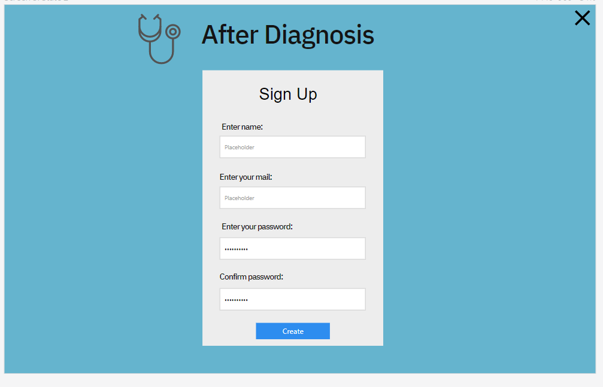

This is the sign up page for patients to create their account. They will create their account by entering their name, mail address and password. The account of other users will be created by admin and their password will be the code which is generated in the “Add a hospital worker” page.

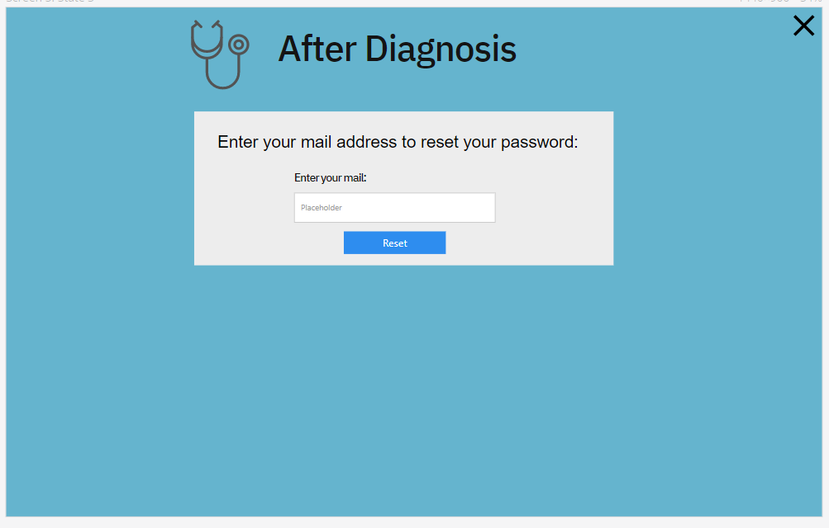

Users can reset their password if they forgot it by clicking “Forgot your password?” in the login page. When they enter their mail address their password will be reseted and they will get an email informing that.

**Messages**

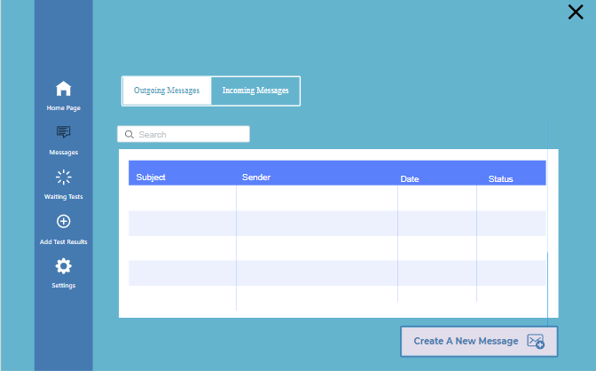

Every user type has its own message page and the menu on the left hand side is different for every user. In this page, the user can look at the messages and search them, also the user can click at the button at the right bottom corner, and send a new message.

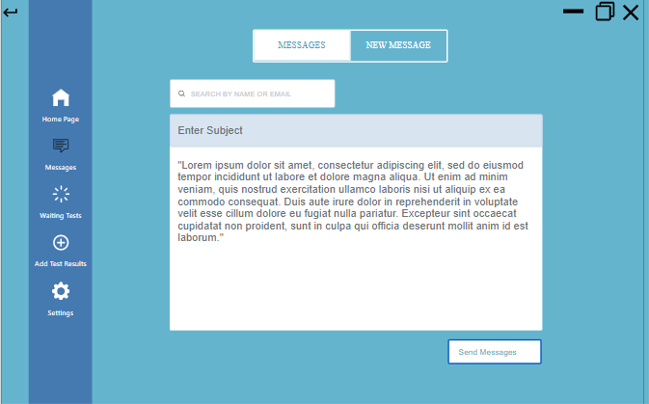When the create a new message button on the incoming messages page clicked, this page opens and the user can search from the hospital workers list and choose the user who he wants to send a message to. Then enters the subject, and by pressing the send messages button he can send the message.

**Settings**

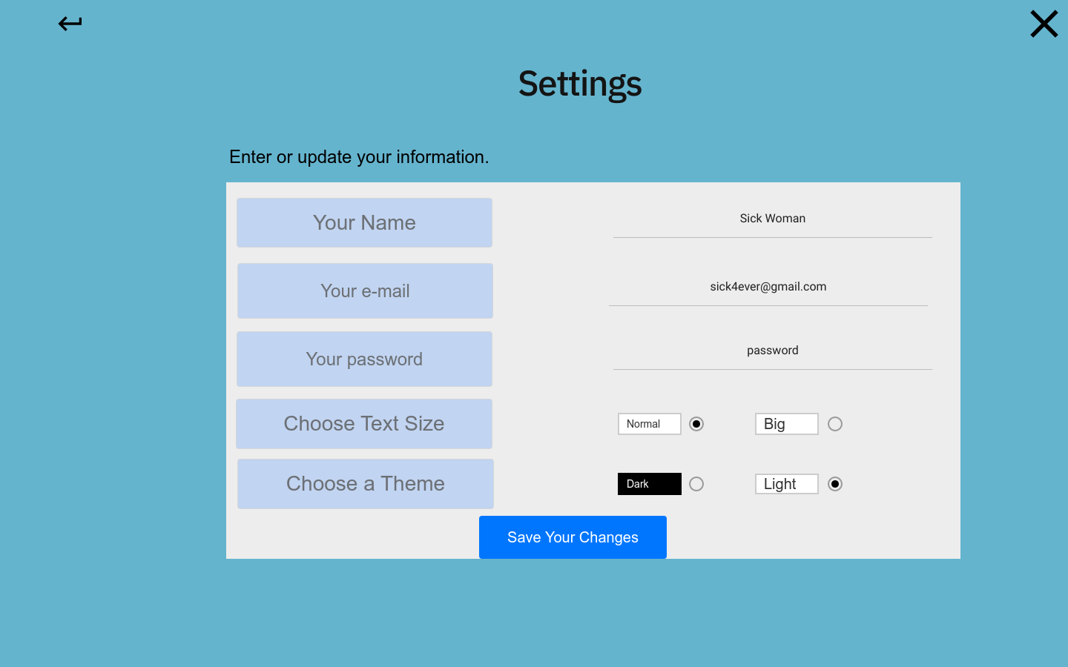

There will be a settings menu for all users which they can change their information and modify some visual settings.

**ADMINS**

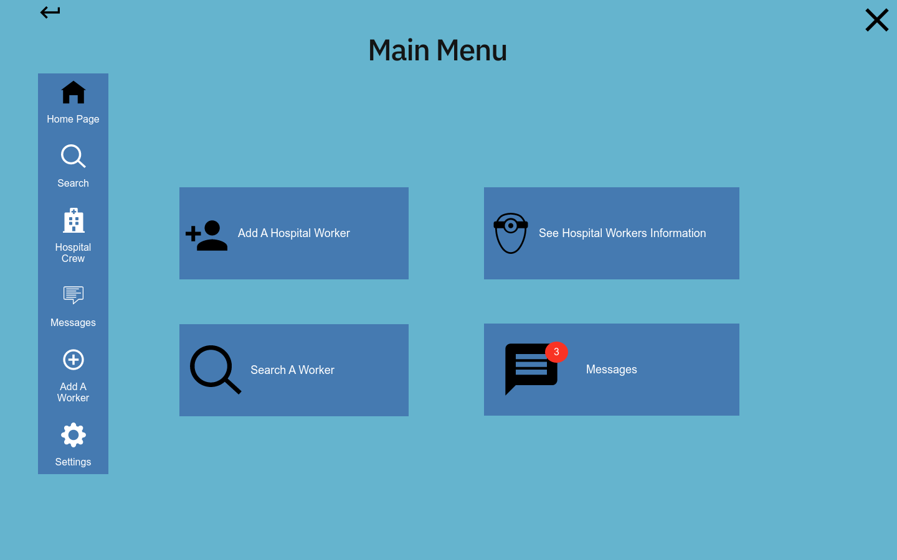

When admin enter their login information, they will get into this home page. As you see, there will be 4 buttons to click and go to the corresponding page.

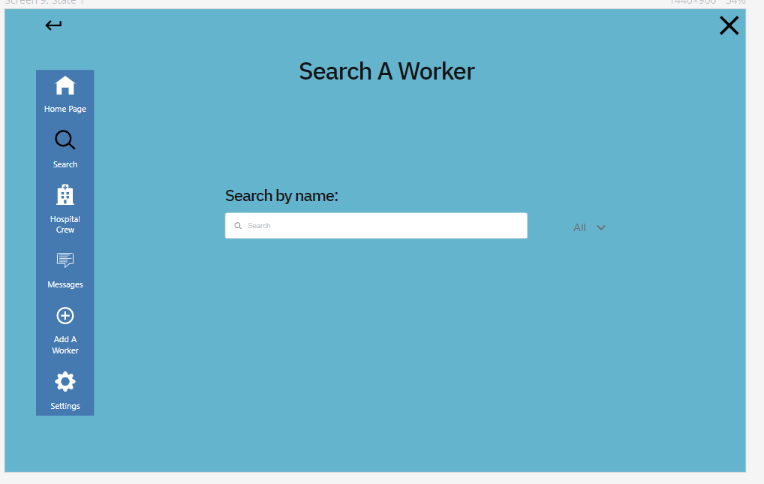

Admins will be able to search through hospital crew by using this page. They can filter their search to specific worker types as well.

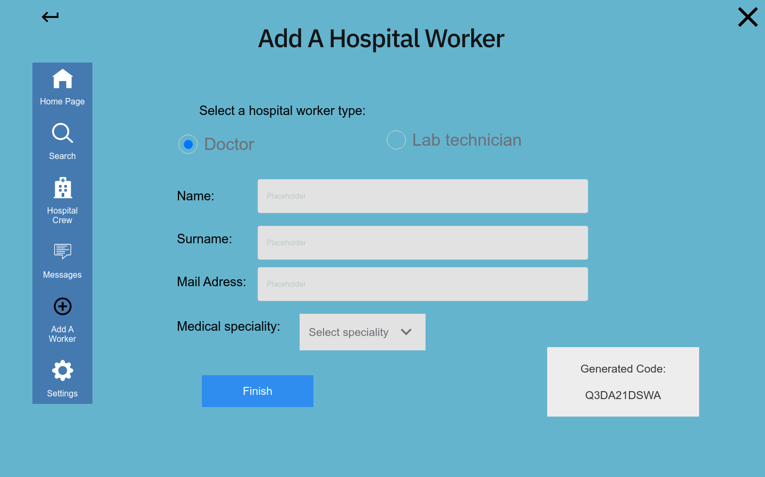Admins will be able to add new hospital workers to the system. They will basically enter the information of these workers and click finish. The generated code will be sent to worker that is added and it will be the initial password for them. They will be able to change it later if they want.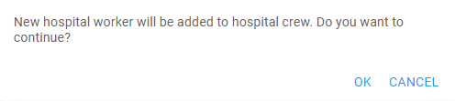

When admins click Finish, they will see this pop up . There will be such pop up messages in the program to provide feedback and prevent mistakes or errors.

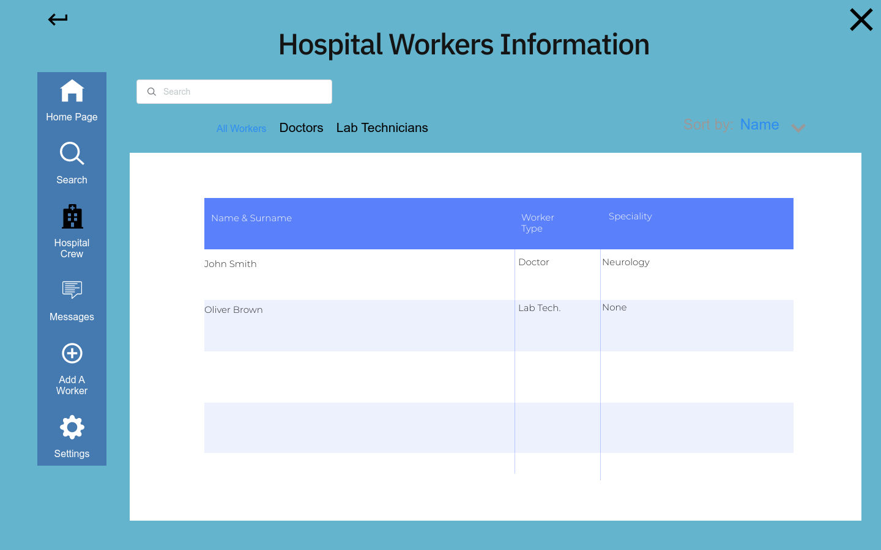

Admins will be able to see the hospital workers as a list. They can see specific types of workers by clicking the tab above. They can use a search bar to find specific workers. They also will be able to sort the list by name, speciality etc.

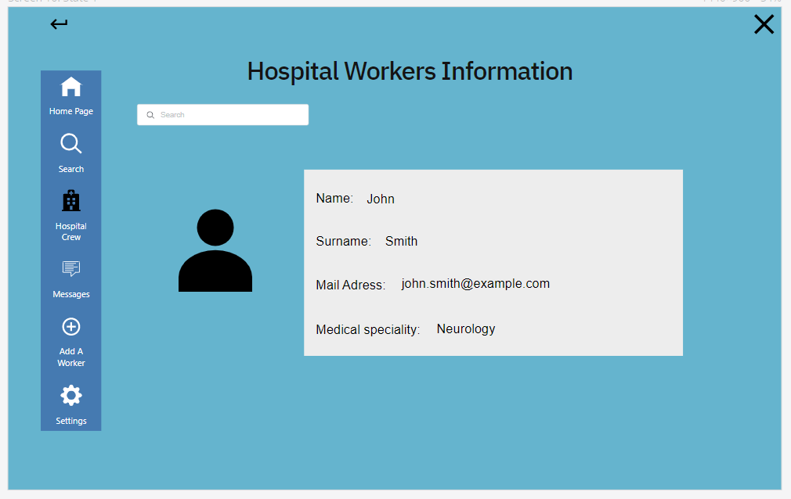

Admins will be able to see information about specific users by clicking their names in the list or by search.

**PATIENTS**

When patients make their login, they will first see the homepage screen. This screen will be an interactive summary of many pages. As it can be seen it will show appointments and provide details on click. It will keep track of how patients are feeling daily. And it will show which medications patients should take on that day.

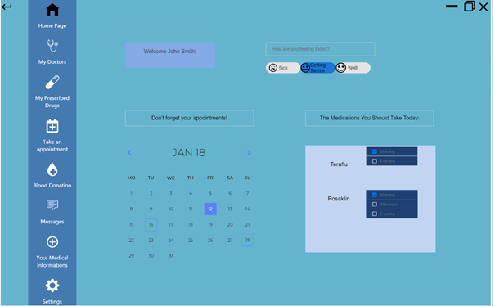

Next screen is the “My Doctors” screen. Here, patients will be able to see every doctor they have and search them. There will be a doctor add button which will be opened on click. That button will ask the patient to enter their code which the doctor gave them.

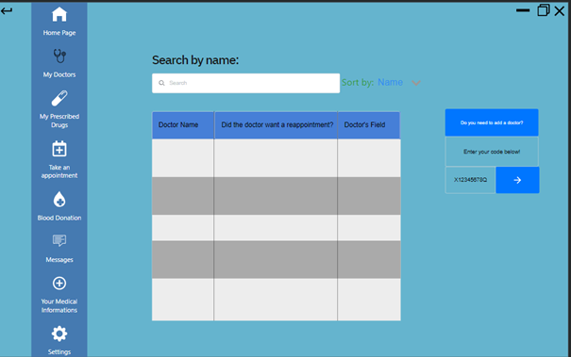

In “My Prescribed Drugs” screen patients will be able to reach 2 other pages that are set as 2 buttons on top. Dark button means that the screen is showing “Your current medications”. These buttons will let them see their current medications and their expired medications.

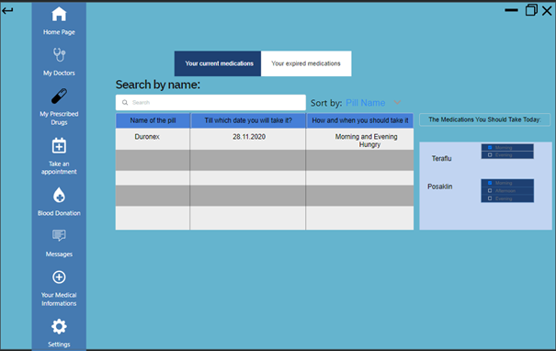

Here’s an example of how “Your Expired Medications” screen looks like.

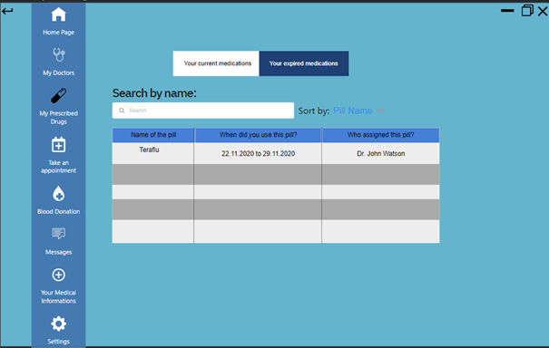

“Take an appointment” page has 2 states. As before, there are 2 buttons on top that will change the screen state. “Take appointments” screen lets patients see which doctors wanted an appointment. When patients click on the “See Available Dates” button, the screen on the right will open. It will state that blue boxes are available days. When a day is clicked, they will see all available times of their doctor and will choose on click. When they are done they will click the button “Take Appointment”.

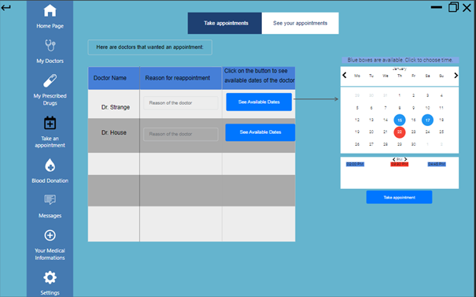

“See your appointments” state lets patients see and change their current appointments.When a day is clicked, it will show all the appointments patients have that day. “Delete the appointment” button will allow them to cancel their appointment.

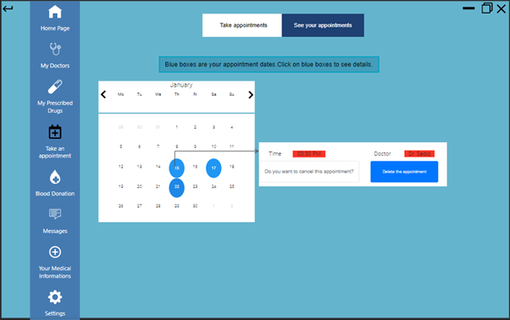

The “Blood Donation” page will give information about the urgency of need of the patient’s blood in the hospital. When there is a need, doctors will update this information and the Resource bar will go down. According to the situation, the program will state the necessity of donation.

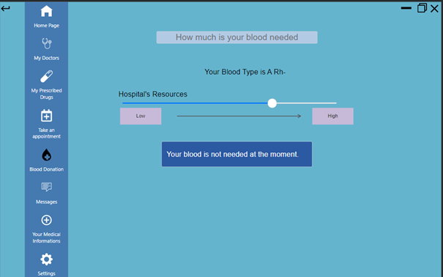

“Your Medical Information” page consists of 3 screen states. First patients will be able to enter their detailed medical information. They will enter their blood type and their allergies from a list. If an allergy is not in the list, they will choose the “other” option and a text field will open where they will be prompted to enter their unlisted allergy. Rest of the options are self-explanatory.

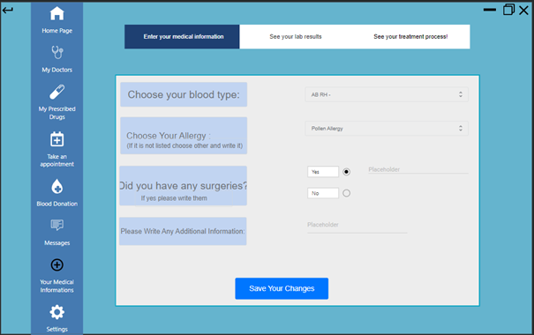

Next screen states “See your lab results” lets patients see their finished lab results. They will choose which test they want to see from a list. A table will show them the values the test has and its reference ranges so that they will understand which values are problematic.

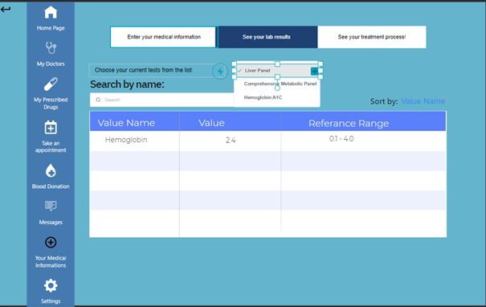

Final screen state of the “Your Medical Informations” screen gives a summary of their past comments for the day. It will ask here how they are feeling as well as the home screen. It will prompt a text according to the patient's past feedback.

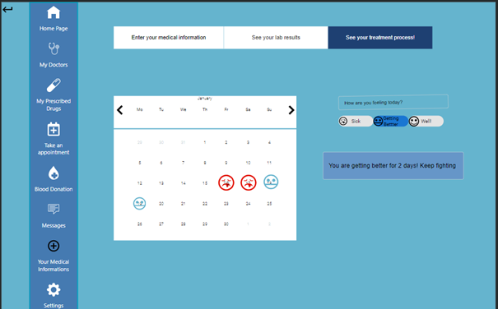

**Lab Technician Interface**

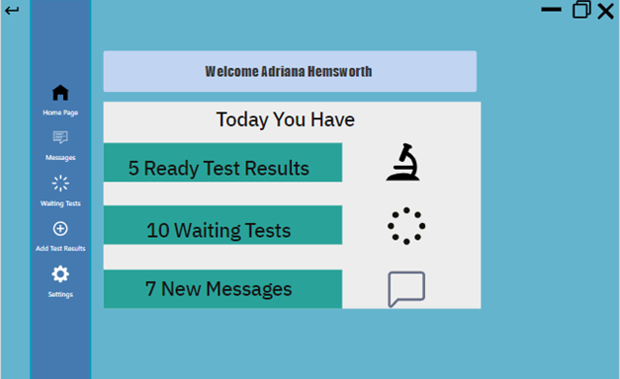

In the Home Page of the lab technician there is a notification bar which informs the lab technician about firstly tests whose results are ready new tests which are added by the doctor and new messages.

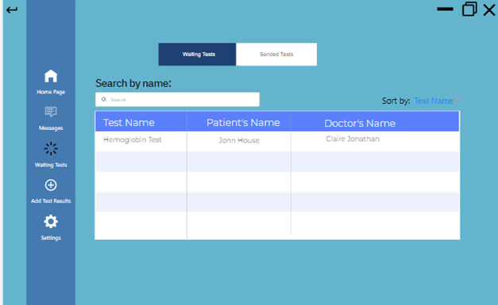

In lab technician’s waiting tests interface, there is a table which shows the waiting tests which are added by the doctor and there is three main features of a tests which are name of the test patient’s name and doctor’s name and lab patient can sort the tests according to those main features at the menu in the right top corner. Also lab technicians can search the tests by name of the patient.

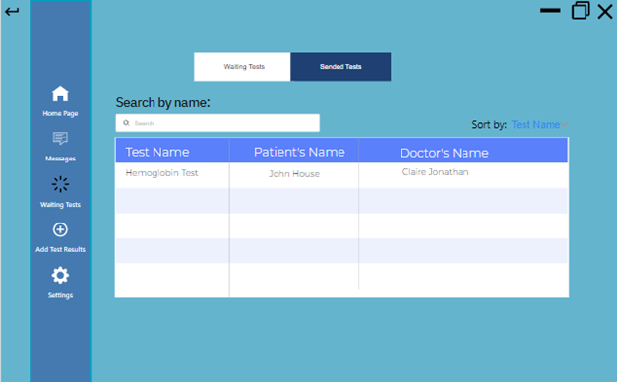

In sent tests part lab technician can see the tests which he sent previously and also this page has the same features with waiting tests part.

**The Doctor Interface:**

After the doctor enters After Diagnosis from the login page, they encounter this main page. In this frame, they see their information and a welcome message.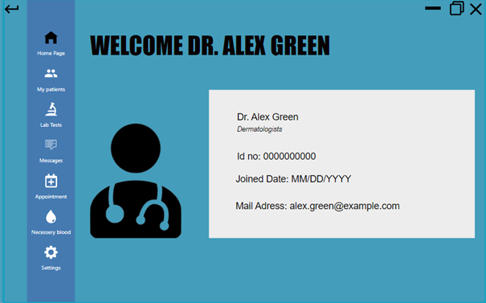

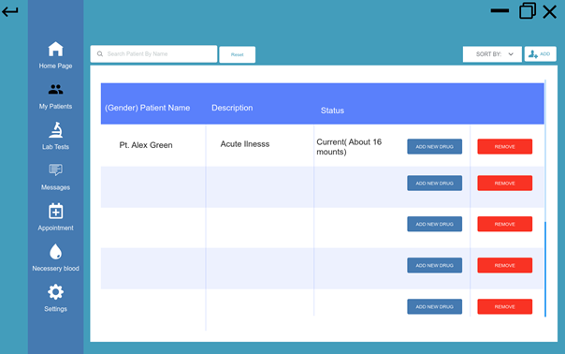

In this frame, doctors can see their patients listed in a table. When the doctor clicks the remove button, a pop up is shown and asks the user whether he/she is sure or not. Then, the patient is removed from the list. Via using “Add New Drug” the doctor can add new drugs to the patient drug lists and the new drug is started to show in the patients' drugs. When the doctor clicks the patient name such as “Pt. Alex Green”, he/she can see the patient's clicked information in a new frame. Doctors can sort the patients by using the sort button. Doctors can search a specific patient in the patient list by using the search edittext. Finally, doctors can use the “Add” button to add new patients to their list and the “New Patient” frame will be opened.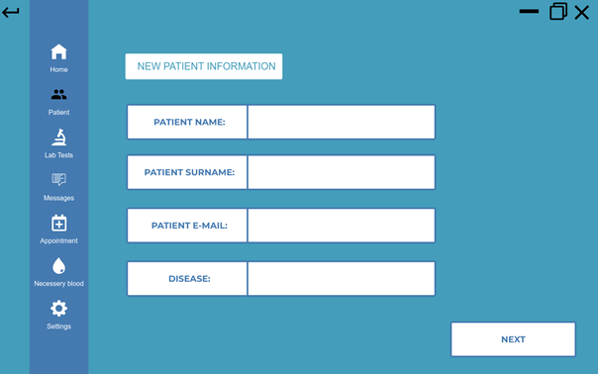

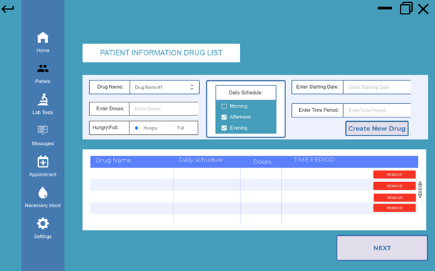This is the “New Patient” frame. In this frame, the doctor can enter the information of the new patient to the related bars. Then, they can click the next button and go on the next frame to resume creating the new patient.

This is the frame opened after clicking “Next Button” in the “New Patient” frame. In this frame, doctors can create drugs for the new patient. They need to write the name of the drug and choose the correct one. They also need to write the number of doses, in what condition the patient needs to take the drug, which is Hungry/Full, the daily schedule of the drug, the starting date and the amount of time the drug is desired to take. Then, they need to click the “Create New Button” button to add the drug to the list in the below of the new drug part. In the list, doctors can see the drugs with their information as a list and remove the drug.

|  |  |
| --- | --- |
|  | This frame is “Patient Information”. When a doctor clicks a patient name in the patient list, they will reach this frame. Here, doctors can see and edit their patient information. Furthermore, they can reach the drug page with the button “Drug List/Add A New Drug”. |
|  | This frame has 2 stages. There are 2 buttons in the North of the frame. When the button is white, the related stage is opened. In the first stage, doctors can send a request to lab technicians to take desired lab tests related to a patient. Doctors can open the second stage by clicking the “See available Test” button and then the button will be white. |

This is the second stage of the lab technicians. In this stage, doctors can see their available and waited tests together as a list. He can remove, sort and search the lab test if he wants.

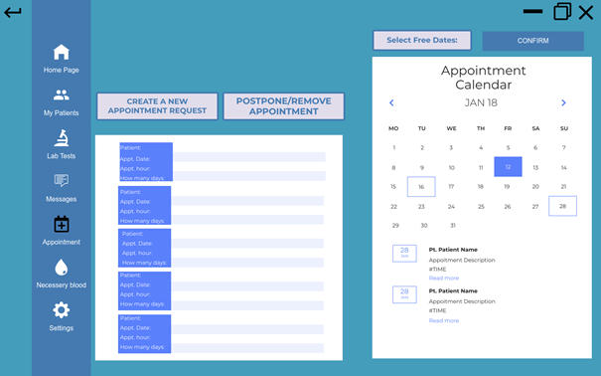

This frame has 3 stages. In the first stage, the doctor can see their upcoming appointment as a list with their information. Also, in every stage, the doctor can see his calendar and upcoming events. Blue box in the calendar shows that day and white box shows upcoming events on that day. In above of the calendar, the doctor selects their available days so that his patients can choose one of the available dates for the future appointments. Then, they can confirm those days.

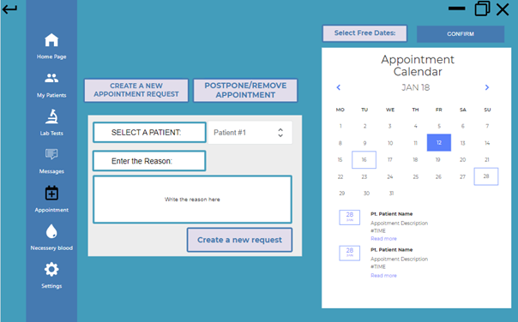

This is the second stage. In this stage, a doctor can create a new appointment request for his patient. They choose the patient from the patient list by using “Select A Patient”. Then, the doctor can write the reason for the appointment. Finally, the doctor can click “Create a new request” and a popup is shown to ask if the doctor is sure.

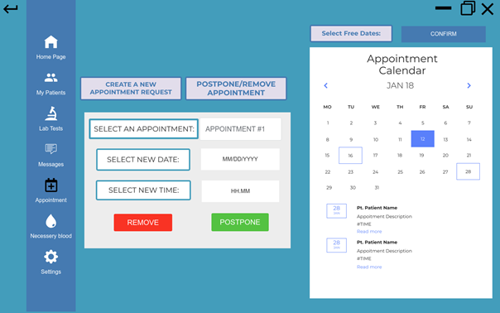

This is the third stage. In this stage, doctors can send, remove or postpone requests to their patient. When doctors click the remove or postpone button, a popup is shown and asks the doctor whether he is sure or not. If the doctor wants to remove the appointment, he doesn’t need to enter a new date and new time but select an appointment. However, the doctor wants to postpone an appointment, he needs to enter the related information to related places in frame unless an error message is shown.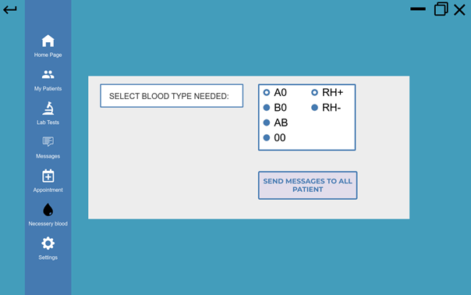

This is the last frame of the doctor user. Doctors can select needed blood types via using a radio button for the blood types. Then, they need to click the “Send Messages To All Patient” button and a popup is shown to ask whether the doctor is sure or not.

# Summary & Conclusions

In conclusion, because of the current conditions related to the pandemic, there is a need to communicate remotely between doctors and patients after the first diagnosis. This app hopefully facilitates this communication with related features. Furthermore, this app is suitable to use at hospitals and clinics.