Gebze Technical University
Computer Engineering

CSE 222
2017 Spring

HOMEWORK 1 REPORT

Furkan AKTAŞ
141044029

Course Assistant:
1. System Requirements

Ubuntu 15.10 64 bit system and java 1.8 version are used.

2. Use Case Diagrams

-

3. Class Diagrams
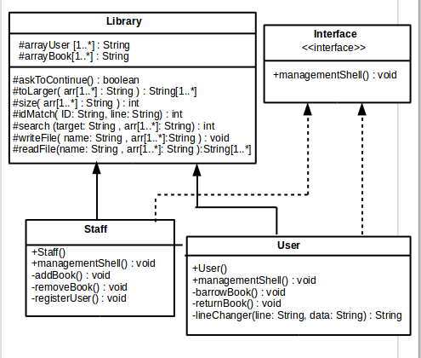

4. Other Diagrams

-

5. Problem Solutions Approach

If there is same name more than one, process continue with ID number ( book ID, person ID).Except this situation, process continue with just name(book name, person name).Every function that we see on screen is between 2 functions (readFile and writeFile). Any function start with readFile and end with writeFile. readFile, if there is file that is opened previosly, read datas from it to local array. writeFile , write datas from local array to file.

6. Test Cases

directories/..../.../ make then directories/..../.../ make run

7. Running and Results

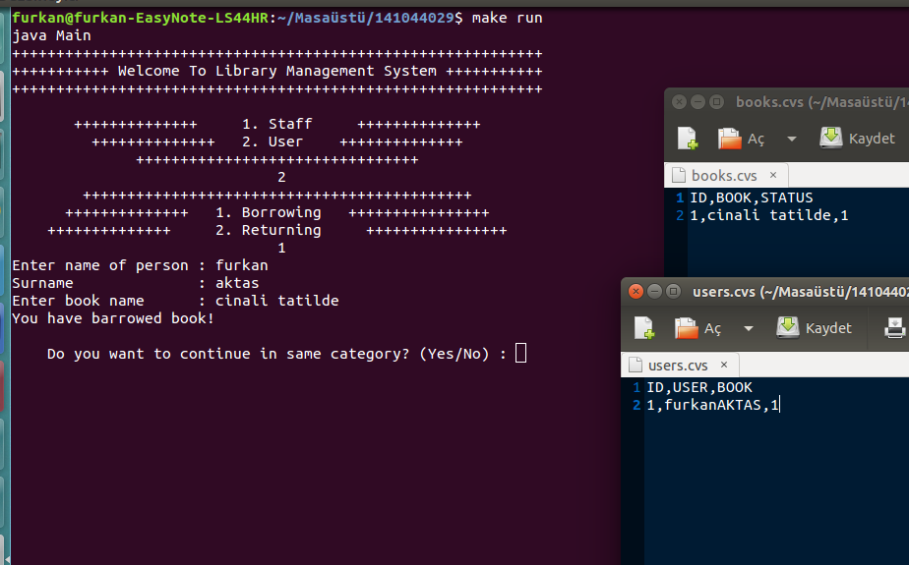
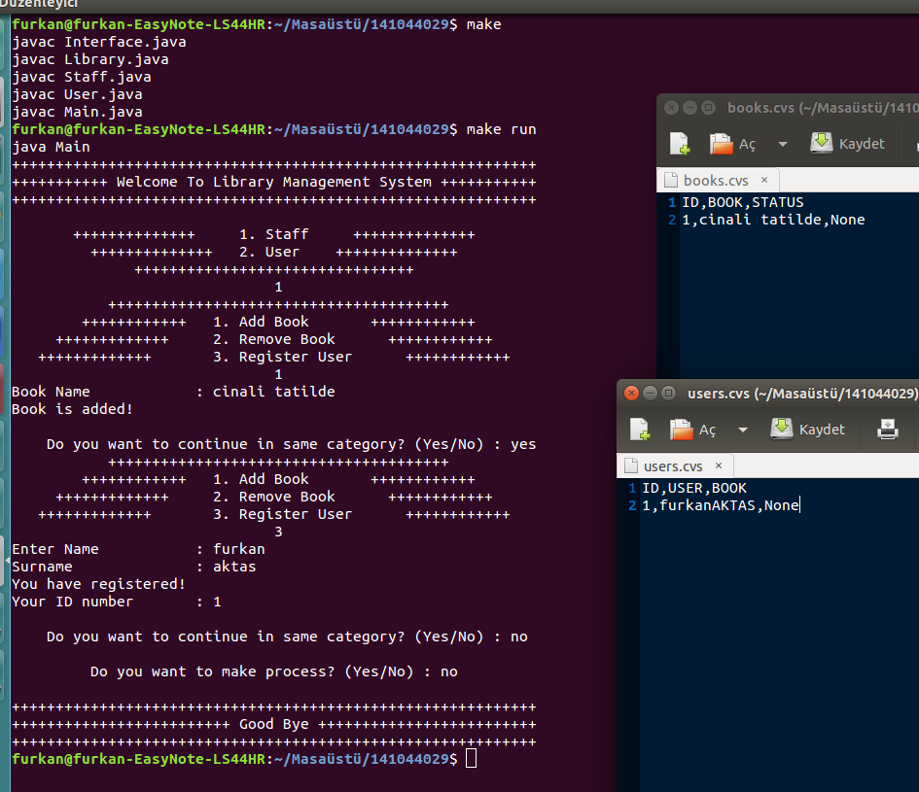
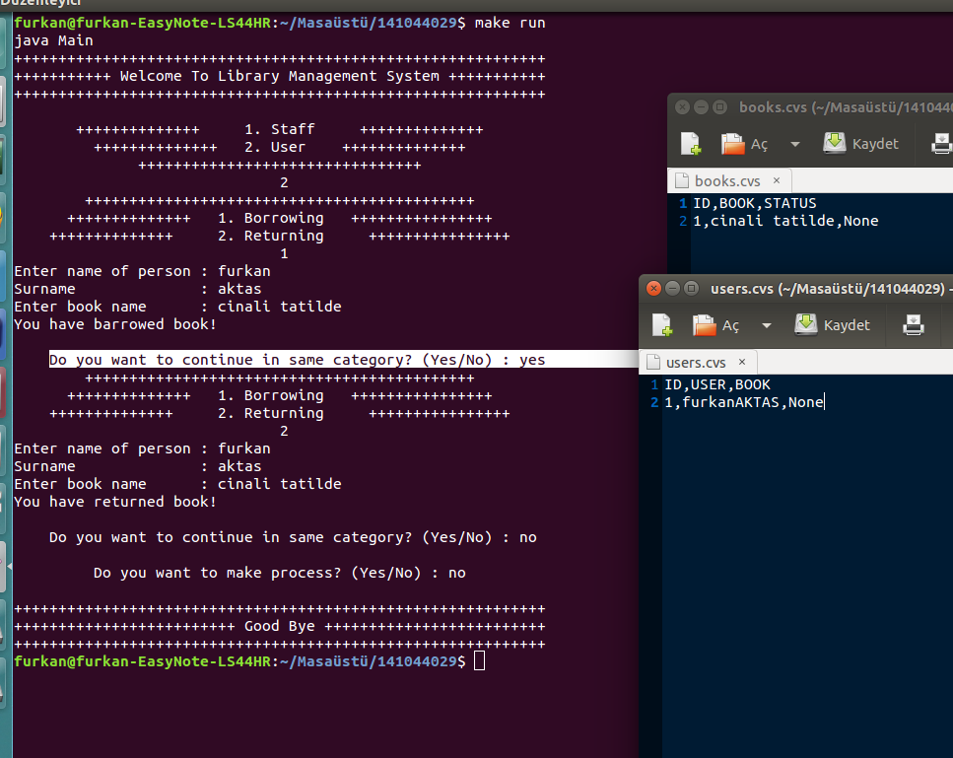

Question 2-)

Encapsulation is hiding datas that users don't have to know from users.While encapsulation is implemented with classes in C++ and Java, it can be implemented with Struct in C . Struct in C can help to hide datas from users.Struct is not same with class completely but it provides a structer that is similar to encapsulation.

