Gebze Technical University
Computer Engineering

CSE 222
2017 Spring

HOMEWORK 2 REPORT

Furkan AKTAŞ
141044029

Course Assistant:
1. System Requirements

Ubuntu 15.10 64 bit system and java 1.8 version are used.

2. Use Case Diagrams

-

3. Class Diagrams
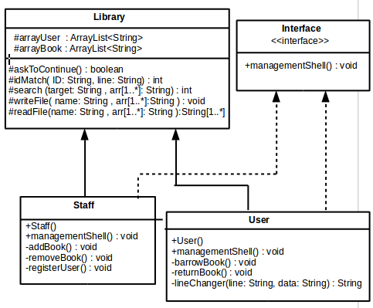

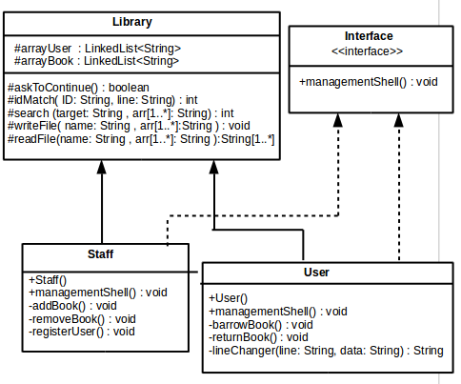

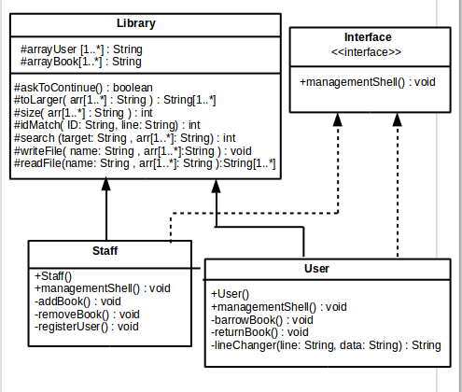
4. Other Diagrams

-

5. Problem Solutions Approach

If there is same name more than one, process continue with ID number ( book ID, person ID).Except this situation, process continue with just name(book name, person name).Every function that we see on screen is between 2 functions (readFile and writeFile). Any function start with readFile and end with writeFile. readFile, if there is file that is opened previosly, read datas from it to local array. writeFile , write datas from local array to file.

6. Test Cases

directories/..../.../ make then directories/..../.../ make run on Terminal

7. Running and Results

I use timer for add function of both LinkedList and ArrayList.I reliaze that LinkedList add is a little faster than ArrayList add.Because when you insert a new element and the array is full, you need to create a new array with more size. The LinkedList just add a new node next to the last.Same function in my array runs avarage 83242,6 nanosecond.It looks like the fastest but my array runs more unbalanced.

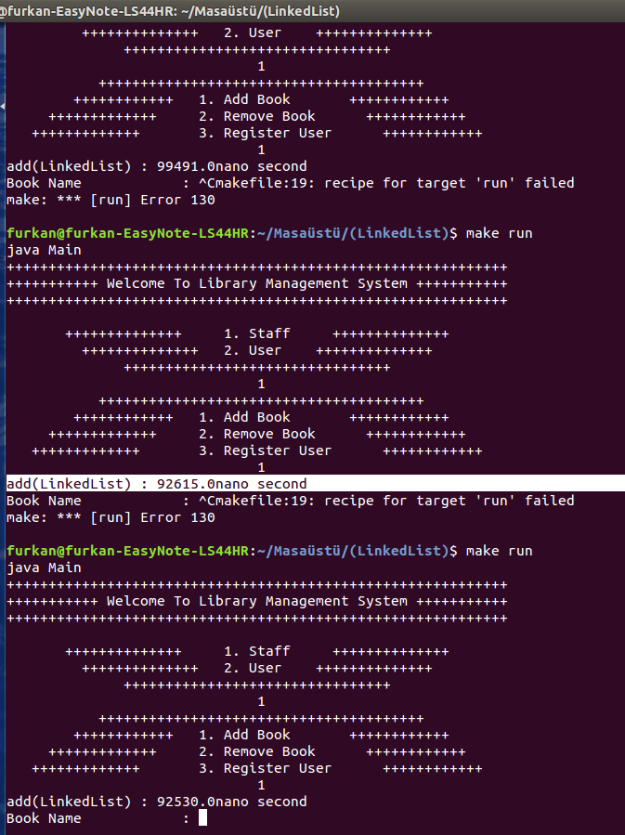

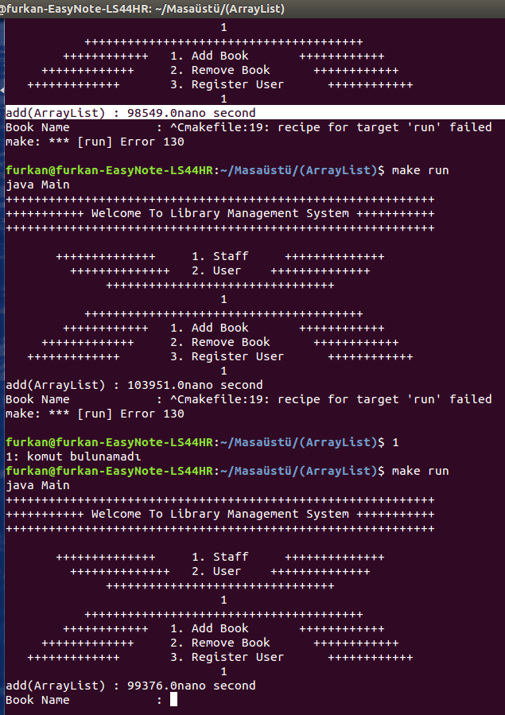

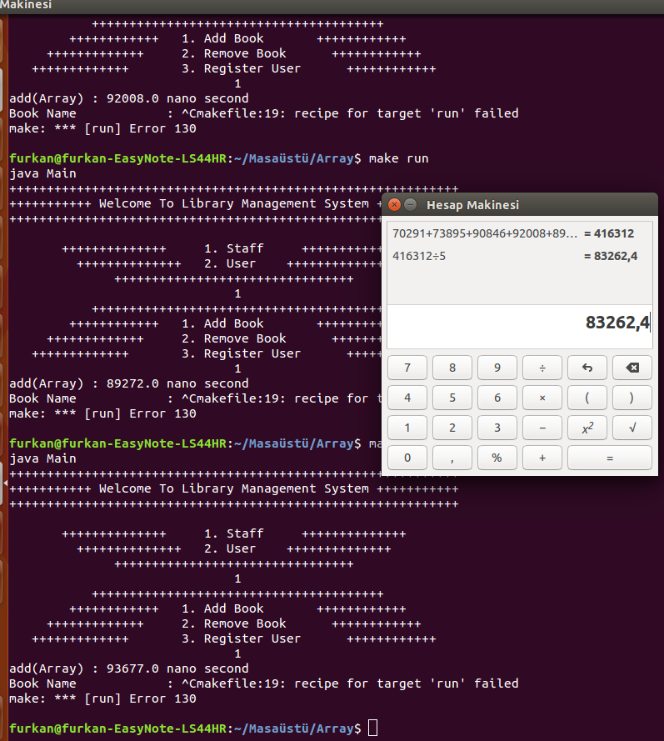

Questions
