**Furkan Gurcay**

**150201018**

**Cs361**

**21.12.2018**

**Antalya Bilim University**

**Project Title : Right Order**

**Problem Statement** :

The main target is that, Wireless Body Area Network’s sensors need be scheduled for their

efficiency because those sensors must not be active together at the same time for error-free

system. They have to partitioned . In this project, those will be scheduled by different

scheduling methods and at the end of project, the result will show the best scheduling method

for WBAN ‘s sensor problem**.**

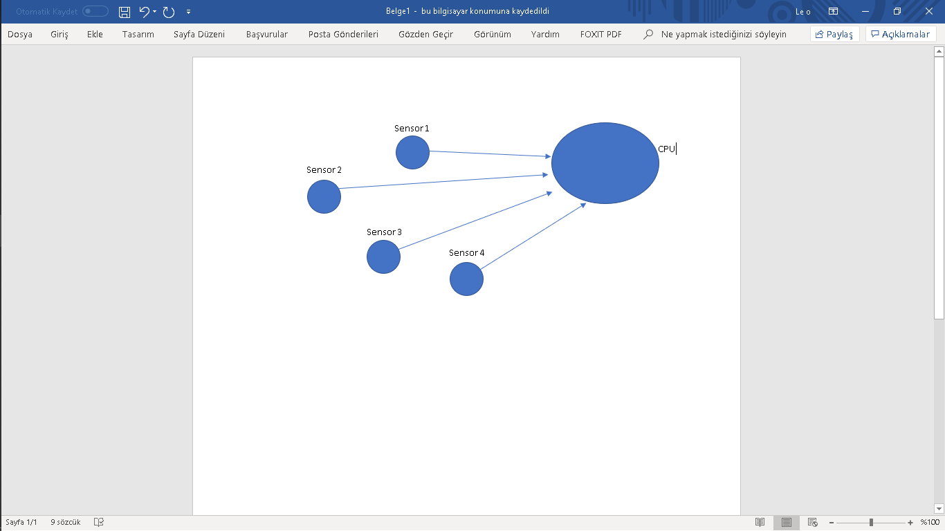

In this figure, all sensors are trying to active at the same time.

**Detailed Literature Review :**

Wireless Body Area Network is one of the fastly developing area in today’s technology.

People wants to know almost everything in their enviroment and also, new datas are important

for our new research and surveys. In the customer’s perspective, they want to be monitored by

some sensors and those datas that comes from sensors should to be understood for users.

Customers want to know some informations about their body such as how many steps they

went daily, what is the average of their heart beat or what is the blood pressure of they have.

All those information comes from wearable tools more clearly, from their sensors but the

importance of that, those sensor are in relation with mobile devices in wireless network. In the

professional eyes, those datas are important in many area such as predicton of future

diagnosis for elder people or some research that targets to find relationship between obesity

and daily distance those people walked.

We can see some professional research and their article about WBAN’s sensors

scheduling in these days. For instance, some researchers interested to that subject from

different views. From the article that they published at June 2015, they worked on “Inter-

wireless body area network scheduling algorithm for livestock health monitoring” and

“their  optimization problem is formulated first to jointly reduce the energy consumption per unit

time and to improve the packet success rate. Due to the combinatorial complexity of the

optimization problem, a two-step heuristic solution algorithm is proposed.

The first step is to find the optimal transmit power and packet payload size for each sensor by

using local information.Then the second step uses a best effort method to assign time slot to

each of the wireless body area networks. At the end of step two, the effect of interference is

known, and this knowledge helps to determine the optimal frame size among all the feasible

choices after several iterations of objective value calculation or a period of performance learning.

The simulation results on packet success rate and energy consumption show that the proposed

best effort time slot allocation method outperforms the color-based scheduling algorithm”**[1]** .

Another article was about the “A Clique-based WBAN Scheduling for Mobile Wireless Body

Area Networks” and that article mention that, “wireless-body-area-networks (WBAN) that

generally comprises different types of sensors are useful to gather multiple parameters

together, such as body temperature, blood pressure, pulse, heartbeat and blood sugar.

However, a dense and mobile WBAN often suffers from interference, which causes serious

problems, such as degrading throughput and wasting energy. So, the sensors in WBAN are

not active together at the same time and they can be partitioned to different groups and each

group works in turn to avoid interference”**[2]**. Last research says that “WBAN also

concentrates on scheduling process for scheduling the sensor data. Packet

prioritizing mechanism is proposed for inter-WBAN data scheduling and

aggregation which is developed for monitoring system in order to satisfy the QoS in

WBAN. Critical delay and waiting delay are two parameters used to classify the

aggregation frame. Based on these parameters priority can be assigned and high

priority data is first send to medical server. However, most important priorities are

under congestion. Fuzzy decision packet scheduling algorithm is implemented to

improve the QoS and overcome the previous paper problem. The advantage of using

fuzzy logic is, it is designed for complex problem with logical rules. Still it takes

longer development time.”**[3]**

To sum up,those sensors that included WBAN system has got huge importance for their field

but there are some problems they brings such as optimization problem or as second article

said “sensors can not be active together at the same time and they should be partitioned.” In

color based scheduling method to schedule all groups to work in a sequence of time slots.

**My Existing Solution:**

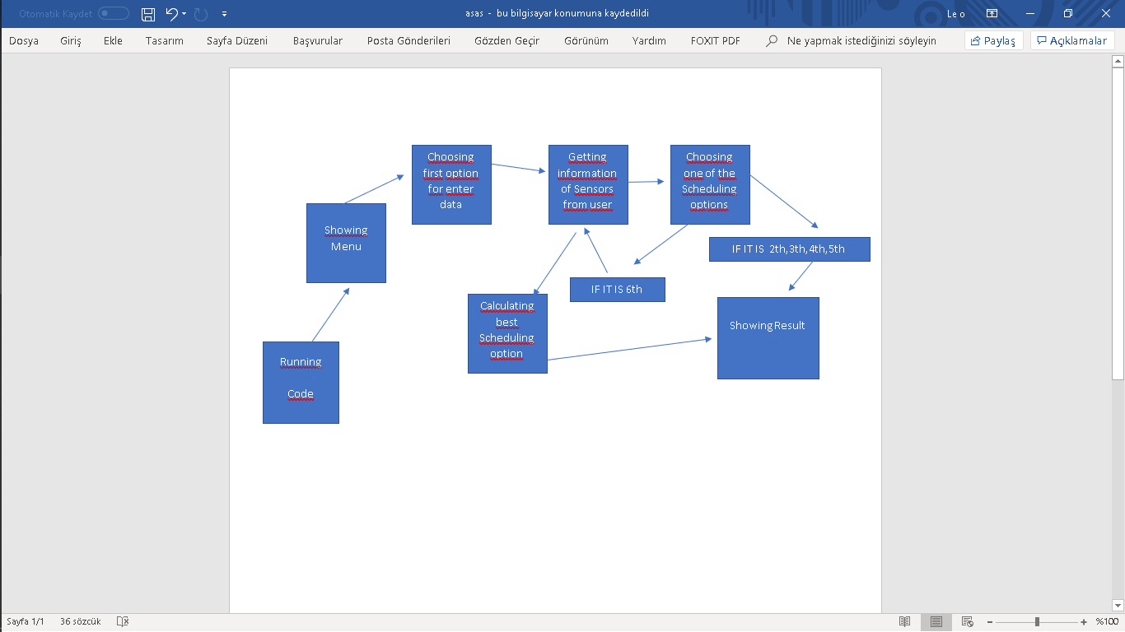

**Selected Baselines :**

In the literature review, there are two different approaches and they are clique-based WBAN

scheduling and parameter based scheduling. For this project, parameter based scheduling is very

similar for our solution. As we know parameter based scheduling is used for decision making in

sensor data and Clique-Based WBAN Scheduling (CBWS) algorithm to cluster sensors of a single or

multiple WBAN into different groups to avoid interference and its purpose coloring based scheduling

method to schedule all groups to work in a sequence of time slots”.

In my project, I mentioned to common WBAN’s sensors problem for creating error-free system and

with sensor’s informations that I get from user for decision making in sensor data we can find best

scheduling option for using wearable devices in more efficient way.

**Discussion Section:**

First of all, in WBAN base, weareable devices is getting more common in everyday and they have got

some sensors for different purposes. For instance, one of these sensors count user’s heartbeats and

another one count steps of user. However, those sensors develop everyday there is always a problem

in their processor because at the same time only one process can handle by processor and all sensors

should wait their order for error-free device system. For that problem, we commonly use scheduling

methods and in this projecet my aim was finding the best scheduling option for those sensors.

For the result, this project is giving the best scheduling option after get the sensors’s datas from

user.

**Results :**

**a) Expected metrics/parameters :**

Sensor nodes will collect the datas from sensor’s data.

Round-robin Sch. : It has got a quantum time for scheduling and its response time is high.

FCFS Sch. : It orders to sensor nodes from their arrival time in ready queue.

Priority Sch. : The scheduling method that schedules to nodes from their priority in ready

queue.

SJF Sch. : It schedules to sensors’s datas for their time that spends on system when they be

Scheduled

Ready-queue: A new process is initially put in the Ready queue. It waits in the ready

queue until it is selected for execution(or dispatched). Once the process is assigned to

the CPU and is executing, one of the following several events can ocur.

Burst time: Sensors’s usage time on system

Turnaround Time: Time taken to complete after arrival. In simple words, it is the

difference between the Completion time and the Arrival time.

Waiting Time: Total time the process has to wait before it's execution begins. It is the

difference between the Turn Around time and the Burst time of the process.

**b) Showing the results**

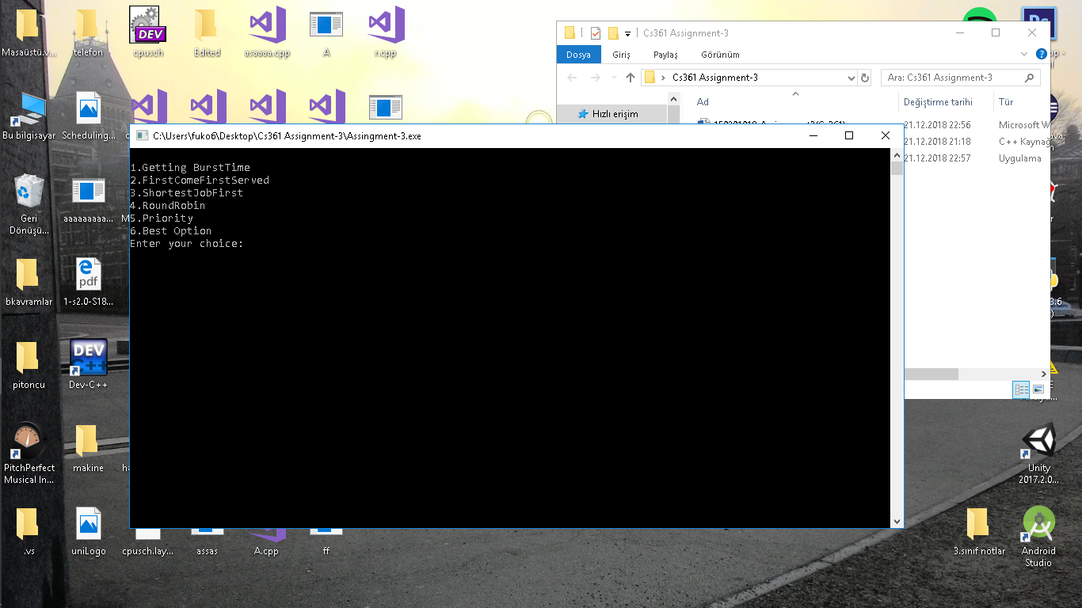

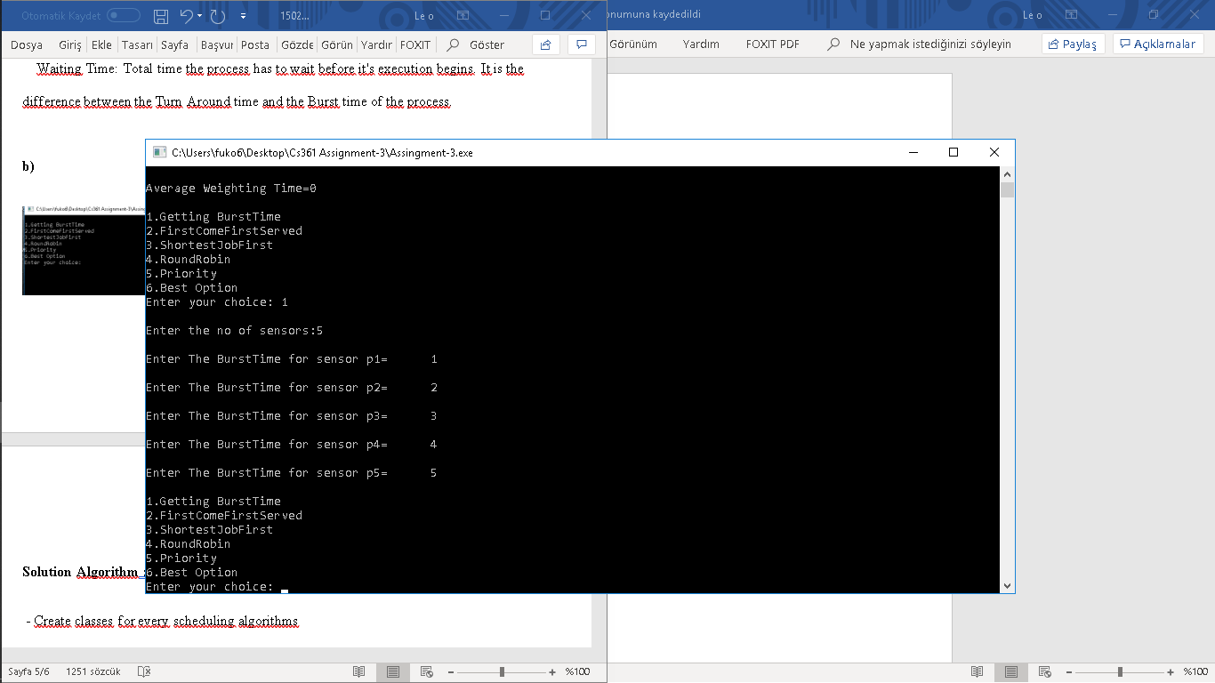

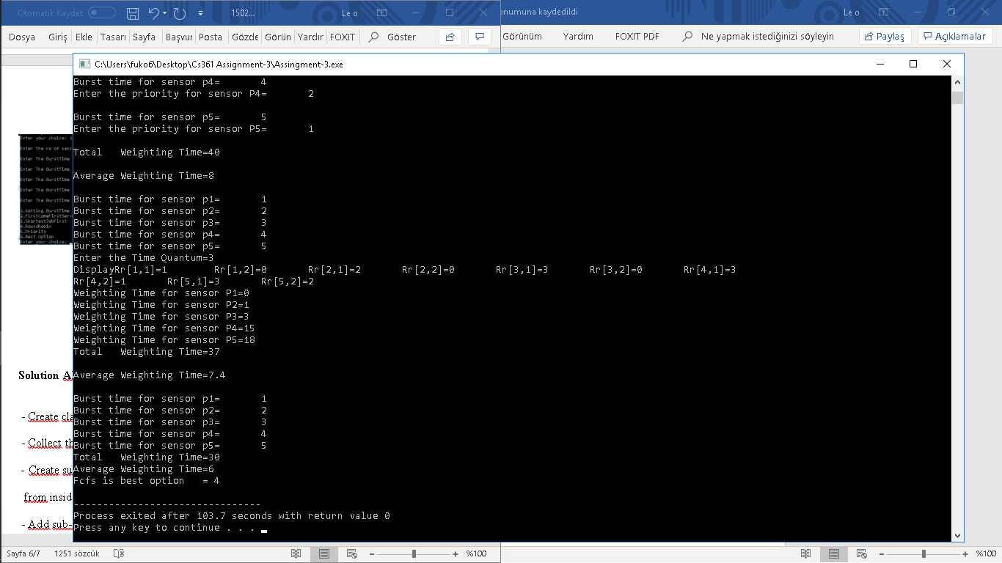

**Conclusion :**

To sum up, my project focused to WBAN sensor problem. Those sensors shouldn’t be

actively together at the same time. There are few solution approaches (Clique-

based, parameter based ) and different scheduling methods (Fsfs, Sjf, Priority, Rrobin). Each

of them uses different ways for do their jobs. Finding best option is important for efficiency

of devices’s system but it depends circumstances of sensors. In my project, I collected

sensor’s informations from user and after finding execution time of each methods I compared

those in each other and I gave the best scheduling option for that system.

**Resources :**

**[1]:** [**https://www.researchgate.net/publication/282742325_Interwireless_body_area_network_scheduling_algorithm_for_livestock_health_monitoring**](https://www.researchgate.net/publication/282742325_Interwireless_body_area_network_scheduling_algorithm_for_livestock_health_monitoring)

**[2]**

[**https://www.sciencedirect.com/science/article/pii/S1877050914005419**](https://www.sciencedirect.com/science/article/pii/S1877050914005419)

**[3]**

**http://www.ripublication.com/awmc17/awmcv10n1_12.pdf**