Fuzzy Logic Method for Predicting of Pulsar Stars

Furkan GURCAY

Antalya Bilim University

May 16, 2019

**Keywords**: Fuzzy Logic, Fuzzy Rules, Neural Network, Pulsar Stars

**Abstract**:

The topics of data science are getting more popular day by day. The reason of the its

popularity is connected with technological improvements and those improvements cause to obtaining

huge and significant volume datas in last years. Telescope satellities have got an important

contribution on this datasets. Huge volume of datas are not efficient if experts could not handle with

them, so with Fuzzy Logic method, those datas could be useful for predicition of targeted space

objects. One of the space objects are Pulsar Stars. In this report, we will looking for an acceptable

Pulsar Star’s predicition model that includes high accuracy.

**Introduction:**

Data Science is highly popular working area nowadays. The reason of that, in last years,

people obtained huge volume of data from different data collectors such as telescope satellities, social

media platforms and banking applications. Those data’s volume is beyond the people can handle with

, so for the making those data to understandable form, most of the experts started to use neural

networks in recent years. The Fuzzy Logic has got the one of the best method(ANFIS) for building

efficient and viewable neural network models .

Telescope satellities are collecting huge volume of data in short periods. People have got a

limited capacity for storing those datas and they need to use those data in efficient way, so for this

reason people have to process to those data before storing them. Processing of those datas can handle

with a few efficient ways. Neural network is one of the best choice fort his kind of high volume datas

works. With Fuzzy Logic principles, we can build a good working models but of course we needed to

have significant process force.

Pulsar Stars is one of the space object and astronomers try to detect them from their datasets.

They use neural network priciples for process those datasets and they make predicition about them.

First of all, they use Fuzzy Logic method(ANFIS) for creating neural network model for it. After that,

they train and test their models with their datasets. Finally, they use their model for making prediction

to targeted space object which is Pulsar Star for this situation.

**Literature Review:**

One the literature review part, there are some interesting researchs. One of those says that,

“Neutron stars are dense and hot objects, they provide unique opportunities to study the laws of physics

in extreme conditions. Pulsars are highly magnetized neutron stars that rotate very fast and yield

detectable periodic strong radio emissions. Modern pulsar surveys produce large volumes of data, the

process of manually labeling candidates is laborious and time consuming. Hence researchers are

currently trying to study and come up with approaches for automatic identifying candidates.”(Carvalho,

2015). Another research mentions that, “An automated method of screening the candidates is needed to

reduce the human e↵ort needed to examine the candidate plots. Eatough et al. (2010) used an Artificial

Neural Network (ANN) as a binary classifier to screen the 2.5 million candidate plots. The goal of the

proposed research was to develop an improved method for pulsar identification using supervised

machine learning techniques.”(Ford, 2017). And the last research find that, “In most of these papers,

the machine learning algorithm used is some variant of an Artificial Neural Network (ANN).

Supervised machine learning using an ANN was first used in the pulsar community by Eatough et al.

(2010) to process 16 million pulsar candidates obtained by reprocessing data from the Parkes multi-

beam survey. Bates et al. (2012) also used an ANN in the data-processing pipeline for the High Time

Resolution Universe (HTRU) mid-latitude survey. They were able to reject 99% of the noise

candidates and detect 85% of the pulsars through a blind analysis.”(Desai, 2018).

**Application to the Problem:**

Firstly, the dataset is determined. After that, this dataset is seperated to train and test samples. With

Matlab ANFIS’s creation is completed. Nextly, the ANFIS model is trained and tested with

samples. Finally the last version of ANFIS model uses for prediction of real data with “evalfis”

methodology. The other variables are defined in below side.

[System]

Name='furkan_gurcay_Fuzzy_Project'

Type='sugeno'

Version=2.0

NumInputs=3

NumOutputs=1

NumRules=48

AndMethod='prod'

OrMethod='probor'

ImpMethod='prod'

AggMethod='sum'

DefuzzMethod='wtaver'

[Input1]

Name='MeanOfTheIntegratedProfile'

Range=[42.9765625 147.8671875]

NumMFs=4

MF1='VLow':'gaussmf',[14.8476490763892 42.9765625]

MF2='Low':'gaussmf',[14.8476490763892 77.9401041666667]

MF3='Medium':'gaussmf',[14.8476490763892 112.903645833333]

MF4='High':'gaussmf',[14.8476490763892 147.8671875]

[Input2]

Name='StandardDeviationOfTheIntegratedProfile'

Range=[29.38290182 61.58903249]

NumMFs=4

MF1='VLow':'gaussmf',[4.5588948134926 29.38290182]

MF2='Low':'gaussmf',[4.5588948134926 40.11827871]

MF3='Medium':'gaussmf',[4.5588948134926 50.8536556]

MF4='High':'gaussmf',[4.5588948134926 61.58903249]

[Input3]

Name='SkewnessOfTheDM-SNRcurve'

Range=[-1.715076049 418.7927267]

NumMFs=3

MF1='Low':'gaussmf',[89.286611016485 -1.715076049]

MF2='Medium':'gaussmf',[89.286611016485 208.5388253255]

MF3='High':'gaussmf',[89.286611016485 418.7927267]

**Result and Discussion:**

From the ANFIS model, we can catch the almost 99.99% accuracy on the real

data predictions with neural networks, so we can say our model’s

predictions are satisfied the real datas circumstances.

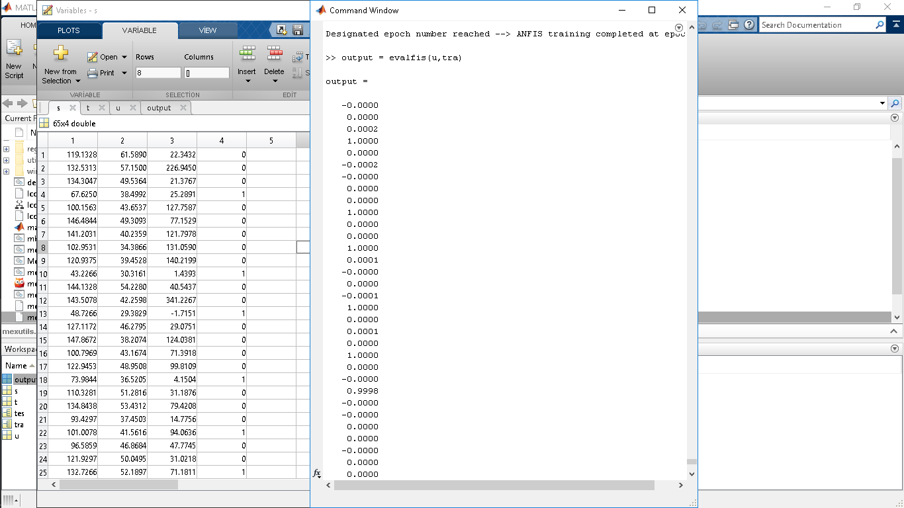

As a result, our model created 48 rules for Pulsar Star’s prediction and

those are listed and visualized in below.

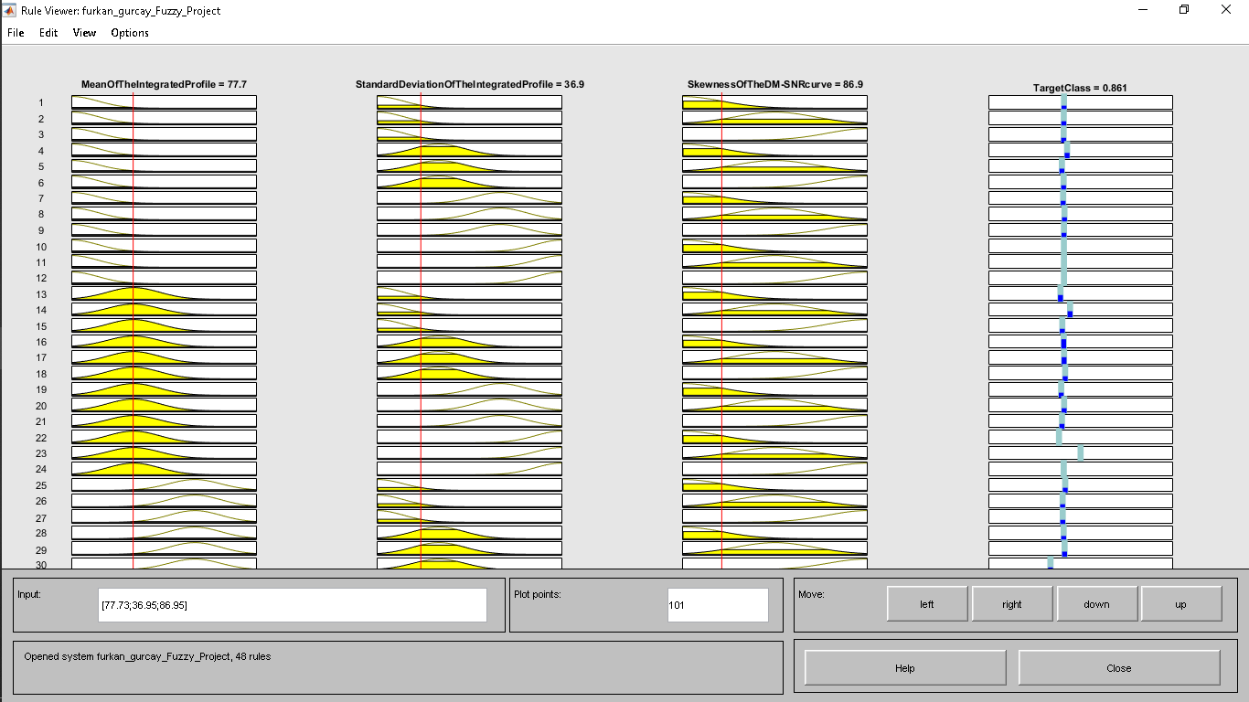

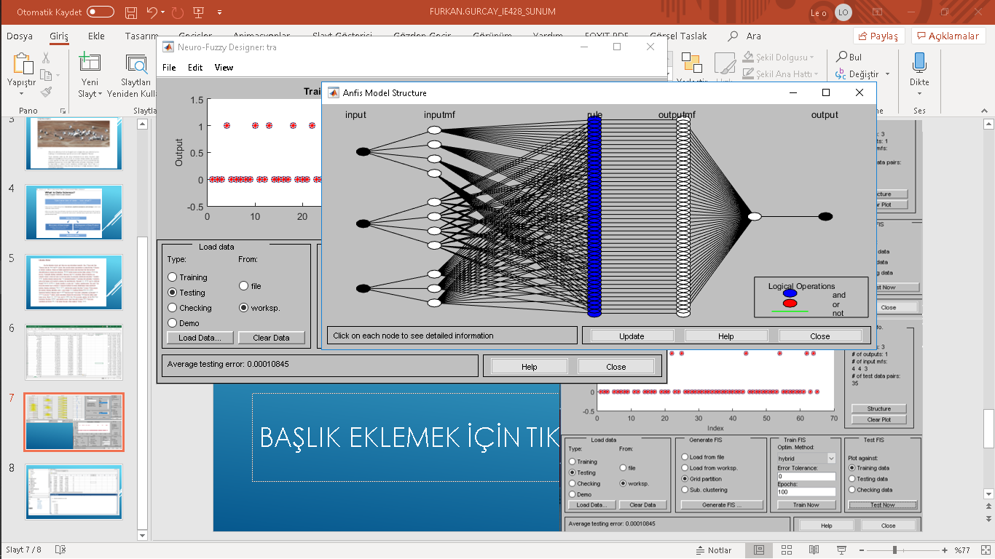

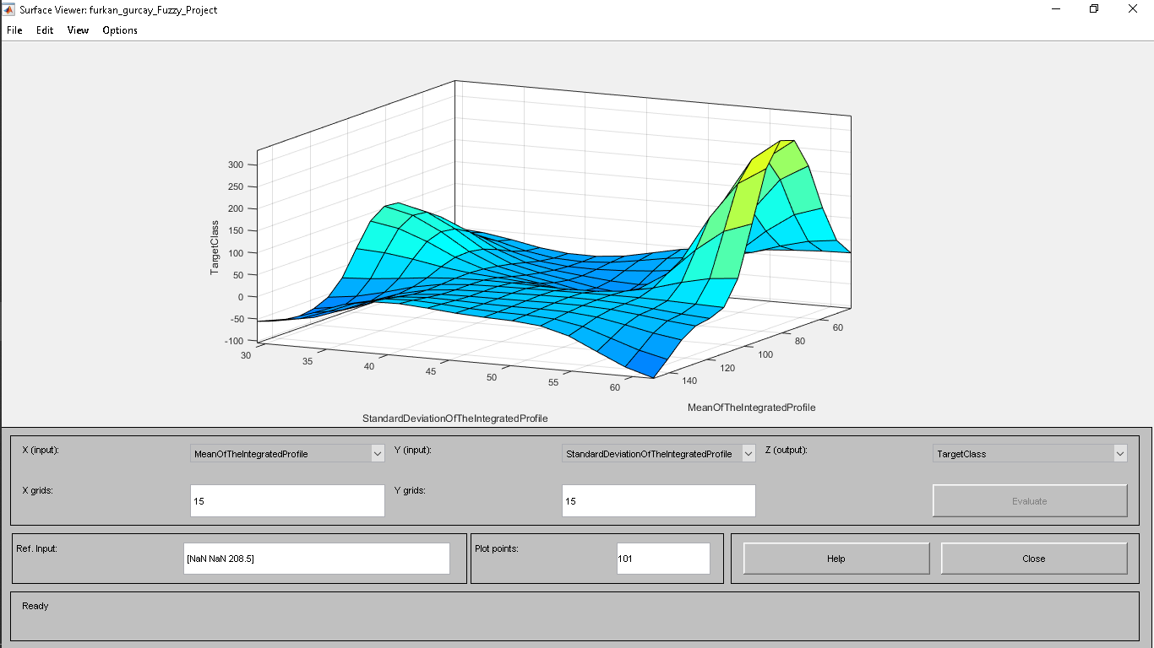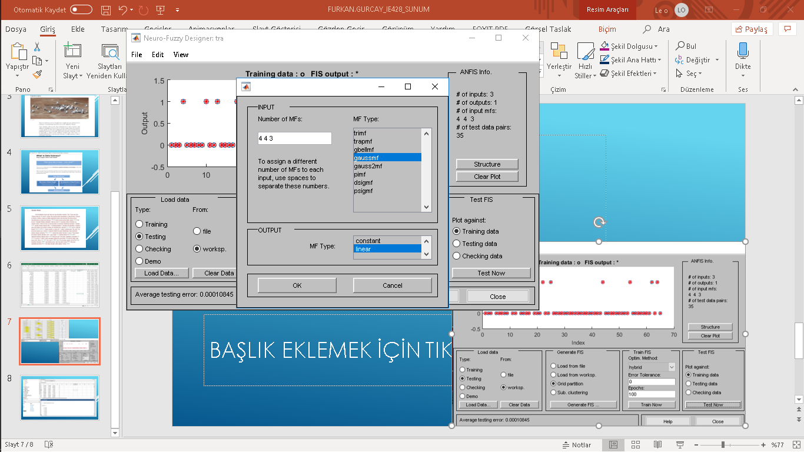

**References:**

https://medium.com/@nunorc/predicting-pulsar-stars-using-neural-networks-ecb3a527336b

https://nsuworks.nova.edu/cgi/viewcontent.cgi?article=1996&context=gscis_etd

<https://arxiv.org/pdf/1704.04659.pdf>

Eatough, R.P., Molkenthin, N., Kramer, M., Noutsos, A., Keith, M.J., Stappers, B.W., Lyne, A.G., 2010.

Selection of radio pulsar candidates using artificial neural networks. MNRAS 407, 2443–2450.

1005.5068.