02.02.2019

Gökhan ÇAKAL – Furkan KARAKAYA

TERM PROJECT

SMPS - Forward Converter Design

Introduction

As a course project, a closed-loop controlled forward converter is designed using synchronous switching. Electrical and magnetic designs are succesfully realized with respect to specifications given below. In order to control the converter an analog controller integrated circuit (IC) is used. In the secondary side another IC for synchronous switching and an opto-driver IC is implemented. These integrated circuits are selected from Analog Devices to take advantage of simulations. The whole circuitry is verified in simulation platform before schematic and printed circuit board (PCB) designs are completed. The PCB is manufactured using a CNC PCB machine.

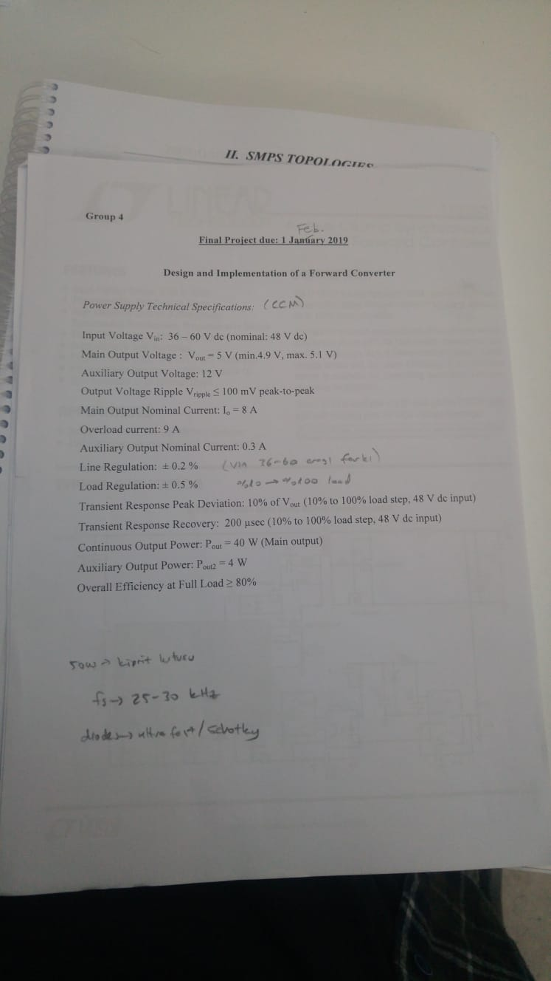

Figure 1: Specifications for Forward Converter

Forward Converter Basics

Forward converter is one of the most widely used DC/DC converter topologies for output powers under 200 W. It is an isolated converter and it employs transformer. Its input voltage range lies typically between 60-200V. There is only one switching power transistor employed in it so, it is more economical compared to its other converter topologies. In order to reset the flux in the transformer core, reset winding is used in the design. There are also different reset mechanisms other than reset winding. The basic schematic of a forward converter is shown in Figure 2.

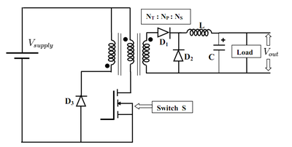

Figure 2. Basic forward converter schematic

During on period, switch S is open and input voltage feeds the primary winding. Since reset diode is reverse biased, reset winding is off in this period. Primary voltage is referred to the secondary side and D1 diode is forward biased. Also, D2 diode is reverse biased and it is in off state. Voltage in secondary winding rises inductor current and feeds the load. When the switch is turned off, D1 diode is reverse biased and no current flows in secondary side. At that moment, current in magnetizing branch has to find a path to flow so that transformer is reset and flux walking case is not observed. In order to achieve this, reset winding is used. In off period, reset diode is forward biased and current flowing in reset winding resets the transformer core. Output voltage is determined using following relation.

where is duty cycle and is turns ratio. Unlike flyback converter, transformer employed in forward converter used as transformer, i.e. energy is transferred to other side instantly. No energy is stored in transformer and transferred to other side during other state like in flyback transformer. In order to be able to reset the core, duty cycle of the forward converter should be maximum 0.45.

Forward Converter Design

# Transformer design

In forward converter topology, transformer is used for instant energy transfer. No energy is stored in the transformer. There is no air-gap employed. Transformer works in first quadrant of the BH curve only. Energy is transferred during only on period of the switches. This means transformer is operated asymmetrically. This lead poor utilization of the core. Therefore, core should be bigger than cores in symmetrical types. Standard un-gapped ferrite cores with high permeability are suitable for core of the transformer. In our design, we used ETD 39 core with N87 material[1]. While selecting core material and size, various design parameters are considered such as rated voltage/current, switching frequency, and number of turns.

In our design, we have primary, secondary and reset windings. Additionally, we have to find a source to feed integrated circuit parts such as controller. One option is using external power supply. This was easy way; but we created our internal supplies from our transformer. We used fourth winding, called auxiliary winding, in order to create required internal supplies. Additionally, we have specification of 12 V second output in addition to 5 V main output. In order to achieve this, we used linear regulator and to feed this, we used this axillary winding. We have following turns ratio in our transformer.

|  |  |
| --- | --- |
| Primary winding | 10 turns |
| Secondary winding | 4 turns |
| Reset winding | 10 turns |
| Auxiliary winding | 5 turns |

Since our switching frequency is 120 kHz, we did multiple checks in our transformer design. We know that in high frequencies, AC losses becomes much larger than DC losses. Considering this case, we did analytical calculations and ended up with some design criteria. For example, we used only one layer in transformer design. Thus, AC losses are limited. We did not use litz wire, analytical calculation showed us that it is not necessary due to one layer of design even if we operate at 120 kHz. Therefore, we used stranded wires for all windings. Experimental results also showed that there is not over temperature of our transformer during rated operation, verifying our analytical results.

# Inductor design / Capacitor selection

Forward converter output is buck type. Therefore, we have LC filter at the output of the converter. First of all, we picked and inductor core considering rated current ratings of the converter. Also, assumed and current ripple value and determined number of turns. In our design, we used T106-8/90 core of Micrometals[2]. It has AL value of 45 nH/N2. We calculated our required inductance value as 10 µH. In order to achieve this, we used 15 turns. Again, solid wires are used in inductor. Since DC current with small ripple will flow from output inductor, there will be not much AC loss on inductor.

While selecting output capacitor for forward converter, we should consider switching frequency. We have switching frequency of 120 kHz. We should put the cut-off frequency of out output filter so that switching frequency harmonics are filtered and not observed at the output. To be safe, we selected cut-off frequency at 2 kHz and find out capacitance value. It is calculated that we should have capacitance of 660 µF. Output voltage ripple specification is also satisfied with this value.

# Analog Controller

In this project, an analog controller, LT1952[3], is used from Analog Devices which support switching frequency upto 500 kHz. In our design, we selected the switching frequency as 120 kHz to reduce output ripple. LT1952 is a professional device which supports current mode control, synchronous rectification in the secondary side, soft-starting, duty-cycle limiting, over current protection, under voltage lock-out and slope compensation for the operations with duty-cycle greater than 50%. It has 16 pins in SSOP package, Figure 3, which is hard to solder onto a PCB without solder mask, so SSOP to DIP converter socket is used.

As seen in the block diagram of LT1952, Figure 4, an external resistor is used to adjust switching frequency. The IC has an unisolated gate driver which is used to drive the main transistor in the primary side. Additionally, it has a synchronous output which is used for synchronization of primary side and secondary side. Moreover, soft-starting is an important ability to limit the in-rush current for starting period.

In the primary side, an N channel MOSFET, TPH2900ENH, is used with 200V / 33A ratings. Considering the maximum input voltage, 60V, 200V rating is safe enough for a cautiously designed PCB layout. With its very low channel resistance and gate charge, this MOSFET is definitely suitable for high-frequency low loss applications.

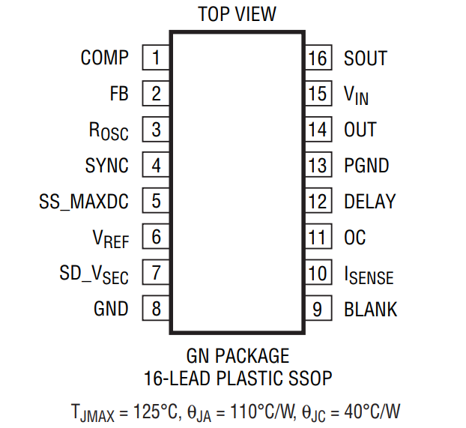

Figure 3: LT1952 pinout diagram

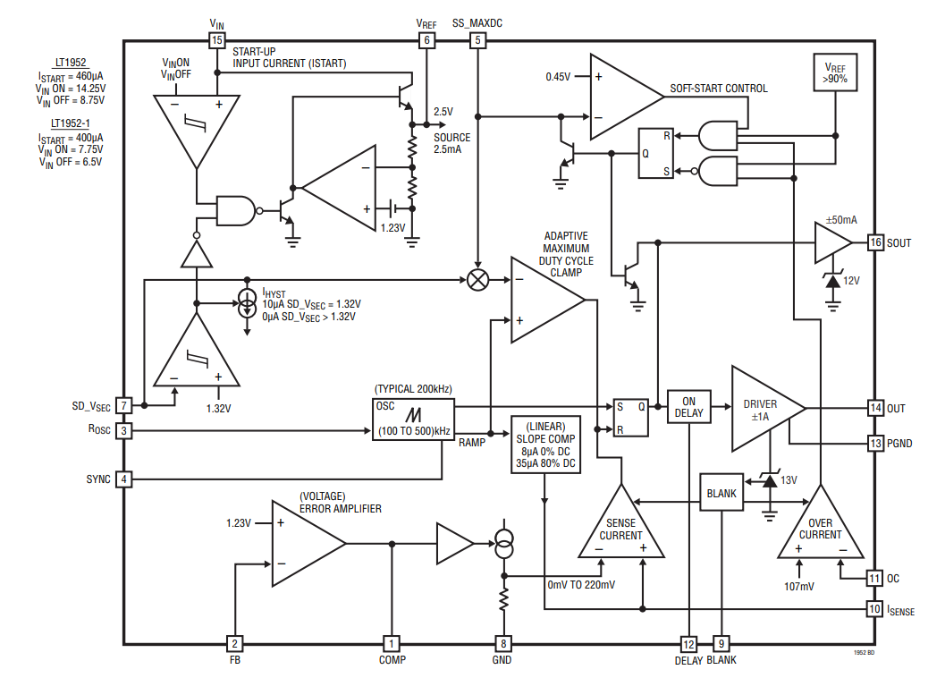

Figure 4: LT1952 block diagram

# Synchronous Switching

In order to increase the efficiency further, synchronous switching is applied. When the body-diodes of secondary side MOSFETs are active, there occurs a voltage drop on them. By enabling channel conduction in the secondary side, that voltage drop is made low to have less conduction loss. To have this ability, an synchronous gate-driver IC, LTC3900[4], is used which belongs to the same family with primary side controller. The main synchronization timing diagram is given in Figure 5. When primary side controller generates an gate signal (OUT) to driver primary MOSFET, it also generates another signal (SOUT) to alert the seconday side. This signal is filtered with an L-C resonant path to create the SYNC output which is transferred from primary side to secondary side using a pulse transformer, P0926NL[5]. The synchronous driver IC senses this SYNC signal to change gate signals of secondary side MOSFETs. In the secondary side, two N channel MOSFETs, HAT2266H[6], with 60V 30A maximum ratings. Therefore, considering the 5V 8A output configurations and 0.4 primary to secondary winding ratio, it is a safe selection for cautiously designe

d PCB. Lastly, the synchronization is important to prevent secondary-side from short circuits and negative current flowing through the filter inductor.

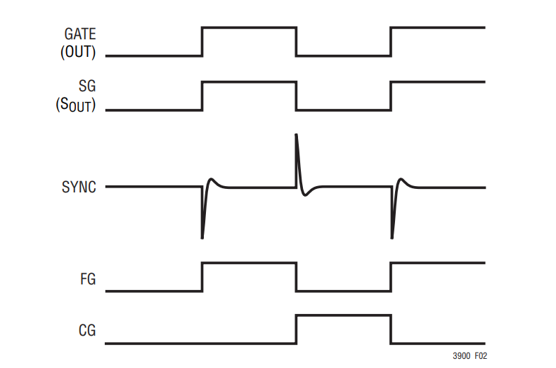

Figure 5: Synchronization waveforms

# Internal Supplies and Auxilary Output

Since integrated circuits are used in both primary side and secondary side, in both sides a supply regulation is required. Due to isolation between primary side and secondary side, it is not possible to use a single supply. For this purpose, a BJT regulator circuit is used in both sides as given in Figure 6.

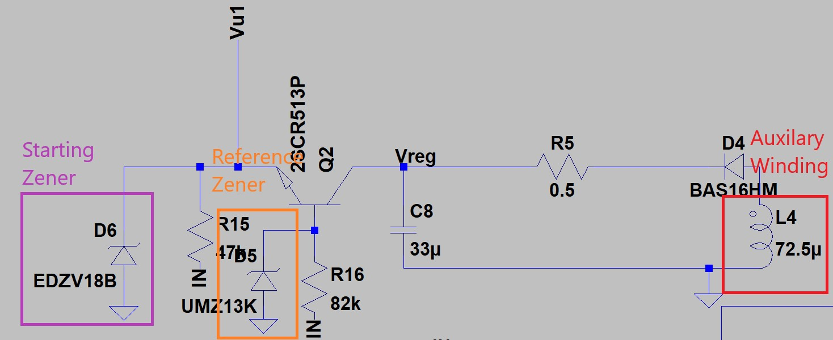

Figure 6: Internal Supply Circuit

Here an 18V zener is used to enpower the controller for the first cycles of operation. Then having the auxilary winding, it behaves as a current source where the voltage level is generated using a reference zener connedted to base of the BJT. In the secondary side, there is no starting zener; therefore, for the first cycles of the operation the synchronous switching is not available. However, as switching continues the regulation circuit in the secondary side reaches the operation point and it supplies the synchronous driver and opto-driver.

Since there is an 12V / 0.3A auxilary supply requirement in the project, the auxilary winding also supplies this output. For this purpose, a fixed 12V regulator, LM340[7], is connected just the output node of the auxilary winding. It regulates the output internally, so it does not require any external control consideration.

# Feedback Loop

In order to control the output voltage, a feedback loop needs to be closed as shown in Figure 7. Since the primary and secondary sides are isolated from each other an opto-coupler[8] is used to transfer the compensator signal from secondary side to primary side. To have the error amplifier in the secondary side an opto-driver IC, LT4430[9], is used to drive the opto-coupler. The opto-driver IC includes an internal reference generator and an error amplifier to regulate te output voltage.

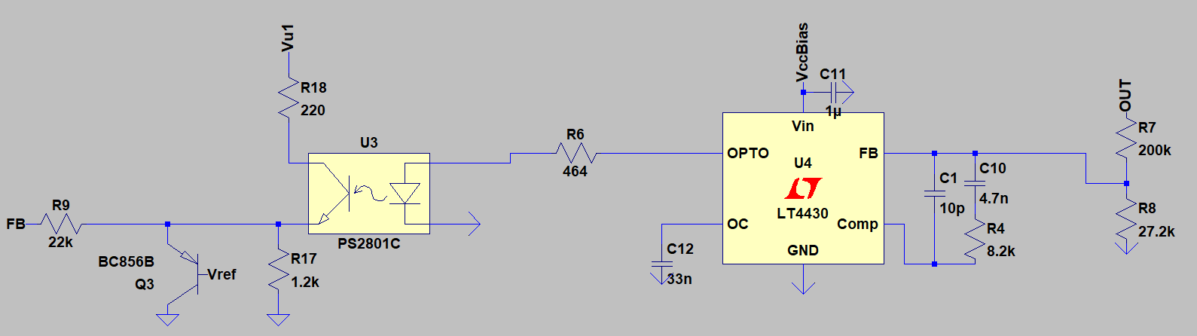

Figure 7: Feedback Loop

To reduce the output voltage to comparable level with internal reference voltage, 0.6V, a resistive division is realized. Then, the inverting input of the error amplifier is connected to divided voltage. One zero, one pole compensation is implemented where the poles and zeros are adjusted with simulation results. The pole frequency is 4.13 kHz and the zero frequency is 2 MHz. Having compensated the error signal, opto-driver generates an output voltage to drive the diode of the opto-coupler. The diode current is transferred to primary side BJT with current transfer ratio. The emitter of the opto-coupler is connected to FB pin of the analog controller via a 22 Kohm resistor. The output waveform is given in Figure 8.

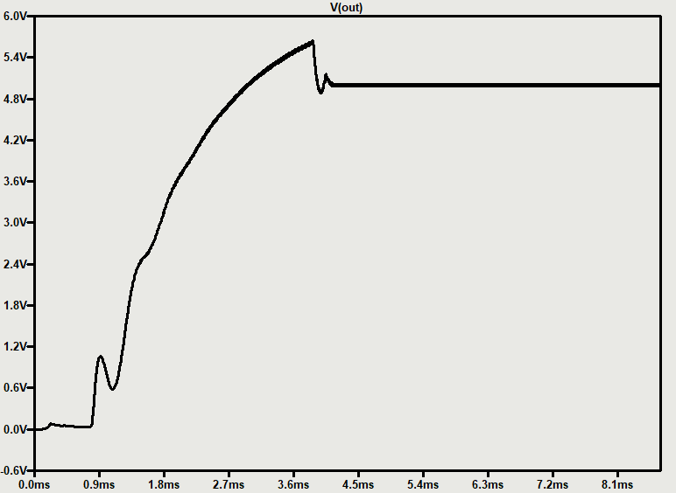

Figure 8: Output voltage waveform

# Schematic and Layout Design

Schematic and layout designs are realized in a professional PCB designed tool. Designing the schematic, the manufacturer suggestions and reference design schematics are taken into account. In the input side a common mode chock filter is used to reduce common mode noise. As shown in the Figure 9, the filter by-pass capacitors are used almost each pin of the controller to prevent the IC from high frequency oscillations. Also, power ground and signal ground are seperated from each other they are connected just at one point to reduce the control loop noise. Since current mode control is implemented the current signal is filtered with an R-C filter to reduce control noise. In Figure 10, a general schematic view is given.

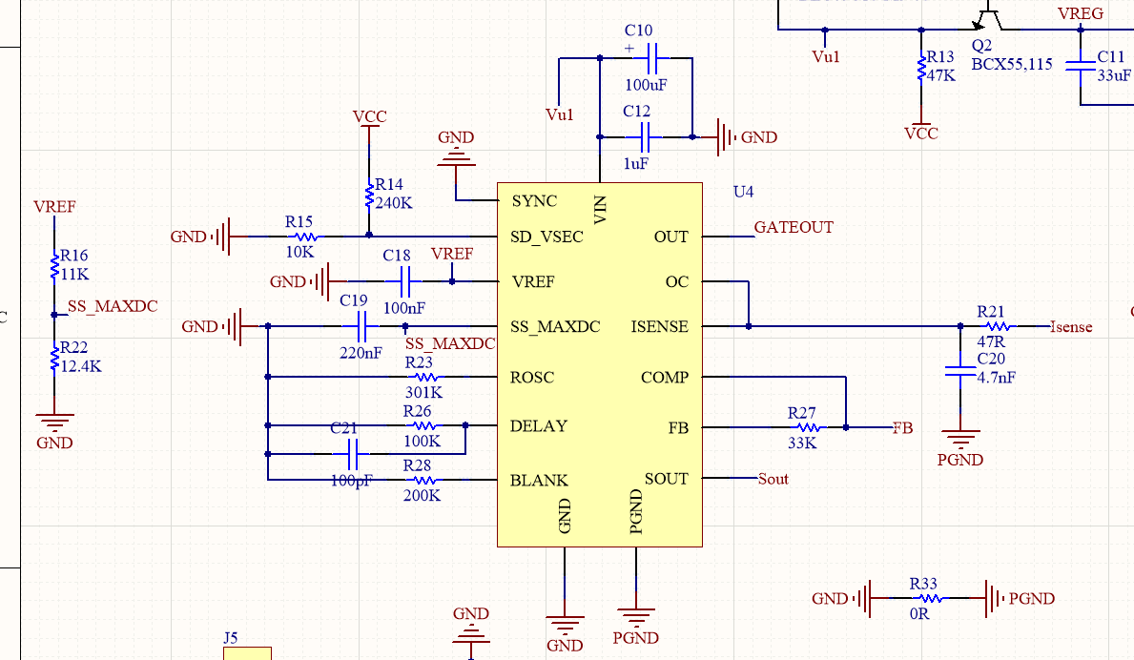

Figure 9: Analog Controller Schematic Design

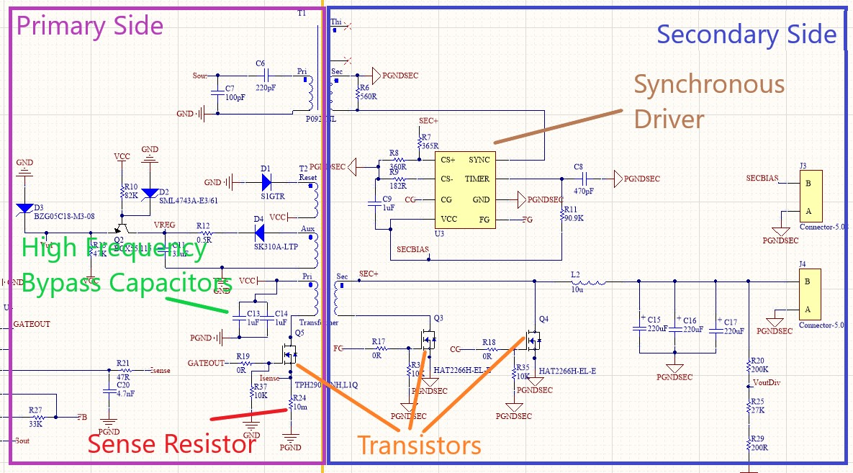

Figure 10: General Schematic View

In PCB design, some considerations need to be taken account the prevent circuitry from noise, heating or unintended short circuits. A two layer PCB is designed where its three dimensional view is given in Figure 11.

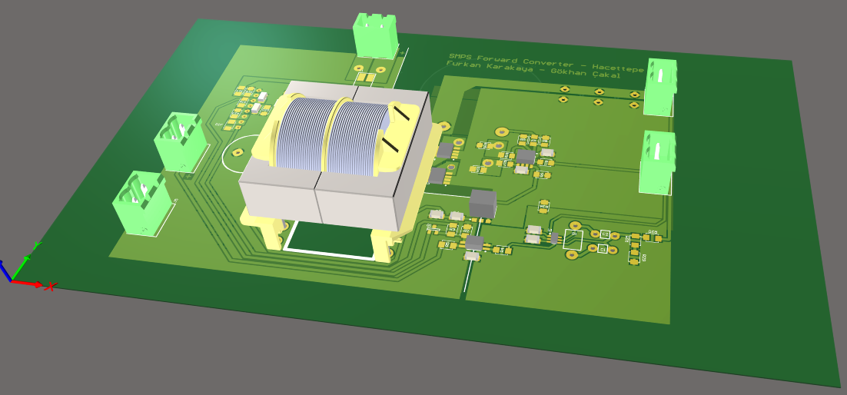

Figure 11: Three dimensional PCB view

To prevent circuit from heating and increased parasitic inductances & resistances the traces are kept in large width. For most of the power or signal traces the wider polygons are used. On the board a very large copper region is seperated for gorund signals in both primary side and secondary side. In order to prevent ground from noise, the power ground and signal grounds are connected in one point and there is no ground plane just under the transformer as shown in Figure 12 and Figure 13.

Furthermore, in order to reduce the primary and secondary side mosfets, the switching current paths are kept closely and bypass capacitors are placed. To minimize the parasitic inductance, power loop is kept small and the high frequency oscillation current flows in opposite directions on top and bottom layer where the going path is just over the returning path. Also, as shown in Figure 12, the secondary side MOSFETs sources where the current commutes from one to another one are kept in close proximity to reduce those MOSFETs stress low.

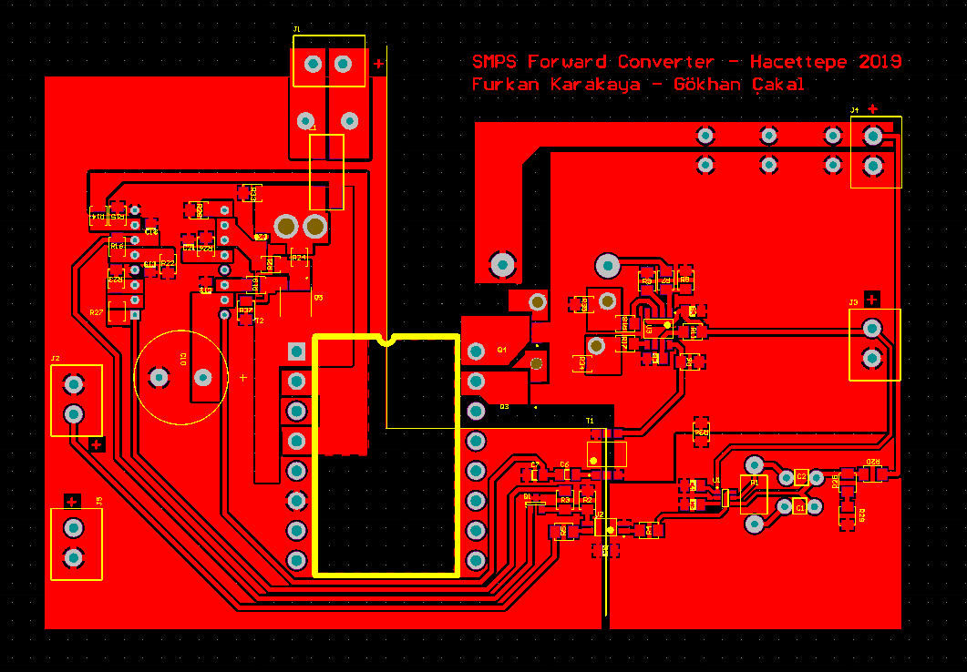

Figure 12: Top Layer

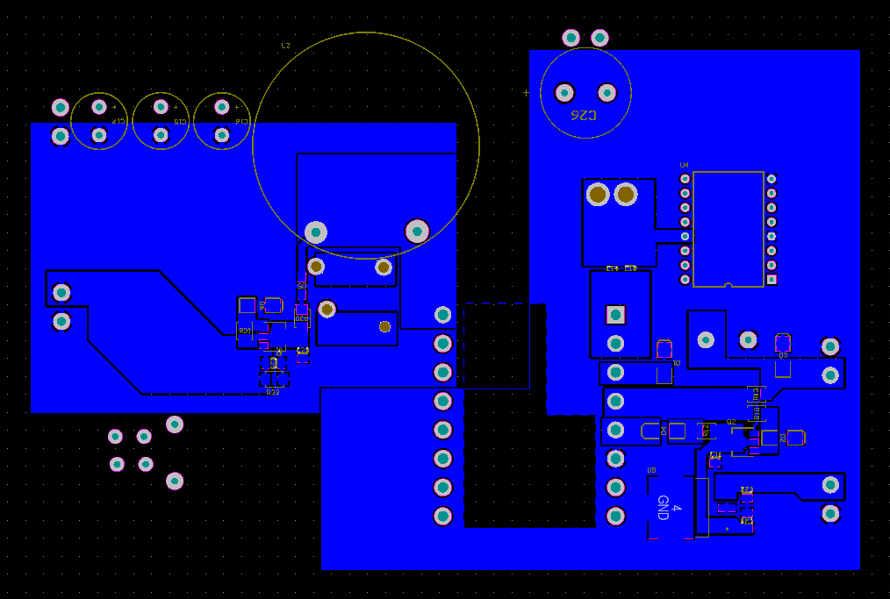

Figure 13: Bottom Layer

Experimantal verification

After designing all blocks of the forward converter and checking our design with simulation results, now it is time to manufacture our converter. We first wind our transformer and inductor and measure calculated values. We applied voltage and load the transformer with an AC source and check whether core is saturated or not with the given rated values. As a second step, we produced PCB board. We have a CNC engraving machine and we decided to print our board with this. To do this, we first bought PCB board and engrave the PCB layout we designed on Altium. Following PCB is achieved after engraving phase.

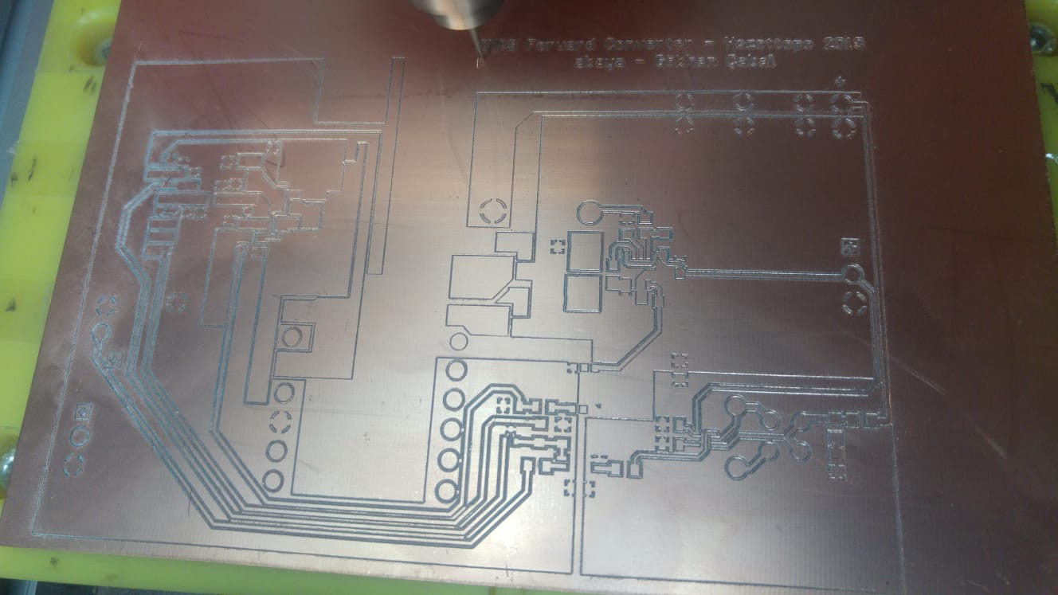

Figure 14. Engraved PCB board

We encountered some problems such as short circuit cases due to engraving process and we solved them before placing components to the board. We mostly used 1206 package components in our design. Our board is two layer and in Figure 14., top layer is shown. In next phase, we placed our component on board and started to test our converter. During test period, we encountered lots of problems and solved by debugging each one. Selected problems that we encountered is listed below.

* Noise emissivity of the transformer core

Since we operate at 120 kHz and rated current of 8 A, we see that at rated operation, our transformer works as broadcasting device and affects the other sensitive parts of the converter such as feedback loop or current sense. In PCB layout, even if we did not put any ground plane or any net under the transformer, this still effects the other parts. Therefore, we shielded our transformer with isolated aluminum sheet so that tried to suppress the noise.

* Cold solder joint

One of the most challenging problems we faced was cold solder joints. It was very hard and time consuming to detect this mistake. Cold solver joint prevents electrical contact in a net and open circuit fault is observed where it should not be. Since we soldered all the components on a copper board, it was hard to heat up a copper plane and solder the components without cold soldering. By some tests and observations, we found them and fix them.

* False triggering of secondary side synchronous mosfets.

In our design, to achieve higher efficiency, we used synchronous switching in secondary side instead of two diodes. This is achieved by LT3900 synchronous gate driver. Synchronous signal is sent to this driver from main controller, which is LT1952. Then mosfets in secondary side switched. When we run our converter, we observed that main controller enters in over current protection state and shuts down itself repeatedly. Then, we observe many signals on board and ended up with a problem on synchronous switching. Let’s consider Figure 15. below.

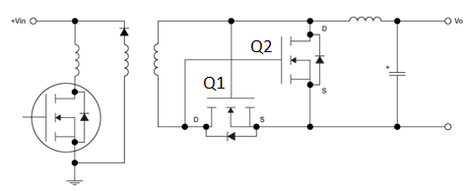

Figure 15. Synchronous switching

In our observations, we see that when main mosfet is on, Q1 is also on as expected. But with false triggered synchronous signal from main controller to the synchronous drive, Q2 turns on when main mosfets is still on. Then, short circuit condition in secondary side is observed and current rises. Main controller shuts-down itself due to over current. We see that there was false triggering in synchronous driver’s synchronous signal. We decreased the amplitude of this synchronous signal and false triggering condition is prevented and converted returns to normal operation mode. It was good to see that our main controller shuts-down itself in case of short circuited secondary side.

* Turn-on and turn-off speed of synchronous mosfets.

We observe that during turn-on of one switch and turn-of of other switch, due to gate inductances, we guess, there was ringing in gate signals and at very small interval during turn off and turn on transition, both mosfets become open and secondary side is short circuited. Again, above shut-down scenario is observed. To solve this, we increased turn on time while keeping turn off time constant. To achieve this, we added a gate resistance of 25Ω to the synchronous mosfets. Then a diode is placed parallel to this resistor for each synchronous mosfets. Anode is connected to the gate of mosfets. By this way, turn-off is achieved with no gate resistance, meaning fastest as it can be and turn-on period is increased with added gate resistance. This proposed solution solved the problem mentioned above.

With lots of other modifications, we ended up with a forward converter, achieving all requirements. We observe the output voltage of 5 V and converter is able to run in rated loads of 8 A. Below, our AC coupling output voltage is shown.

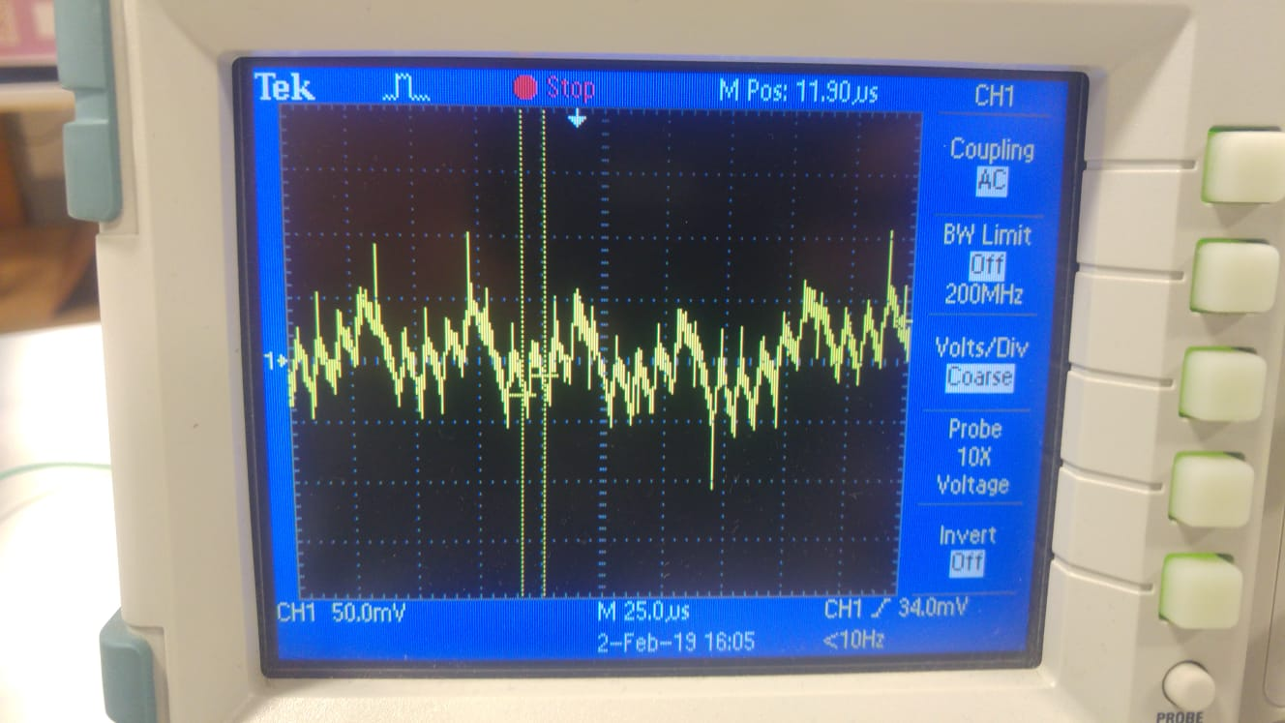

Figure 16. Output voltage AC signal at rated load

It is observed that around 100 mV peak-to-peak voltage ripple is observed at rated load. It is half of the requirements.

Conclusion

In this project, a forward converter is designed with simulation, schematic, layout designs and manufacturing process. The forward converter has capability of current-mode control, soft-starting, overcurrent protection and under voltage lockout. The circuit is fully under closed loop control with tight line and output regulation.

1. <https://en.tdk.eu/inf/80/db/fer/etd_39_20_13.pdf>
2. <https://micrometalsarnoldpowdercores.com/pdf/T106-8-90-DataSheet.pdf>
3. https://www.analog.com/media/en/technical-documentation/data-sheets/19521fe.pdf
4. https://www.analog.com/media/en/technical-documentation/data-sheets/3900fb.pdf
5. http://productfinder.pulseeng.com/products/datasheets/SPM2007_61.pdf
6. https://www.renesas.com/us/en/doc/products/transistor/003/rej03g1370_hat2266hds.pdf
7. http://www.ti.com/lit/ds/symlink/lm340.pdf
8. http://www.cel.com/pdf/datasheets/ps2801.pdf
9. https://www.analog.com/media/en/technical-documentation/data-sheets/4430fd.pdf