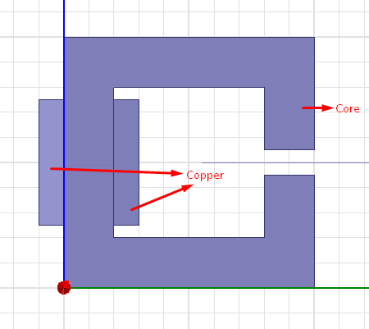

Figure 1: 2D C-Core



Figure 2: Flux Density Distribution around the gap for steel material without saturation

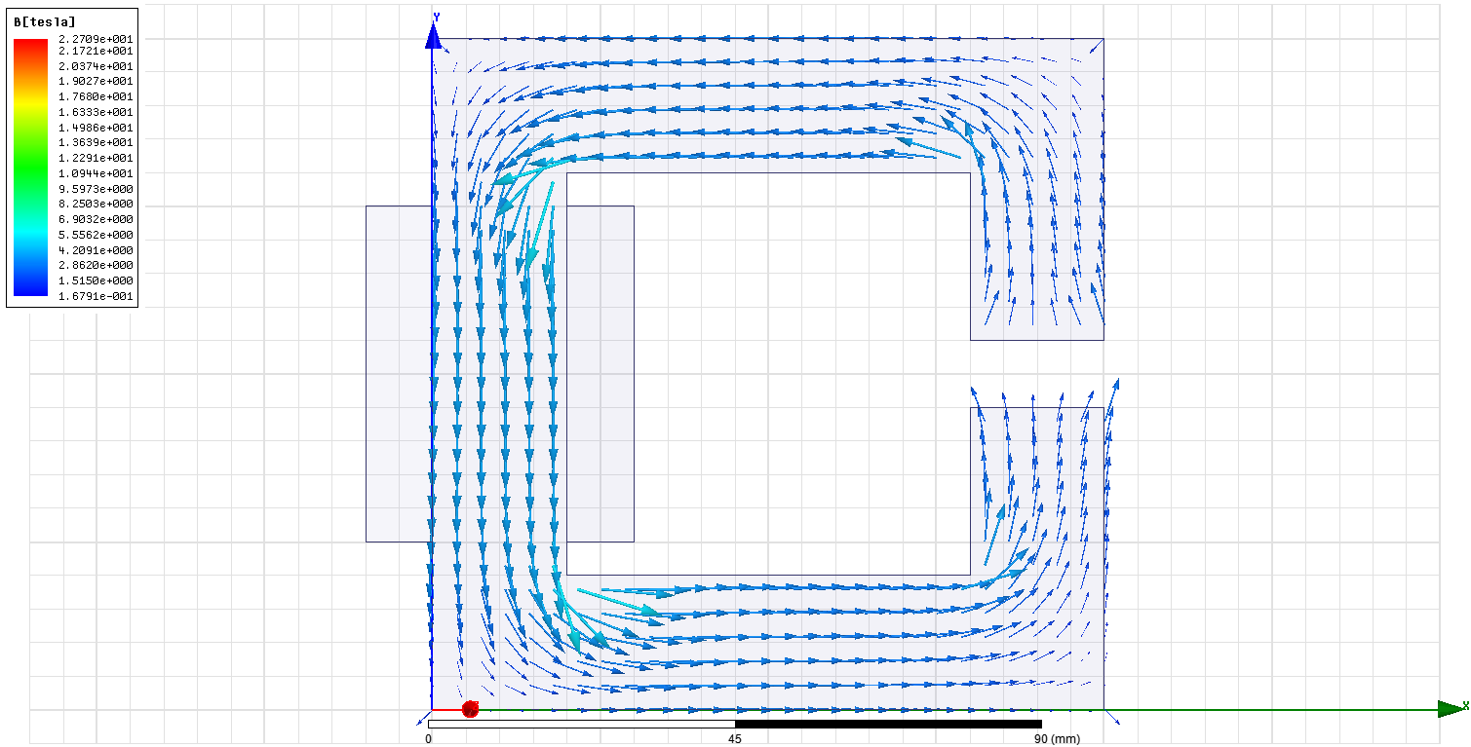

Figure : Flux Vectors for steel without saturation



Figure 4: Flux Density Distribution around the gap for steel-1010 material

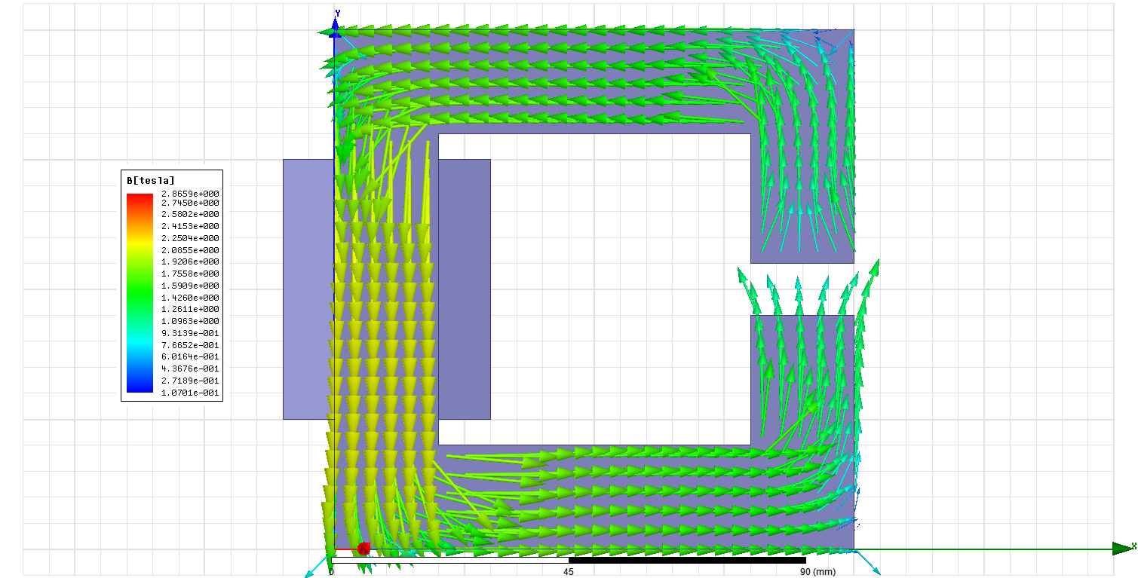

Figure : Flux Density Vectors for Steel-1010



Figure 6: Flux Density Distribution around the gap for iron

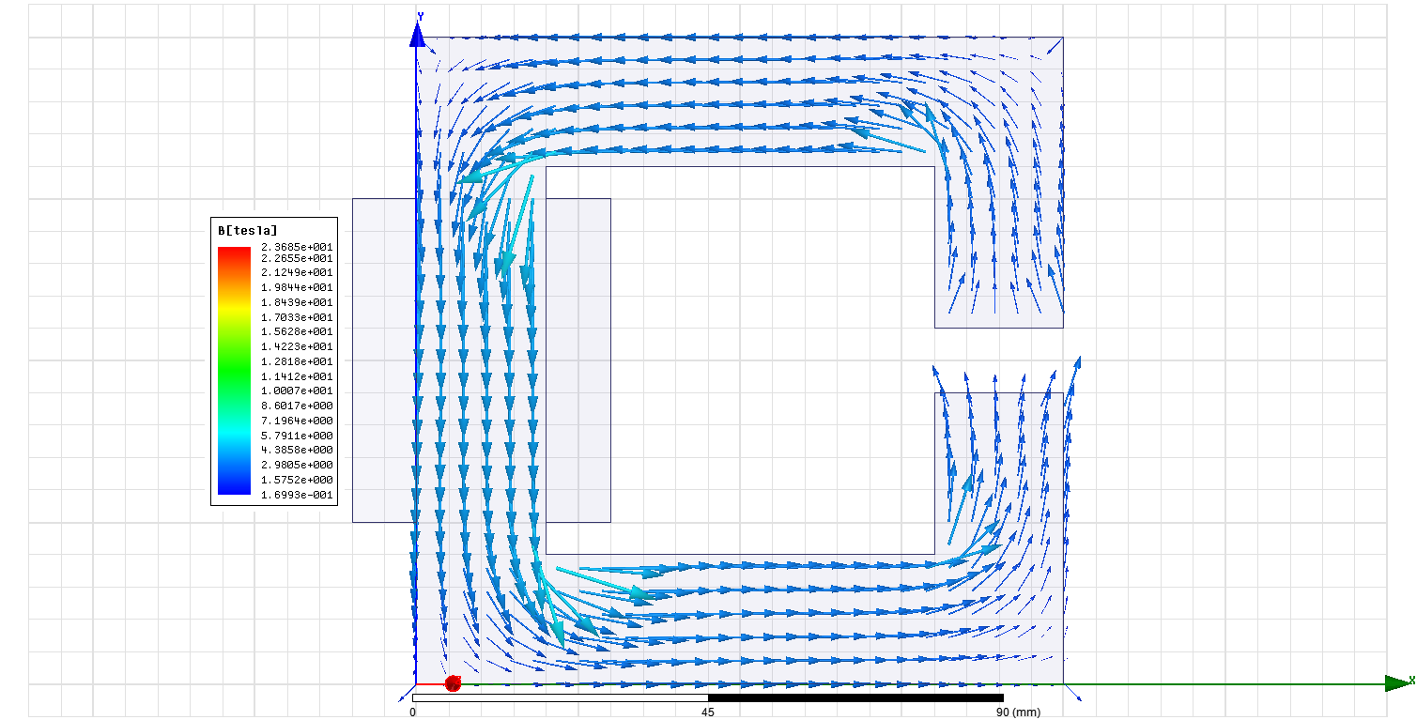

Figure : Flux Density Vectors for Iron Core



Figure 8: Flux Density Distribution around the gap for air-core

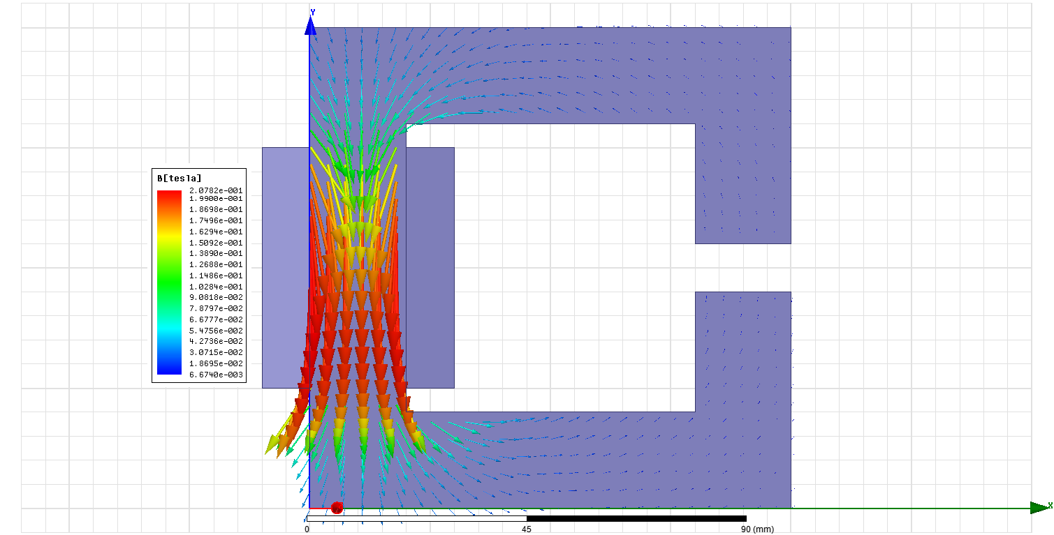

Figure : Flux Density Vectors for Air-Core

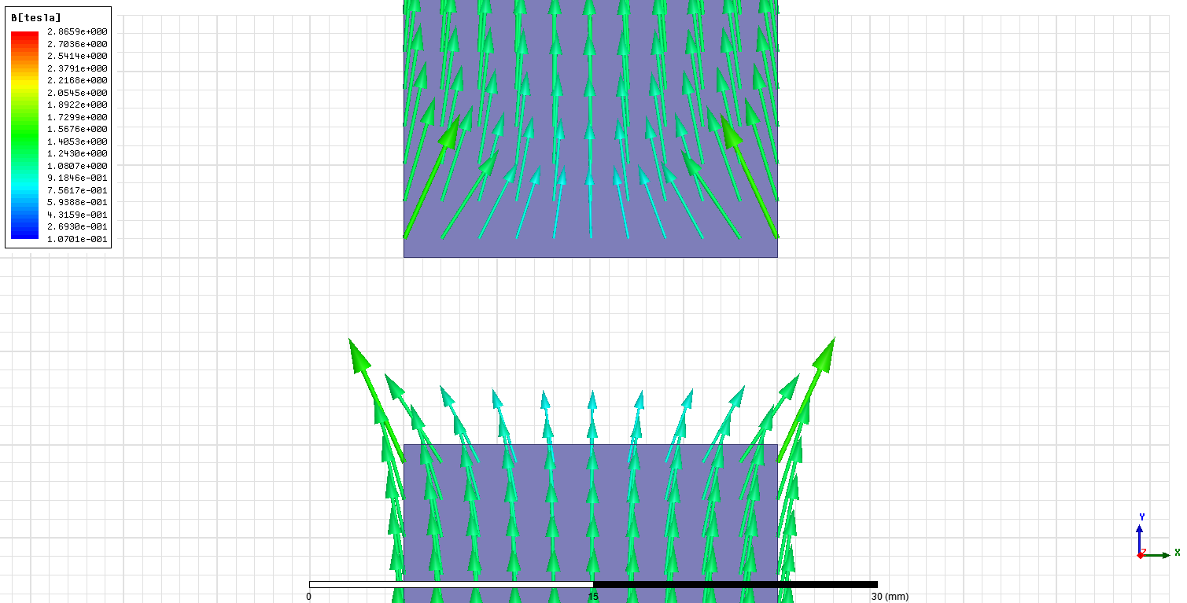

Figure : Flux Vectors around the air gap for unsaturated steel core