**Package-Delivery Services**

**PROJECT # 5:**

By

Mehmet Furkan KOLSUZ

151220142121

151227441: ADVANCED PROGRAMMING

2018-2019 FALL SEMESTERS

Date Submitted: December 27, 2018

**Synopsis:**

This program calculates price according to weight and type of Package. Also program prints information to console screen according to properties of the object created.

For example;

|  |  |  |
| --- | --- | --- |
| **Test Objects** | **Input Values** | **Expected Cost** |
| **Kargo1**  Standard Delivery | sender_name: Seyda Oguz  sender_address: Bagcilar  sender_city: Istanbul  sender_state: Turkiye  sender_ZIP: 34056  recipient_name: M Furkan KOLSUZ  recipient_address: Odunpazari  recipient_city: Eskisehir  recipient_state: Turkiye  recipient_ZIP: 26455  weight: 12.00  costperounce: 1.50 | TL 18 |
| **Kargo2**  Two Day Delivery | sender_name: Ali Cabuk  sender_address: Orta  sender_city: Ankara  sender_state: Turkiye  sender_ZIP: 06154  recipient_name: M Furkan KOLSUZ  recipient_address: Odunpazari  recipient_city: Eskisehir  recipient_state: Turkiye  recipient_ZIP: 26455  weight: 12.00  costperounce: 1.50  two_day_delivery_fee: 3.10 | TL 21.1 |
| **Kargo3**  Overnight Delivery | sender_name: Ahmet Hizli  sender_address: Levent  sender_city: Istanbul  sender_state: Turkiye  sender_ZIP: 34054  recipient_name: Haci Olmus  recipient_address: Gebze  recipient_city: Kocaeli  recipient_state: Turkiye  recipient_ZIP: 41063  weight: 12.00  costperounce: 1.50  overnight_delivery_fee: 5.00 | TL 78 |

**Calculation for each type of Package**

*For Standard Delivery: $Cost=\left(weight×costperounce\right)$*

*For Two Day Delivery: $Cost=\left(weight×costperounce\right)+two_day_delivery_fee$*

*For Overnight Delivery: $Cost=\left(costperounce+ overnight_delivery_fee\right)×weight$*

**Result:**

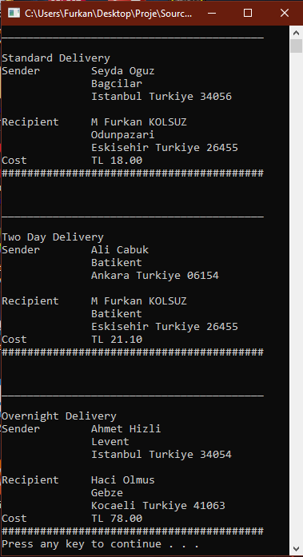

Screen Shot from Console

**Files:**

[**Screen Shot**](ScreenShot.png)

[**SourceCode**](SourceCode)

[**Doxygen Index**](DOX/html/index.html)