Fuzzy Logic-Based Smart Energy Management System for Power-Split Supervisory Control in Hybrid Electric Vehicles
Enes BAYRAM, Tural MAMMADLI, Emir Kağan DUMAN, Emre Can KORKMAZ, Furkan KUMRU

ABSTRACT
This study presents a rule-based Mamdani fuzzy supervisory controller for allocating requested traction power between the electric motor and the internal combustion engine in a simplified hybrid electric vehicle. The controller evaluates battery state of charge, normalized positive torque demand, and estimated remaining trip distance. Its normalized output is explicitly defined as the electric-motor contribution ratio, where values near 0 indicate ICE-dominant operation, values near 0.5 indicate hybrid operation, and values near 1 indicate electric-dominant operation. A complete set of 27 rules covers all linguistic input combinations. MATLAB scenario checks and a representative input-grid test confirm bounded, finite outputs and the intended qualitative mode selection. The present model does not include vehicle dynamics, fuel consumption, emissions, or battery-ageing models; therefore, it demonstrates controller logic rather than quantified vehicle-level efficiency or durability improvements.
Keywords: Hybrid electric vehicle, Fuzzy logic, Energy management, Supervisory control, Power split

Introduction
The global shift toward sustainable transportation has made Hybrid Electric Vehicles (HEVs) an important bridge between conventional internal-combustion vehicles and fully electric vehicles [1-5]. A central HEV control problem is the supervisory allocation of requested power between the engine and electric motor while respecting battery state of charge and driver demand. Intelligent controllers are useful because these operating conditions are nonlinear and uncertain [6-12].
This study develops a Smart Energy Management prototype that selects an electric-dominant, hybrid, or ICE-dominant operating region. The implementation is a rule-based fuzzy controller rather than a numerical optimizer. Its contribution is the explicit inclusion of estimated remaining trip distance as a supervisory input alongside battery state of charge and torque demand.
The controller applies human-readable rules to three normalized inputs and produces a continuous electric-power-share signal. The output can serve as a high-level command for a future closed-loop powertrain model; it does not by itself calculate engine fuel flow, battery current, or emissions.
The organization of this study is structured as follows: Section 2 provides the necessary Preliminaries regarding fuzzy logic and hybrid energy systems; Section 3 details the Methodology; Section 4 presents the Application of the fuzzy controller; and Section 5 offers the Conclusions and Evaluations.

Preliminaries
To develop an effective energy management strategy, it is crucial to understand the components of the Hybrid Electric Vehicle (HEV) powertrain and the principles of Fuzzy Logic. A hybrid system consists of an internal combustion engine (ICE), an electric motor, and a high-voltage battery pack [2]. The interaction between these components needs a complex controller to manage power flow efficiently [6].
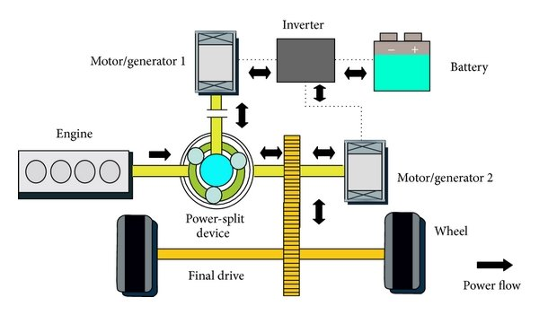
Figure 1: HEV Power-split Architecture
Fuzzy Logic is suited for this application because it can process vague inputs through a three-stage process: fuzzification, inference, and defuzzification [10]. This methodology helps with the examination of complex research problems and the reliability of the system. At the core of this process is the Knowledge Base, which has two main parts:
- Database: This contains the membership functions for the input and output variables, which translate numerical data (like 65% battery) into linguistic terms (like "Medium SoC") [13].
- Rule Base: This contains a set of logic statements derived from expert knowledge, for example "If SoC is Low and Torque Demand is High, Then Engine Power is High" [18].
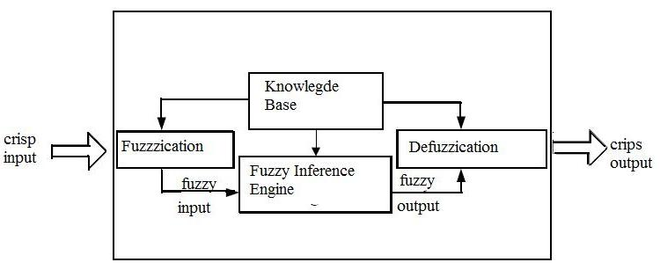
Figure 2: Structure of a Fuzzy Inference System (FIS)
In this study, the controller uses three input variables to make decisions [24]:
- Battery State of Charge (SoC): The percentage of available energy in the battery pack (Low, Medium, High).
- Torque Demand: The immediate rotational force required at the wheels based on driver input (Cruising, Accelerating, Heavy Load).
- Estimated Trip Distance: A predictive variable used to adjust energy conservation strategies (Short/Urban, Medium, Long/Highway).
The Power Split Ratio (PSR) is the normalized electric-motor contribution requested by the supervisory controller. Values near 1 represent electric-dominant operation, values near 0.5 represent hybrid operation, and values near 0 represent ICE-dominant operation with battery charging when the powertrain permits it. Because Mamdani centroid defuzzification returns the center of an activated output set, the representative Electric and ICE-dominant values are approximately 0.87 and 0.13 rather than exact endpoints.

Figure 3: Corrected power-split control maps for the electric-motor contribution ratio.

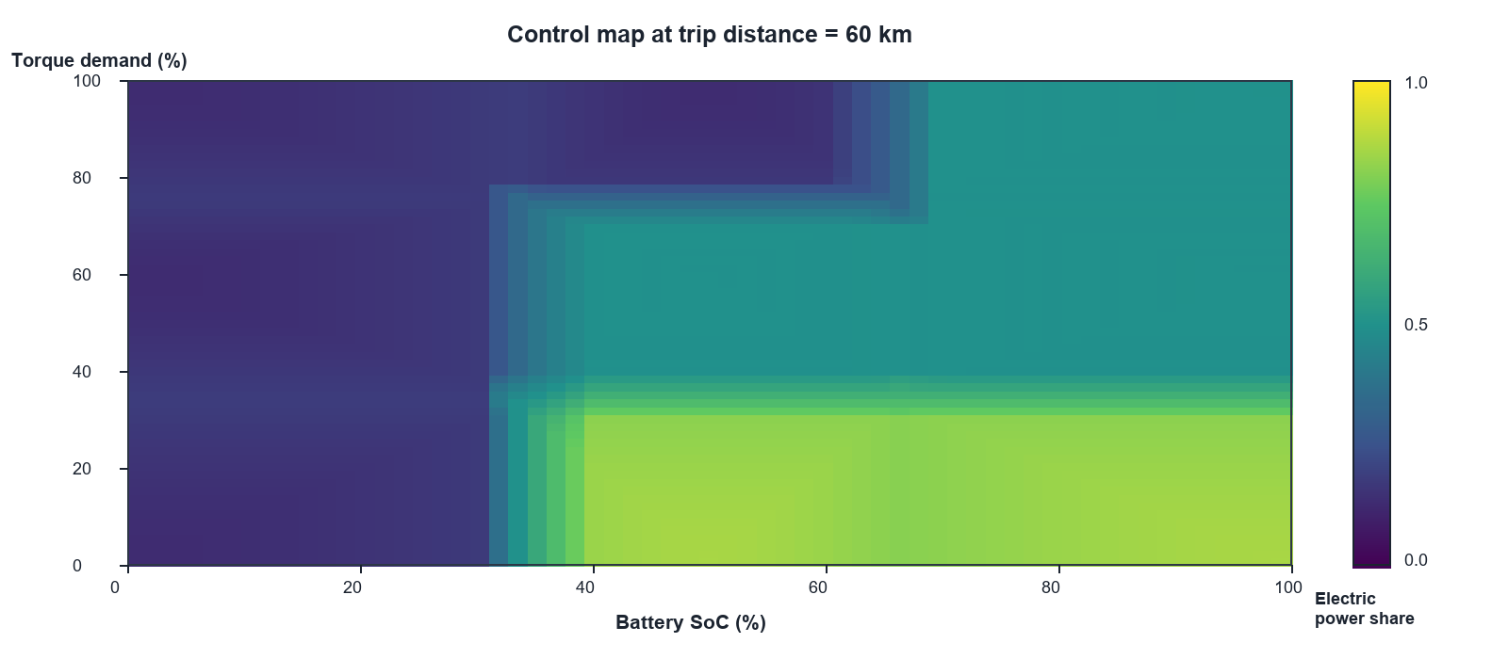
Figure 3(a): Battery SoC versus normalized torque demand at a 60 km trip distance.
Figure 3(a) shows that electric contribution increases at higher SoC and low torque demand. ICE-dominant operation is selected at low SoC or high load, while the overlapping membership regions create gradual hybrid transitions.
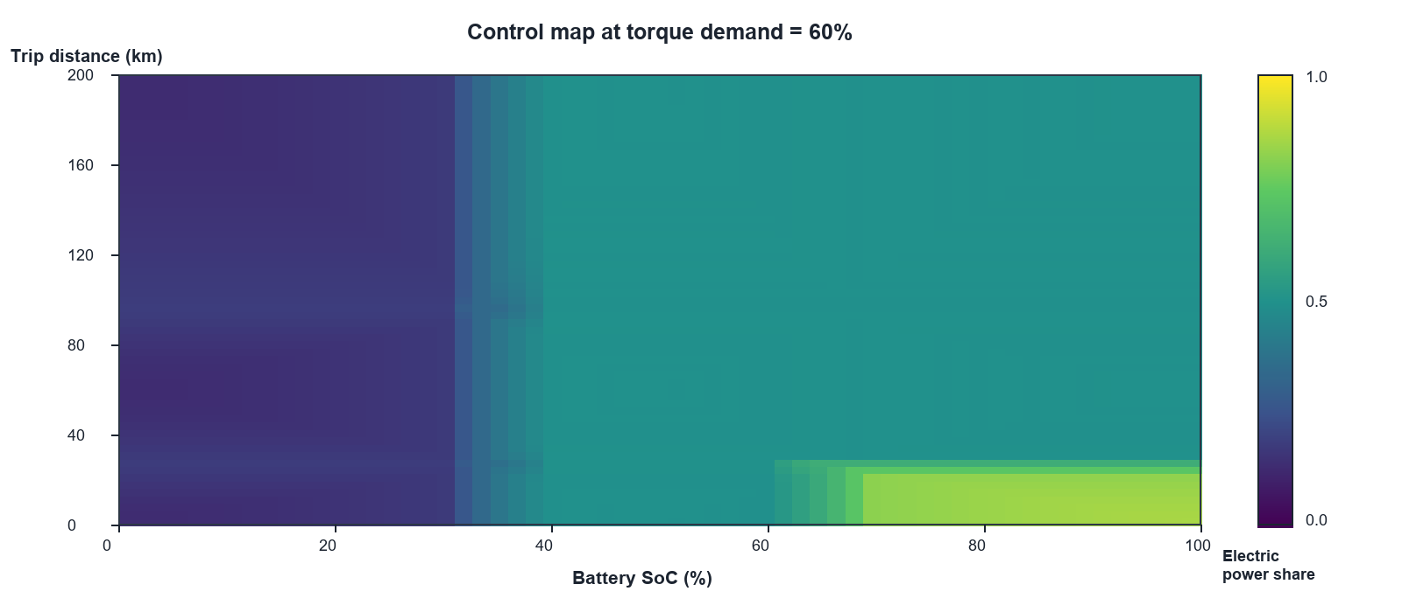
Figure 3(b): Battery SoC versus trip distance at 60% torque demand.
Figure 3(b) illustrates the intended distance-aware behavior at a fixed accelerating demand. Short trips with high SoC permit electric-dominant operation, whereas medium and long trips move the controller toward hybrid operation to conserve battery energy.
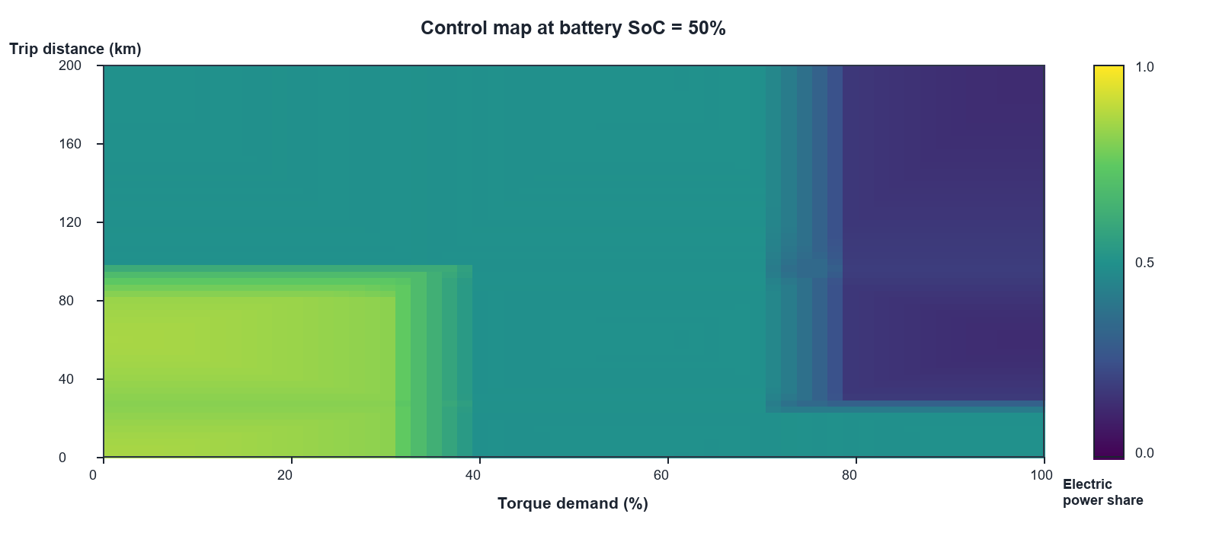
Figure 3(c): Normalized torque demand versus trip distance at 50% battery SoC.
Figure 3(c) shows that cruising demand favors electric operation, accelerating demand produces a hybrid split, and sustained heavy-load operation—especially on longer trips—moves the controller toward ICE-dominant operation.

The maps visualize the supervisory rule base; they should not be interpreted as measured fuel economy, emissions, or battery-life results. Those outcomes require a dynamic vehicle model and a defined driving cycle.

Method (Methodology)
The methodology systematically develops an interpretable supervisory controller for allocating the requested traction contribution between the electric motor and the internal combustion engine (ICE). The work is organized into variable and unit selection, FIS architecture design, rule-base formulation, MATLAB implementation, regression checks, and scenario-based interpretation.

Problem Approach and Variable Selection
Three inputs were selected for the proof-of-concept controller: Battery State of Charge (SoC), normalized positive Torque Demand, and Estimated Remaining Trip Distance. SoC and torque demand represent the battery-energy state and instantaneous traction request, while trip distance adds a simple predictive layer. Each input uses three overlapping triangular membership functions to balance interpretability and rule-base size.
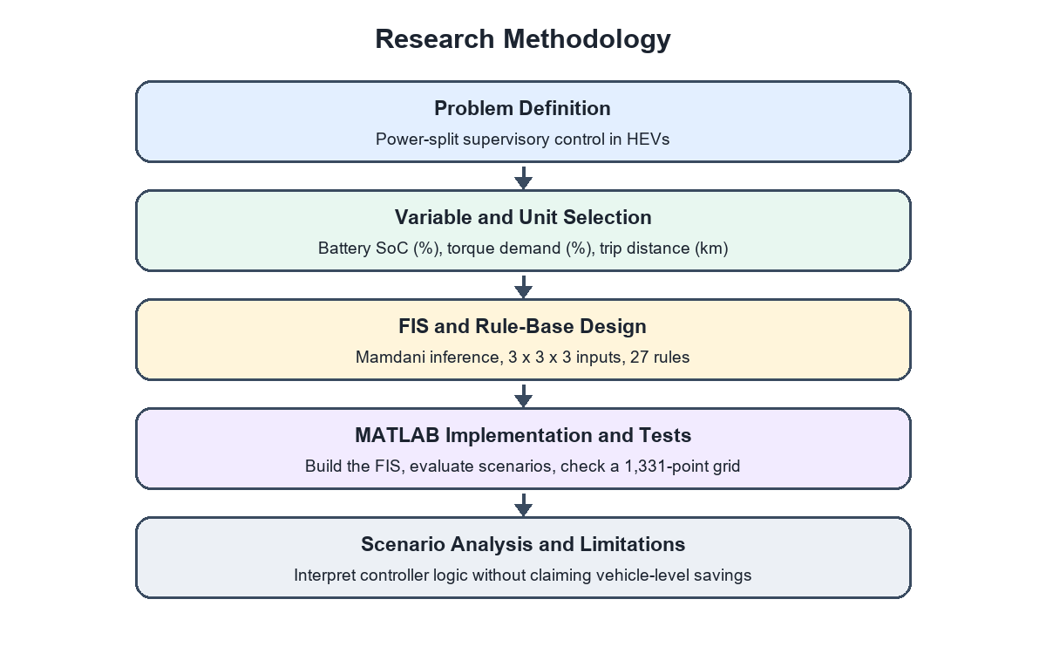
Figure 4: Methodological Flowchart of the Research Process.

The linguistic variables are defined using triangular membership functions (trimf). Torque demand is normalized to 0-100%, and trip distance is expressed in kilometres.
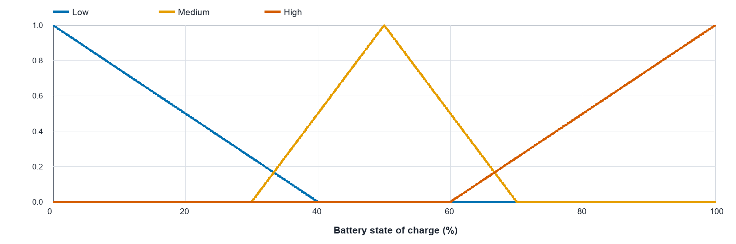
Input membership function — Battery State of Charge (%).
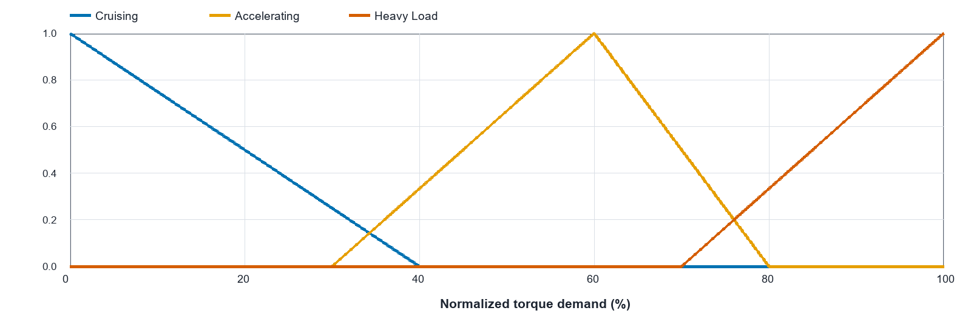
Input membership function — Normalized Torque Demand (%).
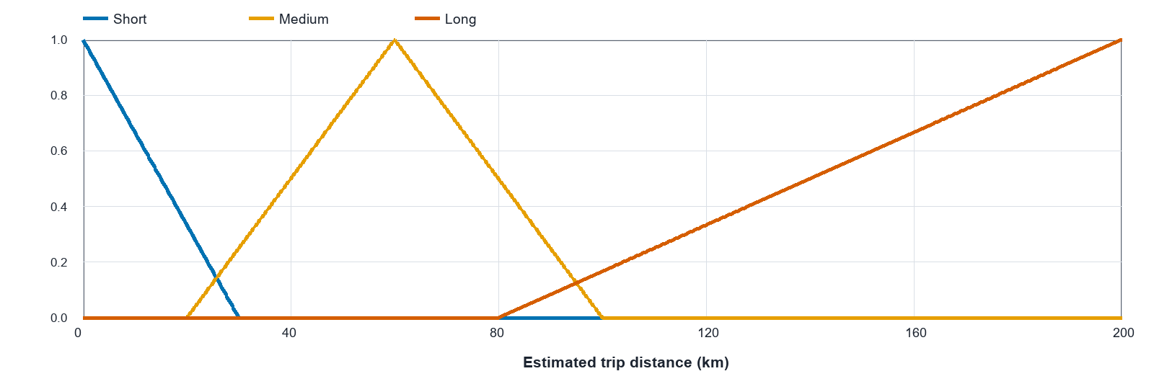
Input membership function — Estimated Remaining Trip Distance (km).

Selection of the Fuzzy Inference System (FIS)
A Mamdani-type Multi-Input Single-Output (MISO) FIS was selected for its interpretable rule representation. The single output is the normalized electric-motor contribution ratio. Its membership functions are arranged so that ICE_Charge occupies the low end of the output range, Hybrid occupies the center, and Electric occupies the high end.

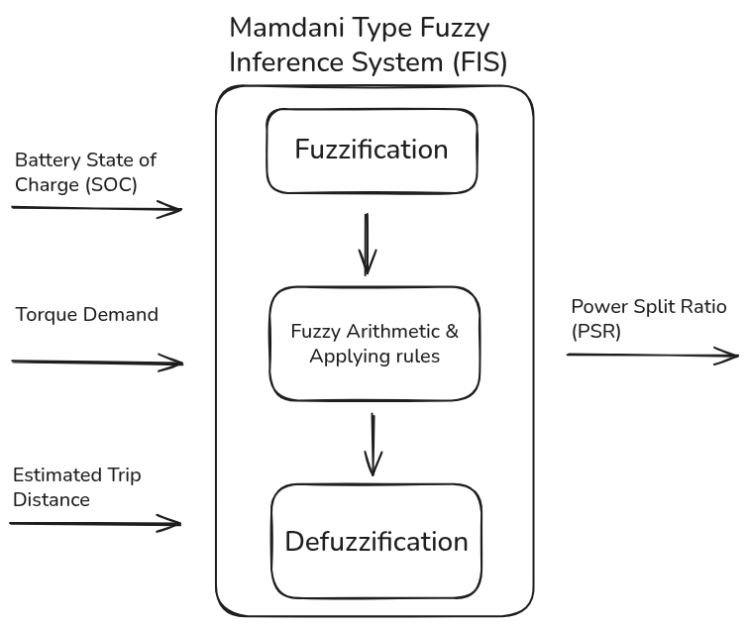
Figure 5: Architecture of the Proposed Mamdani Fuzzy Controller.

The three inputs—Battery SoC, normalized Torque Demand, and remaining Trip Distance—are processed by the Mamdani inference engine. The defuzzified output is a high-level electric-power-share command for subsequent powertrain control.
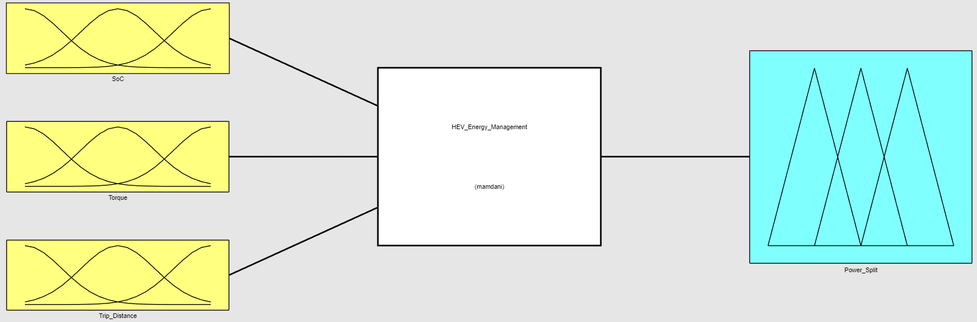Figure 6: Diagram of the input and output variables of the proposed fuzzy logic model.

Rule Base and Defuzzification Process
Three membership functions for each of three inputs produce 3³ = 27 possible antecedent combinations. One rule is defined for every combination. The revised long-trip rules move medium or high-SoC cruising toward Hybrid operation and high-load long-trip operation toward ICE_Charge, making the predictive distance input consistent with the stated conservation strategy.
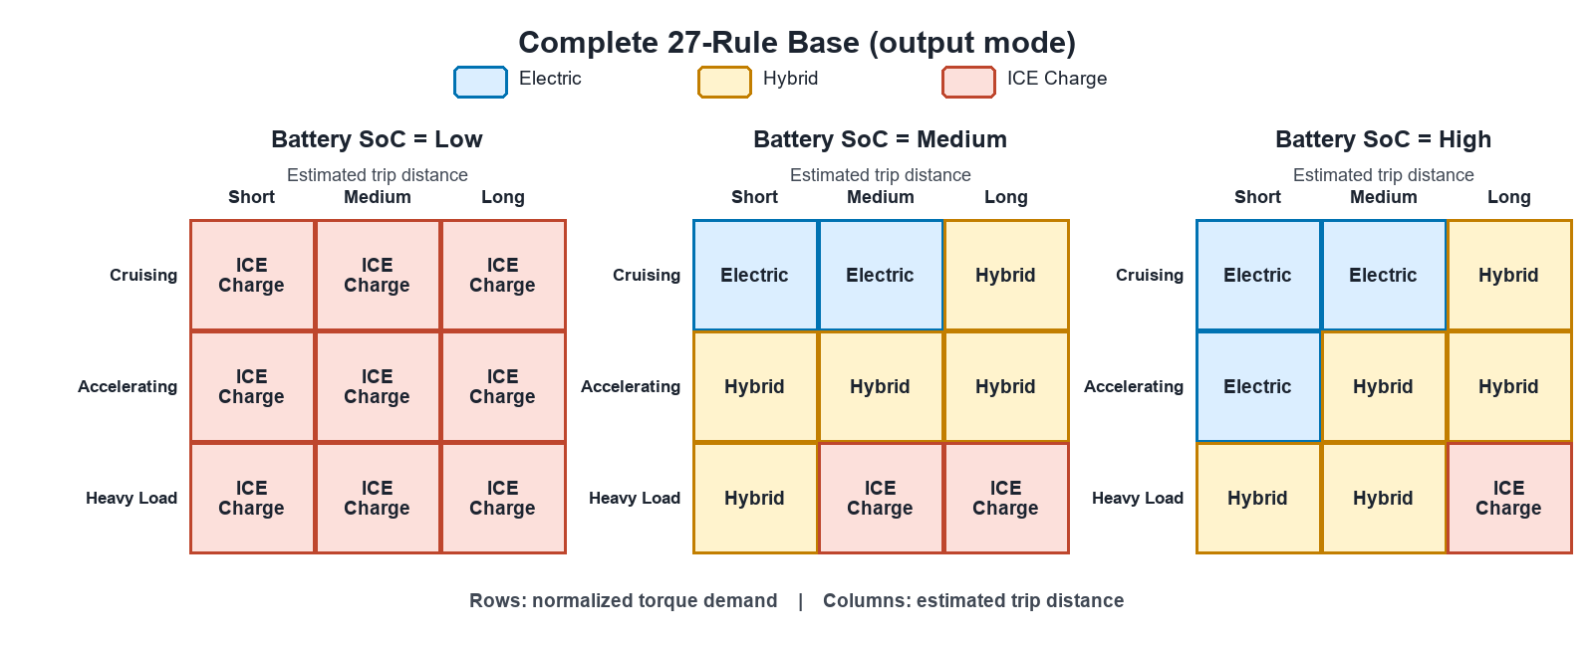Figure 7: Rule base created for the proposed fuzzy logic controller.

The centroid method converts the aggregated output fuzzy set into a continuous crisp signal. For the aggregated membership function μA(z), the electric-power-share command zCOG is the center of area:
z_COG = [∫ μ_A(z) · z dz] / [∫ μ_A(z) dz]

Software Implementation
The controller is implemented with MATLAB Fuzzy Logic Toolbox using mamfis, addInput, addMF, addRule, evalfis, and writeFIS. A separate regression script checks eight reference scenarios and a 1,331-point operating grid for finite outputs within [0,1]. Fuzzy Logic Designer is used for interactive inspection, while report figures can be regenerated programmatically.

Application
The proposed HEV Energy Management Strategy is implemented as a Mamdani fuzzy supervisory controller in MATLAB. This section explains how the controller maps Battery SoC, normalized Torque Demand, and Estimated Remaining Trip Distance to an electric-motor contribution command.

4.1 Implementation
The FIS uses three primary inputs selected for their influence on supervisory energy allocation:
- Torque Demand: A normalized 0-100% positive traction-demand signal. Higher values represent accelerating or heavy-load operation and increase the need for engine assistance.
- Battery State of Charge (SoC): The available battery-energy level expressed as a percentage. Low SoC causes the controller to select ICE-dominant operation to avoid further discharge.
This rule-based protection is qualitative. Quantifying battery ageing or State of Health requires a battery model, current and temperature histories, and cycle-life data.
- Trip Distance: Estimated remaining distance in kilometres. Short trips permit more aggressive electric use when SoC is adequate; selected long-trip rules move the command toward Hybrid or ICE-dominant operation to conserve battery energy.
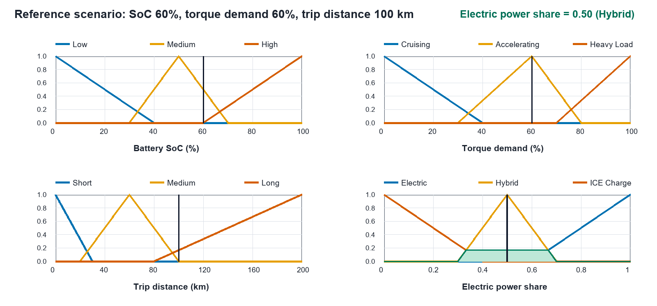
Figure 8: Reference scenario (SoC 60%, torque demand 60%, trip distance 100 km), producing an electric power share of approximately 0.50.

4.2 Findings and Discussions

4.2.1 Findings
The revised FIS was evaluated using representative operating scenarios and a structured input grid. All grid outputs are finite and remain within the normalized [0,1] range. For the reference input [60%, 60%, 100 km], the active rule produces a Hybrid command and centroid output of approximately 0.50. The centroid equation is:
$$z_{COG} =\frac{\int_{ }^{ }{μ_{a}\left(z\right)}⋅z \text{dz}}{\int_{ }^{ }{μ_{a}\left(z\right)\text{ dz}}}$$
The variables in Equation (1) are defined as follows:
- zCOG: The final crisp electric-power-share command. Values near 0 are ICE-dominant; values near 0.5 are hybrid; values near 1 are electric-dominant.
- z: The output universe of discourse, ranging from 0 to 1.
- μA(z): The aggregated output membership function formed from all active rules.
- ∫: Integration over the output range used to determine the centroid of the aggregated area.

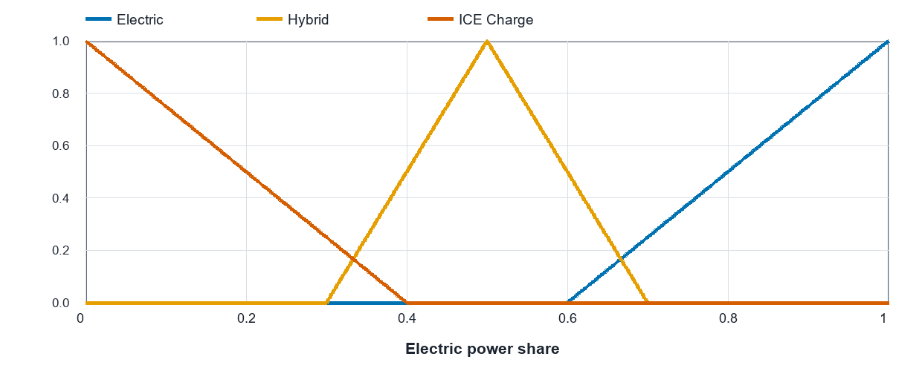
Figure 9: Membership functions defined for the output variable (Power_Split).

Representative input scenarios and power-split results:
SoC | Torque Demand | Trip Distance | Mode / Approx. Electric Share
Low | Accelerating | Long | ICE-dominant / ~0.13
Low | Heavy Load | Medium | ICE-dominant / ~0.13
Medium | Cruising | Long | Hybrid / ~0.50
Medium | Accelerating | Long | Hybrid / ~0.50
High | Cruising | Short | Electric-dominant / ~0.87

4.2.2 Discussion
The scenario checks confirm the intended qualitative rule behavior: low SoC produces ICE-dominant operation, adequate SoC with low demand permits electric-dominant operation, and long-distance or heavy-load cases move toward Hybrid or ICE-dominant modes. These checks verify logical consistency only. They do not establish fuel savings, emission reductions, battery-life improvements, or closed-loop stability relative to another controller.

4.3 Limitations
The controller is a static supervisory FIS. It does not include longitudinal vehicle dynamics, negative torque or regenerative braking, component efficiency maps, battery temperature or ageing, actuator limits, hysteresis, or a drive-cycle baseline. Consequently, vehicle-level fuel economy, emissions, battery durability, and transition stability remain future validation tasks.

Conclusions and Evaluations
A corrected Mamdani fuzzy supervisory controller was developed with three inputs, one normalized electric-power-share output, and 27 rules. The output convention is now consistent across the MATLAB implementation, FIS file, figures, and report: values near 0 are ICE-dominant and values near 1 are electric-dominant.
Regression scenarios show the intended qualitative decisions, including electric-dominant operation for adequate SoC and short low-demand travel, hybrid operation for intermediate cases, and ICE-dominant operation for low-SoC or long high-load cases. These results validate the rule logic but do not quantify whole-vehicle benefits.
Future work should connect the controller to a dynamic HEV model, include regenerative braking and component constraints, obtain trip information from GPS, and compare fuel consumption, emissions, and SoC trajectories against a baseline controller on standardized drive cycles.

References
[1] M. A. Hannan et al., “Review of energy storage systems for electric vehicle applications,” Renewable and Sustainable Energy Reviews, 2018. Publisher link

[2] M. Ehsani et al., Modern Electric, Hybrid Electric, and Fuel Cell Vehicles. CRC Press, 2018. Publisher link

[3] C. C. Chan, “The State of the Art of Electric, Hybrid, and Fuel Cell Vehicles,” Proceedings of the IEEE, 2007. IEEE record

[4] S. F. Tie and C. W. Tan, “A review of energy management and control strategies for HEVs,” Renewable and Sustainable Energy Reviews, 2013. Publisher link

[5] I. Husain, Electric and Hybrid Vehicles: Design Fundamentals. CRC Press, 2021. Publisher link

[6] F. R. Salmasi, “Control Strategies for Hybrid Electric Vehicles: Evolution, Classification, Comparison, and Future Trends,” IEEE Transactions on Vehicular Technology, 2007. IEEE record

[7] A. Panday and H. O. Bansal, “A review of optimal energy management strategies for hybrid electric vehicles,” International Journal of Energy Research, 2014. Record link

[8] A. Sciarretta and L. Guzzella, “Control of hybrid electric vehicles,” IEEE Control Systems Magazine, 2007. Author manuscript
[9] L. A. Zadeh, “Fuzzy sets,” Information and Control, 1965. Publisher link
[10] T. J. Ross, Fuzzy Logic with Engineering Applications. Wiley, 2016.

[11] S. G. Wirasingha and A. Emadi, “Classification and review of control strategies for plug-in hybrid electric vehicles,” IEEE Transactions on Vehicular Technology, 2011. IEEE record
[12] J. S. Won and R. Langari, “Intelligent energy management agent for a parallel hybrid vehicle—Part I: System architecture and design of the driving-situation identification process,” IEEE Transactions on Vehicular Technology, 2005. Record link

[13] N. J. Schouten et al., “Fuzzy logic control for parallel hybrid vehicles,” IEEE Transactions on Control Systems Technology, 2002. IEEE record

[14] H. J. Lee et al., “Fuzzy logic-based torque control strategy for a parallel hybrid electric vehicle,” International Journal of Automotive Technology, 2011. Record link

[15] P. Pisu and G. Rizzoni, “A comparative study of supervisory control strategies for hybrid electric vehicles,” IEEE Transactions on Control Systems Technology, 2007. IEEE record

[16] V. D. Ngo et al., “Real-time control strategy for HEVs based on recursive algorithm,” Journal of Mechanical Science and Technology, 2012.

[17] G. Cican et al., “Energy Management Strategy for HEVs Based on Fuzzy Logic,” Energies, 2021.

[18] S. Zhang et al., “Fuzzy logic-based energy management strategy for a hybrid electric vehicle,” Advances in Mechanical Engineering, 2015.

[19] H. Yin et al., “Optimal fuzzy logic-based energy management of a hybrid electric vehicle,” IEEE Access, 2016.

[20] Q. Li et al., “Energy management strategy for HEV based on a fuzzy logic controller,” Applied Sciences, 2017.

[21] K. C. Vora et al., “Development of Fuzzy Logic Controller for Hybrid Electric Vehicle,” SAE Technical Paper, 2011.

[22] I. Arsie et al., “A Review of Control Strategies for HEVs,” IFAC Proceedings Volumes, 2010.

[23] D. F. Opila et al., “Real-world energy management of a hybrid electric vehicle,” IEEE Transactions on Control Systems Technology, 2012.

[24] B. Geng et al., “Fuzzy logic-based energy management for HEVs with predicted driving conditions,” Energy Procedia, 2019.

[25] Y. Huang, H. Wang, A. Khajepour, H. He, and J. Ji, “Model predictive control power management strategies for HEVs: A review,” Journal of Power Sources, vol. 341, pp. 91-106, 2017, doi: 10.1016/j.jpowsour.2016.11.106. DOI link

[26] S. Siddula et al., “Electric Vehicle Energy Management System Using Fuzzy Logic Controller,” in Proceedings of the Fifth International Conference on Computer and Communication Technologies, 2020. Record link

[27] F. Zhang, L. Wang, S. Coskun, H. Pang, Y. Cui, and J. Xi, “Energy Management Strategies for Hybrid Electric Vehicles: Review, Classification, Comparison, and Outlook,” Energies, vol. 13, no. 13, 3352, 2020, doi: 10.3390/en13133352. DOI link

