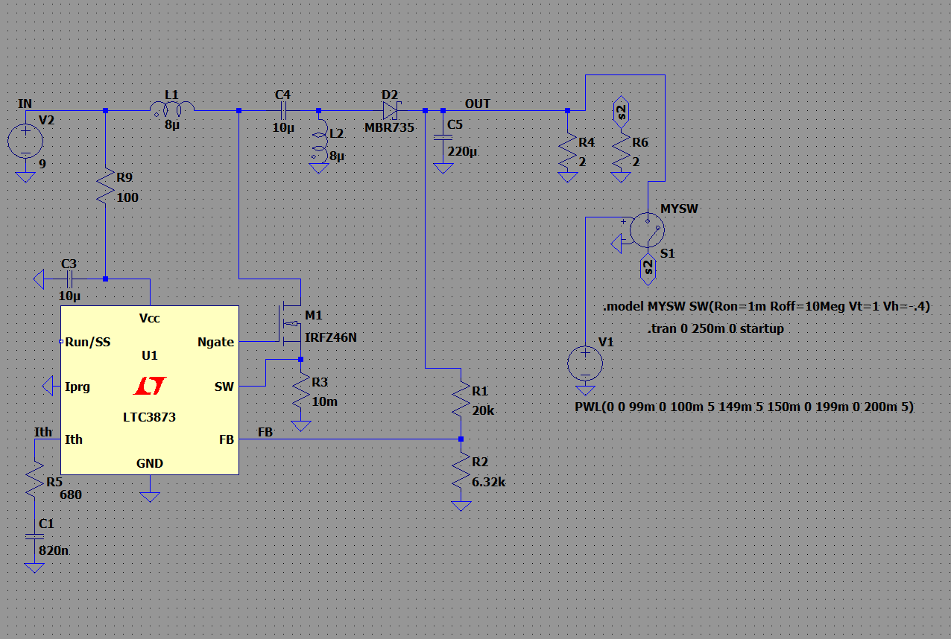

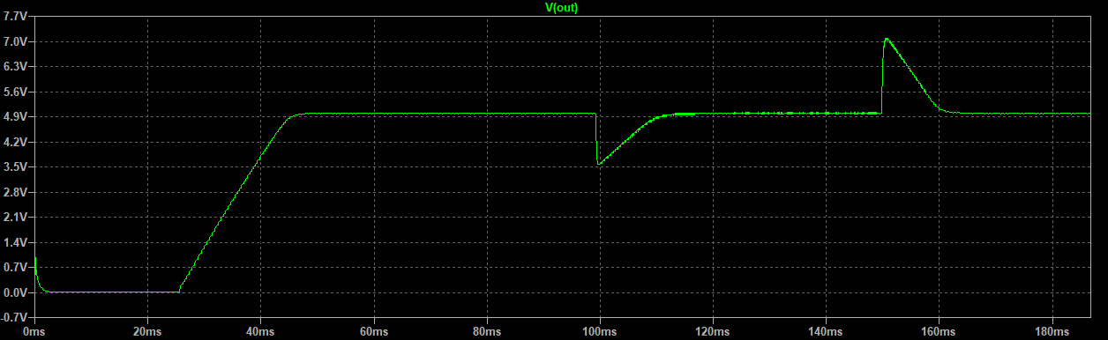

It is so bad for transient response.

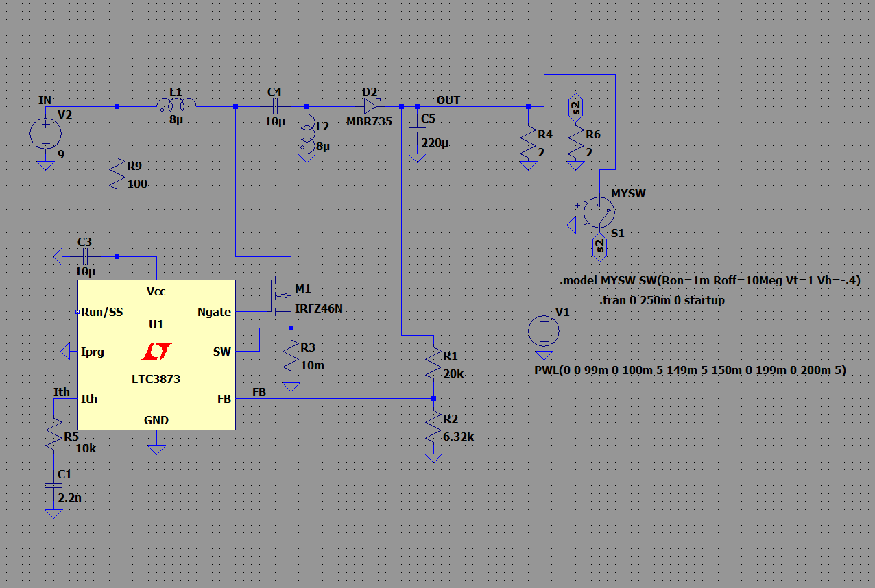

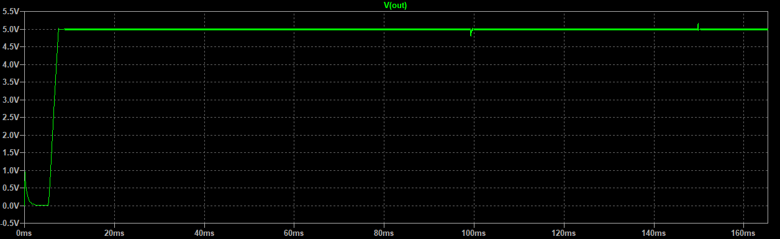

After all this calculation old try and error value 10-15k ohm 2.2-4.7nF compensator network Works better.

And I realized now testing LTC3873 model can’t be used for AC analysis. I changed compensation network contsless times and bode plots are the same so we will do one by one I guess. In dc analysis. First, we need to check if compansator is close to the expecter from edited pdf. We look 3 frequencies fp, fz, fc or fpc, fzc, fc. Also I did put link about this, but did find more clear video: <https://www.youtube.com/watch?v=LDPAbScpzZw&t=192>

Fc=2960Hz, Fz= 296Hz, Fp=2.96Hz

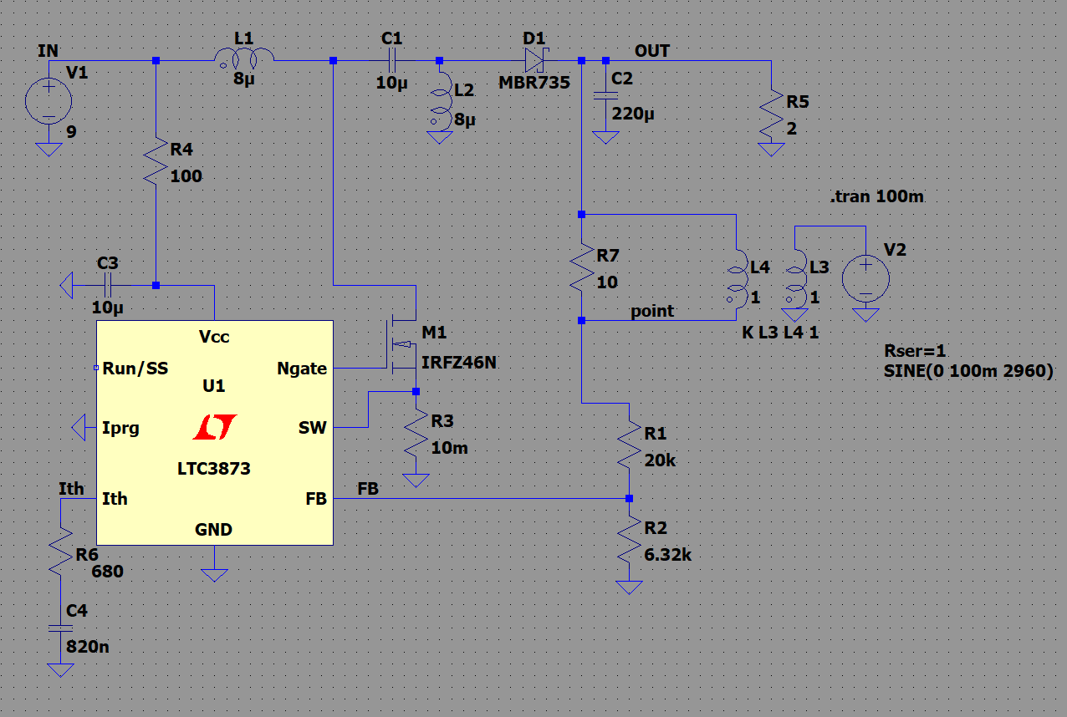

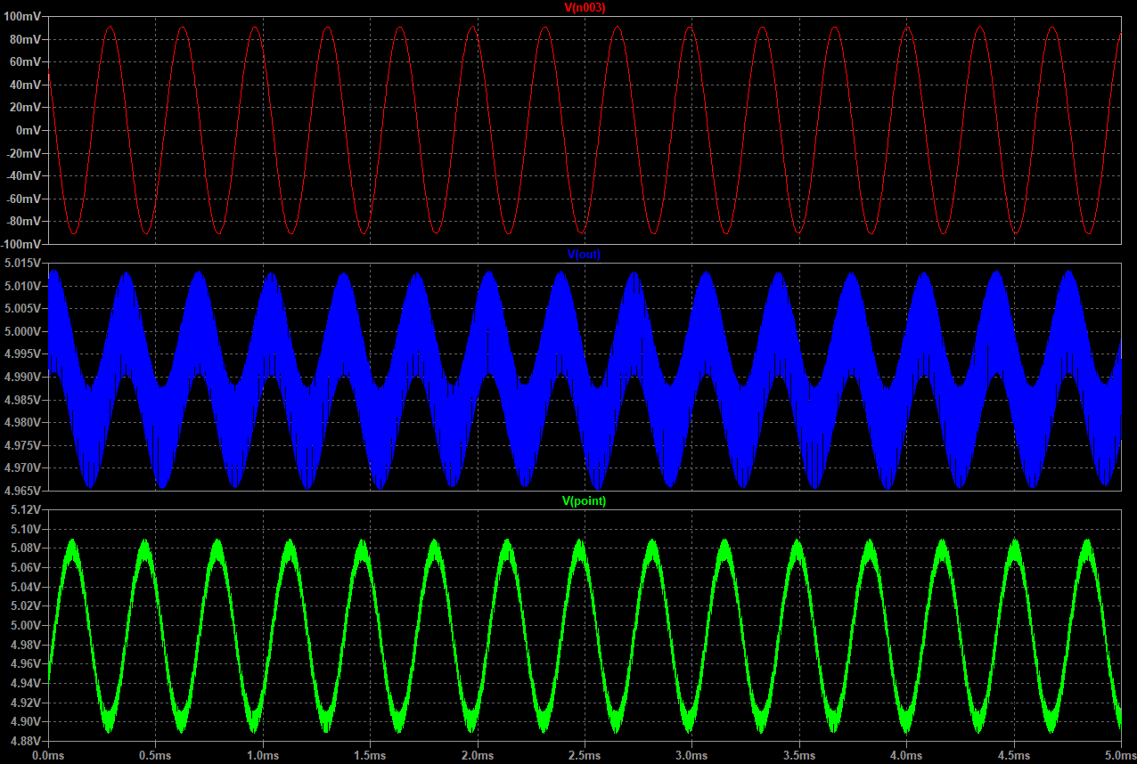

You can see our signal 100mV sinus signal peak to peak 200mV is injected(bit noisy because didn’t find right value for it) on Vpoint and effected Vout.

Calculation of gain is Vout(peak-peak) / Vpoint(peak-peak) = gain

Or Vout(peak-peak) / injected signal(peak-peak) = gain

(5.0132-4.9656) / (5.088-4.89) = .0476 / .198 = .24

Or .0476 / .2 = .2375 = -12.5 dB

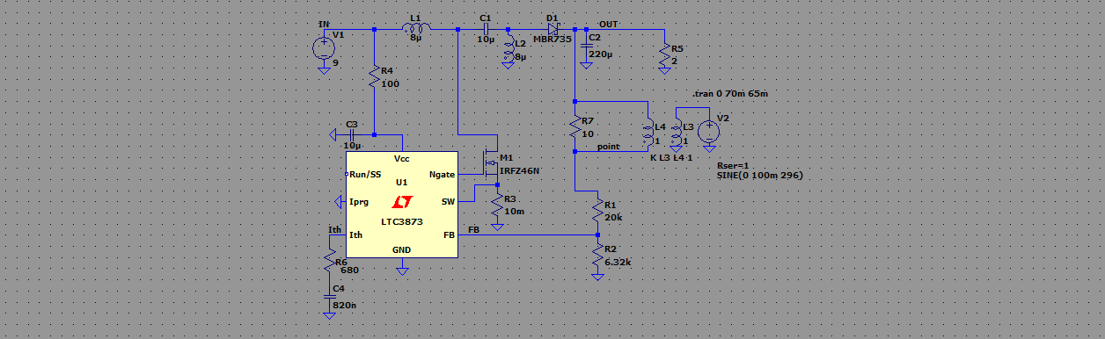

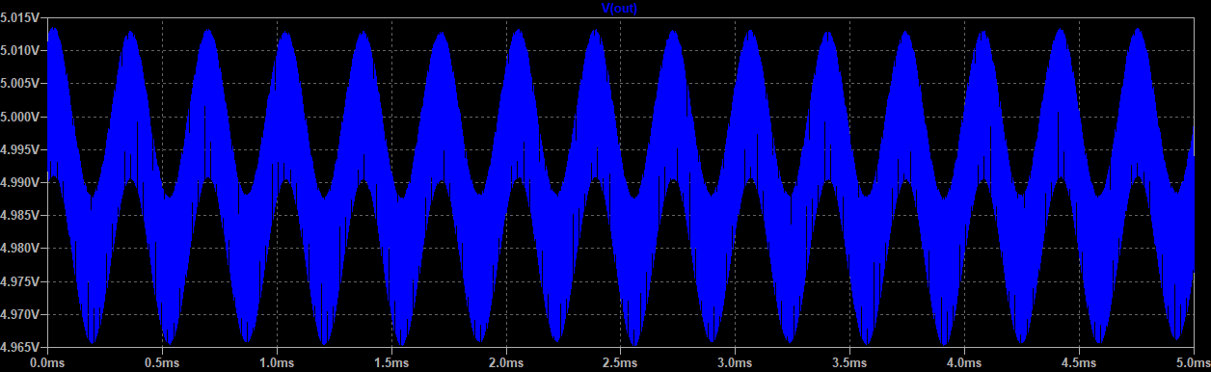

Calculation becomes lower gain than fc that shouldn’t be so didn’t get the loop compensation we want with compensator network. According to gain is so low and fzc gain lower than fc gain. We failed and i tried different ic which has calculation on LT power CAD. Also failed in simulation with results.

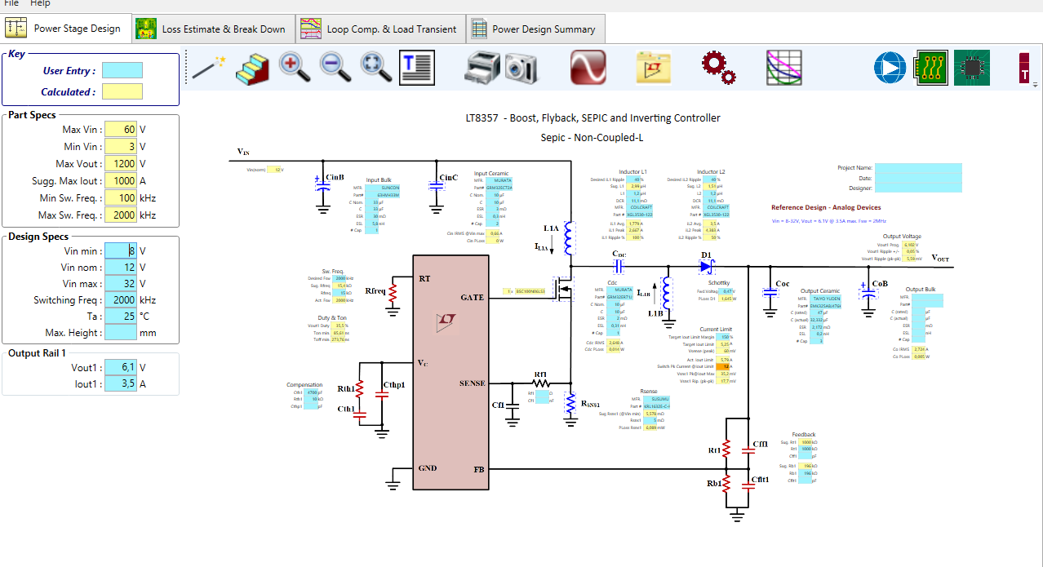 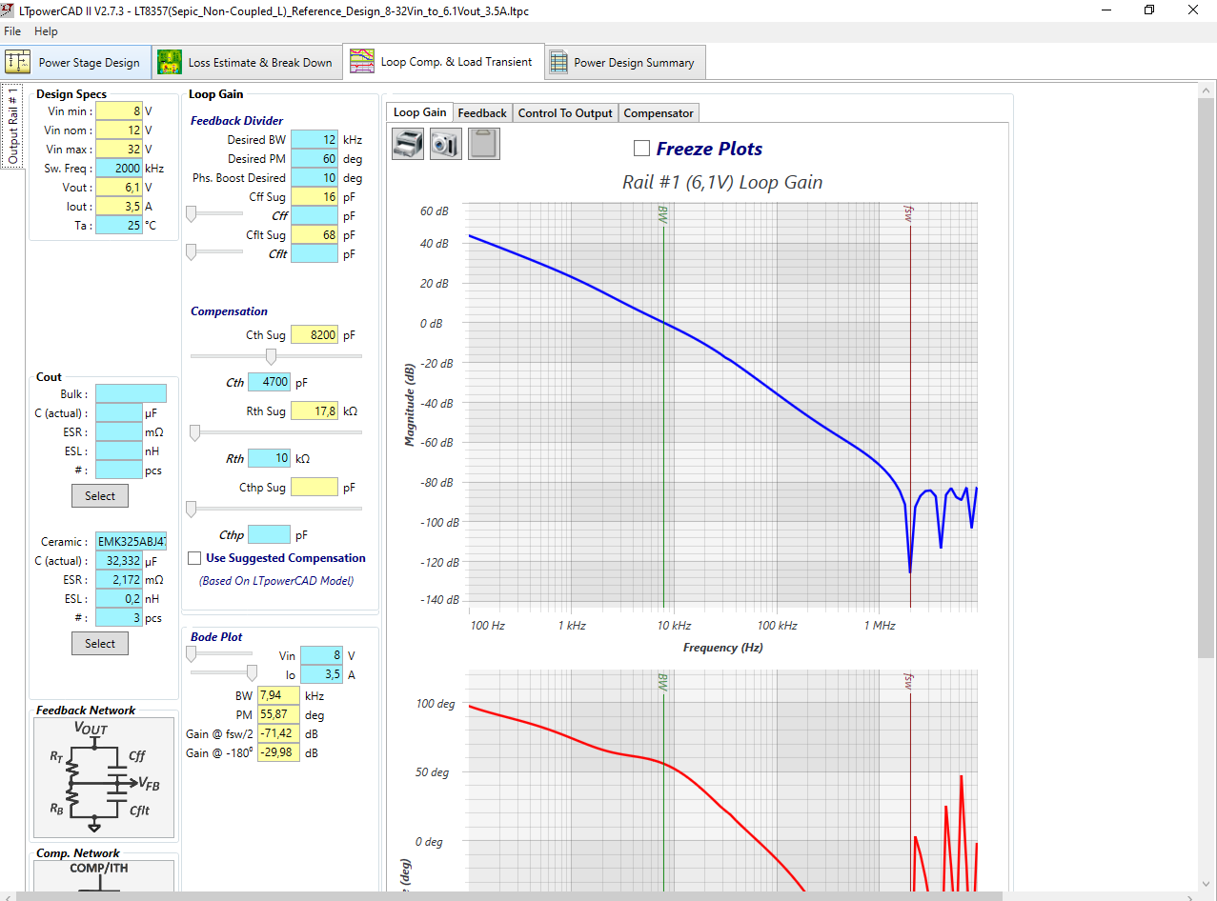

Screen shots for not for my attemts all companies Texas, LT, ST hve this sort of power tools on PC programs and on internet. Also have excel files which does the same calculations for you. I recommend to you use LM51561 it has Excel files. Or IC you cant find for your situation with this kind of tools. Even than power stage calculations didn’t work. Those aren’t different IC to IC if switching frequency is same. I tried above tool for power stage calculation for and our calculation for power stage work better. If we come to compensato, it is to hard and long to confirm compensation if you don’t have the tools. My last recommendation is the same as before. After, I’ll start to explain current mode in this file, voltage mode in other file.

Now we are going to select Rstart and mosfet.

First Rstart, all supply need stable supply to work. Need to be stable like linear supply to operate good. For example if you dont have stable supply, voltage is not stable this could end up situations not stable voltage reference, or opamp or ota(compansator) to work bad…. So most of the high voltage pwm controller like in our situation uses shunt regulator. It is simplest way of doing it. Because, if you need high range of input voltage you can’t put an linear regulator to inside. Because, you need to have low voltage for your ic to operate with lowest input that ic offer. But, linear regulators waste all energy from higher voltage to lower voltage. If you have 5-60 V input ic so, you reference integrated circuit needs to operate lower than 5 V and probably cant use an ldo regulator, so need to be lower than 5V at least margin for transistor drop. So lets call it 3V. So if you ic use 10mA(not 10mA all the time but ic need to drive mosfet with high current to open them in short time to not waste power when converter works. But, when using shunt regulator it is always). Energy wasted will be for ic inside regulator (Vinput-Vreg) \* current to operate.

Heat needs to go somewhere. So, they use shunt regulator to waste this heat on a resistor outside of ic. At least my comment is this. And this is how it works. In our case 9.3V or 9V is the Vcc to operate.

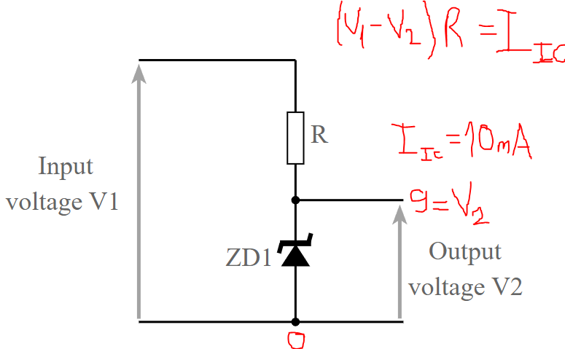

Max 25mA = IIC for LTC3873. But you need to calculate it not so low so IC can open mosfet because if current isn’t enough voltage will be dropped and IC can’t open mosfet. And also, you can choose to low Gate charge mosfets. Also need to be open at least some degree at 10V. Because IC will drive mosfets with shunt regulator voltage 9V. Below, the mosfet datasheet part you will look for.





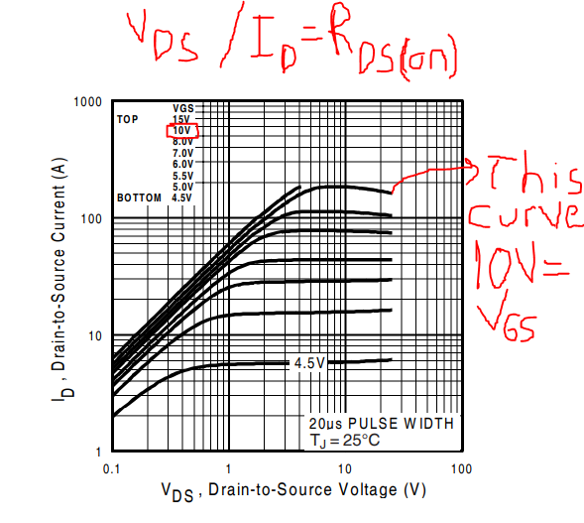

Also, you need to calculate current will pass thorugh and voltage will drop on mosfet. So, you select a mosfet wont damage in your specs of converter. Below, switch closed stage of converter.

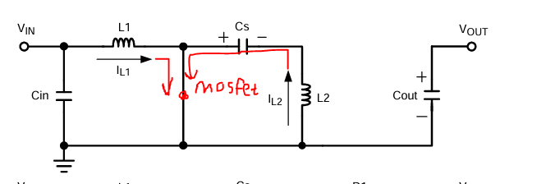

So , I would recommend using IQ1(peak) value choose a mosfet. Mosfet would need to be countinuosly operate. Don’t need to calculate deeper.

For max voltage calculation on mosfet you can simply go with. IQ1(peak) \* RDS(on)

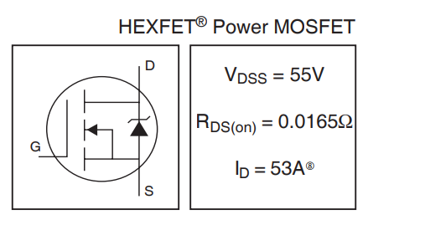

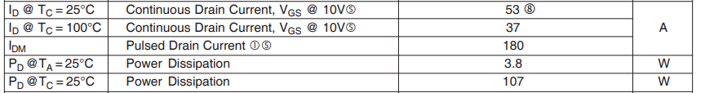

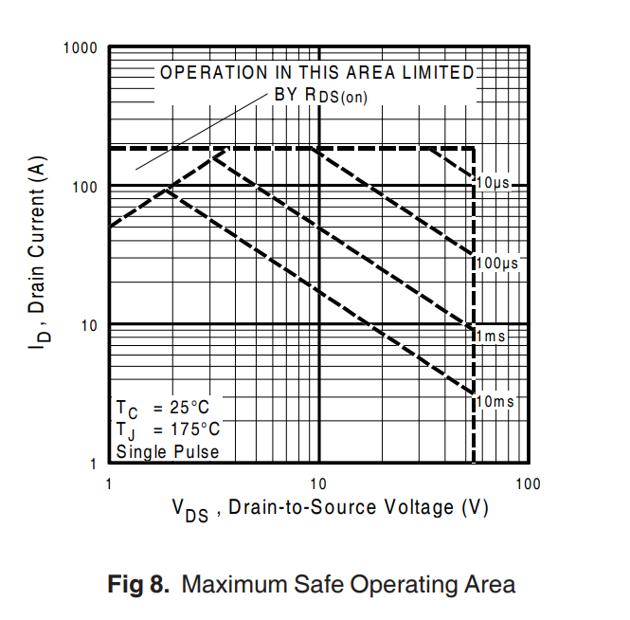

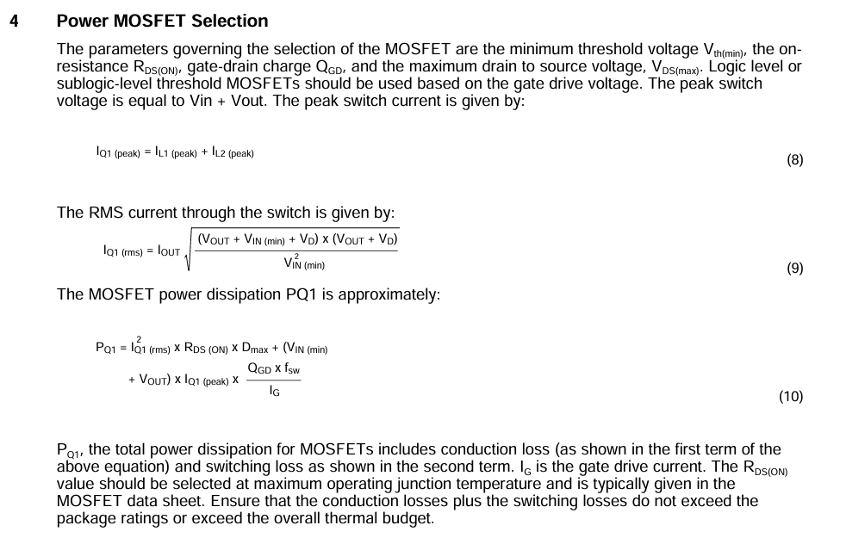

Lasty, I wont recommend logic level mosfet, you can use a standart power mosfet with low gate treshold voltage. And again the same thins I said that will be open enough for 10 V.

The same graph I put. IRFZ46N not ideal but enough with for us because will not work below 10V so good for us. Also, won’t forget to check excel file im gonna prepare it for you for power stage.



Another topic is slope compensation and shunt resistor. LTC3873 switch pin max 60V if im not mistaken. So unless voltage drop on mosfet is higher than 60V, you don’t have to use shunt resistor. Also, shunt resistor affect duty cycle because voltage drop on it causes to peak ramp voltage of comperator. You can understand more cleary about it late when I will talk about current mode operation. Also, it isn’t that much an issue always because in our power stage calculations for 9-21V input, max duty cycle was 39%. Here the calculation for it from datasheet of LTC3873.

