I’ll share pwm regulation techniques page numbers from the book I send you from discord before, dc/dc book of knowledge. Also, I put this book with application notes into same folder, that you can check for lots of things like capacitor types and their properties. I don’t think I can explain pwm regulation better than this. Pages : 46, 47, 48

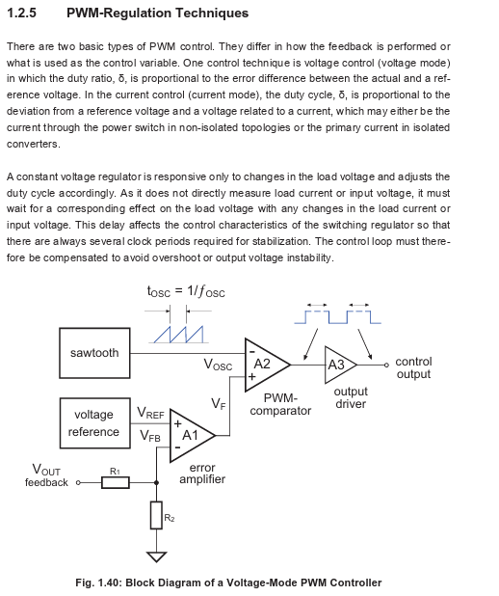

So, now im gonna explain how to implement voltage mode pwm control discretely. Not compensation nor fet driver circuit will be included. Because I show usally how compensator calculation works in current mode. And not gonna show how to implement current mode discretely. Because, it doesn’t make sense to implement discretely expense wise.

But first I can explain how to do compensator design. We did a lag compensator which is below.

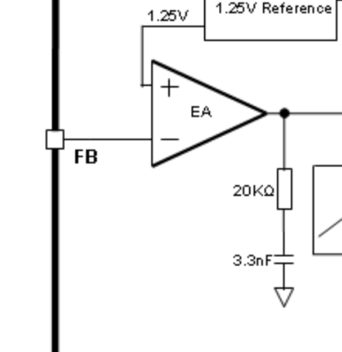 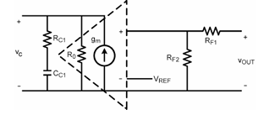

But also you can design type II using SNVA168E application note of cut-off and pole frequency calculations. I show compensator network to point out it’s different. For a second dont think second cc2. Cc1 will have different impedance for different frequencies. So, you can think like Cc1 like a resistor. Rc +Rc1 will give you different gain for different frequencies. So, it is not important to my knowledge if resistor or capacitor is first.

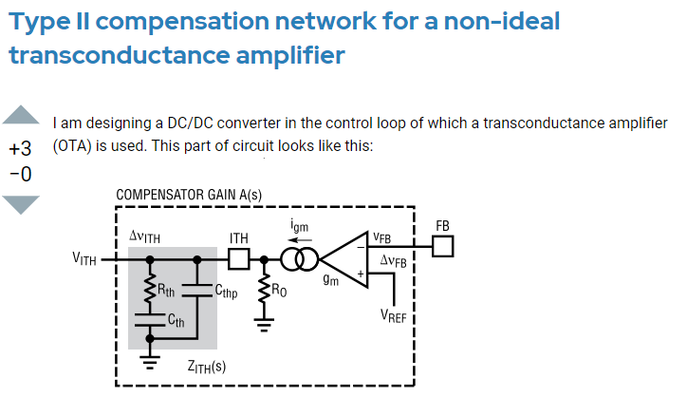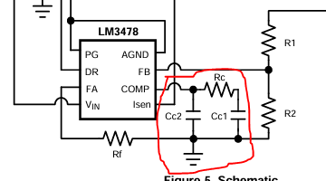

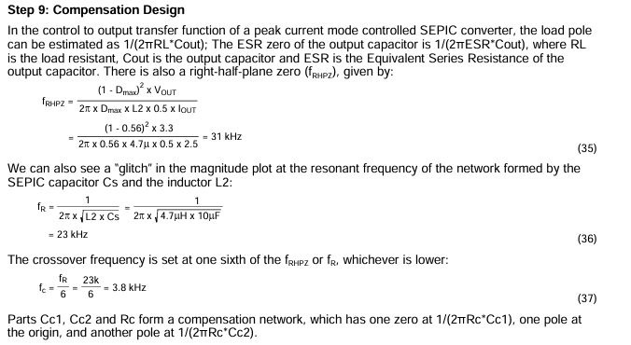

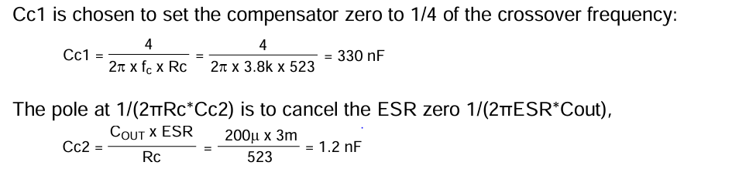

And using SLVA662 to implement an Type II controller using an OTA or Op-Amp. Or just use SNVA168E calculations. I included compensator calculations according to SNVA168E.

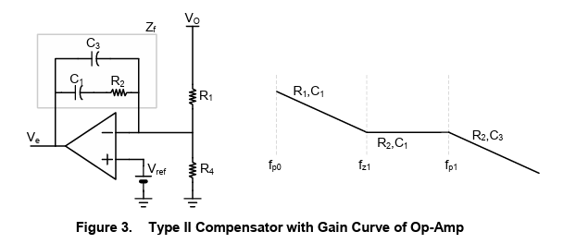

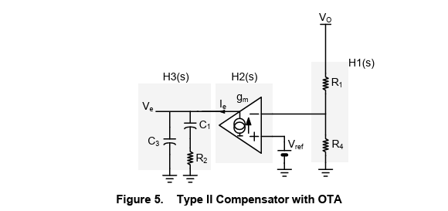

While writing this I calculated for the same power stage we used with Excel I prepared so the result is this. Note, I couldnt find any current sense gain transfer function or formula for current mode sepic converter to use so current gain = 1.

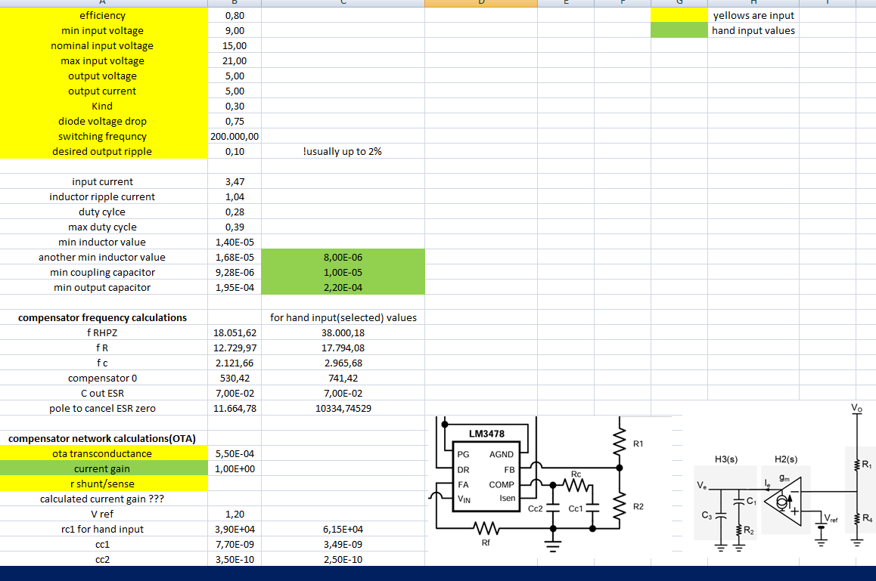

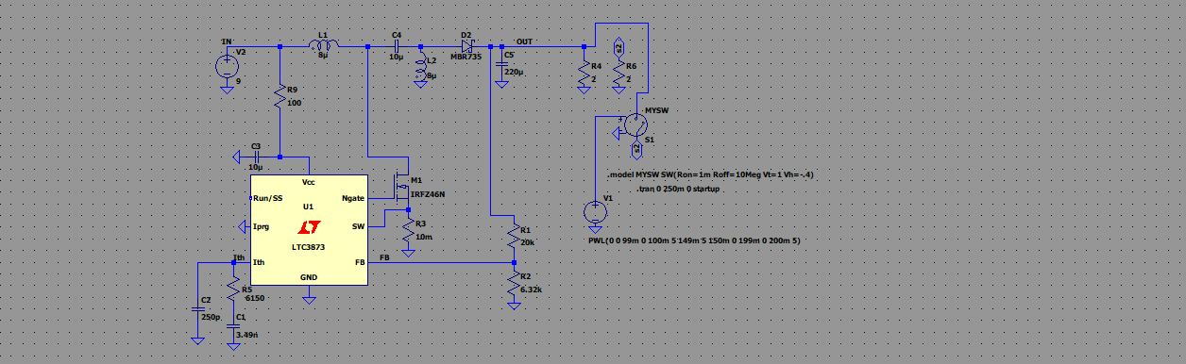

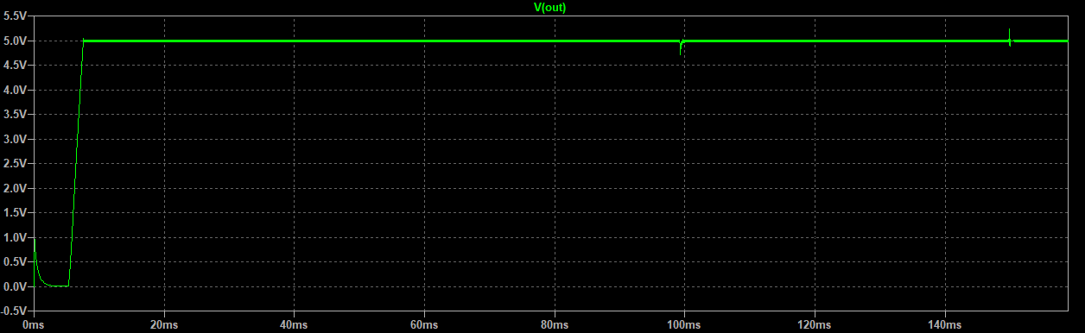

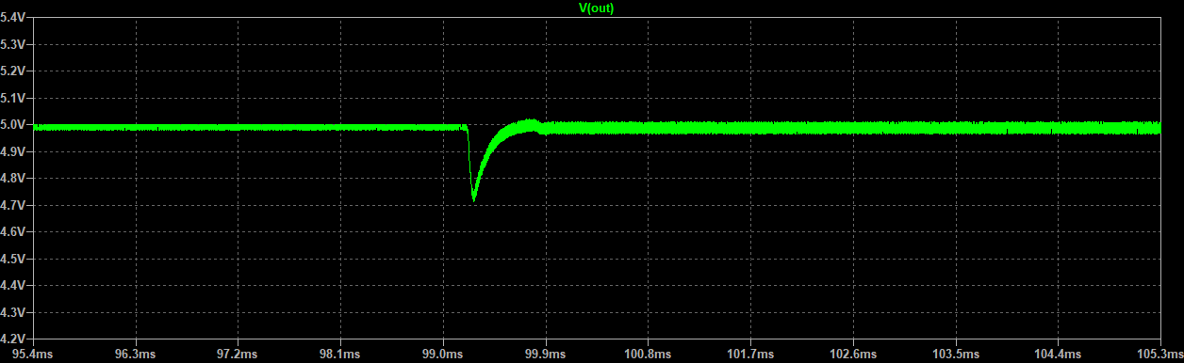

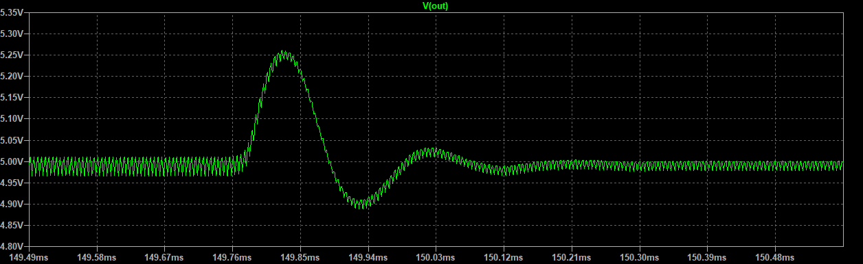

This result much more better and isnt a suprise because it is so muhc closer to lag compensator values I used with trial and error. Also, I tried changing rc1 cc1 places to show you it doesn’t matter like I said. It worked better on simulation. Also, sorry for back and forward situation of this documentation but, desiging controllers usally this type of work.

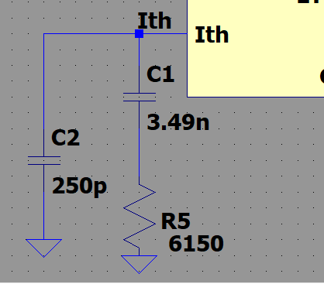

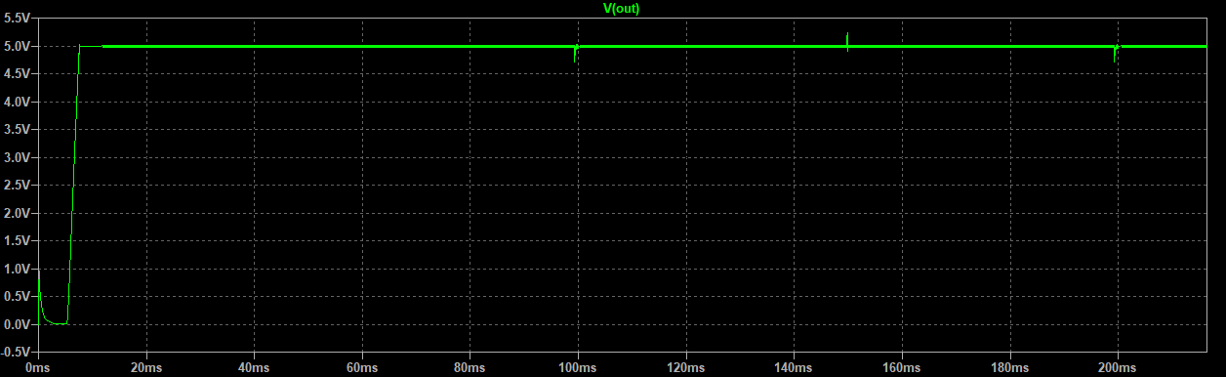

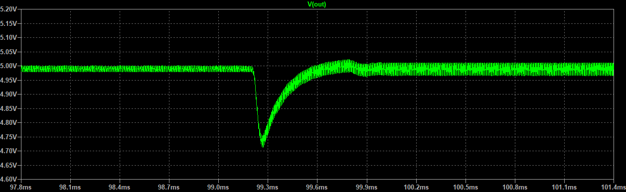

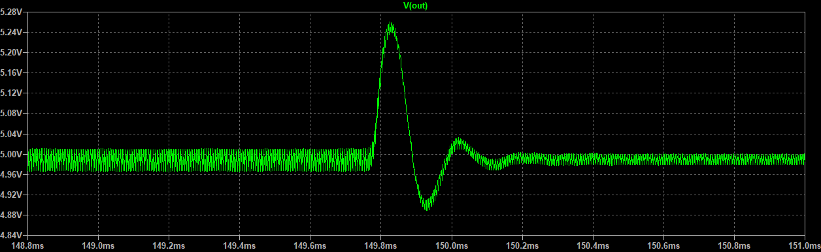

Now, we are going to show you 1 way of triangle wave. But, you can use a 555 or 2 transistors and complementary parts to generat ramp voltage to use.

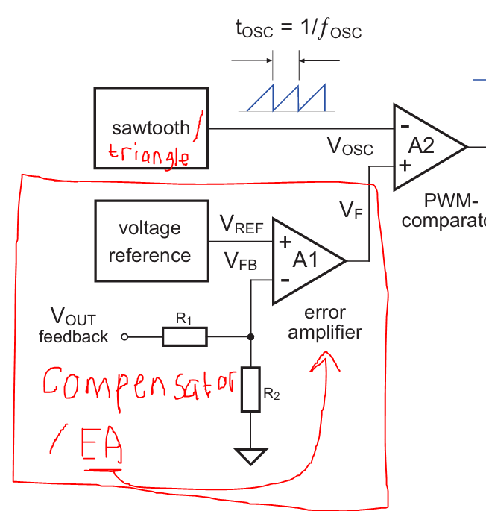

But with using an opamps to generate triangle wave you can simply use one 4 opamp chip for all pwm regulation. 2 opamps for triangle wave, one for error amplifier(compensator), on for pwm comparator. One IC should be better for layout and probably cheaper because at the end you need to use one opamp or ota, one analog comparator, and triangle or ramp generator. Also, It is not ideal to use opamps as an pwm comparator instead of using an analog comperator. But, as long as you don’t go high switching frequency a normal opamp is enough for aspect of speed. For example, you can go up to(with minumum specs of IC by the way) 58kHz – max 80% duty cycle operation under 1 dollar 4 opamp IC that even don’t have that high of a slew rate [TL974IDR](https://www.mouser.com.tr/ProductDetail/Texas-Instruments/TL974IDR?qs=vD%252BlfiDS0%252BOKf6UHUyfKHA%3D%3D). If typical values is thought of, 100kHz- max 80% duty cycle operation.

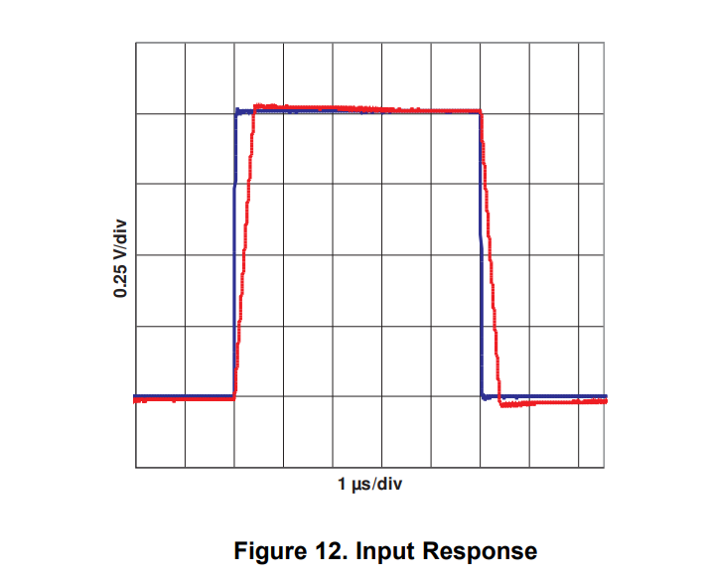

**Triangle wave**

<https://techpicz.blogspot.com/2012/08/triangular-wave-generator-using-op-amp.html>

Below for single supply



Doesn’t matter which point you out pot. Basically 2 input will be V/2 instead of gnd(for dual +/- supply) but at one input trimmer a pot can be benefical if not oscillation may not start. Also, r2/r3 relation can cause not to oscillate to. R2 shouldnt be so close to r3 as value if circuit doesn’t oscillate.

f = R3 / (4*R1*R2*C1)

Vo(p-p) = (2*R2 * Vsat) / R3

Unfortunately, I couldn’t find a guide for voltage mode sepic and transfer functions of the voltage mode control sepic. In voltage mode oscillator peak peak voltage usually is in the calculation. In current mode, it is not because ramp voltage to pwm comparator is provided with current trough inductor. So, in calculation, current gain used instead. But, we are gonna use same frequency point from excel calculations and slva662 to design compensator and will see the results. Also, in those calculations instead of using Vref vout relation, it uses fb network values. Calculations in Excel…

From last try frequencies are cut off 2965, pole to cancel esr 10.334k, compensator0 741Hz.

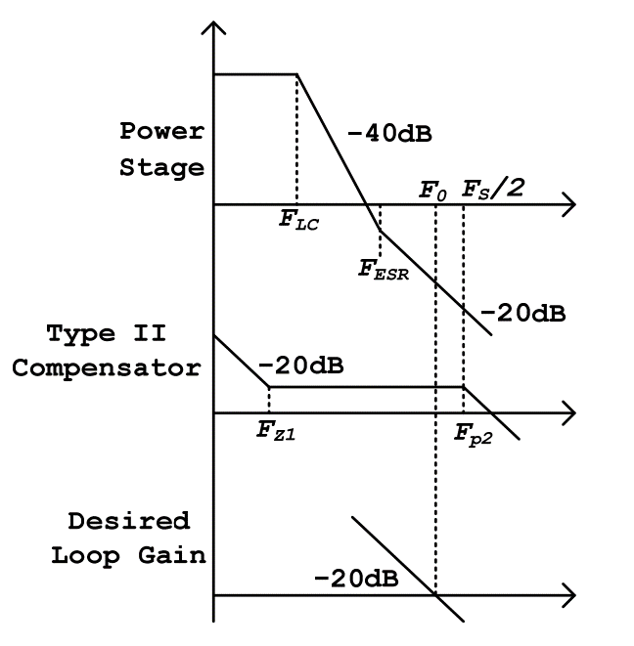

We will put that in this graph this is for buck we have same situation if we use high esr caps. And instead of output lc we have compensator 0 which has simular layout in frequency domain. Below is just type II compensator bode plot not specifically for anything from slva662.

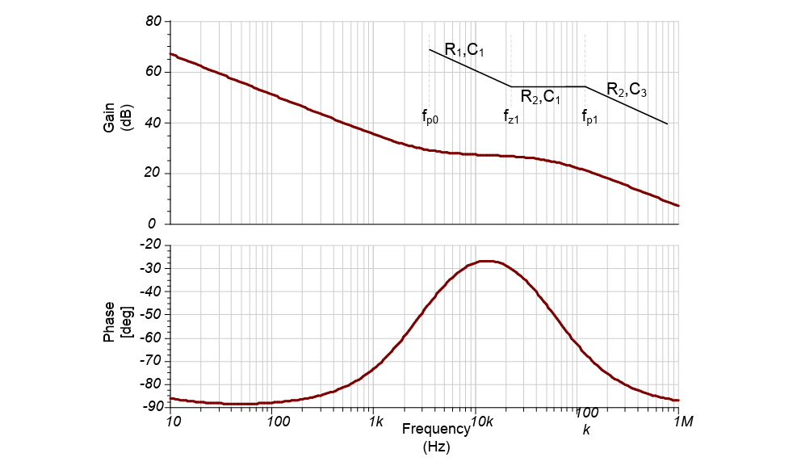

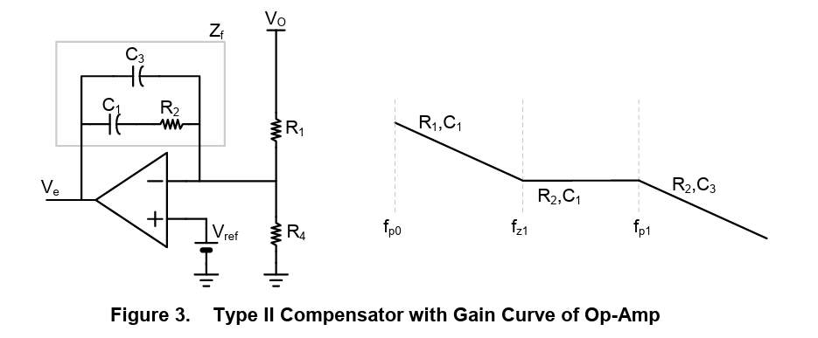

So let fp0=741 , fz1=2965, fp1=10334

So from Excel (I added this part to – name: compensation network calculation(Op-Amp))

But I had terrible result, just terrible.

Sorry but I couldn’t find any guide for voltage mode sepic compensation again (search for very long time).

This is how much I can go further. You may succeed with trial and error. And you can check for driver circuit from here: <https://github.com/furkanmakasci/Asynchronous-Buck-Converter> or you can try this type of circuit below, which is the same with the link I send you with missing part I circled with blue,

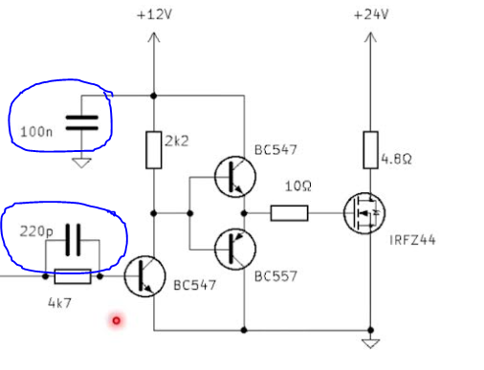 Or 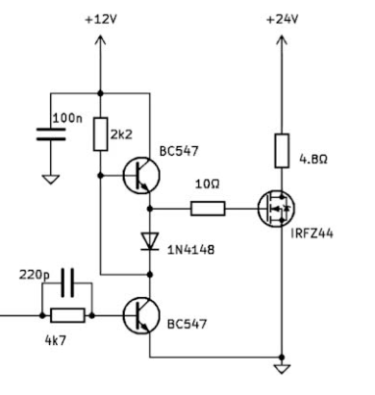

But, safest and easiest way should be use a driver IC for you. If you will implement discere voltage mode control.

So, to show excel calculation work for current mode nicely. Im gonna try another current mode config for 25V 1A the same input (9-21V nominal 15V). Also, by the way I tried no load conditions for all simulation. You don’t need to worry about no load situations. Also, 9V input to 25V ouput near to max duty cycle of LTC3873 won’t recommend it. 15V is more realistic.

