# Coin Smash ASMR - The Game Pitch

1. **Short description of the game**
   1. The Game is about: Balls collects coins by hitting them with cannon.
   2. The Special Sauce is Clicker ASMR
   3. The Wow moment of the game will be Visually satisfaction moments
2. **Core mechanic and fun element**
   1. The Player needs to upgrade core loop via buttons and touch the screen to speed up
   2. If a player completes a level , new coin building (eiffell,pyramid vs) shows up
3. **Controls, lose/fail condition, and progression**
   1. The players control the balls speed with touching screen
   2. The player will past next building when: building mades of coins is collapsed
4. **Art references**

The art will look like this game: [Marble ASMR]

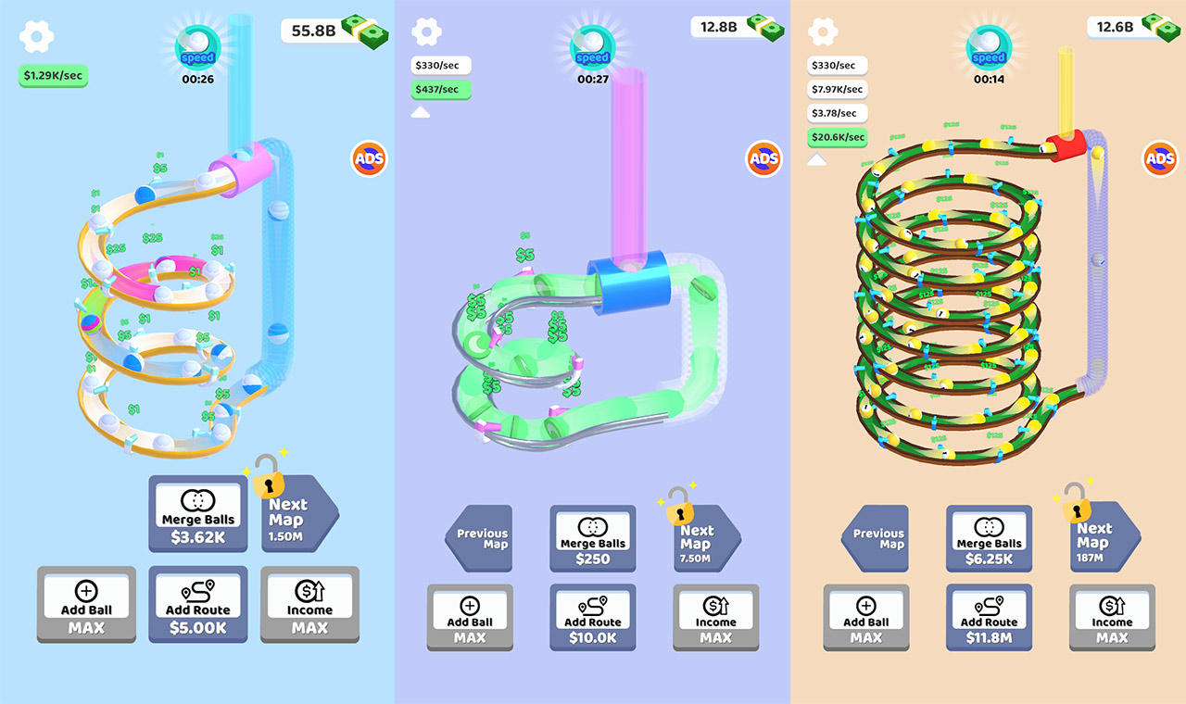

1. **Game references** The gameplay will be like in this game: [Marble ASMR]



The gameplay will be like in this game: [Little Breakers]

