1. padImage

|  |  |
| --- | --- |
| Original Image | Output |
|  |  |

1. cropImage

|  |  |
| --- | --- |
| Original Image | Output |
|  |  |

1. filterImage

|  |  |  |
| --- | --- | --- |
| Original Image | X-directional HP | Y directional HP |
|  |  |  |
| Laplacian | Gaussian | Uniform averaging |
|  |  |  |

1. orderStFiltering

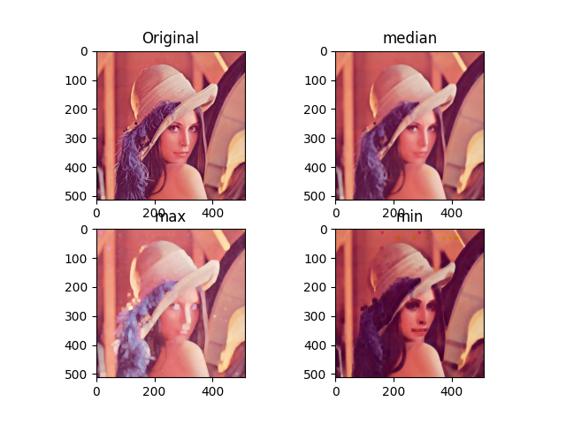

1. unsharpMasking

