G:27

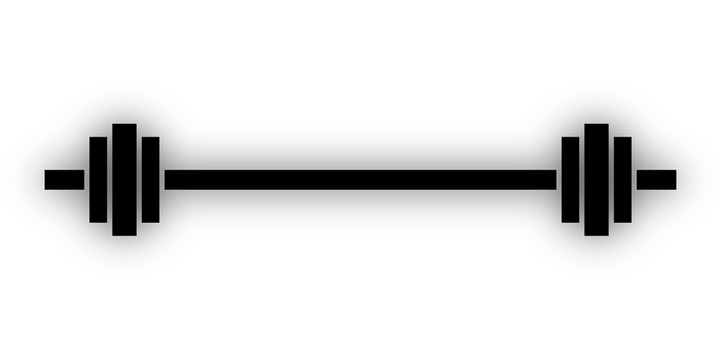

**Gym management System**

**BIM312 DATABASE MANAGEMENT SYSTEM**

Homework

# CONTENTS

FURKAN ZORLU

furkanzorlu@eskisehir.edu.tr

Id: 15803560996

SERKAN GÖRKEM ÖZUÇAR

[serkangorkemozucar@eskisehir.edu.tr](mailto:serkangorkemozucar@eskisehir.edu.tr)

Id:13336177742

## PAGE

Introduction………………………………………............2

Requirements……………………………………………..3

Assumptions and Queries………………………………4

E/R Diagram……………………………………...……….5,

*Relational Chema…………………………………….6*

FUNCTIONAL DEPENDENCIES……………………………….7

DATABASE NORMALIZATION ………………………………7

FINAL RELATİONAL SCHEMA………………………………….7

APPLİCATİON AND SCREENSHOTS…………………………….8

# INTRODUCTION

## People live in accordance with the rules of society, are able to establish good relationships, depends on physical and mental development of people. The maintenance of health and fitness helps a person to be in the general state of health and well-beingIt provides ability to perform physical actions without being tired or restless. However, the maintenance of health and fitness requires regular physical exercise with balanced diet,Moreover, Staying fit and making exercise is also good for their joints and makes their body stronger overall.Attending a fitness center regularly is a good way to achieve them all.

## All in all , we are going to develop a database system which is related to our fitness center.

## In this step of the Project , we show case the complex Fitness Center System by a simplified Entity-Relationship Diagram including a Requiremen Analysis.

# *REQUIREMENTS*

##### Members(Customers)

##### Staff

##### 2.1.Trainer

##### 2.2. Supervisor

**Member:**

🡺Our members use the System to Access their Trainer , Branch Details , and Customer Report.

🡺Member can register for the Fitness Center.

🡺Members can update their Profile.

🡺Members can see what all Facilities are avaliable to them.

🡺Members can upgrade their Membership.

🡺Members can acces Trainers and type of Equipments which are available

**STAFF:**

SUPERVISOR:

🡺Supervisor will manage the entire Fitness Branch.

🡺Supervisor will work all clerical tasks such as Member Report , and maintaining Equipments.

TRAINER:

🡺Trainer will provide personal training to member.

# ASSUMPTIONS AND QUERIES

* -One Facility can used multiple by multiple Members provided at the Fitness Center.
* -One Supervisor maintains multiple Member Report.
* -One Fitness Branch can have multiple Equipments.
* -We store a single updated Fitness Report for each Member.
* -A Member may or may not have a Personal Trainer.
* -A Staff can be a Supervisor or Trainer.
* -A Supervisor may or may not maintain Equipments
* -There is a one Supervisor for each Fitness-Branch.

There are also such queries that can seen at below:

1 -Which of the condition machine were most used at the Fitness Center ?

2-How many member do we have ?

3-how many female and man members do we have

4-What is the age of avarage our members?

5-What is the body-mass index our members?

# E/R DIAGRAM

NOTE: The high resolutiony version of the diagram is in the folder

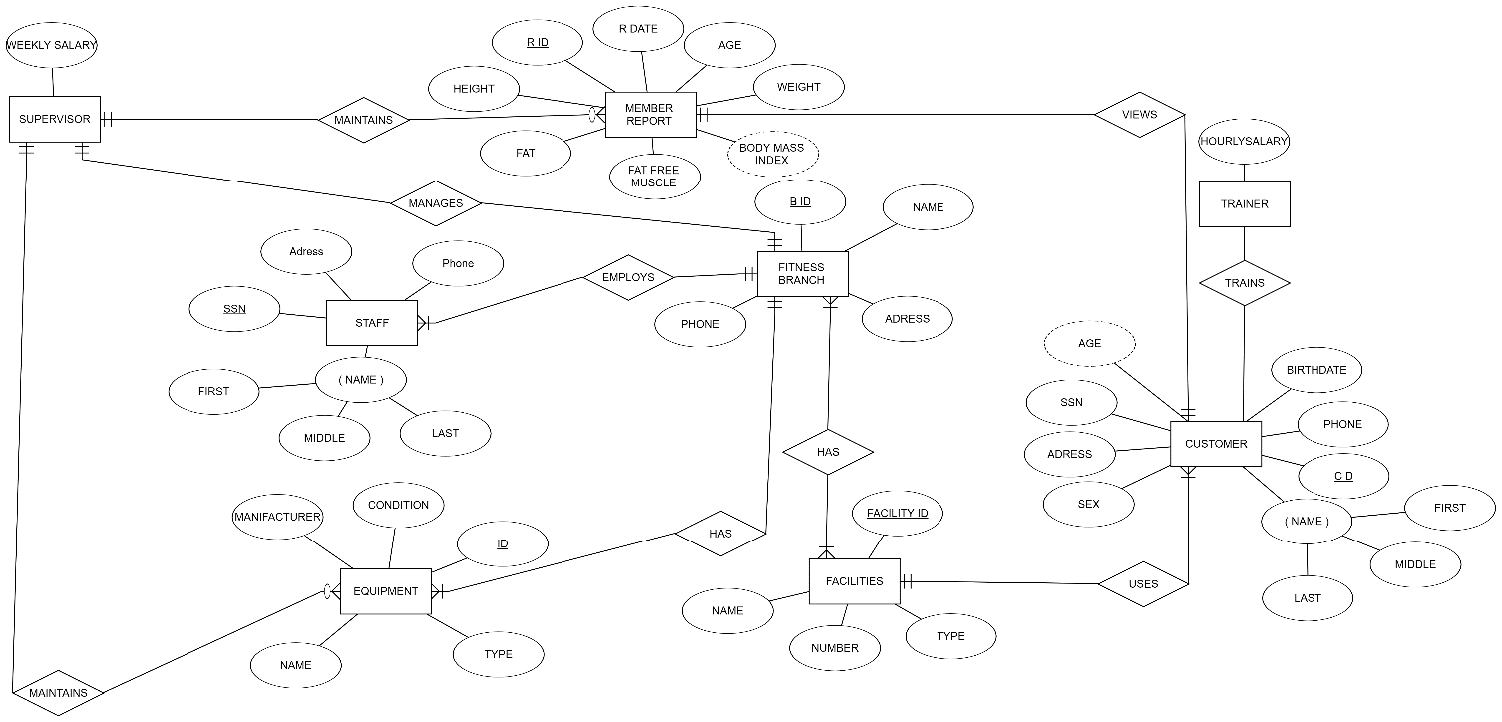

# *RELATİONAL SCHEMA*

NOTE: The high resolution version of the diagram is in the folder

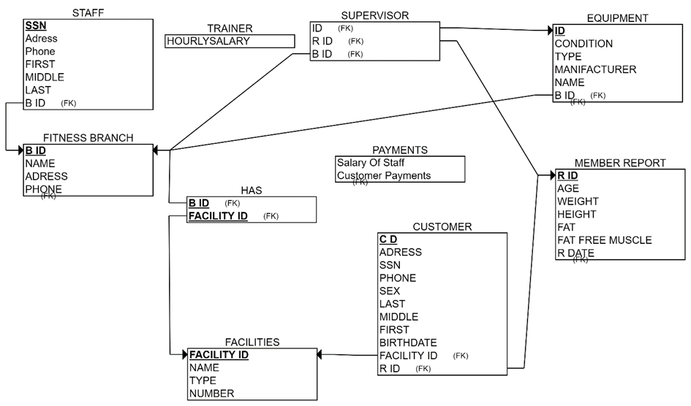

# *FUNCTIONAL DEPENDENCIES*

###### **CUSTOMER**

###### **C_ID→ {SSN, C_NAME, ADDRESS , SEX ,PHONE ,TRAINER_SSN ,FACILITY_ID}**

###### **FACILITIES**

###### **FACILITIY_ID→ {FC_NAME, F_TYPE , COUNT}**

###### **FITNESS_BRANCH**

###### **B_ID→ {ADDRESS, F_NAME ,PHONE }**

###### **F_STAFF**

###### **SSN→ {F_NAME , F_ADDRESS , F_PHONE }**

###### **EQUIPMENT**

###### **E_ID→ {AGE , E_CONDITION,MANUFACTURER , E_NAME , SUPERVISOR_SSN }**

###### **MEMBER REPORT**

###### **R_ID→ { AGE , WEIGHT , HEIGHT , FAT_PERCENTAGE , FAT_FREE_MUSCLE, C_ID }**

# *DATABASE NORMALIZATION*

From our database it seems that there can be one functional dependency in Customer Table for SSN → {C_NAME , ADDRESS , SEX , PHONE }. But here we have no information that depends on it or its components. Thus splitting them is not desired as that may increase number of queries unnecessarily.Hence the database is already in 3 NF.

# *FINAL RELATİONAL SCHEMA*

###### As there is no normalization the final relational schema is same as above.

# *Application*

The application interface is about java swing. Add, delete and update methods and 5 different query databases.

