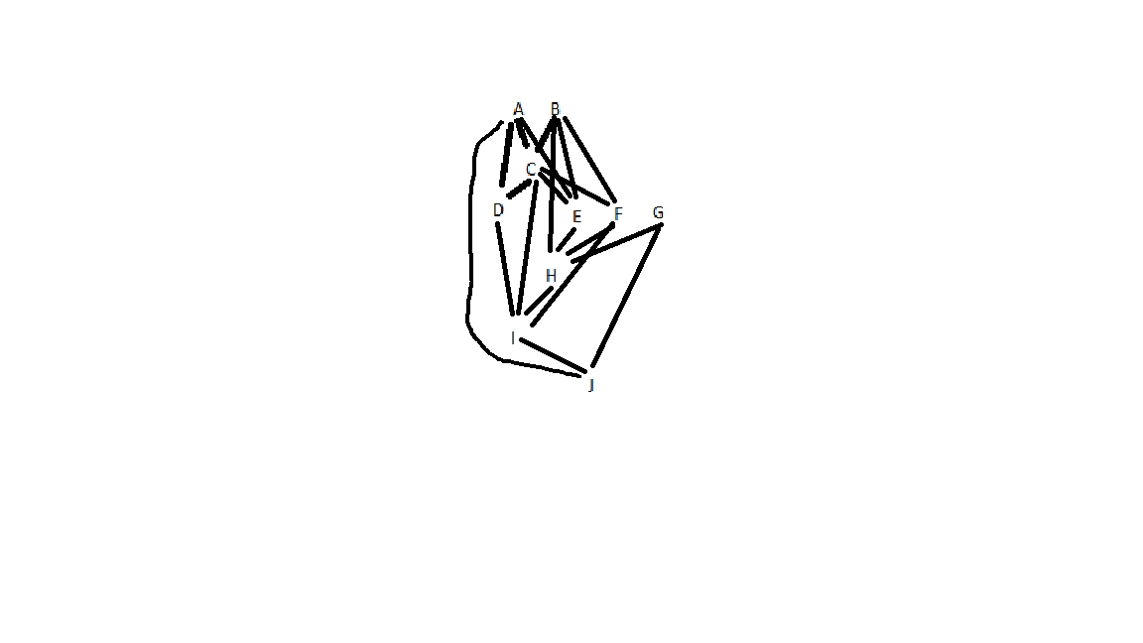fork B

fork G

A

join B

join G

C

fork D

fork E

F

join E

H

join D

I

J