 **Department of Computer Science**

**Faculty of Computing and Artificial Innovation**

**Member Name : Furqan Rasheed**

**Member Reg Id : 221427**

**Class : Bs Computer Science - V (C)**

**Instructor : Ma’am Warda Aslam**

**Course Name : Operating Systems Lab**

**Course Code : CS225**

**Comparative Analysis of Mobile OS (iOS) and macOS through Operating System Concepts**

**1. Introduction**

Operating systems (OS) are the foundational software that manage hardware resources, coordinate processes, and facilitate user interactions in computing devices. This report conducts a comparative analysis of two prominent operating systems developed by Apple: iOS (designed for mobile devices) and macOS (designed for desktops and laptops). The analysis delves into key operating system concepts, including process management, memory management, file systems, security, and scheduling, highlighting both similarities and distinctions influenced by their respective use cases.

**2. Summary of Research Papers**

Extensive research on iOS and macOS underscores their shared heritage, both being built on the Darwin foundation with a hybrid kernel architecture. Despite this common lineage, their divergent use cases necessitate significant architectural and functional differences:

**2.1 iOS**

* **Optimization for Mobile Devices:** Tailored for devices with limited processing power and memory.
* **Power Efficiency:** Prioritizes battery conservation through efficient resource management.
* **Touch-Based Interfaces:** Designed to support intuitive and responsive touch interactions.
* **Enhanced Security:** Implements app sandboxing to isolate applications and protect user data.

**2.2 macOS**

* **Designed for Desktops and Laptops:** Focuses on supporting high-performance applications and multitasking capabilities.
* **Professional Applications Support:** Extensive compatibility with a wide range of professional software and hardware peripherals.
* **Resource Management:** Utilizes more robust resource allocation to handle complex and resource-intensive tasks.

**3. Comparative Analysis**

**A. Process Management**

**iOS**

* **Process Creation:** Utilizes an application lifecycle model with states such as inactive, active, background, and suspended to efficiently manage processes based on user interaction and system resources.
* **Multitasking:** Optimized for limited resources; background tasks are restricted or suspended to conserve power and enhance performance.
* **Inter-Process Communication (IPC):** Employs XPC (Cross-Process Communication) for lightweight and secure communication between processes, minimizing overhead and enhancing security.

**macOS**

* **Process Creation:** Adopts a traditional multitasking model that supports the creation and management of complex, resource-intensive processes essential for desktop environments.
* **Multitasking:** Features robust multitasking capabilities with preemptive scheduling and thread prioritization, allowing multiple applications to run concurrently without significant performance degradation.
* **Inter-Process Communication (IPC):** Utilizes Mach ports, providing a flexible and powerful IPC mechanism suitable for diverse and complex communication needs between processes.

**B. Memory Management**

**iOS**

* **Memory Allocation:** Implements dynamic memory allocation tailored to app requirements, with aggressive recycling strategies to free up memory resources when needed.
* **Virtual Memory:** Limited reliance on virtual memory due to the constraints of mobile hardware; applications are terminated when the system detects low memory conditions to maintain overall stability.
* **Protection:** Enforces strict app sandboxing and data execution prevention to safeguard memory integrity and prevent unauthorized access.

**macOS**

* **Memory Allocation:** Supports extensive memory allocation through mechanisms like demand paging, allowing applications to utilize large memory spaces efficiently.
* **Virtual Memory:** Fully leverages virtual memory with disk-backed paging, enabling the system to handle larger datasets and more demanding applications seamlessly.
* **Protection:** Incorporates advanced security features such as Address Space Layout Randomization (ASLR) to mitigate memory-based attacks and enhance overall system security.

**C. File System**

**iOS**

* **File System Type:** Utilizes the Apple File System (APFS), optimized specifically for flash and solid-state storage, ensuring fast read/write operations and efficient storage management.
* **File Access:** Enforces restricted user access, with applications operating within isolated directories to maintain security and prevent unauthorized data access.
* **Backup:** Integrates seamlessly with iCloud, enabling automatic data synchronization and backup across Apple devices, ensuring data availability and recovery.

**macOS**

* **File System Type:** Also employs APFS but extends support to external file systems like NTFS and FAT32, enhancing compatibility with a broader range of storage media and devices.
* **File Access:** Offers a flexible file access model with a hierarchical directory structure, allowing users and applications to navigate and manage files efficiently.
* **Backup:** Features Time Machine, a comprehensive backup and recovery system that provides incremental backups, easy restoration of previous states, and protection against data loss.

**D. Security**

**iOS**

* **Permissions:** Implements app-based permissions strictly enforced through sandboxing, ensuring that each application has limited access to system resources and user data.
* **Encryption:** Provides end-to-end encryption for data protection, securing data both at rest and in transit to prevent unauthorized access and breaches.
* **Authentication:** Utilizes biometric authentication methods such as Face ID and Touch ID, offering secure and convenient access control mechanisms.

**macOS**

* **Permissions:** Employs user and group-based permission models, granting extensive control over file and system access to accommodate multi-user environments and complex workflows.
* **Encryption:** Features FileVault, which offers full-disk encryption to protect all data on the system from unauthorized access, ensuring comprehensive data security.
* **Authentication:** Supports multi-factor authentication and enforces strong password policies, enhancing the security framework against unauthorized access attempts.

**E. Scheduling**

**iOS**

* **CPU Scheduling:** Optimizes for energy efficiency using a priority-based scheduler that balances performance with power conservation, crucial for mobile device longevity.
* **Real-Time Processing:** Offers limited real-time capabilities, focusing instead on maintaining responsiveness and user experience under varying workloads.

**macOS**

* **CPU Scheduling:** Utilizes priority-driven scheduling algorithms that prioritize performance, allowing for efficient handling of demanding applications and multitasking scenarios.
* **Real-Time Processing:** Supports real-time tasks essential for professional applications such as video editing, audio production, and scientific computing, ensuring timely and predictable task execution.

**4. Creative Analogy**

The relationship between iOS and macOS can be compared to that of a sports car and a luxury SUV:

* **iOS (Sports Car):** Lightweight, efficient, and engineered for speed and responsiveness. It excels in delivering a smooth and agile user experience on mobile devices, emphasizing power conservation and swift interactions.
* **macOS (Luxury SUV):** Powerful, versatile, and capable of handling heavy loads. It is designed for robust performance and multitasking, accommodating professional workflows and demanding applications with ease.

**Visual Representation**

To enhance understanding, the following diagrams are recommended:

1. **App Lifecycle in iOS vs. Process Lifecycle in macOS:**
   * Illustrates the states of app processes in iOS (inactive, active, background, suspended) contrasted with the more traditional process states in macOS.
   * 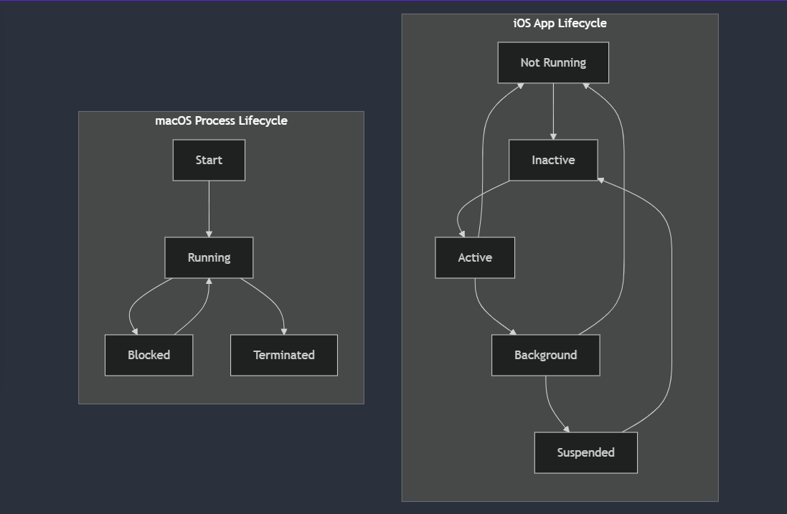
2. **Comparison of Memory Allocation Techniques:**
   * Visualizes the dynamic memory allocation and recycling in iOS against the demand paging and virtual memory utilization in macOS.



1. **Security Architecture of Both OS:**
   * Depicts the sandboxing and permission models in iOS alongside the user/group-based permissions and encryption mechanisms in macOS.

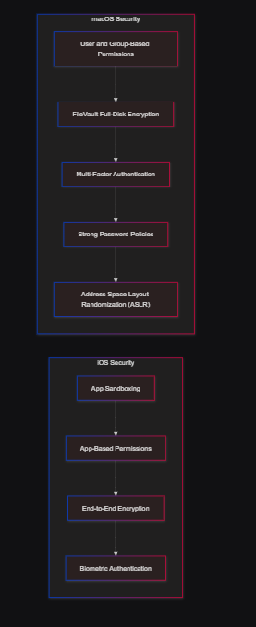 

**5. Insights and Observations**

* **Usability:** iOS excels in delivering a streamlined and intuitive user experience, ideal for casual and on-the-go usage. In contrast, macOS offers greater flexibility and depth, catering to professional users who require advanced functionalities and customization options.
* **Efficiency:** iOS is meticulously optimized for battery life and resource conservation, ensuring prolonged device usage. macOS, on the other hand, is designed for sustained high performance, supporting intensive applications and multitasking without compromising speed.
* **Security:** Both operating systems maintain high security standards. However, iOS's stringent sandboxing approach provides superior isolation for individual apps, minimizing the risk of cross-application vulnerabilities.
* **Scalability:** macOS demonstrates superior scalability, supporting a wide range of hardware configurations and peripherals. This makes it particularly suitable for diverse professional environments that demand flexibility and compatibility with various hardware setups.

**6. Conclusion**

iOS and macOS exemplify the evolution of operating systems tailored to distinct use cases within the Apple ecosystem. iOS's emphasis on mobility, efficiency, and user-friendly interfaces makes it ideal for mobile devices, while macOS's versatility, robust performance, and extensive support for professional applications underscore its suitability for desktop and laptop environments. Together, they showcase Apple's proficiency in developing specialized, high-performance systems that cater to the unique demands of different computing platforms.