A Systematic Literature Review Protocol for Testing and Regression Testing of Quantum Software Compilers
Furqan Nasir, Arif Shah, Iftikhar Alam
Department of Computer Science, City University of Science & Information Technology, Peshawar, Pakistan
Abstract
Quantum software development kits such as Qiskit change constantly, and the transpiler, the component that rewrites an abstract circuit onto real hardware, is one of the parts that changes most. When a single compilation pass is altered it can introduce a regression: the compiled circuit may return a wrong result, or it may still be correct but larger, or simply slower to produce. Judging whether a compiled circuit is correct is itself hard, an instance of the quantum oracle problem, and the community has no consolidated picture of how quantum compilers are tested, still less how they are regression-tested. This paper sets out a protocol for a Systematic Literature Review (SLR) of that area, following Kitchenham's guidelines and the PRISMA reporting standard. It states the research questions and objectives, the databases to be searched, the search strategy, the inclusion, exclusion, and quality-assessment criteria, the data to be extracted, and the way studies will be selected and synthesised. The aim is a reproducible map of the field that can ground later work on testing the quantum compiler in a way that is both trustworthy and affordable. The protocol is registered in the Open Science Framework; it uses two independent reviewers with a measured level of agreement, a thematic plan for synthesising the evidence, and an explicit analysis of threats to validity.
Keywords: Quantum software testing, Quantum compiler, Transpiler, Regression testing, Test oracle, Equivalence checking, Systematic Literature Review Protocol (SLRP), Qiskit.
I. Introduction
Quantum computing has moved from theory to practice, and much of that practice is mediated by software development kits (SDKs) such as Qiskit, Cirq, and tket. Before a quantum program can run on real hardware, it must be rewritten to respect the machine's native gate set and its limited qubit connectivity. In Qiskit [10] this rewriting is performed by the transpiler, a staged compiler whose passes carry out layout, routing, translation, optimisation, and scheduling. These SDKs evolve at a rapid and continuous pace, and the transpiler is among the most frequently revised components.
A change to any pass can introduce a regression, and these come in a few forms. The compiled circuit may compute a different result or crash outright; it may still be correct yet carry more two-qubit gates or greater depth, losing fidelity on noisy hardware; or it may simply take longer or use more memory to produce. Catching such regressions early is a testing problem, but the quantum oracle problem makes it awkward: deciding whether a compiled circuit is correct is expensive, and for the black-box output-equivalence oracle the field usually relies on, some faults cannot be seen at all.
Testing of quantum software, and of quantum compilers in particular, is now an active area, with work on metamorphic testing, differential testing, property-based testing, equivalence checking, and formal verification. That work is scattered across communities, though, and no one has yet drawn it together into a systematic view of how the quantum compiler is tested, or especially how it is regression-tested. This paper therefore lays out an SLR protocol, following Kitchenham [1] and PRISMA [2], to plan such a review rigorously and reproducibly.
The primary contributions of this protocol are:
• To identify and classify the testing techniques proposed for quantum software compilers.
• To analyse the correctness oracles used for compiled quantum circuits and their limitations.
• To assess how regression testing, including test selection and prioritisation, is addressed for quantum compilers.
• To catalogue the benchmarks, datasets, and tools used to evaluate quantum-compiler testing.
• To synthesise the open challenges and research gaps that motivate future work.
The rest of the paper is organised as follows. Section II gives the background on quantum compilation and testing and reviews the related work. Section III presents the research method, comprising the research questions, objectives, data sources, search strategy, study-selection process, quality assessment, and data extraction. Section IV concludes and outlines the expected outcomes of the review.
II. Background
Quantum compilation transforms an abstract, hardware-agnostic quantum circuit into an equivalent circuit that a specific device can execute. In a staged pass manager, layout assigns program qubits to physical qubits, routing inserts operations to satisfy the coupling map, translation rewrites gates into the native basis, optimisation reduces gate count and depth, and scheduling places operations in time. Because the passes that actually run depend on the circuit, the backend, the configuration, and the exact SDK revision, and because compilation may permute qubits, a compiled circuit equals the original only up to a permutation of the qubit layout and a global phase. This makes correctness checking subtle and expensive.
Deciding whether two circuits are equivalent is itself an instance of the quantum oracle problem. Exact unitary comparison does not scale past small circuits, so in practice the field falls back on sampled, observable, metamorphic, or structural checks that trade completeness for tractability. The de-facto criterion, a black-box output-equivalence oracle, looks only at the output map; it can therefore pass a circuit whose internal compiler state has been corrupted, as long as the output still matches. Difficulties of this kind are what make a systematic look at compiler testing worthwhile.
Related work.
A number of research threads feed into this review. Empirical studies have shown that compiler and transpiler components are a significant source of defects in quantum platforms [3], [4]. Metamorphic and differential testing tools such as MorphQ [5], QDiff [7], and QSPE, together with fuzzing and equivalence-modulo-inputs approaches such as QuteFuzz [11] and QEMI [12], generate, transform, or fuzz programs to expose miscompilations; property-based tools such as QuCheck [8] bring assertions and generators to Qiskit; equivalence-checking techniques compare circuits efficiently before and after compilation [6]; formal tools such as Giallar [13] and CertiQ [14] verify individual compiler passes; and bug benchmarks such as Bugs4Q [15] collect real quantum-program faults for reuse. Classical software engineering, for its part, has a mature literature on regression test selection and prioritisation, where cost-, history-, and change-aware heuristics are well-established baselines [9]. What no one has done is pull these threads together into a systematic synthesis centred on the quantum compiler.
Existing systematic reviews.
To confirm that a systematic review of this specific scope has not already been performed, we searched the electronic databases for existing secondary studies using strings such as (“quantum compiler” OR “quantum transpiler”) AND (“systematic literature review” OR “survey” OR “mapping study”) AND (testing OR “regression testing”). Existing secondary studies address quantum software testing broadly, but none focuses specifically on testing and regression testing of the quantum compiler, which confirms the need for this review.
III. Research Method
The research method follows the SLR guidelines of Kitchenham [1]. It comprises the research questions (Table 1), the research objectives (Table 2), the electronic data sources (Table 3), the search strategy and search terms (Table 4), the study-selection process using the inclusion/exclusion criteria (Table 5) and the study-selection flow (Figure 1), the quality-assessment checklist (Table 6), and the data-extraction form (Table 7).
Protocol Registration and Amendments.
The protocol was registered in the Open Science Framework (OSF) before the review was carried out (registration DOI: to be inserted on registration). Fixing the questions, the search, and the selection and analysis rules in advance is what later lets a reader check the finished review against its plan and see where, if anywhere, the two diverge. Should anything change while the review is under way, say a search string, an inclusion rule, or an extraction item, the change will be logged in the OSF record with its date and the reason for it, and reported in the final paper.
Research Questions.
The review is organised around five research questions, shown in Table 1.
Table 1: Research Questions
ID | Research Question | Motivation
RQ1 | What testing techniques have been proposed for quantum software compilers (transpilers)? | To identify and classify the landscape of quantum-compiler testing approaches.
RQ2 | What correctness oracles are used for compiled quantum circuits, and what are their limitations? | To understand how correctness is decided and where the oracles fall short.
RQ3 | How is regression testing, including test selection and prioritisation, addressed for quantum compilers? | To determine whether budgeted regression testing exists for the compiler.
RQ4 | What benchmarks, datasets, and tools support the evaluation of quantum-compiler testing? | To catalogue the evaluation infrastructure available to researchers.
RQ5 | What are the open challenges and research gaps in testing quantum compilers? | To surface directions for future research.

Research Objectives.
The objectives, mapped one-to-one to the research questions, are shown in Table 2.
Table 2: Research Objectives
ID | Objective (answers)
O1 | To catalogue and classify the testing techniques proposed for quantum compilers. (RQ1)
O2 | To analyse correctness-oracle strategies for compiled circuits and their limitations. (RQ2)
O3 | To assess regression-testing, selection, and prioritisation methods for quantum compilers. (RQ3)
O4 | To identify the benchmarks, datasets, and tools used for evaluation. (RQ4)
O5 | To synthesise the open challenges and research gaps in the area. (RQ5)

Data Sources.
The primary sources are the electronic databases listed in Table 3, chosen for their coverage of software engineering and quantum-computing venues; arXiv and Google Scholar are included to capture recent preprints and grey literature.
Table 3: Data Sources
Source | URL
IEEE Xplore | https://ieeexplore.ieee.org
ACM Digital Library | https://dl.acm.org
ScienceDirect (Elsevier) | https://www.sciencedirect.com
SpringerLink | https://link.springer.com
Scopus | https://www.scopus.com
Web of Science | https://www.webofscience.com
arXiv | https://arxiv.org
Google Scholar | https://scholar.google.com

Search Strategy.
The search covers the period from 2015 to 2026, because sustained research on testing quantum SDKs and their compilers is recent, and includes journals, conferences, symposiums, workshops, and peer-reviewed preprints. Search terms are grouped by concept (Table 4) and combined with Boolean operators. The concepts are joined with AND, and the terms within each concept with OR. A representative combined string is: (“quantum” AND (“transpiler” OR “quantum compiler” OR “compilation”)) AND (testing OR bug OR fault OR oracle OR “equivalence checking” OR “regression testing” OR “test selection”).
Table 4: Search Terms by Concept
Concept | Search terms (combined with OR)
Quantum software | “quantum software”, “quantum program”, “quantum SDK”, Qiskit, Cirq, tket, PyQuil
Compiler / transpiler | transpiler, “quantum compiler”, compilation, “pass manager”, “qubit mapping”, routing
Testing / faults | testing, test, bug, fault, defect, miscompilation, regression
Oracle / technique | oracle, “equivalence checking”, metamorphic, “differential testing”, “property-based”, mutation
Selection | “test selection”, “test prioritisation”, “regression test”, cost-aware

Search Procedure.
To make the search reproducible, the concept-based terms in Table 4 are compiled into a database-specific query. For IEEE Xplore, the full query, applied to the document title, abstract, and index-terms fields and restricted to 2015-2026, is: ("quantum" AND ("transpiler" OR "quantum compiler" OR "compilation" OR "pass manager" OR "qubit mapping")) AND ("testing" OR "test" OR "bug" OR "fault" OR "miscompilation" OR "oracle" OR "equivalence checking" OR "regression testing" OR "test selection" OR "test prioritisation"). Equivalent queries, adapted to each engine's syntax and field tags, are used for the other databases and archived in full in the OSF record. In addition to the database search, backward and forward snowballing following Wohlin's guidelines [19] is applied to the reference lists and citing papers of every included primary study, to recover relevant work not indexed under the search terms.
Study Selection.
Primary studies are selected by applying the inclusion and exclusion criteria of Table 5, focusing first on the title, abstract, and conclusion of each candidate and then on the full text. The study-selection process follows the PRISMA stages of identification, screening, eligibility, and inclusion, as shown in Figure 1. Figure 1 also records the main title-and-abstract exclusion reasons to make the large reduction from the broad search results to the final full-text set transparent and reproducible.
Table 5: Inclusion / Exclusion Criteria
Inclusion criteria | Exclusion criteria
Peer-reviewed papers or citable preprints on testing or analysis of quantum compilers or transpilers. | Duplicate records of the same study across databases.
Studies proposing or evaluating a testing technique, oracle, or regression-testing method for quantum compilation. | Papers not available in the English language.
Studies published between 2015 and 2026. | Papers on a different subject (for example, pure quantum algorithms or hardware) not concerned with compiler testing.
Empirical or methodological studies with a described approach and evaluation. | Short abstracts, posters, or editorials without a described method.

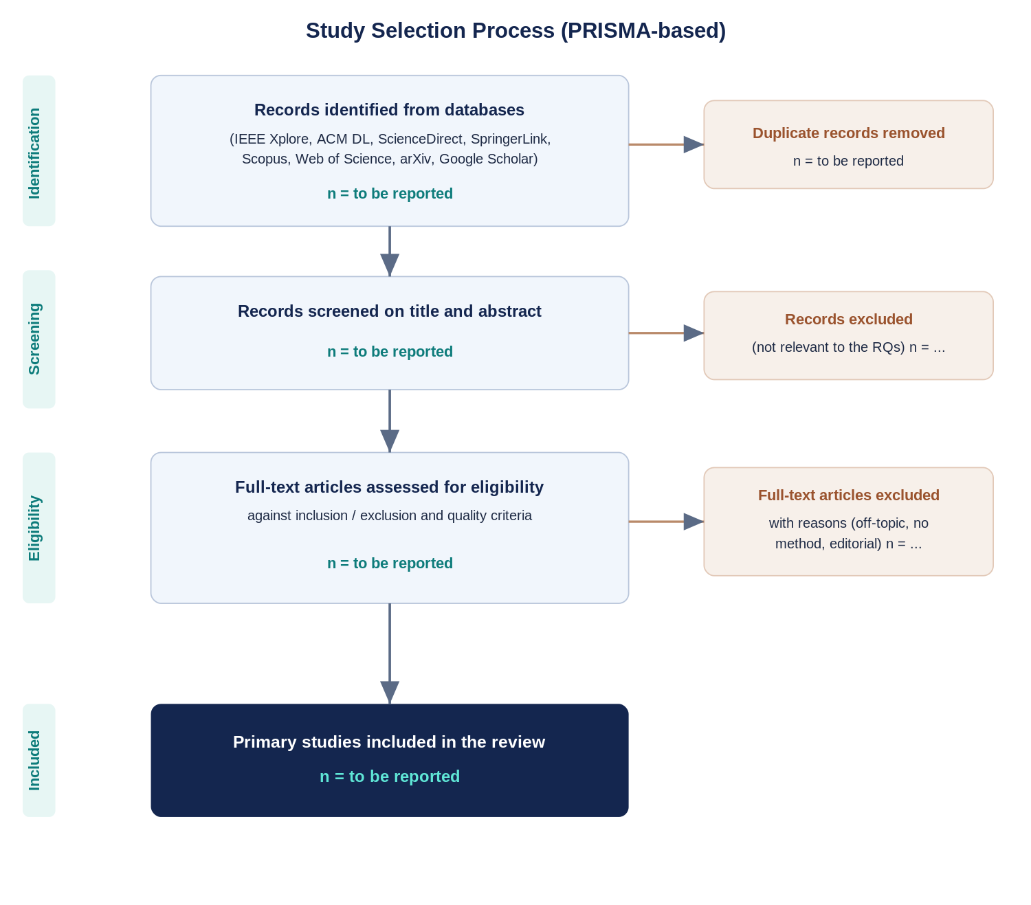
Figure 1: Primary studies selection process (PRISMA-based).
The search is deliberately broad, so a steep drop from the initial hits to the final set is expected. At the title-and-abstract stage, records are set aside once they turn out to be about quantum algorithms, hardware, or physics, about quantum software in general, or about compiler optimisation with no testing, oracle, or verification angle, along with papers that report no real method. Figure 1 records these reasons.
Selection Procedure and Reliability.
Every record from the databases is imported into a reference manager (Zotero [17]), where exact and near-duplicate entries are removed before screening; the screening itself runs in Rayyan [16]. Two reviewers then work through the titles and abstracts, and later the full texts, independently, against the criteria in Table 5. Their agreement is measured with Cohen's kappa [20], or Fleiss' kappa [21] once a third reviewer is involved, and screening continues only after agreement reaches at least 0.6; disagreements are talked through, and a third reviewer settles whatever remains. Before full extraction, both reviewers pilot the form in Table 7 on a random handful of included studies so that each item is read the same way, and the rest of the extraction is cross-checked. Being independent and agreement-controlled, the process is both harder to bias and straightforward to audit.
Quality Assessment.
Each eligible study will be scored against the six checklist items of Table 6: QA1 = aims and scope clearly stated; QA2 = testing technique or oracle clearly described; QA3 = sound evaluation methodology, including benchmarks, metrics, and baselines; QA4 = results clearly reported and supported by evidence; QA5 = limitations and threats to validity discussed; and QA6 = tools, data, or artifacts available for reproduction. Each item is scored 1 (yes), 0.5 (partly), or 0 (no). The pre-declared quality threshold is 4.0 out of 6; studies below this threshold will be excluded or flagged for sensitivity analysis.

Table 6: Quality Assessment Checklist
ID | Quality assessment question | Score
QA1 | Are the aims and scope of the study clearly stated? | 0 / 0.5 / 1
QA2 | Is the testing technique or oracle clearly described? | 0 / 0.5 / 1
QA3 | Is the evaluation methodology sound (benchmarks, metrics, baselines)? | 0 / 0.5 / 1
QA4 | Are the results clearly reported and supported by evidence? | 0 / 0.5 / 1
QA5 | Are the limitations and threats to validity discussed? | 0 / 0.5 / 1
QA6 | Are the tools, data, or artifacts available for reproduction? | 0 / 0.5 / 1
Data Extraction.
For every included study, the form in Table 7 captures the same things: the testing technique, the correctness oracle and the fault classes it can and cannot see, how far the study bears on regression testing (including any mechanism for selecting or prioritising tests), the benchmarks and tools involved, and the open problems the authors report. Using one form for every study is what makes the extracted data comparable when it comes to synthesis.
Outcomes and data-item prioritization. The items that matter most are the testing technique, the oracle and its limitations, and the study's relevance to regression testing, since these answer RQ1 to RQ3 directly; the benchmarks and tools and the reported open challenges are secondary, feeding RQ4 and RQ5. Table 7 lists the full set and the question each item serves.
Table 7: Data-Extraction Form (Data-Item Description)
Data item | Description | RQ(s)
Study metadata | Title, authors, publication venue, year, and source database | RQ1
Testing technique | The testing or analysis technique proposed or evaluated (differential, metamorphic, fuzzing, equivalence modulo inputs, formal verification, or benchmark) | RQ1
Correctness oracle | The oracle used to decide correctness and how it is computed | RQ2
Oracle limitations | The fault classes the oracle can and cannot observe | RQ2
Regression-testing relevance | Whether and how the study supports regression testing, test selection, or prioritisation | RQ3
Benchmarks and tools | Benchmarks, datasets, subject compilers, and tool or artifact availability | RQ4
Open challenges | Limitations and open problems the study reports | RQ5
Data Synthesis.
The included studies differ too much in technique, oracle, target compiler, and evaluation for a meta-analysis to make sense, so the evidence is drawn together qualitatively. The approach is thematic synthesis in the sense of Cruzes and Dyba [18]: extracted text is coded, the codes are gathered into themes that line up with the research questions, and the themes are then compared across studies. Three tables carry most of the weight. One classifies each study by technique, whether differential, metamorphic, fuzzing, equivalence-modulo-inputs, formal-verification, or benchmark-based, and so answers RQ1. A second sets each study's correctness oracle against the fault classes it can and cannot observe, which answers RQ2. The third maps technique against oracle against research question, and it is here that RQ3 to RQ5 are addressed, showing which studies actually tackle regression-test selection or prioritisation, what benchmarks and tools they lean on, and what is left unsolved. Around these tables the review states, question by question, what the evidence settles, where it disagrees, and what stays open. Because the method is fixed before the search runs, the eventual findings cannot be quietly shaped to fit the data.
Threats to Validity.
This protocol, and the review it will guide, face the usual threats. The search may miss papers that use vocabulary we did not anticipate; concept-based strings with synonyms, several databases, and forward and backward snowballing are meant to keep that loss small. Screening is a matter of judgement, so two reviewers work independently, agreement is held to at least 0.6, and a third reviewer breaks ties. There is also the familiar bias that striking or tool-backed results are the ones that get published, compounded here by databases that resist automated querying; including grey literature and arXiv preprints, and searching every database by hand where automation fails, is meant to stop tooling from skewing coverage. Classifying techniques and oracle limitations again calls for judgement, which the piloted form and the cross-checking are there to contain. Finally, because this is a qualitative mapping of techniques rather than a meta-analysis of interventions, a formal GRADE rating would not fit; instead, the confidence placed in each finding is stated in plain terms, according to how many independent studies support it and how well they score on quality (Table 6).
Review Team, Timeline, and Dissemination.
The work is shared across the author team. The lead author designs the protocol and carries out the searching, screening, extraction, and synthesis, while the two co-authors serve as the second reviewer and adjudicator and provide methodological oversight. We expect the full review to take about six months: roughly a month to finalise and register the protocol and run the search across all eight databases, two months for screening and full-text selection, two more for quality assessment, extraction, and synthesis, and a final month for writing and internal review. The finished review will go to a peer-reviewed software-engineering venue, and the protocol, the search exports, and the extraction records will be posted in the OSF repository so others can replicate the work.
IV. Conclusion and Future Work
This paper has set out a protocol for a systematic review of testing and regression testing in quantum software compilers. Built on Kitchenham's guidelines and the PRISMA standard, it fixes the research questions and objectives, the data sources and search strategy, the selection and quality criteria, the extraction plan, the synthesis method, and the threats to validity that a rigorous, reproducible review needs. Once it is carried out, the review should yield a classified map of compiler-testing techniques, an account of the correctness oracles in use and where they fall short, a catalogue of the benchmarks and tools available, and a clear statement of what remains open. Those results are intended as the evidence base for further work on testing the quantum compiler in a way that is both trustworthy and affordable.
Funding. This research received no specific grant from any funding agency in the public, commercial, or not-for-profit sectors.
Author Contributions. F.N. designed the protocol, defined the research questions and search strategy, and drafted the manuscript. A.S. and I.A. contributed to the methodology, acted as second reviewer and adjudicator for study selection, and critically revised the manuscript. All authors read and approved the final protocol.
Data Availability. The protocol, the full database-specific search strings, the screening decisions, and the data-extraction records are available in the Open Science Framework repository (DOI to be inserted on registration).
References
[1] B. Kitchenham and S. Charters, “Guidelines for performing systematic literature reviews in software engineering,” Technical Report EBSE-2007-01, Keele University and Durham University, 2007.
[2] M. J. Page et al., “The PRISMA 2020 statement: an updated guideline for reporting systematic reviews,” BMJ, vol. 372, n71, 2021.
[3] M. Paltenghi and M. Pradel, “A survey on testing and analysis of quantum software,” arXiv:2410.00650, 2024.
[4] M. Paltenghi and M. Pradel, “Bugs in quantum computing platforms: an empirical study,” Proc. ACM Program. Lang. (OOPSLA), 2022.
[5] M. Paltenghi and M. Pradel, “MorphQ: metamorphic testing of the Qiskit quantum computing platform,” in Proc. ICSE, 2023.
[6] L. Burgholzer and R. Wille, “Advanced equivalence checking for quantum circuits,” IEEE Trans. Comput.-Aided Des. Integr. Circuits Syst., vol. 40, no. 9, pp. 1810–1824, 2021.
[7] J. Wang, Q. Zhang, G. H. Xu, and M. Kim, “QDiff: differential testing of quantum software stacks,” in Proc. IEEE/ACM ASE, 2021.
[8] G. Pontolillo et al., “QuCheck: a property-based testing framework for quantum programs in Qiskit,” arXiv:2503.22641, 2025.
[9] S. Yoo and M. Harman, “Regression testing minimization, selection and prioritisation: a survey,” Softw. Test. Verif. Reliab., vol. 22, no. 2, pp. 67–120, 2012.
[10] A. Javadi-Abhari et al., “Quantum computing with Qiskit,” arXiv:2405.08810, 2024.
[11] I. Iwumbwe, B. Z. Liu, and J. Wickerson, “QuteFuzz: fuzzing quantum compilers using randomly generated circuits with control flow and subcircuits,” in Proc. PLanQC, 2025.
[12] J. Luo, S. Xia, F. Zhang, and J. Zhao, “QEMI: a quantum software stacks testing framework via equivalence modulo inputs,” arXiv:2602.09942, 2026.
[13] R. Tao et al., “Giallar: push-button verification for the Qiskit quantum compiler,” in Proc. PLDI, 2022.
[14] Y. Shi et al., “CertiQ: a mostly-automated verification of a realistic quantum compiler,” arXiv:1908.08963, 2020.
[15] P. Zhao, J. Zhao, Z. Miao, and S. Lan, “Bugs4Q: a benchmark of real bugs for quantum programs,” in Proc. ASE-NIER, 2021.
[16] M. Ouzzani, H. Hammady, Z. Fedorowicz, and A. Elmagarmid, "Rayyan: a web and mobile app for systematic reviews," Systematic Reviews, vol. 5, art. 210, 2016.
[17] Corporation for Digital Scholarship, "Zotero (reference management software)," 2024. [Online]. Available: https://www.zotero.org
[18] D. S. Cruzes and T. Dyba, "Recommended steps for thematic synthesis in software engineering," in Proc. Int. Symp. Empirical Software Engineering and Measurement (ESEM), 2011, pp. 275-284.
[19] C. Wohlin, "Guidelines for snowballing in systematic literature studies and a replication in software engineering," in Proc. Int. Conf. Evaluation and Assessment in Software Engineering (EASE), 2014, pp. 1-10.
[20] J. Cohen, "A coefficient of agreement for nominal scales," Educational and Psychological Measurement, vol. 20, no. 1, pp. 37-46, 1960.
[21] J. L. Fleiss, "Measuring nominal scale agreement among many raters," Psychological Bulletin, vol. 76, no. 5, pp. 378-382, 1971.

Appendix A. PRISMA-P 2015 Compliance
Table 9 maps each item of the PRISMA-P 2015 reporting checklist to the section of this protocol where it is addressed.
Table 9: PRISMA-P 2015 checklist mapping
PRISMA-P item | Where addressed in this protocol
1a Title - identification | Title (identified as a review protocol)
1b Title - update | Not applicable (new review)
2 Registration | Protocol Registration and Amendments (OSF)
3a Authors - contact | Author block
3b Authors - contributions | Author Contributions
4 Amendments | Protocol Registration and Amendments
5 Support / funding | Funding
6 Rationale | Section I, Introduction
7 Objectives | Research Questions (Table 1); Objectives (Table 2)
8 Eligibility criteria | Inclusion / Exclusion Criteria (Table 5)
9 Information sources | Data Sources (Table 3)
10 Search strategy | Search Strategy and Search Procedure (Table 4; IEEE query)
11a Data management | Selection Procedure and Reliability (Zotero, Rayyan)
11b Selection process | Selection Procedure and Reliability; Figure 1
11c Data collection process | Selection Procedure and Reliability; Data Extraction
12 Data items | Data Extraction (Table 7)
13 Outcomes and prioritization | Outcomes and data-item prioritization
14 Risk of bias in individual studies | Quality Assessment (Table 6; QA1-QA6)
15 Data synthesis | Data Synthesis
16 Meta-bias(es) | Threats to Validity
17 Confidence in cumulative evidence | Threats to Validity (narrative; GRADE not applicable)

