SLR — Preliminary Search Results and Data Extraction
Working material for the full Systematic Literature Review (not part of the protocol paper)
This document holds the executed pilot output that was moved out of the SLR protocol paper: the preliminary search funnel, the primary studies found, their quality-assessment scores, and the completed data extraction. It is retained here as the seed for the full SLR so the work does not need to be repeated. When the full search across all eight databases is run, these tables are extended to the complete study set.
Preliminary Search Results
A preliminary execution of the search strategy was carried out on 9 July 2026. Of the eight planned databases, three could be queried automatically in this run: IEEE Xplore (151 records), SpringerLink (4,483 records), and arXiv (539 records); the ACM Digital Library, ScienceDirect, Scopus, Web of Science, and Google Scholar could not be accessed automatically because of subscription or bot-protection barriers, and will be searched in the full review. This gave 5,173 records; after removing 20 duplicates, 5,153 were screened on title and abstract. The screening stage deliberately applied the scope of the review strictly: records were excluded when they were not about quantum compiler/transpiler testing, were hardware-, physics-, or algorithm-focused, discussed compiler optimisation without testing/oracle/verification, or lacked a described method. As a result, 5,143 records were excluded at title-and-abstract screening and 10 full texts were assessed against the inclusion/exclusion and quality criteria. Three full texts were excluded, yielding seven primary studies (Figure 1, Table 8). Notably, the preliminary search found no dedicated regression-testing or test-selection framework for quantum compilers: existing work targets bug detection through differential, metamorphic, fuzzing, equivalence-modulo-inputs, or formal-verification techniques. This confirms regression testing of the quantum compiler as an open research gap (RQ3, RQ5).
Figure: Study selection funnel (preliminary search, PRISMA-based).
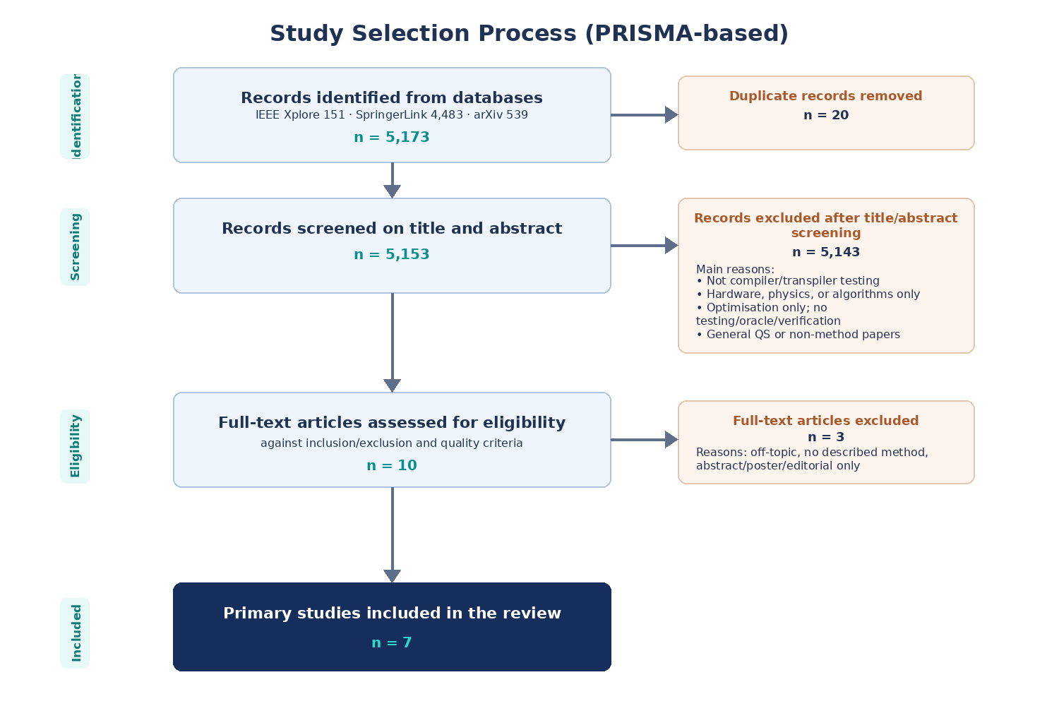
Primary Studies Identified
ID | Primary study (authors, year, venue) | Testing technique | RQs
S1 | Wang et al., 2021 (ASE) — QDiff [7] | Differential testing | 1, 2, 4, 5
S2 | Paltenghi and Pradel, 2023 (ICSE) — MorphQ [5] | Metamorphic testing | 1, 2, 4, 5
S3 | Iwumbwe et al., 2025 (PLanQC) — QuteFuzz [11] | Structured fuzzing | 1, 2, 4, 5
S4 | Luo et al., 2026 (arXiv) — QEMI [12] | Equivalence modulo inputs | 1, 2, 3, 4, 5
S5 | Tao et al., 2022 (PLDI) — Giallar [13] | Formal pass verification | 1, 2, 4, 5
S6 | Shi et al., 2020 (arXiv) — CertiQ [14] | Formal verification (SMT) | 1, 2, 4, 5
S7 | Zhao et al., 2021 (ASE-NIER) — Bugs4Q [15] | Bug benchmark | 4, 5
Quality Assessment Results
ID | Primary study | QA1 | QA2 | QA3 | QA4 | QA5 | QA6 | Total / 6 | Decision
S1 | Wang et al., 2021 — QDiff [7] | 1 | 1 | 1 | 1 | 1 | 0.5 | 5.5 | Include
S2 | Paltenghi & Pradel, 2023 — MorphQ [5] | 1 | 1 | 1 | 1 | 1 | 1 | 6.0 | Include
S3 | Iwumbwe et al., 2025 — QuteFuzz [11] | 1 | 1 | 0.5 | 1 | 0.5 | 1 | 5.0 | Include
S4 | Luo et al., 2026 — QEMI [12] | 1 | 1 | 1 | 1 | 1 | 1 | 6.0 | Include
S5 | Tao et al., 2022 — Giallar [13] | 1 | 1 | 1 | 1 | 1 | 1 | 6.0 | Include
S6 | Shi et al., 2020 — CertiQ [14] | 1 | 1 | 1 | 1 | 0.5 | 0 | 4.5 | Include; flag
S7 | Zhao et al., 2021 — Bugs4Q [15] | 1 | 0.5 | 1 | 1 | 0.5 | 1 | 5.0 | Include; RQ4/RQ5
The recalculated total quality score is 38.0 out of 42, with an average score of 5.43 out of 6. No study was excluded by the quality threshold. S6 is retained but flagged because public artifact availability is limited; S7 is retained mainly as a benchmark study for RQ4 and RQ5 rather than as a compiler-testing technique.
Completed Data Extraction
ID | Study and technique | Oracle strategy and regression-testing relevance | Benchmarks / tools | Open challenges / gaps
S1 | QDiff [7]. Wang et al., 2021, ASE. Database: IEEE Xplore / ACM Digital Library. Technique: differential testing using semantically equivalent circuit variants and comparisons across quantum software stacks. | Oracle: statistical comparison of output distributions, including tests such as Kolmogorov-Smirnov and cross-entropy. Regression relevance: can be rerun across versions, but it does not define change-aware test selection or prioritisation. | Qiskit, Cirq, and PyQuil; seed algorithms including Deutsch-Jozsa, Bernstein-Vazirani, Grover, QAOA, VQE, and X-gate programs; simulators and IBM quantum hardware. | Hard to separate software bugs from hardware noise; sampling variation affects thresholds; execution cost and circuit size limit scalability.
S2 | MorphQ [5]. Paltenghi and Pradel, 2023, ICSE. Database: ACM Digital Library / IEEE Xplore. Technique: metamorphic testing with generated quantum programs and quantum-specific transformations. | Oracle: expected metamorphic relations between original and transformed programs. Regression relevance: useful for rerunning after Qiskit updates, but no explicit regression-test selection or prioritisation is proposed. | MorphQ tool; Qiskit; program generator; ten metamorphic transformations; more than 8,000 program pairs; public implementation and experimental results. | Generalisation beyond Qiskit; duplicate warnings; emphasis on crashes; stronger support needed for semantic miscompilation and prioritised regression testing.
S3 | QuteFuzz [11]. Iwumbwe, Liu, and Wickerson, 2025, PLanQC. Database: ACM SIGPLAN / Google Scholar. Technique: structured fuzzing of quantum compilers using random circuits with control flow and subcircuits. | Oracle: detects crashes, compiler/simulator inconsistencies, and silent miscompilations by executing generated programs through different stacks. Regression relevance: useful as a bug-finding regression workload, but it does not rank or select tests based on compiler changes. | QuteFuzz tool; Pytket, Qiskit, and Cirq; generated circuits with subroutines, if-else or switch-style control flow, nesting, and varied gates; public repository. | Needs stronger oracles for silent miscompilation; random generation may miss important compiler paths; practical regression use needs reduction, minimisation, and prioritisation.
S4 | QEMI [12]. Luo, Xia, Zhang, and Zhao, 2026, arXiv. Database: arXiv / Google Scholar. Technique: quantum adaptation of equivalence modulo inputs; generates variants by removing quantum-control-flow dead code. | Oracle: compares the original program and EMI variant; a crash in only one version or statistically different output distribution indicates a potential bug. Regression relevance: closest to regression testing because variants can be reused across versions, but it still lacks a formal selection/prioritisation framework. | QEMI framework; Qiskit, Q#, and Cirq; random quantum program generator; quantum control-flow dead-code patterns; early-stop strategy; public artifacts. | Richer equivalence-preserving rewrites are needed; high-level quantum reachability analysis remains difficult; probabilistic outputs complicate dead-code reasoning.
S5 | Giallar [13]. Tao et al., 2022, PLDI. Database: ACM Digital Library / arXiv. Technique: formal pass verification using symbolic execution, rewrite rules, SMT solving, and automatically inferred loop invariants. | Oracle: formal semantic preservation of compiler passes. Regression relevance: not regression-test selection, but can prevent regressions by verifying changed or newly implemented compiler passes after updates. | Giallar toolkit; Qiskit compiler; 44 of 56 passes across 13 Qiskit versions; QASM benchmarks; public artifact. | Trusted computing base remains non-trivial; depends on loop templates and rewrite rules; incomplete gate/rule coverage; does not verify some non-critical or debugging statements.
S6 | CertiQ [14]. Shi et al., 2020, arXiv. Database: arXiv / Google Scholar. Technique: mostly automated formal verification of Qiskit compiler passes using contracts, SMT solving, and quantum circuit calculus. | Oracle: formal equivalence encoded as SMT verification conditions. Regression relevance: mentions Qiskit regression tests and helps prevent regressions through verified pass implementations, but does not propose regression-test selection or prioritisation. | CertiQ framework; Qiskit compiler; 26 of 30 Qiskit compiler passes reimplemented and verified; verified passes passed Qiskit regression tests. | Proof/specification burden still exists; more automation is needed; public reproducibility appears limited; not a complete regression-testing method.
S7 | Bugs4Q [15]. Zhao, Zhao, Miao, and Lan, 2021, ASE-NIER. Database: IEEE Xplore / ACM Digital Library / arXiv. Technique: real-bug benchmark rather than a testing technique. | Oracle: reproducible test cases distinguish buggy and fixed behaviour. Regression relevance: strongly relevant as a reusable historical-bug benchmark, but no test-selection or prioritisation algorithm is proposed. | Bugs4Q benchmark; 36 real manually validated Qiskit bugs from Terra, Aer, Ignis, and Aqua; buggy/fixed versions and reproduction tests. | Needs expansion beyond Qiskit; compiler-specific labelling could be stronger; benchmarks can become stale as Qiskit evolves; no cost-aware prioritisation.
Study references
[5] M. Paltenghi and M. Pradel, “MorphQ: metamorphic testing of the Qiskit quantum computing platform,” in Proc. ICSE, 2023.
[7] J. Wang, Q. Zhang, G. H. Xu, and M. Kim, “QDiff: differential testing of quantum software stacks,” in Proc. IEEE/ACM ASE, 2021.
[11] I. Iwumbwe, B. Z. Liu, and J. Wickerson, “QuteFuzz: fuzzing quantum compilers using randomly generated circuits with control flow and subcircuits,” in Proc. PLanQC, 2025.
[12] J. Luo, S. Xia, F. Zhang, and J. Zhao, “QEMI: a quantum software stacks testing framework via equivalence modulo inputs,” arXiv:2602.09942, 2026.
[13] R. Tao et al., “Giallar: push-button verification for the Qiskit quantum compiler,” in Proc. PLDI, 2022.
[14] Y. Shi et al., “CertiQ: a mostly-automated verification of a realistic quantum compiler,” arXiv:1908.08963, 2020.
[15] P. Zhao, J. Zhao, Z. Miao, and S. Lan, “Bugs4Q: a benchmark of real bugs for quantum programs,” in Proc. ASE-NIER, 2021.

