cvxEDA Testing

I have tested the code on specific time intervals. It provides these components in return.

1. sparse SMNA driver of phasic component
2. phasic component
3. tonic component
4. coefficients of tonic spline
5. offset and slope of the linear drift term
6. model residuals

The tonic component is not making any sense to me as it is being shown as the opposite of phasic component. Here is a output plot

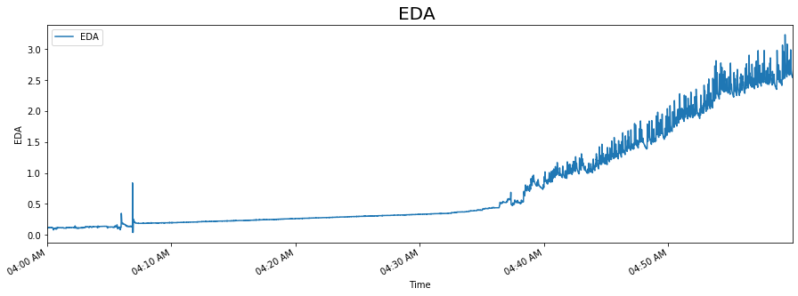

Original Plot

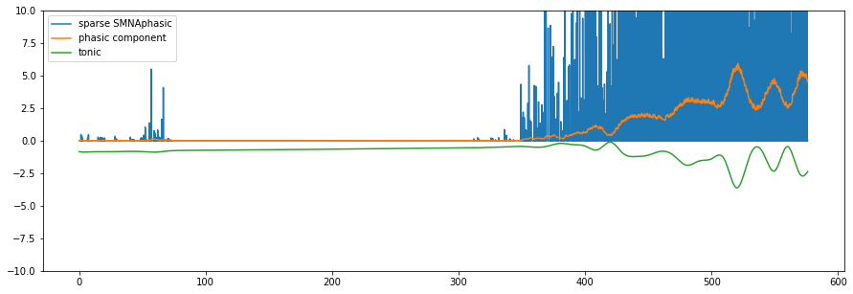

cvxEDA tonic and phasic component

In the above graph the tonic component stays in between o and 3 range.

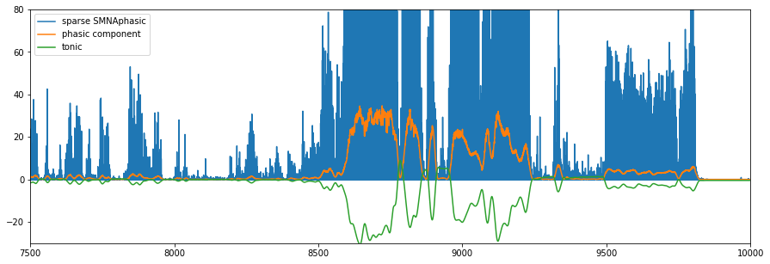

While in this figure the tonic component is the inverse of phasic component. I am going to test more.

Testing MIT media lab EDA code

They have an online viewer as well. I tested it and got these outputs.

Accelerometer Data Plot  
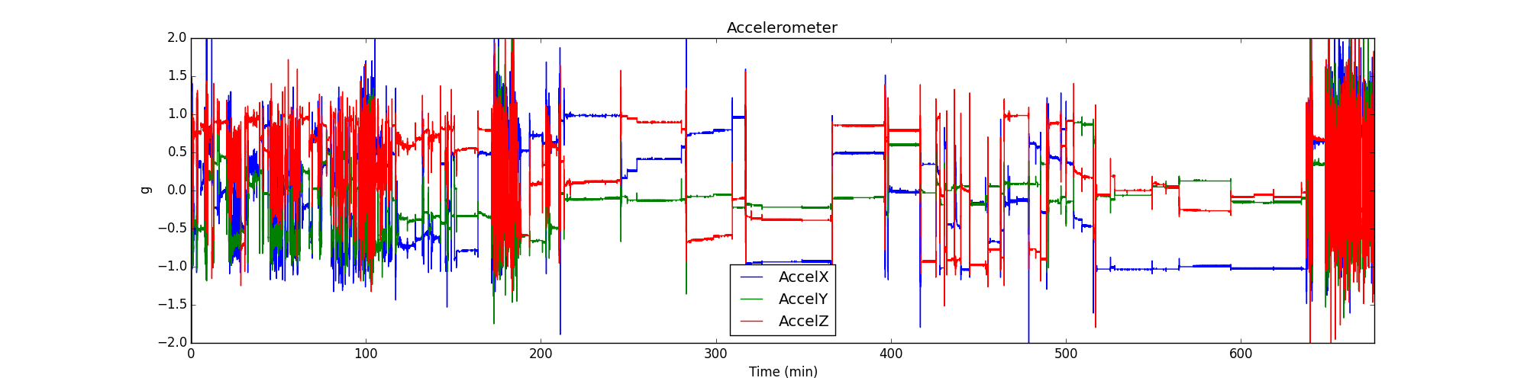

This plot was generated by the online EDA explorer.

Peak Finder

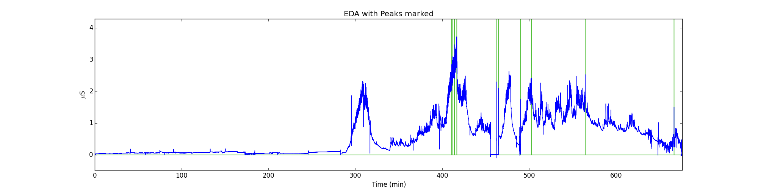  
  
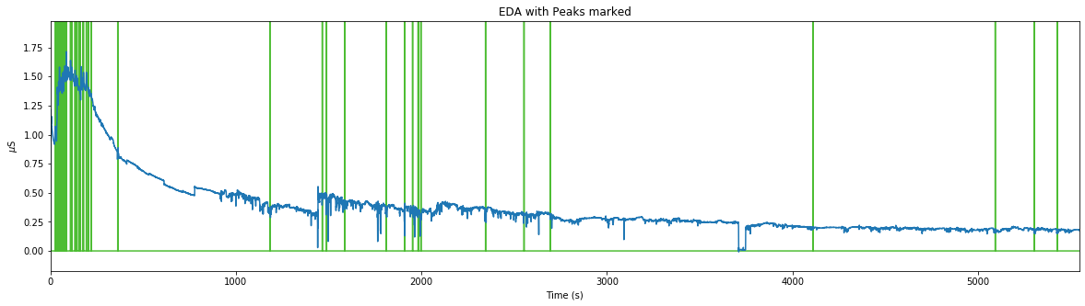

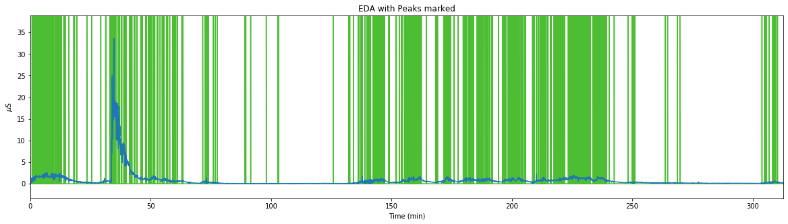

# Accelerometer Output

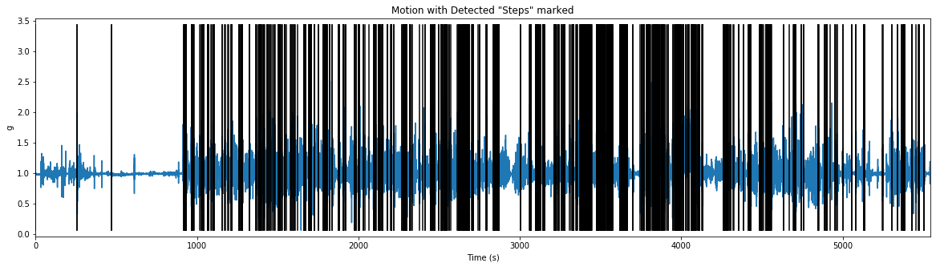

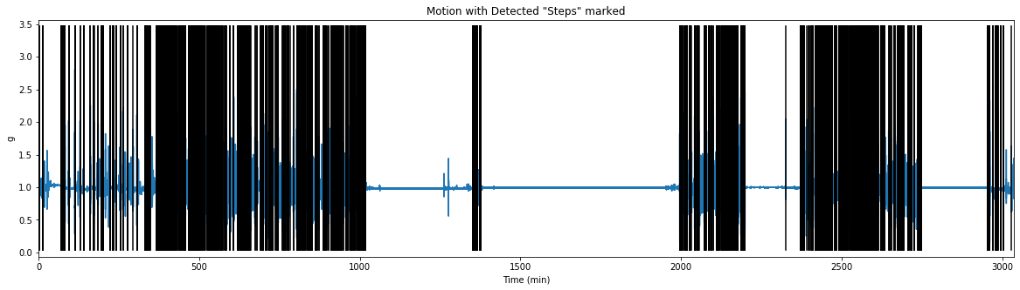

## Accelerometer output showing number of step count and mean step time

Using the code we can find the number of steps a person took in a specific time duration and we can know when the person was idle.

|  |  |  |  |  |
| --- | --- | --- | --- | --- |
| Time period start hour | Time period end hour | Step count | Mean step time during movement | Percent stillness |
| 0 | -1 | 10403 | 375.88205 | 0.767358419 |

# https://eda-explorer.media.mit.edu/static/SCR_withFeatures.png

# [**Rise_time**](https://eda-explorer.media.mit.edu/info/#compFeatThree)

The time, in seconds, it takes for the SCR to rise from the start of the SCR to the apex.  
The start of the SCR is computed by going backwards from the apex of the peak to point where derivative is less than 1% of its maximum value.

# [**Max_deriv**](https://eda-explorer.media.mit.edu/info/#compFeatFour)

Maximum derivative of SCR, in µSiemens per second.

# [**Amp**](https://eda-explorer.media.mit.edu/info/#compFeatFive)

Amplitude of peak; that is [amp = (EDA at apex) - (EDA at start of the SCR)], in µSiemens.

# [**Decay_time**](https://eda-explorer.media.mit.edu/info/#compFeatSix)

The time, in seconds, that it takes for the SCR to decay to 50% of its amplitude. Note that this is blank if an SCR doesn’t decay to 50% before another peak starts or before the maximum decay time is reached.

# [**SCR_width**](https://eda-explorer.media.mit.edu/info/#compFeatSeven)

The time in seconds between the 50% of the amplitude on the incline side of the peak to 50% of the amplitude on the decline side of the SCR.  
Note that this is blank if a Decay_time wasn’t computed.

# [**AUC**](https://eda-explorer.media.mit.edu/info/#compFeatEight)

Area under the Curve; approximated by multiplying the Amplitude by the SCR_width. Note that this is blank if a Decay_time wasn’t computed.

# Resultant files the code provide

|  |  |  |  |  |  |  |  |
| --- | --- | --- | --- | --- | --- | --- | --- |
|  | EDA | rise_time | max_deriv | amp | decay_time | SCR_width | AUC |
| 57:24.5 | 0.02689 | 1.5 | 0.029867 | 0.02689 | 0.25 | 1.25 | 0.033613 |
| 59:09.2 | 0.167743 | 2.625 | 0.087075 | 0.124207 | 0.75 | 3 | 0.372621 |
| 59:27.4 | 0.045457 | 2.25 | 0.042457 | 0.024329 | 0.125 | 2.25 | 0.05474 |
| 59:52.9 | 0.066586 | 3.625 | 0.007414 | 0.033293 | 0.25 | 3.625 | 0.120685 |
| 01:52.5 | 0.038414 | 1 | 0.08722 | 0.023048 | 0.125 | 1.125 | 0.025929 |
| 09:07.0 | 0.062744 | 2.25 | 0.068481 | 0.040976 | 0.125 | 1.75 | 0.071708 |
| 09:16.7 | 0.049939 | 2.5 | 0.015291 | 0.02561 |  |  |  |
| 09:48.7 | 0.078109 | 1.125 | 0.084977 | 0.02817 | 0.125 | 1.125 | 0.031691 |
| 10:24.6 | 0.043536 | 1.75 | 0.038991 | 0.023049 | 2.625 | 3.75 | 0.086432 |
| 10:48.8 | 0.057622 | 3.5 | 0.013706 | 0.047378 |  |  |  |
| 13:37.1 | 0.235609 | 1 | 0.069132 | 0.020488 | 0.25 | 0.375 | 0.007683 |
| 15:27.0 | 0.217682 | 1.5 | 0.095698 | 0.05378 | 0.125 | 0.25 | 0.013445 |
| 16:18.6 | 0.10436 | 4 | 0.008938 | 0.022409 | 0.25 | 3.25 | 0.072829 |
| 16:41.1 | 0.165822 | 1 | 0.196102 | 0.033292 | 0.125 | 1 | 0.033292 |
| 17:13.6 | 0.062744 | 1.125 | 0.099404 | 0.035854 | 0.75 | 1.875 | 0.067225 |
| 17:57.5 | 0.116524 | 2.625 | 0.021207 | 0.022409 | 2.875 | 5.125 | 0.114844 |
| 22:14.5 | 0.163902 | 1.75 | 0.094707 | 0.048659 | 0.375 | 2 | 0.097318 |
| 23:36.1 | 0.234329 | 1.375 | 0.052997 | 0.0525 | 0.25 | 1.5 | 0.078749 |
| 24:00.7 | 0.242011 | 1.5 | 0.060428 | 0.048658 | 0.25 | 1.625 | 0.079069 |

## Labels provided

The code provide a csv file for the labels. The online version of EDA explorer has a section to upload labels and view them.

|  |  |  |  |  |
| --- | --- | --- | --- | --- |
| EpochNum | StartTime | EndTime | BinaryLabels | MulticlassLabels |
| 0 | 4/25/2017 15:32 | 4/25/2017 15:33 | -1 | -1 |
| 1 | 4/25/2017 15:33 | 4/25/2017 15:33 | 1 | 1 |
| 2 | 4/25/2017 15:33 | 4/25/2017 15:33 | 1 | 1 |
| 3 | 4/25/2017 15:33 | 4/25/2017 15:33 | 1 | 1 |
| 4 | 4/25/2017 15:33 | 4/25/2017 15:33 | 1 | 1 |
| 5 | 4/25/2017 15:33 | 4/25/2017 15:33 | 1 | 1 |
| 6 | 4/25/2017 15:33 | 4/25/2017 15:33 | 1 | 1 |
| 7 | 4/25/2017 15:33 | 4/25/2017 15:33 | 1 | 1 |
| 8 | 4/25/2017 15:33 | 4/25/2017 15:33 | 1 | 1 |
| 9 | 4/25/2017 15:33 | 4/25/2017 15:33 | 1 | 1 |
| 10 | 4/25/2017 15:33 | 4/25/2017 15:33 | 1 | 1 |
| 11 | 4/25/2017 15:33 | 4/25/2017 15:33 | 1 | 1 |
| 12 | 4/25/2017 15:33 | 4/25/2017 15:34 | 1 | 1 |
| 13 | 4/25/2017 15:34 | 4/25/2017 15:34 | 1 | 1 |
| 14 | 4/25/2017 15:34 | 4/25/2017 15:34 | 1 | 1 |
| 15 | 4/25/2017 15:34 | 4/25/2017 15:34 | 1 | 1 |
| 16 | 4/25/2017 15:34 | 4/25/2017 15:34 | 1 | 1 |
| 17 | 4/25/2017 15:34 | 4/25/2017 15:34 | 1 | 1 |
| 18 | 4/25/2017 15:34 | 4/25/2017 15:34 | 1 | 1 |
| 19 | 4/25/2017 15:34 | 4/25/2017 15:34 | 1 | 1 |
| 20 | 4/25/2017 15:34 | 4/25/2017 15:34 | 1 | 1 |