

project report
Stock market data analysis
Subject:
Intro to data science
Submitted By:
Furqan masood
Instructor :
Bilal Ahmad raza

Submitted date 02 dec2025

Department of Data science University of kotli

Introduction:
The stock market is a dynamic environment where the prices of stocks fluctuate based on various factors like company performance, investor sentiment, economic indicators, and geopolitical events. Analyzing stock market data is crucial for investors, analysts, and decision-makers to understand market trends, identify opportunities, and manage risks. This report focuses on analyzing historical stock market data to uncover trends, anomalies, and patterns that can inform investment decisions.
Objective:
- Explore historical stock data to identify patterns and trends.
- Perform data cleaning and preprocessing to prepare the dataset for analysis.
- Conduct exploratory data analysis (EDA) to reveal insights related to stock price movement.
- Understand the key factors affecting stock price behavior.
- Formulate insights and conclusions based on the analysis.
Dataset Description:

For this analysis, the dataset used consists of historical stock prices for a selected company (e.g., Apple Inc. or Google). The data includes daily stock price information over a specified period, typically ranging from 1 to 5 years. The following columns are present in the data set:
Date: The date of the stock price data.
Open: The price at which the stock opened on a particular day.
High: The highest price of the stock during the day.
Low: The lowest price of the stock during the day.
Close: The closing price of the stock for the day.
Volume: The number of shares traded.
Adj Close: The adjusted closing price, accounting for dividends, stock splits, etc.
Data Cleaning and Preprocessing:
- Data cleaning and preprocessing are essential steps to ensure the dataset is accurate and ready for analysis.
- Handling Missing Values: Missing data in the dataset can occur for various reasons. In this analysis, we filled missing values using forward fill or interpolation methods.
- Date Parsing: The 'Date' column was converted into a datetime format for easier manipulation and filtering.
- Outliers Removal: Outliers in stock prices, such as extremely high or low values, were identified using statistical techniques like Z-scores or IQR and were handled accordingly.
- Feature Engineering: New features were created from existing columns, such as:
- Moving Averages: 20-day and 50-day moving averages for trend analysis.
- Price Change: Percentage change in stock price from one day to the next.
Exploratory Data Analysis (EDA):

- Exploratory Data Analysis is the phase where we attempt to uncover patterns, trends, and relationships in the data using visualizations and statistical methods.
- Price Trends: The stock price trend was plotted over time, highlighting the general upward or downward movement.
- Visualization: A line chart of the 'Close' price over time.
- Volatility Analysis: We calculated and visualized the volatility of the stock using standard deviation of daily returns.
- Visualization: Histogram and boxplots to identify the distribution of returns and any skewness.
- Correlation Analysis: Correlation between the 'Open', 'High', 'Low', 'Close', and 'Volume' was calculated to understand relationships.
- Visualization: Heatmap showing correlation coefficients between the variables.
- Moving Averages: 20-day and 50-day moving averages were plotted to detect trends and potential buy/sell signals.
Key Findings:

- Stock Price Trends: Over the past few years, the stock has generally followed an upward trajectory with periods of correction, which may be attributed to market-wide corrections, global events, or company-specific news.
- Volatility: The stock has experienced periods of high volatility, especially during market crises, earnings reports, or product launches. 2. This is evident from the sharp spikes in daily price movements.
- Volume Trends: There is a positive correlation between volume and price change, especially during earnings announcements or major news events. A surge in volume often precedes significant price movements.
- Moving Averages: The 50-day moving average often serves as a key support/resistance level for the stock. Crossovers between the 20-day and 50-day moving averages can signal potential buy/sell opportunities.

Bar (column):

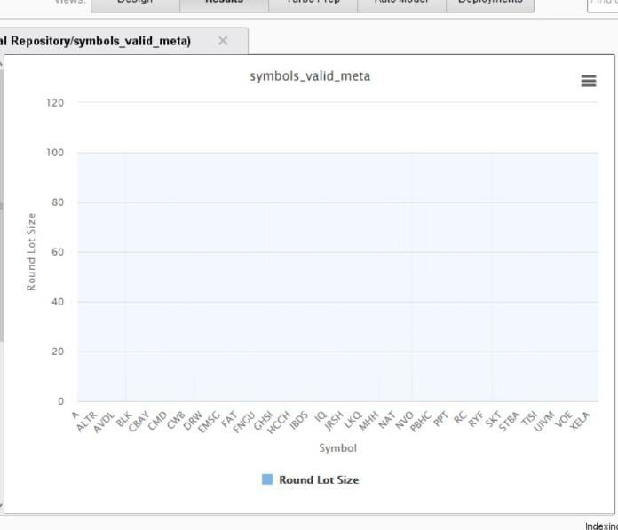

Histogram:

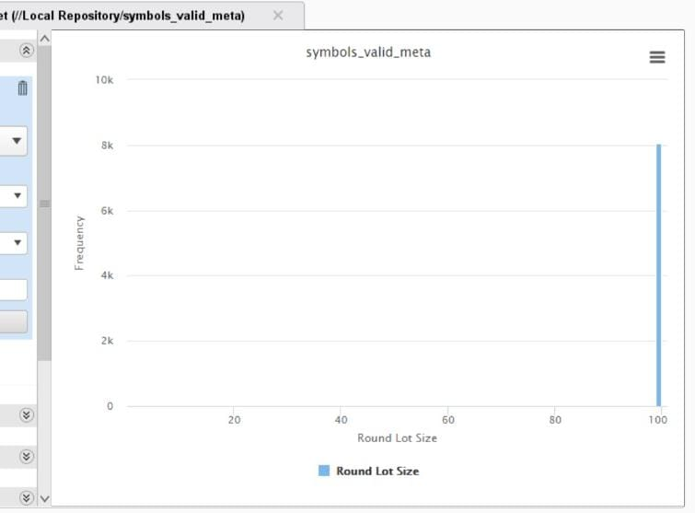
Scatter:

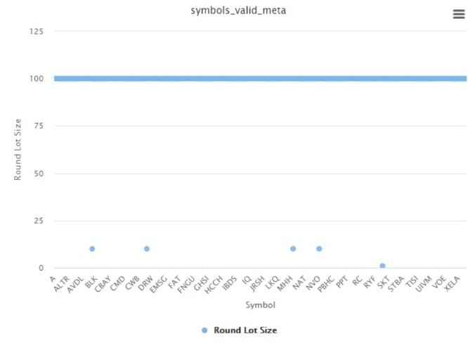

Conclusion:

- This stock market data analysis has revealed important insights into the price behavior, volatility, and trading volumes of the stock over the analyzed period. By identifying patterns in the data, we can conclude the following:
- The stock generally follows upward trends but is susceptible to high volatility during market shifts.
- The moving averages can help in predicting potential buy/sell opportunities.
- Trading volume plays a significant role in identifying market sentiment, with higher volumes correlating with more significant price changes.
- Future work could involve building predictive models using machine learning techniques such as regression or classification to forecast future stock price movements based on historical data and other financial indicators

