Final Project Report

ADVOCATE AND CLIENT MANAGEMENT



Project Supervisor
Muhammad Tahir Jan

Submitted By

F1802494AF (MC170401410)

Muhammad Furqan MC170401410

Software Projects & Research Section,
Department of Computer Sciences,
Virtual University of Pakistan


CERTIFICATE

This is to certify that Muhammad Furqan (MC170401410) has worked on and completed my Software Project at Software & Research Projects Section, Department of Computer Sciences, Virtual University of Pakistan in partial fulfillment of the requirement for the degree of BS in Computer Sciences under my guidance and supervision.

In my opinion, it is satisfactory and up to the mark and therefore fulfills the requirements of BS in Computer Sciences.

Supervisor / Internal Examiner

Muhammad Tahir Jan
Supervisor,
Software Projects & Research Section,
Department of Computer Sciences
Virtual University of Pakistan

___________________
(Signature)

External Examiner/Subject Specialist
<<External Supervisor Name>>

___________________
(Signature)

Accepted By:

_____________
(For office use)

EXORDIUM

In the name of Allah, the Compassionate, the Merciful.

Praise be to Allah, Lord of Creation,
The Compassionate, the Merciful,
King of Judgment-day!

You alone we worship, and to You alone we pray for help,
Guide us to the straight path

The path of those who You have favored,

Not of those who have incurred Your wrath,
Nor of those who have gone astray.

DEDICATION

THIS PROJECT IS DEDICATED TO MY BELOVED

PARENTS AND TEACHERS

ACKNOWLEDGEMENT

I have taken efforts in this project. However, it would not have been possible without the kind support and help of many individuals and organizations specially my Parents. I would like to extend my sincere thanks to all of them.

Apart from the efforts of myself, the success of any project depends largely on the encouragement and guidelines of many others. I take this opportunity to express my gratitude to the people who have been instrumental in the successful completion of this project. I am highly indebted to Muhammad Tahir Jan for their guidance and for providing necessary information regarding the project and also for their support in completing the project.

I would like to express my gratitude towards member of Virtual University of Pakistan for their kind co-operation and encouragement which help me in completion of this project. I would like to express my special gratitude and thanks to industry persons for giving me such attention and time. My thanks and appreciations also go to my colleague in developing the project and people who have willingly helped me out with their abilities.

PREFACE

This Project Report has been prepared in partial fulfillment of the requirement for the subject “CS619 - Final Project” of the program “MCS” in academic year “2017 – 2019”.

For preparing the project, I have visited the advocates to avail the necessary information, to know what advocates need, what are the difficulties they are facing for managing their clients, cases, documents, payments and etc before starting the project. When I was meeting with advocates, I have also met with their clients, and there, I realized that they also have many problems in finding best advocate according to their requirements, needs and case type for example civil and criminal. In this project, I have addressed the issues of both advocates and applicants.

In this project advocates are being facilitate by management of their clients, cases, payments, hearings and documents. It is also facilitating applicants by helping them in hiring the advocate according to their needs like, city, case type and advocate’s fees. At last, it is a best solution for the both advocates and applicant needs.

TABLE OF CONTENTS

CHAPTER NO. 1
gathering & Analyzing info 9
1.1 Introduction 10
1.2 PURPOSE 11
1.3 SCOPE 12
1.4 definitions, acronyms and abbreviations 13
1.5.4.1 FUNCTIONAL AND NON Functional requirements 15
1.5.4.1.1 Functional requirements 15
1.5.4.1.2 Non Functional requirements 16
1.5 supplementary requirements 17
1.5.1 Usability 17
1.5.2 Reliability 17
1.5.3 Supportability 17
1.5.4 Availability 18
1.5.4 System Requirements 18
1.5 use cases and usage scenarios 19
1.5.1 USE CASE DIAGRAM 19
1.5.2 USAGE SCENARIOS 20

CHAPTER NO. 2
planning the project 28
2.1 Methodology 29
2.3 Available Methodologies 30
2.4 Chosen Methodology 32
2.5 Reasons for Chosen Methodology 33
2.6 Work Plan 34
2.7 Project Structure 35
2.7.1 Team Structure 35
2.7.2 Project Schedule (Submission Calendar) 36

CHAPTER NO. 3
designing the project 37
3.1 Dynamic Model: Sequence Diagrams 37
3.2 Object Model/Logical Model: Class Diagram 50
3.3 Database Model (Database Diagram) 51
3.4 entity relational diagram 53
3.4 Graphical User Interfaces 54

CHAPTER NO. 4
DEvelopment 62
4.1 Development plan (Architecture Diagram) 63

CHAPTER 1
Gathering & Analyzing Info

1.1 INTRODUCTION
Advocate and Client Management is a online web application that can be accessed from anywhere in the world. This software is meant to be used by both Advocate and Applicant. It is a very powerful software. Any advocate or applicant who is using this software does not need to worry about maintaining any paperwork. This software would maintain everything which an advocate or applicant needs to do. This application will store the data about advocate’s clients, client payments, case details, case documents. Now, there is no need of maintaining different diaries for recording cases over years. This software enables advocates to save and manage unlimited cases, clients, payments, hearings, and documents, making it one source of information for advocates. It has monthly calendar view of hearings, advocate just have to click on date, and it shows hearings of clicked data. This software makes easy to search about the case, case details, or clients using the search option.
The applicant can view according to their cities and search about advocate, view their profiles, and book their slot if available. An email will be sent to advocate for case allocation request. If he is ready to take the case, then he can confirm and take the case for further processing.

1.2 PURPOSE
The advancement in technology had bring automation in various fields. Every thing is computerized now. Technology has also increased the productivity of almost every industry in the world including legal. With the mission to make latest technology available to advocates at affordable cost, this application offers many advantages over the traditional paper one. It allows advocate to save unlimited cases, clients, and documents, yet find and search them more easily It reminds advocates and can be accessed from anywhere be it over mobile or PC. At same time it keeps data safe and secure and ensure never lose it. It is convenient and easy to use. Now, advocates can say bye to paperwork and truly embrace the technology. No more fear of losing diary, documents and hence the data or someone peeping into your data.

1.3 SCOPE
Advocate and Client Management is a online web application that can be accessed from anywhere in the world, it will revolutionize the process of managing law cases for both advocates and clients. It will computerize the process of client management and hiring advocates. Almost every man in the world have to hire advocate for their law cases at least once in his life. So, this project facilitate clients to visit the application from anywhere, anytime and search for suitable advocate according to their requirements. When client will make search to find best advocate to hire, advocate details will also being listing, like city, fees, availability, rating and etc, which will helpful in hiring best advocate. This application also have a lot of services to offer to advocates. Client, cases, payments and daily hearing management is a really big deal for advocates. Usually they use paper diary for these purposes, which is not as good as it should be. This project will computerize the whole process of client, cases, payments, and daily hearing management. Advocate will manage their clients and their information like name, email, contact no, address and client’s payments also. They will manage their cases and cases related documents. They also list their daily hearing. This application also promote advocates according to their rating.

1.4 definitions, acronyms and abbreviations
Advocate: A person who puts a case on someone else's behalf.
Applicant: A person who brings a case against another in a court of law.
Client: A person or organization using the services of a advocate.
Case: A case is a dispute between opposing parties resolved by a court.
Document: A piece of written, printed, or electronic matter that provides information or evidence related to a case.
Hearing: A hearing is a proceeding before a court.
Payment: An amount paid or payable for a case.
Guest: A person who visits site.
Administrator: A person responsible for carrying out the administration of a business or organization.
MySQL: MySQL is an open-source relational database management system (RDBMS). Its name is a combination of "My", the name of co-founder Michael Widenius's daughter, and "SQL", the abbreviation for Structured Query Language.
Framework: A framework provides a standard way to build and deploy applications. A framework is a universal, reusable software environment that provides particular functionality as part of a larger software platform to facilitate development of software applications, products and solutions.
Laravel: Laravel is a free, open-source, PHP web framework, following the model-view-controller (MVC) architectural pattern.
PHP: Hypertext Preprocessor is a general-purpose programming language originally designed for web development.
Nuxt.js: Nuxt.js is a free and open source web application framework based on Vue.js.
Vue.js: Vue.js is an open-source JavaScript framework for building user interfaces and single-page applications.
Single-Page-Application: A single-page application is a web application or web site that interacts with the user by dynamically rewriting the current page rather than loading entire new pages from a server.
JavaScript: Alongside HTML and CSS, JavaScript is one of the core technologies of the World Wide Web. JavaScript enables interactive web pages and is an essential part of web applications.
DOM: Document Object Model.
Buefy: Buefy is a user interface component library made on top of two frameworks, Vue.js and Bulma.
Bulma: Bulma is a free, open source CSS framework.
CSS: Cascading Style Sheets is a style sheet language used for describing the presentation of a document written in a markup language like HTML.
HTML: Hypertext Markup Language, a standardized system for tagging text files to achieve font, colour, graphic, and hyperlink effects on World Wide Web pages.
Web Application: In computing, a web application or web app is a client–server computer program which the client (including the user interface and client-side logic) runs in a web browser, server side runs in a server.
Web Browser: A web browser is a software application for accessing information on the World Wide Web.
Server: A server is a computer program or a device that provides functionality for other programs or devices, called clients.
Client: A client is a piece of computer hardware or software that accesses a service made available by a server.

1.5 FUNCTIONAL AND NON Functional requirements
A functional requirement describes what a software system should do, while non-functional requirements place constraints on how the system will do so.

1.5.1 FUNCTIONAL requirements
Following are the functional requirements:
- Admin can login.
- Admin can manage website content, like contact us information, about us content etc.
- Admin can send email to the users.
- Admin can manage blog.
- Guest can view advocates list with their details like fees, availability and rating.
- Guest can search the advocates according to cities, fees, rating etc.
- Applicant can register and login.
- Applicant can take send appointment request to advocates.
- Advocate can register and login.
- Advocate can manage clients, and their information like name, email, address etc.
- Advocate can manage client payments.
- Advocate can manage cases and their related documents.
- Advocate can management his hearings using and can list calendar view of hearings.

1.5.2 NON Functional requirements
Non functional requirements are:
- Application should be available twenty four hours.
- It should be user friendly so all of its users can easily use it without any inconvenience.
- It should have a very low load time.
- It should provide users only what is related to them.
- People are very concerns about their data, so it should also have a good security.
- Languages to be use are HTML, CSS as markup language and PHP, JavaScript as programming language.
- Tools to be use are Apache Server, MySql for database, Laravel (PHP framework) for backend, Nuxt.js (JavaScript framework) for frontend, Buefy (CSS framework) for designing and style.

1.6 SUPPLEMENTARY REQUIREMENTS
Supplementary requirements are all types of constraints and quantities related to the system as a whole and not only to individual functions. For example, a supplementary requirement may establish that the system must be compatible with a given legacy database, or be implemented with a given programming language, or even follow a given look and feel.

1.6.1 USABILITY
Site load time is reasonable on all devices, like mobile and desktop. Font size and spacing is easy to read. Navigation menu is easily identifiable, buttons and labels are clear. User is facilitated to view and make entries in the forms easily. Real time validations are provided in each field to avoid invalid entry in the database. Some forms also consists useful links. Site design is responsive which means site looks and design according to the screen resolution. Buefy is used which used flexbox for maintaining responsiveness.
1.6.2 RELIABILITY
Reliability is a measure for the probability of a software failure occurring. There are two terms related to reliability. First is fault which means a defect in the software, for example, a bug in the code which may cause a failure. Second is failure which means a derivation of the program observed behavior from the required behavior. Its been make sure that there will not be any failure in the system, apart from that reasonable messages being used to appear in case of any system failure.
1.6.3 SUPPORTABILITY
Software Supportability is the capability of supporting a software system over its whole product life. Right now support is not available in the project, but it is in the future plan to hire a man which will answer the questions of users and provide support.
1.6.4 AVAILABILITY
System availability is of high importance. Availability is highly depend on web server, and user internet connection.

1.6.5 SYSTEM REQUIREMENTS
There are two types of system requirements.
Server:
Following are requirements of server:
- Operating System (Windows, Linux etc)
- Apache Server 2.4
- PHP 7.2
- MySQL 5.7
Client:
- Operating System (Windows, Linux etc)
- Web Browser (Google Chrome, Firefox)

1.7 USE CASES AND USAGE SCENARIOS
Use case diagrams are diagrams that can be used to more clearly illustrate the set of use cases that are provided by the functionality in a system. The diagrams contain both the external entities that will be using the system also known as actors and the discrete use cases that the users will be carrying out. While, a scenario involves a situation that may have single or multiple actors that take a given functionality or path to resolve the scenario.
1.7.1 USE CASE DIAGRAMS
Administrator
Guest
Plaintiff
Advocate
Send Email
Register
Login
Manage Blog
Send appointment request
Manage Clients
Manage Client’s
Payments
Manage Cases
Manage Hearings
Manage Cases
Documents
Visit Site
View
Add
Edit
Delete
View Advocates

1.7.2 USAGE SCENARIOS

Use Case Title | Login
Use Case Id | 1
Author | Admin
Description | Admin want to login to do some task.
Actions | - Admin will provide email and password provided by developer. (Admin can not register because of security)  - Click submit.
Alternative Path | N/A
Pre Condition | Email should be a valid email, password should be minimum six character long.
Post Condition | Redirect to Admin dashboard. Admin login successfully.
Exceptions | Provided email and password must be match.

Use Case Title | Manage Site Content
Use Case Id | 2
Author | Admin
Description | Admin want to change willing content, like “Contact Us Info”, “About Us Paragraph” etc.
Actions | - Provide valid content.  - Click save.
Alternative Path | N/A
Pre Condition | Content must be a valid content. For example, contact number must be number type.
Post Condition | Content update successfully.
Exceptions | Admin must login before updating content.

Use Case Title | Send Email
Use Case Id | 3
Author | Admin
Description | Admin want to send email to all register advocates or all register clients to inform them about something.
Actions | - Provide email content.  - Click save.
Alternative Path | N/A
Pre Condition | N/A
Post Condition | Email sent successfully.
Exceptions | Admin must login before updating content.

Use Case Title | Manage Blog
Use Case Id | 4
Author | Admin
Description | Blog is use to inform visitors about something. Admin can create, update, view, delete blogs.
Actions | - Provide blog content.  - Click save.  - Can view all blogs.  - Can update any blog.  - Can delete any blog.
Alternative Path | N/A
Pre Condition | Admin should provide valid content, like title should be less than 255 characters etc.
Post Condition | Blog successfully post, Blog successfully update, Blog successfully delete.
Exceptions | Admin must login before access blog.

Use Case Title | View Advocates List
Use Case Id | 5
Author | Guest
Description | Guest want to view all advocates list.
Actions | - Visit project website.
Alternative Path | N/A
Pre Condition | N/A
Post Condition | N/A
Exceptions | N/A

Use Case Title | Search Advocates
Use Case Id | 6
Author | Guest
Description | Guest to find suitable advocate according to his requirements.
Actions | - Provide inputs fields for search, like city, fees range etc.  - Click submit.
Alternative Path | N/A
Pre Condition | Guest must provide at least one input field before making search.
Post Condition | N/A
Exceptions | N/A

Use Case Title | Register
Use Case Id | 7
Author | Applicant
Description | Applicant want to hire an advocate, and he have no account in database.
Actions | - Provide input fields, like email, password and etc  - Click save
Alternative Path | N/A
Pre Condition | Applicant must provide a valid email and password with more than eight characters etc.
Post Condition | Redirect to client dashboard. Applicant register successfully.
Exceptions | There must be no account in database with given email.

Use Case Title | Login
Use Case Id | 8
Author | Applicant
Description | Applicant want hire advocate, and he has already registered himself.
Actions | - Provide input fields, like email, password.  - Click submit.
Alternative Path | If client forgot his password. He can reset his password via email.
Pre Condition | Applicant must provide a valid email and password which must be eight character long.
Post Condition | Redirect to client dashboard. Applicant login successfully.
Exceptions | Given email must register before and email and password must match.

Use Case Title | Hire Advocate
Use Case Id | 9
Author | Applicant
Description | Applicant want to hire advocate.
Actions | - Select willing advocate.  - Click submit
Alternative Path | N/A
Pre Condition | Applicant must login before hiring advocate.
Post Condition | Advocate hire successfully.
Exceptions | Applicant must select one advocate.

Use Case Title | Register
Use Case Id | 10
Author | Advocate
Description | Advocate want use project advocate’s services, and he have no account in database.
Actions | - Provide input fields, like email, password and etc  - Click save
Alternative Path | N/A
Pre Condition | Admin must provide a valid email and password with more than eight characters etc.
Post Condition | Redirect to advocate dashboard. Advocate register successfully.
Exceptions | There must be no account in database with given email.

Use Case Title | Login
Use Case Id | 11
Author | Advocate
Description | Advocate want use project advocate’s services, and he has already registered himself.
Actions | - Provide input fields, like email, password and etc  - Click save
Alternative Path | If advocate forgot his password. He can reset his password via email.
Pre Condition | Advocate must provide a valid email and password which must be eight character long.
Post Condition | Redirect to advocate dashboard. Advocate login successfully.
Exceptions | Given email must register before and email and password must match.

Use Case Title | Manage Clients
Use Case Id | 12
Author | Advocate
Description | Advocate want to add new client, or update, delete any client, or view all clients.
Actions | - Provide input fields, like email, password and etc  - Click save.  - Can view all clients.  - Can update any client.  - Can delete any client.
Alternative Path | N/A
Pre Condition | Advocate must provide a valid input fields, like email should be a valid email or contact number must be number.
Post Condition | Client add successfully or Client update successfully etc.
Exceptions | N/A

Use Case Title | Manage Client’s Payments
Use Case Id | 13
Author | Advocate
Description | Advocate want to add new payment, delete any payment, or view all payments.
Actions | - Select client name, case and provide input fields, like payment and etc  - Click save  - Can view all payments.  - Can update any payment.  - Can delete any payment.
Alternative Path | N/A
Pre Condition | Advocate must provide a valid input fields.
Post Condition | Payment add successfully or Case payment delete successfully etc.
Exceptions | Case payment must less than provided payment.

Use Case Title | Manage Cases
Use Case Id | 14
Author | Advocate
Description | Advocate want to add new case, or update, delete any case, or view all cases.
Actions | - Provide input fields, like email, password and etc  - Click save  - Can view all cases.  - Can update any cases.  - Can delete any cases.
Alternative Path | N/A
Pre Condition | Advocate must provide a valid input fields.
Post Condition | Case add successfully or Case update successfully etc.
Exceptions | N/A

Use Case Title | Manage Case’s Documents
Use Case Id | 15
Author | Advocate
Description | Advocate want to add new document, delete any document, or view all documents.
Actions | - Select case name, provide input fields, like document etc  - Click save  - Can view all documents.  - Can update any document.  - Can delete any document.
Alternative Path | N/A
Pre Condition | Advocate must provide a valid input fields.
Post Condition | Document add successfully or Document delete successfully etc.
Exceptions | N/A

Use Case Title | Manage Hearings
Use Case Id | 16
Author | Advocate
Description | Advocate want to add new hearing, or update, delete any hearing, or view all hearings.
Actions | - Select data from calendar, select case name and provide input fields.  - Click save  - Can view all hearings.  - Can update any hearing.  - Can delete any hearing.
Alternative Path | N/A
Pre Condition | Advocate must provide a valid input fields.
Post Condition | Case add successfully or Case update successfully etc.
Exceptions | N/A

CHAPTER 2
Planning The Project

2.1 METHODOLOGY
A methodology is the process of dividing software development work into distinct phases to improve design, product management, and project management. It is also known as a software development life cycle. The methodology may include the pre-definition of specific deliverable and artifacts that are created and completed by a project team to develop or maintain an application. Methodology can also define as a framework that is used to structure, plan, and control the process of developing an information system.

2.2 AVAILABLE METHODOLOGY
There are a wide variety of methodologies available in software development life cycle. Some of them are discussed below:
WATERFALL
Waterfall model happens to clarify the process into a linear flow with a sequence to let the users understand that further level is made progressive on completion of the previous one. Moreover, this methodology also talks about the fact that going back to deal with the changes is not possible. It is easy to understand but it has drawbacks one of them is that it is not applicable for maintenance project.
PROTOTYPE
Prototyping is the activity of creating prototypes of software applications. In this model, user is involved throughout the process, which increases the likelihood of user acceptance of the final implementation. Drawback of this model is that, excessive involvement of client can affect processing.

AGILE
Agile software development is an approach to software development under which requirements and solutions evolve through the collaborative effort of self-organizing and cross-functional teams and their customers and user. It advocates adaptive planning, evolutionary development, early delivery, and continual improvement, and it encourages rapid and flexible response to change.
RAPID APPLICATION DEVELOPMENT
This model is aimed at providing quick results, rapid application development is meant to give excellent development processes with the assistance of other development approaches. It encourages feedback from customers for improvement. Its drawbacks are that it requires extremely skilled personnel to handle complexities and it is not applicable for the small budgeted projects.
SPIRAL MODEL
Being a highly sophisticated design, it is meant to reduce the early risks in the project. The developers are intended towards crafting a plan for iterating of the spiral. Advantages of this model is that risk factors are considerably reduced and excellent for large and complex projects. Disadvantages of spiral model are that failure in risk analysis phase may damage the whole project and might get continued and never finish.
VU PROCESS MODEL
It is a combination to two models waterfall and spiral model. The idea behind VU process model is that it allows implementing changes in any stage. In waterfall model, each phase must be fully completed before the next phase begins, there is no back way in waterfall, while spiral model is almost like waterfall but with one additional phase which is risk analysis as there is always a possibilities of risk in development of software.

2.3 CHOSEN METHODOLOGY
Chosen methodology for this project is VU Process Model. There are five stages in VU process model. In all the phases, we will be analyzing risks for each phase at its start and will resolve them before entering into next phase. Every phase is describe in detail below:
- Requirement Analysis : All possible requirements of the system to be developed are captured in this phase. These requirements are analyzed for their validity and the possibility of incorporating the requirements in the system to be development is also studied.
- Risk Analysis And Work Plan: In this phase we will be defining time line in which this project should be completed, the cost which will be allocated for our project and all the basic planning activities will be done in this phase.
- System Design: In this phase we will understand what we are going to create and what it should look like? System Design helps in specifying hardware and system requirements and also helps in defining overall system architecture. We will be defining all the aspects of design of system. We will work on the architecture of the system, the internal and external entities, their relations among each other and to the others, etc. After completing the basic design phase we will build our system.
- Implementation: This step consists of actually constructing the product as per the design specifications. This step is performed by a development team consisting of programmers, interface designers and other specialists, using tools such as compilers, debuggers, interpreters and media editors.
- Testing: In this phase we will verify and test our system. We will perform different type of testing here.
- Maintenance: In this phase we will work on the maintenance of our system after deploying it and if needed.

2.4 REASONS FOR CHOSEN METHODOLOGY
Reasons for choosing VU Process Model are given below:
- It is an enforced disciplined approach because to having stage development cycle and every phase has defined start and end date.
- Testing is inherent every phase.
- It is documentation driven which means documentation is produced at every stage
- It is sequential model with backward repetition, if there will some correction to make at any phase then we can go back and make changes.
- Emphasis on requirement and design before writing code ensure minimal wastage of time and efforts.
- Combination of both waterfall and spiral model is called hybrid approach of system development that maximize the quality of system and minimize the disadvantages and risk.

2.5 WORK PLAN

GATHERING REQUIREMENTS AND PLANNING PHASE
In this phase we gathered information regarding scope, functional and non- functional requirements of our project and also prepared use case diagrams to understand actors and use cases of project and develop usages scenarios to understand all those situations which will come across while using this applications, chosen the adopted methodology, and also created work plan.

DESIGN PHASE
This phase involved designing the project using different types of diagrams like entity relationship diagram, sequence diagram, architecture design diagram, class diagram, database diagram, and interface design.
DEVELOPMENT AND FINAL REPORT PHASE
In this phase necessary code for implementation of application had been written. And also made final report and presentation.

2.6 PROJECT STRUCTURE
2.6.1 TEAM STRUCTURE

Project Manager
Analyst
Designer
Developer
Representative
Tester

Job Title | Description
Project Manager | To manage and lead all the process in the project.
Analyst | To analyze the requirements of project.
Designer | To design the models, diagrams, banners, and video tutorial for clients.
Developer | To convert the design into code. Professional in Laravel, Nuxt.js, Buefy. Well versed in web designing and database designing.
Tester | For testing purpose.
Representative | For support purpose. To answering user questions.

2.6.2 PROJECT SCHEDULE

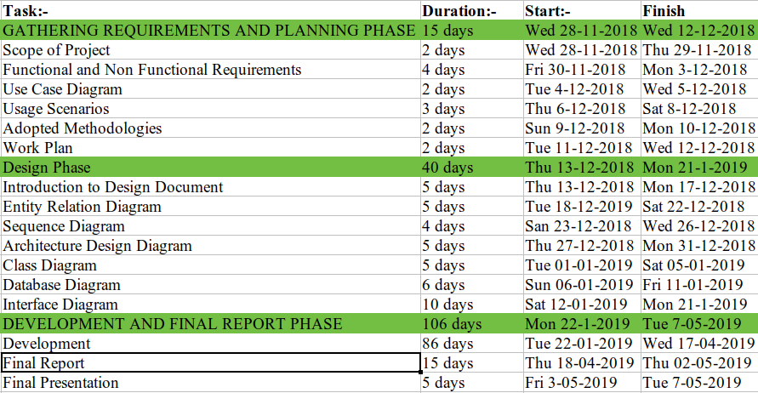

CHAPTER 3
Designing the Project

3.1 Dynamic Model: Sequence Diagrams

REGISTER INTO THE SYSTEM

Advocate
Applicant
Homepage
Click on register
Display register field
Web API
Request register page
Return register page
Enter user detail and
click submit
Check validity of
register fields
Redirect back with
errors
Database
Save user
Save user
User saved
Redirect to dashboard

LOGIN INTO THE SYSTEM

Advocate
Applicant
Homepage
Click on login
Display login field
Web API
Request login page
Return login page
Enter user detail and
click submit
Check validity of
login fields
Redirect back with
errors
Database
Check user
Return user
Redirect to dashboard
Admin

MANAGE BLOG/EMAIL
ADD BLOG/EMAIL

Admin
Homepage
Click on add
Display create field
Web API
Request create page
Return create page
Enter create detail and
click submit
Check validity of
create fields
Redirect back with
errors
Database
Save entry
Entry saved
Show success message

VIEW BLOG/EMAIL:-

Admin
Homepage
Click on view
Display view
Web API
Request view page
Return create page
Database
Fetch entries
Return entries

UPDATE BLOG

Admin
Homepage
Click on edit
Display edit field
Web API
Request edit page
Return edit page
Enter edit detail and
click submit
Check validity of
edit fields
Redirect back with
errors
Database
Save entry
Entry saved
Show success message

DELETE BLOG/EMAIL

Admin
Homepage
Click on delete
Web API
Request to delete entry
Show success message
Database
Delete entry
Entry deleted

MANAGE CLIENTS/CASES/DOCUMENTS/PAYMENTS/HEARINGS
ADD CLIENTS/CASES/DOCUMENTS/PAYMENTS/HEARINGS

Advocate
Homepage
Click on add
Display create field
Web API
Request create page
Return create page
Enter create detail and
click submit
Check validity of
create fields
Redirect back with
errors
Database
Save entry
Entry saved
Show success message

VIEW CLIENTS/CASES/DOCUMENTS/PAYMENTS/HEARINGS

Advocate
Homepage
Click on view
Display view
Web API
Request view page
Return create page
Database
Fetch entries
Return entries

UPDATE CLIENTS/CASES/DOCUMENTS/PAYMENTS/HEARINGS

Advocate
Homepage
Click on delete
Web API
Request to delete entry
Show success message
Database
Delete entry
Entry deleted

DELETE CLIENTS/CASES/DOCUMENTS/PAYMENTS/HEARINGS

Advocate
Homepage
Click on delete
Web API
Request to delete entry
Show success message
Database
Delete entry
Entry deleted

MANAGE ADVOCATE/APPOINTMENT
VIEW ADVOCATES/APPOINTMENTS

Applicant
Homepage
Click on view
Display view
Web API
Request view page
Return create page
Database
Fetch entries
Return entries

ADD APPOINTMENT

Applicant
Homepage
Click on add
Display create field
Web API
Request create page
Return create page
Enter create detail and
click submit
Check validity of
create fields
Redirect back with
errors
Database
Save entry
Entry saved
Show success message

3.2 Object Model/Logical Model: Class Diagram

Advocate
AdvocateID : Integer
Name : String
Email : String
Phone No : Integer
Fees : String
Rating : Float
Password : String
Register()
Login()
Logout()
Update()
Add_Client()
Update_Client()
Delete_Client()
Add_Case()
Update_Client()
Delete_Client()
Add_Hearing()
Update_Hearing()
Delete_Hearing()
Add_Payment()
Update_Payment()
Delete_Payment()
Applicant
PlaintiffID : Integer
Name : String
Email : String
Password : String
Register()
Login()
Logout()
Update()
Hire_Advocate()
Dehire_Adovocate()
Client
ClientID: Integer
Name : String
Email : String
Phone No : String
Address : String
Add()
Update()
Delete()
Cases
CaseID : Integer
CaseNo : String
CourtNo : String
JudgeName : String
Total Payment : Integer
Add()
Update()
Delete()
Payment
Receive : Integer
Remaining : Integer
Add()
Update()
Delete()
Hearing
Data : String
Time : String
Add()
Update()
Delete()
Admin
AdminD : Integer
Name : String
Email : String
Password : String
Login()
Logout()
Update()
Send_Email()
Manage_Blog()
Manage_Site_Content()
Blog
BlogID : Integer
Title : String
Detail : String
Add()
Update()
Delete()
Emails
EmailID : Integer
Subject : String
Message : String
Add()
Update()
Delete()
Document
FileName : String
FilePath : String
Add()
Update()
Delete()

3.3 Database Model (Database Diagram)
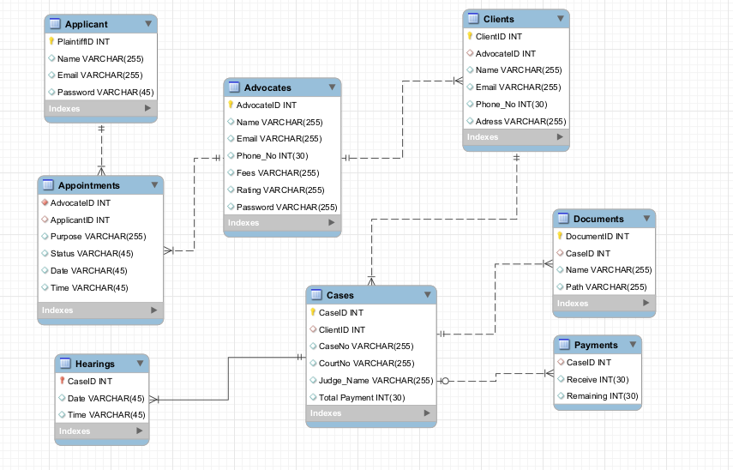

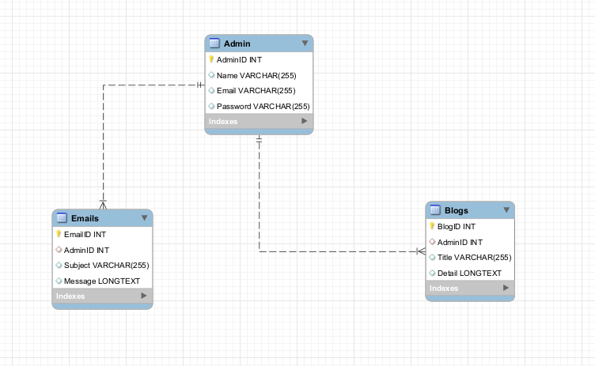

3.4 Entity relational diagram

Advocate
ID
Fees
Rating
Name
Email
Password
Case
ID
Case No
Court No
Judge
Name
Add
Total
Payment
Contains
Hearing
Add
Date
Time
Hearing
Add
Payment
Remaining
Receive
Administrator
ID
Name
Email
Password
Applicant
ID
Name
Email
Password
Hire
Hire

3.5 GRAPHICAL USER INTERFACES

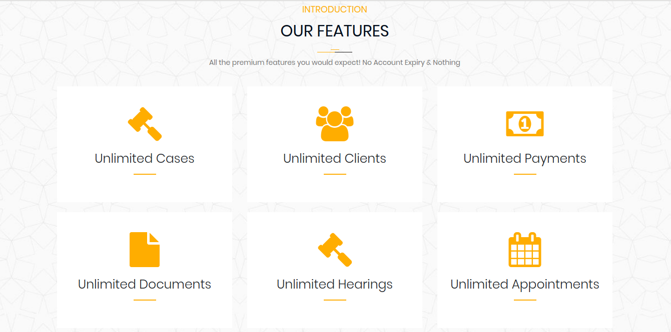
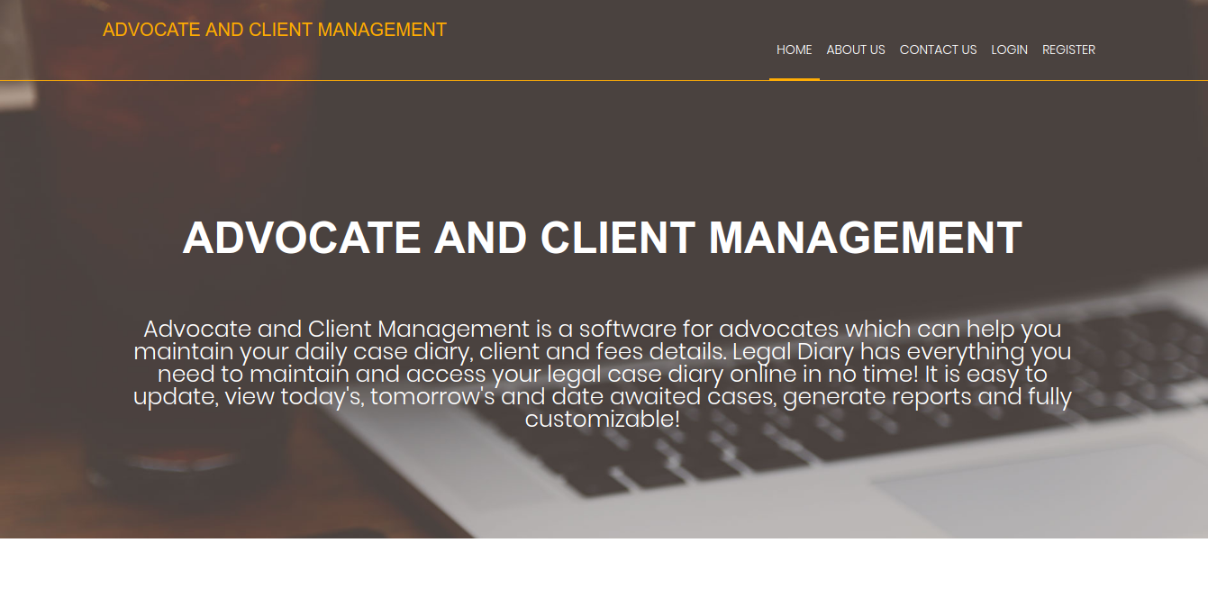

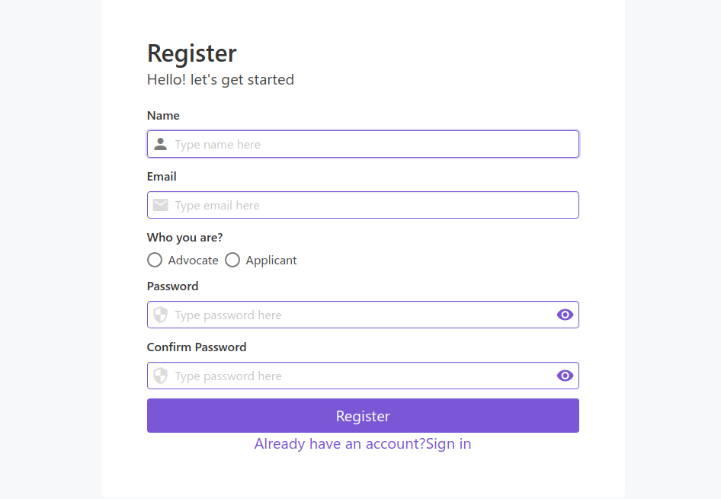

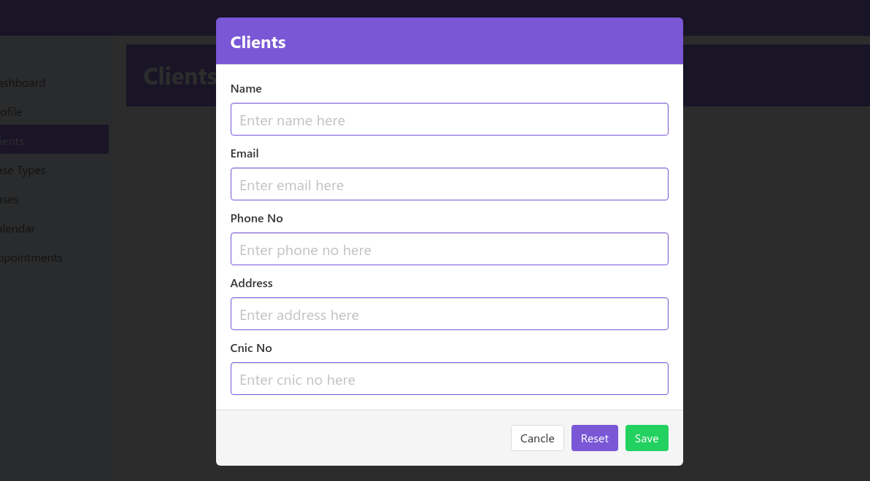

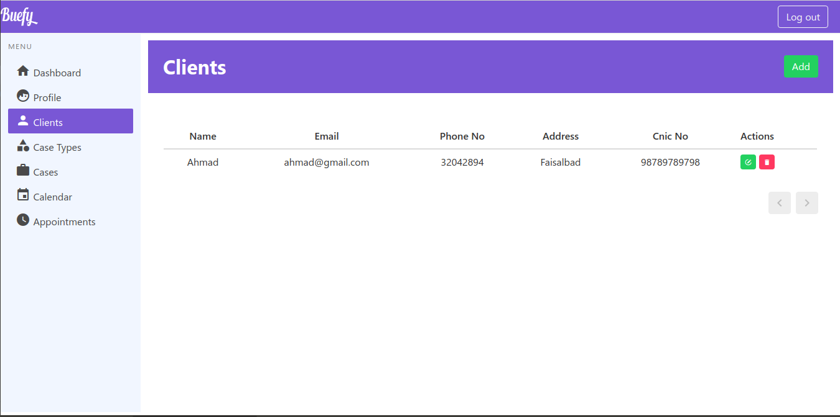

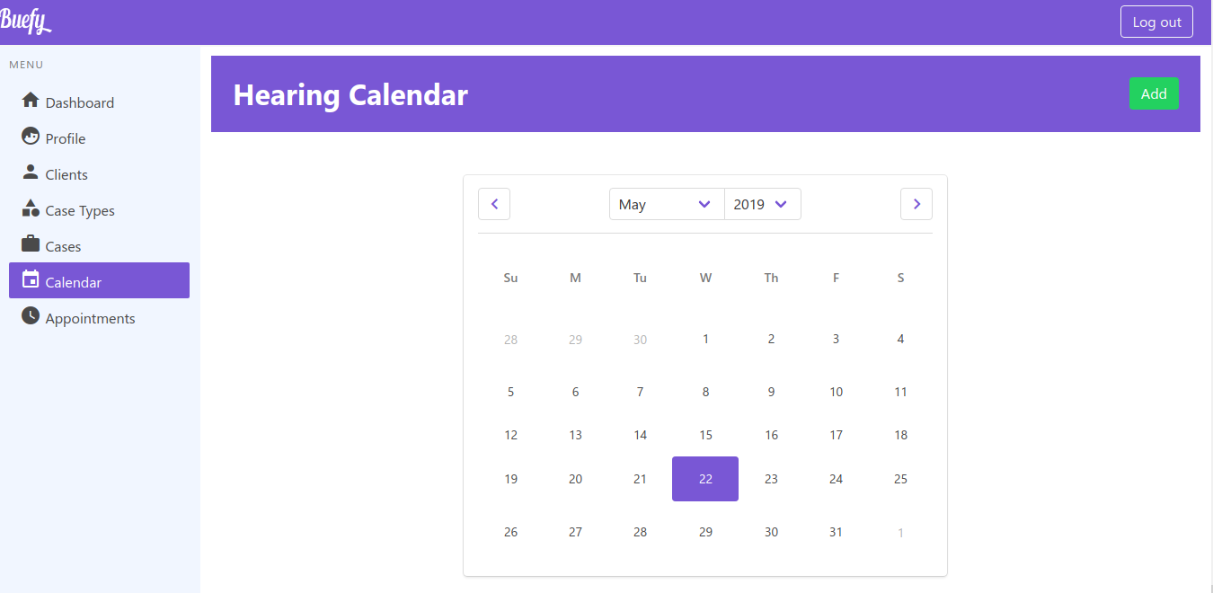

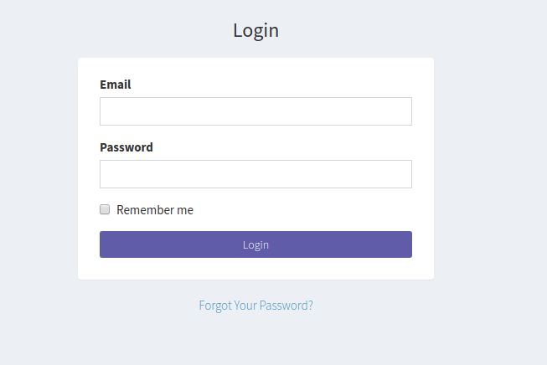

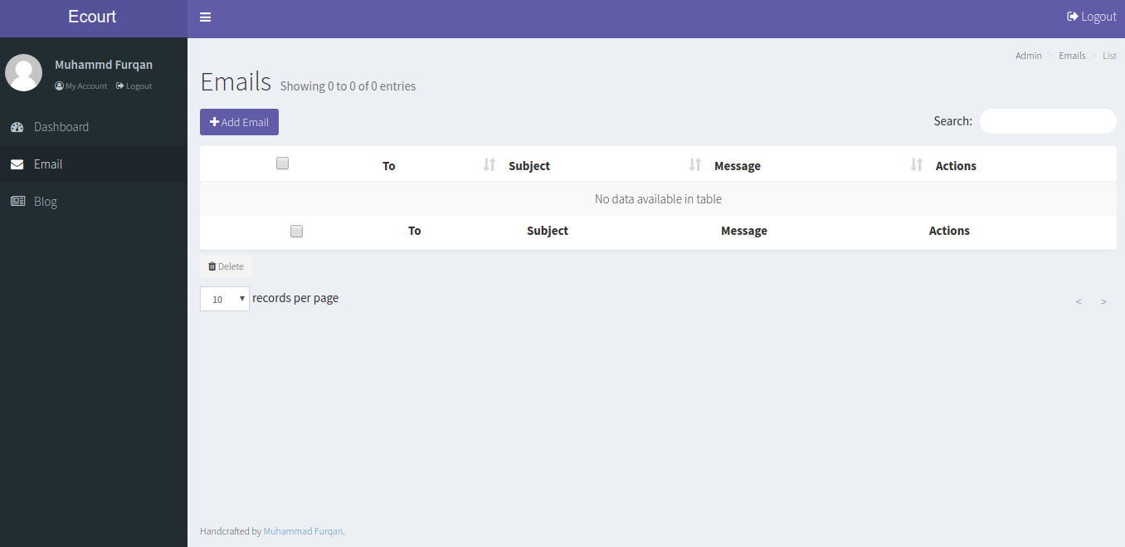

CHAPTER 4
Development

4.1 DEVELOPMENT PLAN
In this section we will discuss about used tools, used architecture and things related to development.
4.2 USED TOOLS
Apache HTTP Server: The Apache HTTP Server, colloquially called Apache, is free and open-source cross-platform web server software, released under the terms of Apache License 2.0. Apache is developed and maintained by an open community of developers under the auspices of the Apache Software Foundation.
MySQL: It is used for storing data. MySQL is an open-source relational database management system. Its name is a combination of "My", the name of co-founder Michael Widenius's daughter, and "SQL", the abbreviation for Structured Query Language.
Laravel: It is used for back end development. Its code will be run on server side. It is a free, open-source, PHP web framework, created by Taylor Otwell and intended for the development of web applications following the model–view–controller (MVC) architectural pattern and based on Symfony. Some of the features of Laravel are a modular packaging system with a dedicated dependency manager, different ways for accessing relational databases, utilities that aid in application deployment and maintenance.
Nuxt.js: It is used for front end development. Its code will be run on client side. is a free and open source web application framework based on Vue.js. It is a progressive framework for building user interfaces. is also perfectly capable of powering sophisticated Single-Page-Applications.
Buefy: It is used for styling the front end. Its code will also be run on client side.

4.3 USED ARCHITECTURE
For the project, two different architecture are used. Single-Page-Application (SPA) being used for advocate and plaintiff console, while MVC architecture for visitors. Reason for choosing two different architecture is that SPA is good for real-time view changes but there is two drawbacks of this architecture, one is its require the user to download and execute the JavaScript payload before being able to view any content, and second failing to display any HTML content can hurt SEO rankings if bots are not able to view any of the headers or content. These drawbacks cannot damage advocate and plaintiff console but they will damage visitors. To tackle these drawbacks, MVC architecture being used for visitors.

4.4 WHAT IS SPA ARCHITECTURE
For advocate and plaintiff console, used architecture is Single-Page-Application (SPA). A single-page application (SPA) is a website design approach where each new page's content is served not from loading new HTML pages but generated dynamically through JavaScript's ability to manipulate the DOM elements on the existing page itself. In a more traditional web page architecture, an index.html page might link to other HTML pages on the server that the browser will download and display from scratch. An SPA approach allows the user to continue consuming and interacting with the page while new elements are being updated or fetched, and can result in much faster interactions and content reloading. In addition, the HTML5 History API allows us to alter the page's URL without reloading the page, allowing us to create separate URLs for different views. Once inside of the SPA, the application is able to dynamically fetch content from the server through AJAX requests. This allows the browser to keep the current page open while making requests to the server in the background to fetch additional content or new "pages" altogether.

Client
Initial Request
HTML Response
AJAX Request
JSON Response
Data
Server
Model

4.4 WHAT IS MVC ARCHITECTURE
MVC stands for Model, View and Controller. MVC separates application into three components - Model, View and Controller. Model represents shape of the data and business logic. It maintains the data of the application. Model objects retrieve and store model state in a database. View is a user interface. View display data using model to the user and also enables them to modify the data. Controller handles the user request. Typically, user interact with View, which in-turn raises appropriate URL request, this request will be handled by a controller. The controller renders the appropriate view with the model data as a response.
View
Controller
Model
Request
Response
Data
Data

