1. 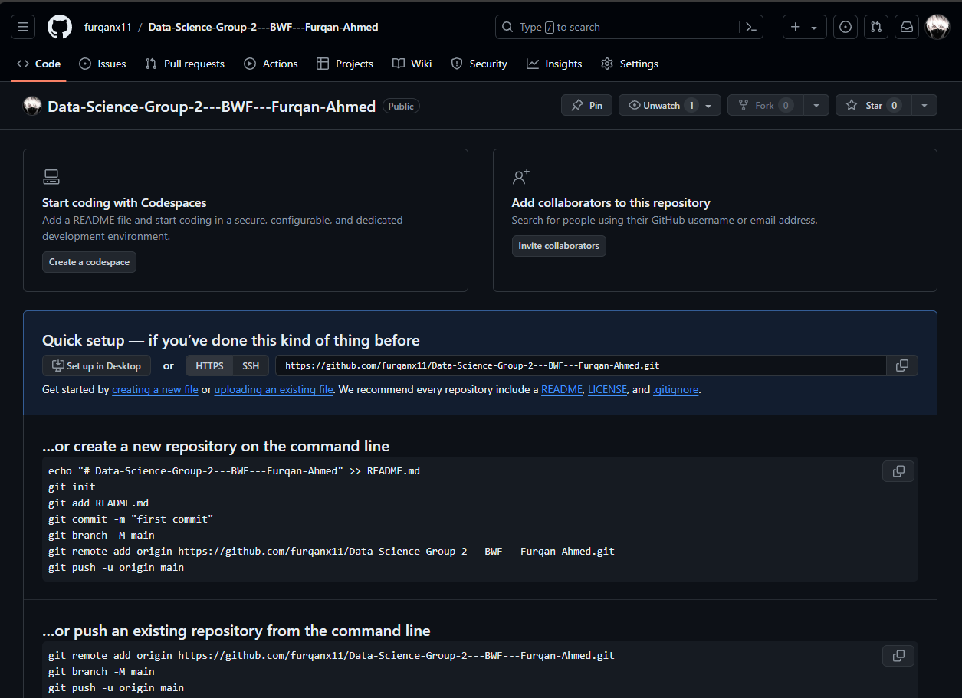Creating the repository:
2. A screenshot of a computer

   Description automatically generatedVerifying Git installation on local system
3. A screenshot of a computer

   Description automatically generatedAdding Task-1 folder to the repository

