HERMES GAME DESIGN DOCUMENT
Project Name: Hermes
Studio: Team Nyx
Course: DOT 3016 – Game Studio II
Engine: Unreal Engine 5.6.1

Project Description: "Project Hermes" is a third-person adventure and survival game set in a mythical world inspired by Greek mythology. Players control Hermes on a perilous journey, managing survival mechanics while solving environmental puzzles and facing moral dilemmas.
Core Vision & Aesthetic: The game heavily draws inspiration from Disney and Hercules animations. The visual direction is defined by a vibrant, cartoonish, and hand-painted aesthetic, creating a welcoming yet mysterious atmosphere.

TEAM & ROLES
Our studio operates with a multi-disciplinary approach. Core responsibilities are distributed as follows:
- A. Furkan Yıldız: Game Designer / Main Programmer
- Şevval Çağan: Project Manager / 2D–3D Artist
- Selinay Can: 3D Artist / UI Designer
- Fatih Aslan: 3D Artist / Texture Artist
- Alp Hasan Seçil: 3D Artist / Programmer

GAMEPLAY & MECHANICS
The gameplay loop integrates exploration, puzzle-solving, and resource management.

Completed Core Systems:
- Locomotion: Custom third-person camera control with fundamental movement mechanics (Walk, Run, Jump).
- Survival System: Blueprint foundations for Hunger, Thirst, Sleep, and Stamina management.
- Inventory & UI: Base inventory system structure implemented alongside functional compass and HUD elements.

ART & AUDIO
The artistic vision relies on high-quality 3D modeling matched with stylized hand-painted textures.
Completed Milestones:
- Character & Props: Hermes (main character) and Pandora's Box have been fully modeled. Retopology of the main character is complete.
- Environment: Base models for village houses are finished. The texture structure and stylized hand-painted material approach are successfully established in Unreal Engine.
- Animation & Cinematics: Core locomotion animations (Walk/Run) for Hermes are implemented. The first 2D/3D hybrid cinematic sequence (Hermes' Introduction) is fully planned and completed.

LEVEL DESIGN
The world map is designed to guide the player through distinct thematic zones.
- Current State: The overarching draft of the game map is finalized, with village and temple zones roughly outlined to prepare for the blockout phase.

TECHNICAL STACK
The following software pipeline is utilized to bring the project to life:
- Game Engine: Unreal Engine 5.6.1 (Blueprints, VFX, Material Setup)
- 3D Modeling & Retopology: Blender, TopoGun
- Texturing: Substance Painter
- 2D Art & UI: Photoshop, Krita, Procreate
- Cinematics & Animation: Procreate Dreams
- Audio & Music: FL Studio
- Version Control: GitHub

ROADMAP & NEXT STEPS
https://trello.com/invite/b/69cd1d290f87ca715602c676/ATTIba1f57fc951303d66ce9f43dea0bf7605BE69EF0/project-hermes

Sevval’s Work in the 2nd Term
Şevval (2D & 3D Designer):
- Designed village and town assets with a focus on wood, in both 3D and 2D formats.
- Created modular assets for houses, market stalls, and environmental props to allow flexible use in the game.
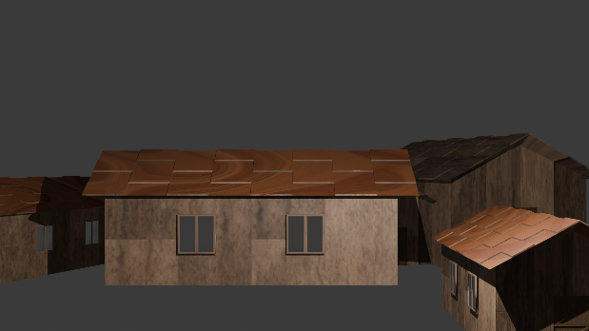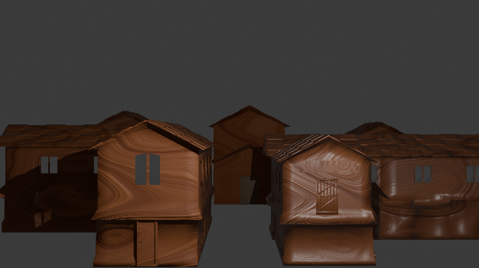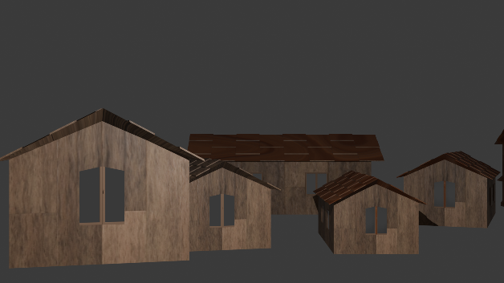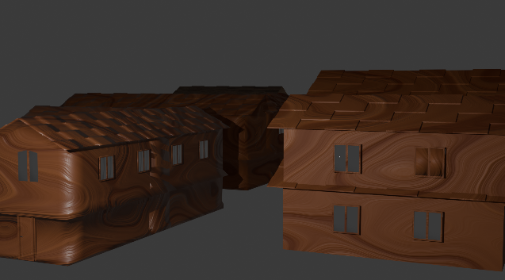

- Adapted the 3D map we created into a 2D version, preserving depth, perspective, and spatial relationships while simplifying the scene for better readability.

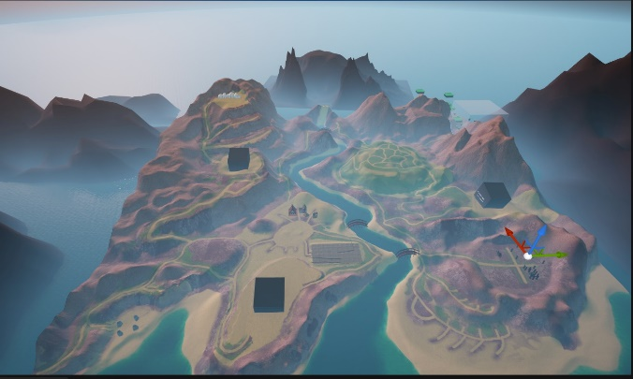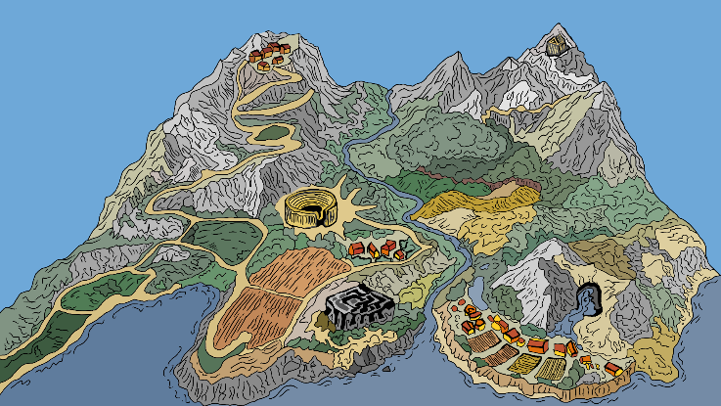

- Refined the 2D characters I personally designed, enhancing their poses, expressions, and outfit details.
- Detailed the designs of Hermes and other NPCs.
- Added small animations to the UI for characters, such as click and selection effects.
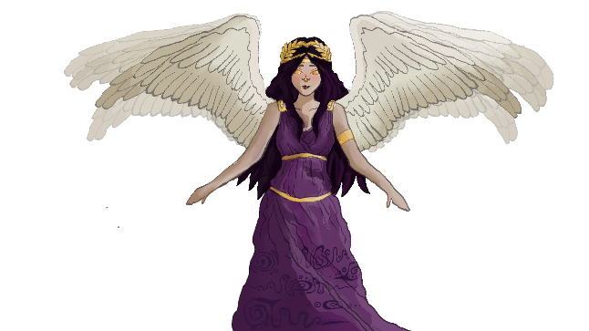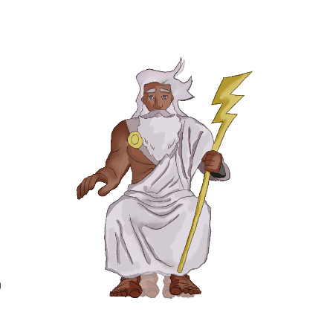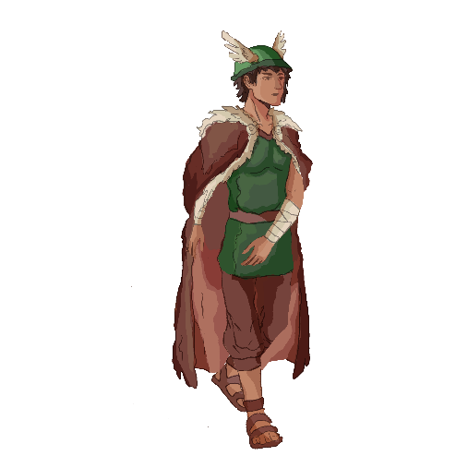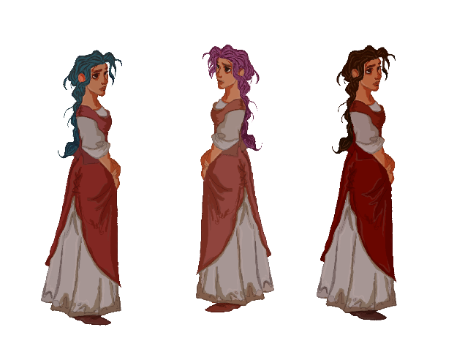

Alp’s Work in the 2nd Term
Alp (Programmer, Level Designer, VFX):
- Completed VFX development for the level design and environment, including the creation of the Flamethrower, Floating Dandelion Seeds, and Magic Circle effects.
- Designed the architectural plan and structural layout for the Minotaur’s Labyrinth section.
- Developed the Flying Bird Possess System mechanic, specifically engineered for navigation within the Minotaur’s Labyrinth.
- Executed the full migration of assets from the previous map to the new environment, ensuring all 1st-term work was successfully integrated.
- Refined and updated all materials, colors, and effects during the transition process to maintain visual consistency and quality in the new map.
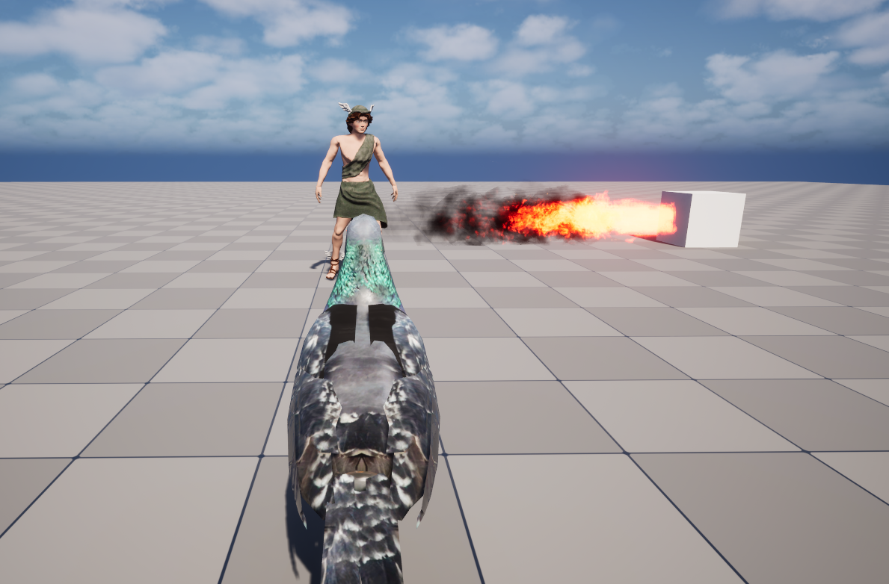
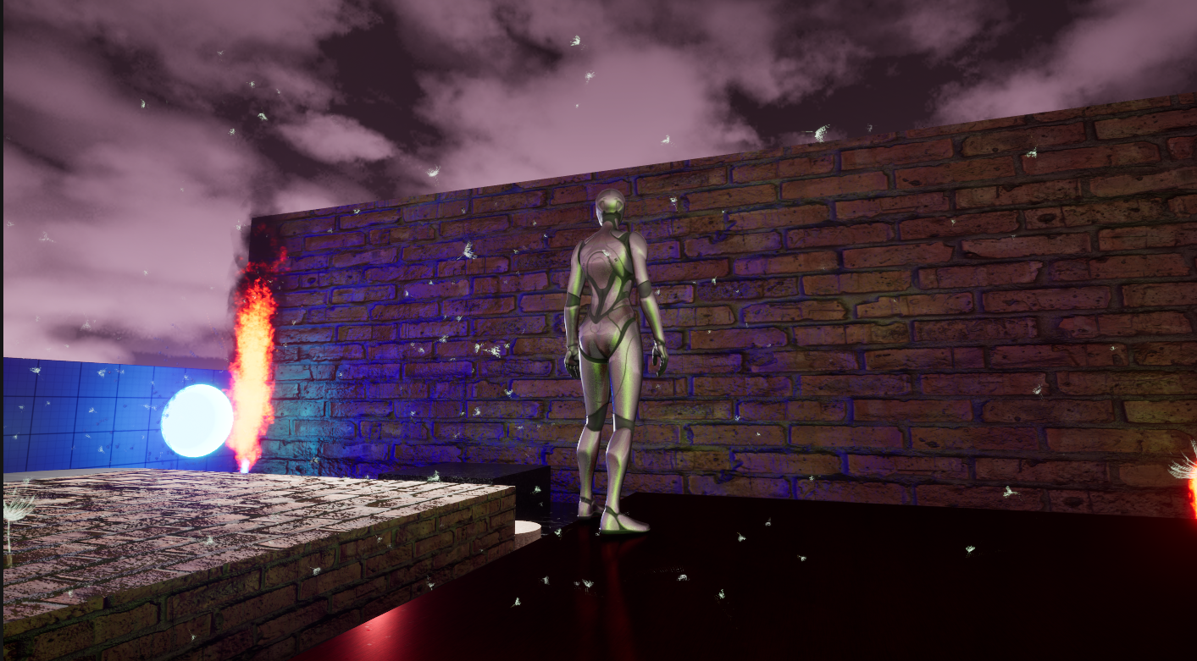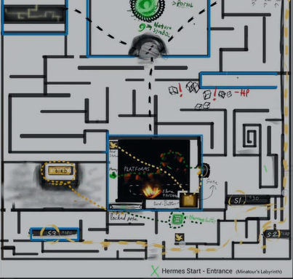

Selinay’s Work in the 2nd Term
Selinay (3D and UI Designer):
- Designed village and town assets with a focus on wood 3D formats.
- Created modular assets for houses.
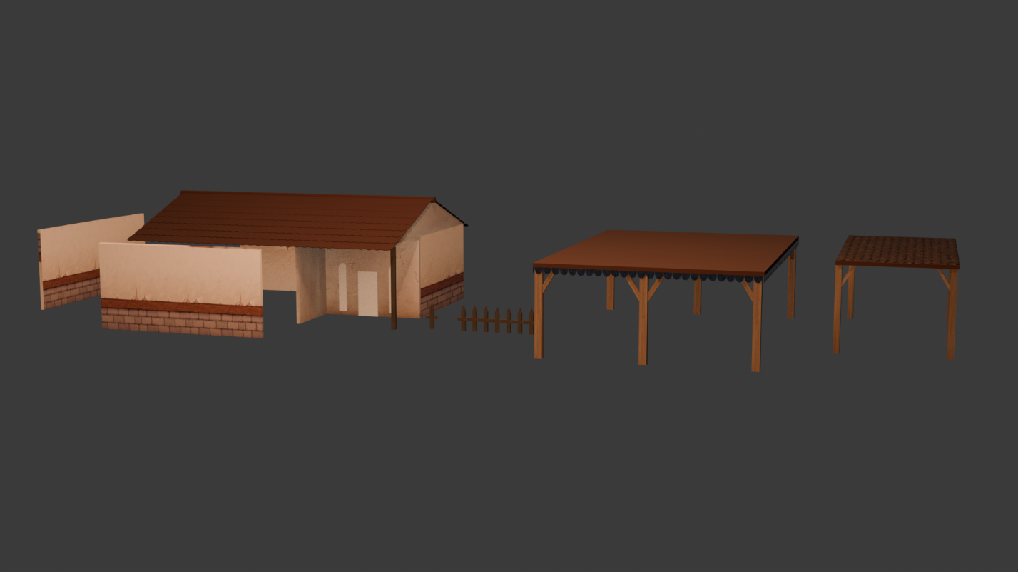

Fatih’s Work in the 2nd Term
Fatih (Environment Designer & 3D Designer):
1. Modular Construction System
For the Coastal Village project, a modular workflow was implemented instead of modeling individual, unique houses. This strategic approach allows for:
- High Versatility: The ability to create an infinite variety of building types and household structures using a single set of modular assets.
- Workflow Efficiency: Significantly reducing the time required to populate the game map with diverse architectural elements.
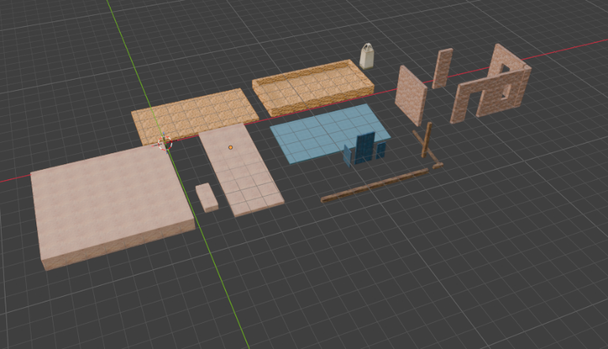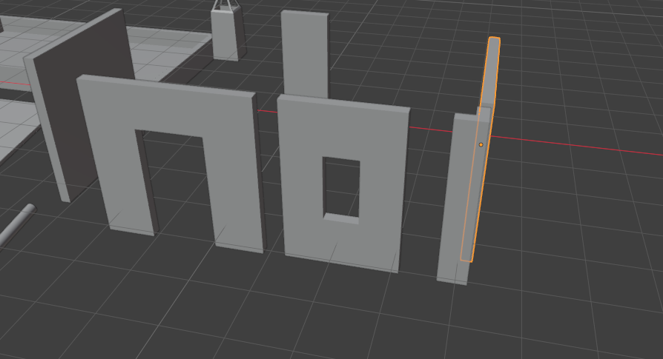
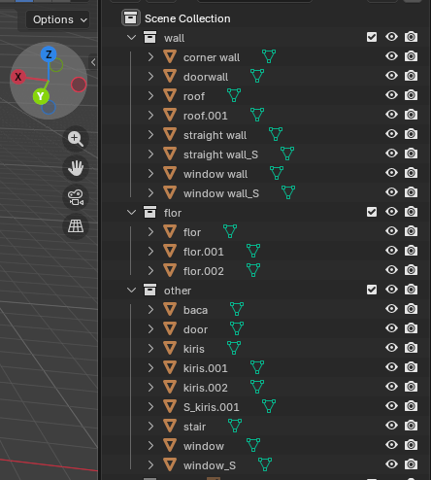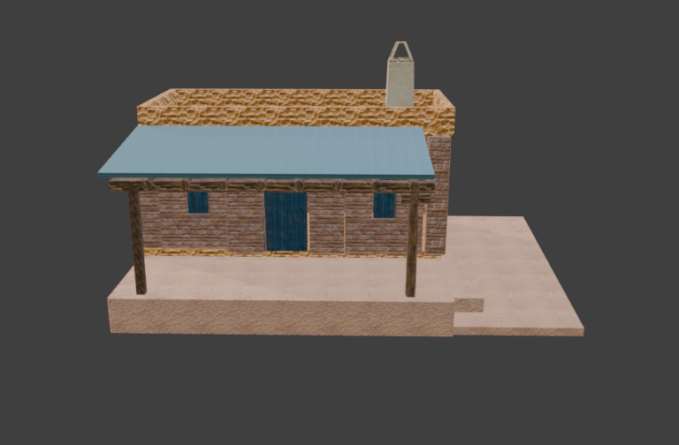
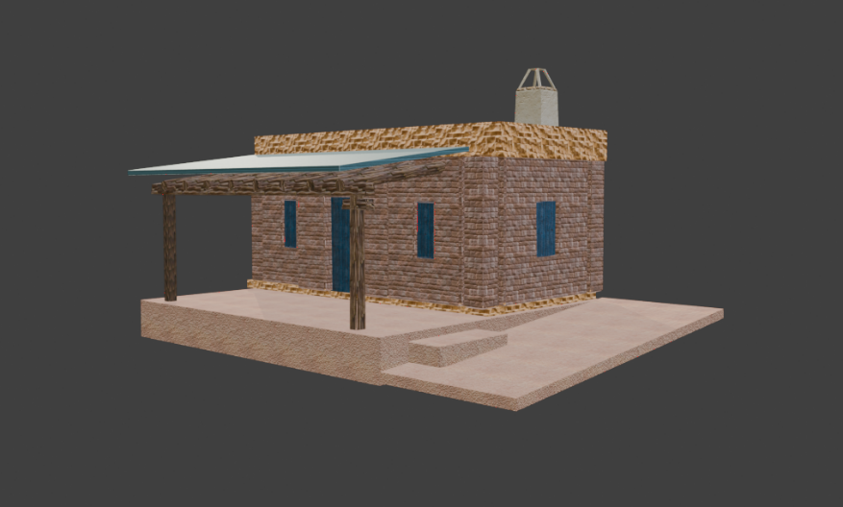
2. Optimization and Trim Sheet Strategy
To ensure high performance and maintain a smooth frame rate, optimization was prioritized from the beginning:
- Draw Call Reduction: All modular components were assigned to a single material, significantly reducing the overhead on the game engine.
- Trim Sheet Workflow: The UV layouts were organized according to a Trim Sheet logic. This allows multiple assets to share the same texture space without sacrificing visual quality.
- Note: The textures currently visible in the screenshots are placeholders used for identification; the final Trim Sheet painting phase is currently in progress.

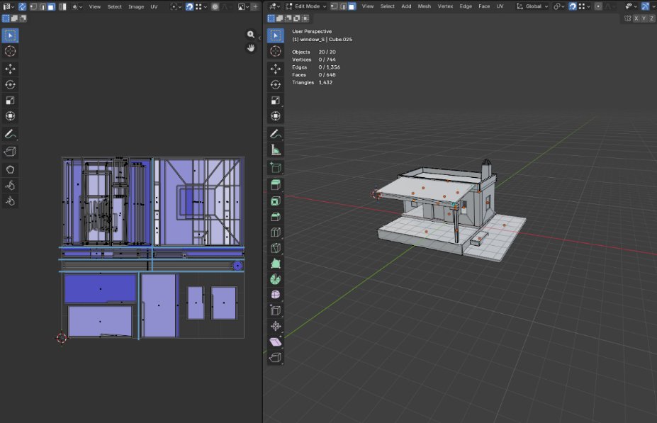

3. Hero Assets and Props
To enhance the atmosphere of the village, two key narrative assets were developed:
- Coastal Boat: A thematic asset designed to reinforce the coastal identity of the village.
- Village Agora Well: A central prop designed as a focal point for the village square (Agora).
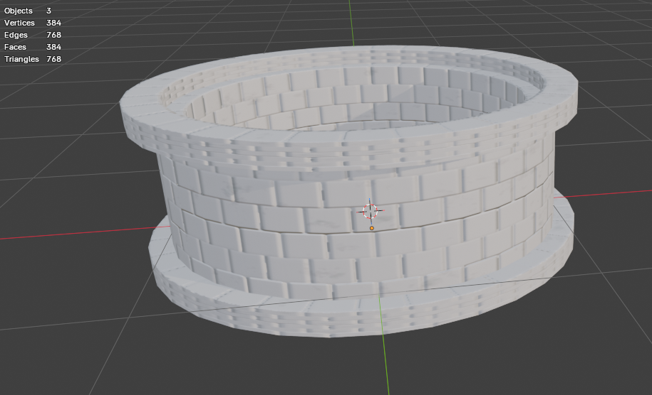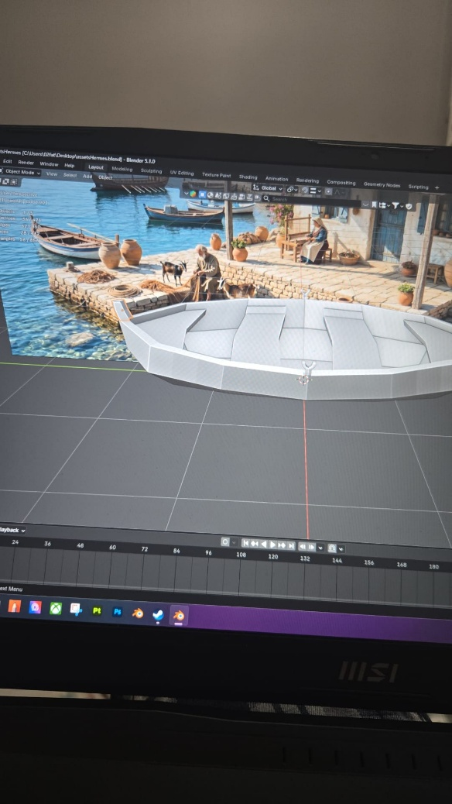
4. Landscape Design and Revision
Since the second semester, my primary focus has shifted toward Landscape Design. After evaluating the initial landscape created in the first semester, a strategic decision was made to overhaul the terrain:
- The previous landscape was replaced with a new, more refined topography to better suit the coastal theme and player navigation.
- Current efforts are concentrated on sculpting and painting the terrain to integrate seamlessly with the modular village structures.

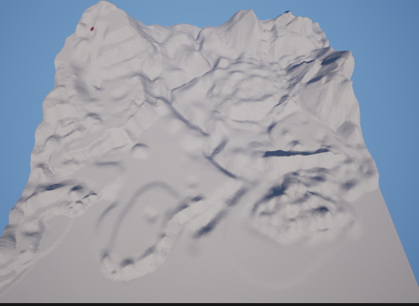

Furkan’s Work in the 2nd Term
- Dynamic Time Infrastructure: Engineered a fully functional 24-hour dynamic time system and a day counter using Blueprints. This system was specifically designed as a highly scalable foundation that will easily drive upcoming core mechanics, such as the visual Day/Night cycle and time-based ambient audio triggers.
- Optimization & Bug Fixing: Conducted extensive profiling and optimization passes (including Culling, Foliage Shadow adjustments, and Texture Budget management) resulting in significantly improved frame rates and stability for the game build.
- UI & Navigation: Updated and polished the current in-game map interface within the menu. Laid the backend groundwork for a more advanced, interactive map/exploration mechanic scheduled for the upcoming development sprints.
