Youth Mappers Brand, Name, and Logo Usage Policy

Thank you for being a part of the Youth Mappers Network! We encourage you to promote this effort by utilizing our program branding with your own chapter outreach. This helps us to increase visibility and raise awareness of not only your own local campus group, but also the larger network and what it stands for. This is a serious responsibility at the same time that it is a privilege to be associated with all of the outstanding campuses. This program logo helps to unify the efforts and signal our collaboration and partnership across all of the participating campuses and other organizations. Being consistent with the graphic brand and wording acknowledgements not only helps us to get it right, it can increase our impact in the community.

Here is our policy on how you can manage this branding with respect and care to the program and your fellow members and their home institutions.

**Chapter Branding**

When you established your chapter you agreed to terms of participation that included following these specific branding and acknowledgement guidelines in all print and digital communications.

**Affiliated groups names and logos**

Existing campus student groups can be approved for affiliation into the network and maintain their original name, logo, and branding practices. By affiliating with Youth Mappers, you also agree to add the unaltered main program name and logo to any and all efforts that are related to your participation in this network.

**Formed Youth Mappers chapter names and logos**

Each newly created campus chapter has an official chapter name that includes the words Youth Mappers and some reference to the home campus institution where it is located. The logo you may use at the chapter specific level must be approved by our steering committee and should reflect the main logo of the program. Changing the logo to fit university or city-specific colors or graphics are not allowed. Abbreviations to chapter names are allowed, but not to the program name. For example: *Youth Mappers at Texas Tech University*, can be abbreviated as *Youth Mappers at TTU*, etc. consistent with common or formal abbreviations put forth by your particular university.

For activities that receive funding support from the calls for participation of the program, all affiliated or created chapters will also acknowledge such funding support and the main sponsor with wording provided when you are awarded funding. (One example of such wording may be as follows: “Funding support for this activity was provided by Youth Mappers, MappersU and the USAID GeoCenter.”) See also Acknowledgements, below.

**Content Consistency**

When referring to the network of chapters, please refer to the following statements of vision and mission:

*Our vision: To cultivate a generation of young people to develop this leadership ability and create resilient communities around the world.  To empower youth to define and change their world by mapping it.*

*Our mission: Youth Mappers is a network of university-student-led campus chapters in the developing world and in the US. We organize, collaborate, and implement mapping activities that respond to actual development needs around the globe, creating and using spatial data and information that is made publically available through open platforms. We share experiences and results while learning, leading, and making a difference in the world.*

**Naming Conventions**

When writing the full program name inside of text documents without the logo attached, no hyphen is required and each word should have initial caps: Youth Mappers. Using the word “network” is optional, but should not be capitalized. There is no official abbreviation to be used.

When appropriate to refer to the organizers, the following language may be used:

*The Youth Mappers network is an activity of MappersU: the Mapping for Resilience International University Consortium.*

For further acknowledgement, you may add:

*Founding universities are Texas Tech University, The George Washington University, and West Virginia University, with support from the United States Agency for International Development’s GeoCenter.*

**Logo Usage**

The program logos are to be used with all print and digital communications, including but not limited to publicity, promotion, legal documentation, grant applications, report submissions, and other organizational purposes. Logos may be resized, but the ratio between height and width must be maintained. Changes to the logo, the logo text, colors, placement, or any other elements are prohibited unless expressly approved by the Project Director.

**Color Scheme**

Any print or digital production of the logo must adhere strictly to the color scheme as follows:

Macintosh HD:Users:patriciasolis:Desktop:Screen Shot 2016-02-08 at 1.27.53 PM.png Orange (location icon)

*RGB (252,99,32) ; CMYK (0,76,100,0) ; Hex (#fc6320)*

Macintosh HD:Users:patriciasolis:Desktop:Screen Shot 2016-02-08 at 1.34.55 PM.png

Dark Blue (people-arrows)

*RGB (51,66,109) ; CMYK (91,81,31,17) ; Hex (#33426d)*

Macintosh HD:Users:patriciasolis:Desktop:Screen Shot 2016-02-08 at 1.35.05 PM.png

Light Blue (ocean)

Macintosh HD:Users:patriciasolis:Desktop:Screen Shot 2016-02-08 at 1.36.16 PM.png*RGB (145,204,202) ; CMYK (43,3,22,0) ; Hex (#91ccca)*

Green (land)

*RGB (79,129,6) ; CMYK (73,27,100,13) ; Hex (#4f8106)*

Text for the logo should be Black. A white background should be used whenever possible. A gray scale version is also available when color production is not feasible or possible. Please download these logo assets from the links provided to you upon chapter approval.

*Banner Style logo header* : for webpages, emails, letterhead, T-shirts, anywhere where a horizontal logo is useful. This is the preferred logo, with text.



*Icon Style logo:* for use as avatar or whenever a circular or minimal logo presence is needed.



On the rare occasion that you may need to acknowledge or refer to the organizing consortium, the following logos are available and should link to [www.mappersu.org](http://www.mappersu.org):

*Full Banner Style Logo:* this is the preferred use for reference if rendered at a legible size.

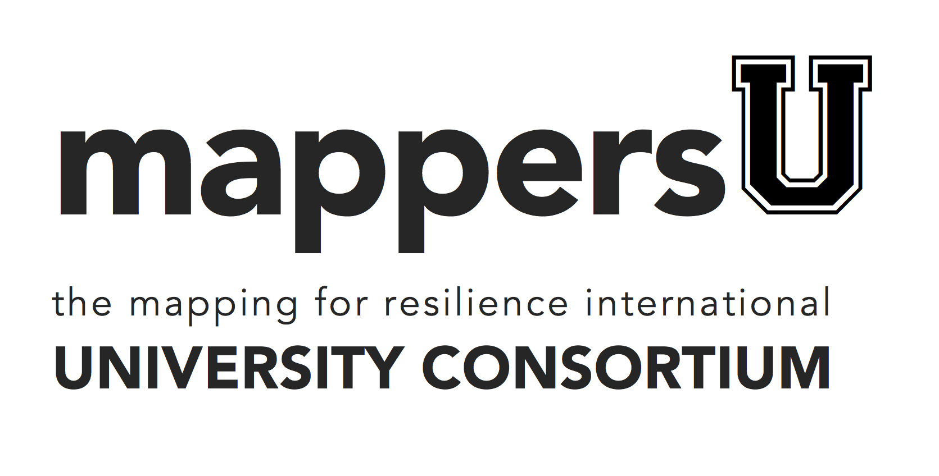

*Modified Banner Style Logo:* this may be used if the logo space is limited and a horizontal logo is at all possible.



*Avatar Style Logo:* this may be used in infrequent cases of the need for a very small footprint or avatar.



**Typography**

Recommended typefaces are listed below. Fonts outside of those indicated here are not approved for official use in branded materials, neither at the headquarters and chapter levels.

*Logo:* Avenir Black (for the word youth, uncapitalized) and Avenir Book (for the word mappers, uncapitalized) with no space in between.

*Headers / Headlines:* Avenir family of fonts; Century Gothic

*Body:* Century Gothic, Calibri

*Alternative Body:* Arial

**General Compliance**

Chapters may NOT sell items bearing the program logo or name without prior approval by the steering committee with the mockup and purpose explicitly specified. Chapters must take care to follow any and all relevant university branding guidelines and restrictions of their home campuses and should not violate the guidelines of partner or collaborator campuses either.

**Website Promotion**

We strongly encourage embedded urls and explicit links to the program’s website and social media. These include:

*Main url:* [www.youthmappers.org](http://www.youthmappers.org)

*Facebook page* : <https://www.facebook.com/YouthMappers-134190910280566/>

*Twitter:* @youthmappers <https://twitter.com/youthmappers>

*Instagram:* <https://www.instagram.com/youthmappers/> username: youthmappers

*Hashtags in use include*: #youthmappers #mappyending

*Other key organizations to follow include:* @USAIDGeo @HOTOSM

**Acknowledgements**

The following must always include acknowledgement and visibly bear the USAID identity (for questions, please contact the Program Director):

* program, project, or activity websites funded by USAID, including visible infrastructure projects or other programs, projects, or activities that are physical in nature;
* technical assistance, studies, reports, papers, publications, audio-visual productions, public service announcements, Web sites/Internet activities and other promotional, informational, media, or communications products funded by USAID; multi-media website, videos, news stories, press releases, training or orientation powerpoints, etc.
* any posters by the implementing partners or participants presenting work conducted with support from USAID (such as the fellowships) that is presented at Mappers U and Youth Mappers events will follow guidelines provided
* events financed by USAID, such as training courses, conferences, seminars, exhibitions, fairs, workshops, press conferences, and other public activities; and mapathons;
* all commodities financed by USAID, including commodities or equipment provided under humanitarian assistance or disaster relief programs, and all other equipment. Supplies and other materials funded by USAID, and their export packaging.

**Media & Press**

For local media inquiries it is important to identify a specific person with clear communication skills from your chapter to manage positive attention to your activities. If a national press contact makes an inquiry, you should be responsive to requests for information or interviews, but also forward them to the program organizers via email at [mappers.vpr@ttu.edu](mailto:mappers.vpr@ttu.edu). In the rare or unexpected case of negative media attention, we recommend honesty and responsibility, and encourage such situations to be brought to our attention immediately. We request that copies of any and all publicity, interviews, photographs, and media coverage in any format be provided to the main program for our media page and further dissemination.

**Questions**

May be directed to [mappers.vpr@ttu.edu](mailto:mappers.vpr@ttu.edu).