Interactive visualization tool for end user to create their own reports with out reliaing on IT. Data warehouse capabilities

**Features:**

Real time trends

Auto search capabilities

Advance analytics : Analyse data

Enterprise ready : Securely connect on onpremesis database like sql server, Secure, liable

Integration with Azure cloud for various ETL operations

+ prebuilt dashboards

+ real time dashboard updates

+ secure, live connection to onpremesis data sources as well as cloud

+ forecast future trends

+ natural lang query

+ Highly scalable

+ quick deployment

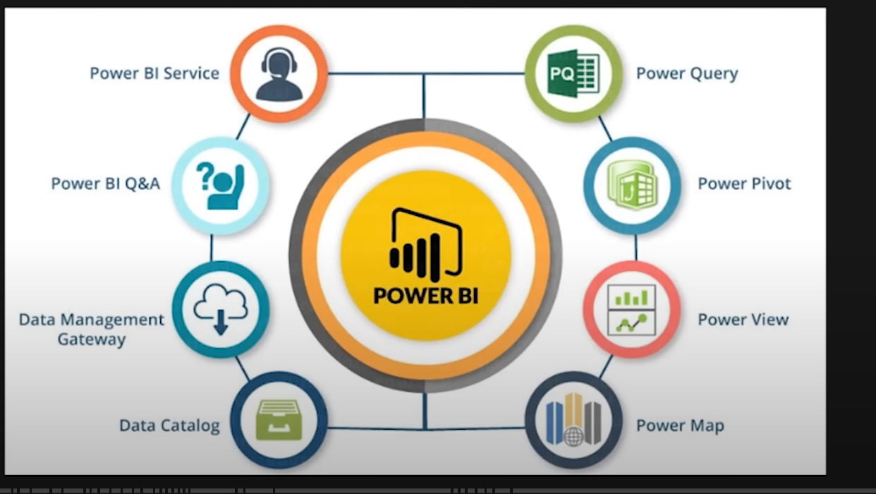

Components

Visualizations : Graphs, charts

Data sets : from different sources like excel, databasases

Reports :

Dashboard : One page. only important information

Tile: Single visualation found in a report or on a dashboard

Install: <https://powerbi.microsoft.com/en-us/downloads/> 🡪 Download 🡪 get

Report view,Data view and Model view

Charts:

Column chart:

Clusted column chart:

A clustered column charts is a type of column chart in which you compare two values side by side. you will compare the Loan_disbursed values against two categories, Purpose and Gender.

Bar Charts and column charts:

https://www.pluralsight.com/guides/bar-and-column-charts-in-power-bi

Line charts and area charts

Combination charts

Pie chart, Doughnut chart & Tree maps

Maps

Funnel charts

Guage cards

Table and Matre