Preliminary microsimulation analysis for alcohol policy and harms

21 March, 2022

Table of Contents

Introduction 1

Methods 1

Transition probabilites 1

Two-state with two paths (alcoholic/non-alcoholic) 2

On Monte Carlo process 3

Rounding of survey weights 3

Results 7

Microsimulation results 7

Detail results for randomly selected individuals 7

Questions for Michael Wolfson 10

References 10

# Introduction

This analysis applies discrete-event microsimulation to understand the impact of alcohol policies on the Ontario population. The interest is to understand how alcohol policy impact differ by age, sex, and socioeconomic groups. Currently, we are at the initial stage of building the microsimulation model structure. The results presented here are preliminary in that they predict alcohol-related mortality without policy effect and only consider differences in age and sex, but not socioeconomic levels.

# Methods

## Transition probabilites

We obtained alcohol-attributable and non-attributable mortality rates from the Sheffield Alcohol Policy Model (Holmes et al. 2016). These mortality rates are stratified by age group and sex (Table 1). We consider The mortality rates as transition probabilities since their denominators are they underlying population, but not time-to-event. If their denominators are time-to-event, we will need to apply formulas to convert them to transition probabilities. While morbidity rates are also available from the Sheffield Model, we choose to focus on the two-state model at this stage, as we are unavailable to locate many studies with data on the sick-to-death rates or rate ratio of death when sick versus healthy.

**Table** **1**: Ontario population and mortality rates from Sheffield model (or transition probabilites) by age group and sex

| **Age group** | **Sex** | **Alcoholic death rates (per 100K)** | **Non-alcoholic death rates (per 100K)** |
| --- | --- | --- | --- |
| 16-24 | Male | 10.6 | 43.5 |
| 16-24 | Female | 2.1 | 26.3 |
| 25-34 | Male | 16.6 | 58.1 |
| 25-34 | Female | 4.4 | 36.0 |
| 35-54 | Male | 41.4 | 192.5 |
| 35-54 | Female | 20.4 | 148.2 |
| 55+ | Male | 72.1 | 2,741.1 |
| 55+ | Female | 28.9 | 3,083.5 |
| Total | Male | 42.8 | 1,000.0 |
| Total | Female | 17.8 | 1,082.2 |
| All | All | 30.3 | 1,041.0 |
|  | | | |

## Two-state with two paths (alcoholic/non-alcoholic)

We consider both the alcoholic-attributable and non-alcoholic-attributable mortality rates in Table 1 in the microsimulation models. The method to combine them are illustrated in Figure 1. For each individual, Monte-Carlo simulations are performed in parallel based on the alcohol- and non-alcoholic-attributable mortality rates. For both the alcoholic and non-alcoholic paths, the individual either stay in the *healthy* state or move to the *death* state in the next time cycle. If either of the paths proceed to the *death* state, then the individual is considered to be deceased the next and all future time cycles. Only when the individual stay in the *healthy* state for both paths, the individual will remain in the *healthy* state for the next time cycle. We keep track of whether a person die due to either alcoholic or non-alcoholic, or both alcoholic and non-alcoholic causes, from these information we can calculate the percent of alcoholic- or non-alcoholic attributable deaths for the population group.

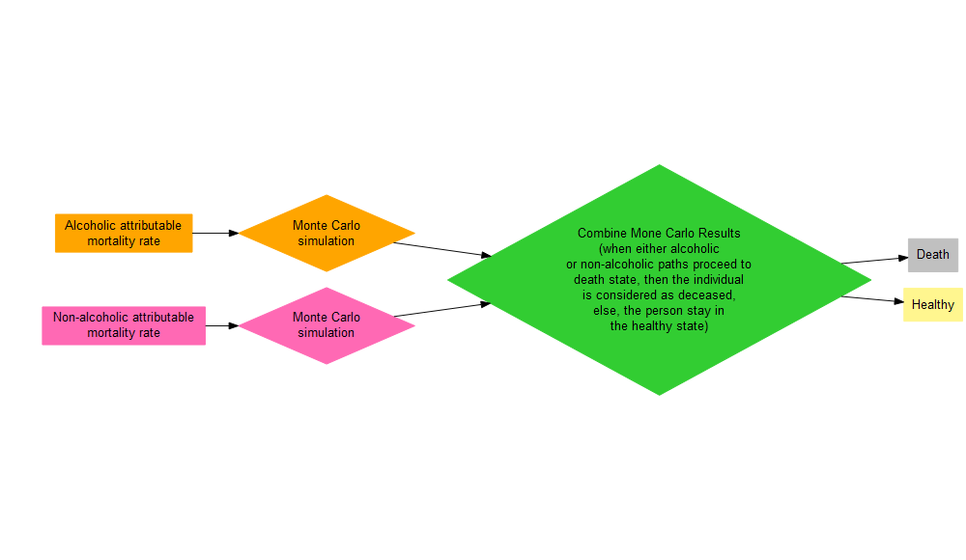

Figure 1. Schematic diagram of microsimulation at each time cycle

## On Monte Carlo process

Since microsimulation models rely on Monte Carlo simulation methods to describe the stochastic transition process of individuals through the model, given the same transition probabilities, individuals will have different results in terms of proceeding to the “death” state (Krijkamp et al. 2018). We carried out the microsimulation based on sample R codes from the tutorial paper by Krijkamp et al. (2018). The stochastic transition process involves using random numbers generated from a uniform(0,1) distribution.

The algorithm proceed for each individual as follows:

1. Generate a random number $u1$ from a uniform(0,1) distribution for the alcoholic path
2. Generate a random number $u2$ from a uniform(0,1) distribution for the non-alcoholic path
3. If $u1$ is greater than $1-\text{alcoholic death rate}$ (or probability of staying in the healthy state), then the person would have died from alcoholic cause
4. If $u2$ is greater than $1-\text{non-alcoholic death rate}$ (or probability of staying in the healthy state), then the person would have died from non-alcoholic cause
5. If the person either died from alcoholic or non-alcoholic cause, then the person is deceased in the next and all future time cycles; else, the person stays in the healthy state in the next time cycle and repeat #1-5 again.

## Rounding of survey weights

We apply the above methods to the Ontario population. We use the Canadian Community Health Survey (CCHS) data to obtain population by age and sex groups. The CCHS data provide survey weights for each survey individual (Table 2), we simply sum the rounded survey weights by age and sex group to obtain the age- and sex-specific Ontario population (Table 3). Alternatively, we can sum the survey weights first (without rounding) by age and sex group then round this total value. However, with this approach we are not able to link the microsimulation results back to the CCHS individuals. Therefore to choose to round the survey weights at the individual-level. In Table 3, we compare the sum of survey weights versus the sum of rounded survey weights for a list of variables of interest, the two values are the same to the 4th decimal place.

**Table** **2**: A snapshot of CCHS data with age, sex, survey weights, and rounded weights

| **Age** | **Sex** | **Survey weights** | **Rounded survey weights** |
| --- | --- | --- | --- |
| 12-29 | Male | 62.01 | 62 |
| 12-29 | Male | 560.02 | 560 |
| 12-29 | Male | 604.45 | 604 |
| 12-29 | Female | 108.97 | 109 |
| 40-49 | Male | 161.86 | 162 |
| 40-49 | Male | 84.85 | 85 |
| 40-49 | Female | 79.92 | 80 |
| 50-59 | Male | 89.82 | 90 |
| 50-59 | Male | 198.93 | 199 |
| 50-59 | Male | 105.05 | 105 |
| 50-59 | Female | 110.13 | 110 |
| 50-59 | Female | 274.98 | 275 |
| 60-69 | Male | 188.66 | 189 |
| 60-69 | Female | 345.57 | 346 |
| 70-79 | Male | 166.31 | 166 |

**Table** **3**: CCHS data by age, sex, alcohol-related variables with proportion based on survey weights, and rounded weights

| **Variable** | **Category** | **CCHS weighted proportion** | **Rounded proportions for microsim.** |
| --- | --- | --- | --- |
| Age | 12-29 | 0.2716463104 | 0.2716434003 |
| Age | 30-39 | 0.1492591710 | 0.1492608362 |
| Age | 40-49 | 0.1633120829 | 0.1633153107 |
| Age | 50-59 | 0.1742447665 | 0.1742438295 |
| Age | 60-69 | 0.1285846148 | 0.1285845707 |
| Age | 70-79 | 0.0748675981 | 0.0748662044 |
| Age | 80+ | 0.0380854564 | 0.0380858481 |
| Sex | Male | 0.4890179481 | 0.4890136581 |
| Sex | Female | 0.5109820519 | 0.5109863419 |
| Alcohol drinking frequency | NS | 0.0165622797 | 0.0165611970 |
| Alcohol drinking frequency | NA | 0.2623282498 | 0.2623252821 |
| Alcohol drinking frequency | DK | 0.0019352115 | 0.0019352541 |
| Alcohol drinking frequency | Refusal | 0.0006117378 | 0.0006119573 |
| Alcohol drinking frequency | less than once a month | 0.1687811763 | 0.1687812393 |
| Alcohol drinking frequency | once a month | 0.0745743541 | 0.0745746494 |
| Alcohol drinking frequency | 2 to 3 times a month | 0.1006303800 | 0.1006314143 |
| Alcohol drinking frequency | once a week | 0.1110776772 | 0.1110780028 |
| Alcohol drinking frequency | 2 to 3 times a week | 0.1517592486 | 0.1517594266 |
| Alcohol drinking frequency | 4 to 6 times a week | 0.0452206730 | 0.0452212415 |
| Alcohol drinking frequency | every day | 0.0665190119 | 0.0665203356 |
| Type of alcohol drinker | NS | 0.0191092290 | 0.0191084084 |
| Type of alcohol drinker | Regular drinker | 0.5497813448 | 0.5497850702 |
| Type of alcohol drinker | Occasional drinker | 0.1687811763 | 0.1687812393 |
| Type of alcohol drinker | Did not drink in the last 12 months | 0.2623282498 | 0.2623252821 |
| Heavy drinking | NS | 0.0174501337 | 0.0174489588 |
| Heavy drinking | NA | 0.2623282498 | 0.2623252821 |
| Heavy drinking | DK | 0.0027260162 | 0.0027256027 |
| Heavy drinking | Refusal | 0.0010243138 | 0.0010244657 |
| Heavy drinking | Heavy drinking in the past year at least once per month | 0.1628624442 | 0.1628633406 |
| Heavy drinking | Did not heavy drink in the past year | 0.5536088423 | 0.5536123502 |

# Results

## Microsimulation results

We performed microsimulation for 31 time cycles. In the initial time cycle, all individuals begin in the *healthy* state. We ran the age- and sex-specific models (excluding models for all ages and both sexes), based on the transition probabilities in Table 1. The percentage of attributable deaths by cause at the end of the time cycles are summarized in Table 4.

**Table** **4**: Microsimulation results: percentage (%) of deaths attributable to alcoholic or non-alcoholic causes by age and sex groups

| **Age group** | **Sex** | **Total population** | **Alcoholic deaths** | **Non-alcoholic deaths** | **Deaths due to both alcoholic and non-alcoholic causes** | **Percent of alcoholic deaths (%)** | **Percent of non-alcoholic deaths (%)** | **Percent of deaths due to both alcoholic and non-alcoholic causes (%)** |
| --- | --- | --- | --- | --- | --- | --- | --- | --- |
| 16-24 | Female | 818,220 | 519 | 6,407 | 0 | 0.06343037 | 0.7830412 | 0.0000000000 |
| 16-24 | Male | 861,105 | 2,704 | 11,274 | 1 | 0.31401513 | 1.3092480 | 0.0001161299 |
| 25-34 | Female | 903,256 | 1,198 | 9,763 | 0 | 0.13263128 | 1.0808674 | 0.0000000000 |
| 25-34 | Male | 867,389 | 4,319 | 15,054 | 4 | 0.49793115 | 1.7355535 | 0.0004611541 |
| 35-54 | Female | 1,959,818 | 11,763 | 84,686 | 18 | 0.60020879 | 4.3211155 | 0.0009184526 |
| 35-54 | Male | 1,895,180 | 22,820 | 105,469 | 54 | 1.20410726 | 5.5651178 | 0.0028493336 |
| 55+ | Female | 1,997,749 | 11,041 | 1,212,645 | 363 | 0.55267203 | 60.7005685 | 0.0181704508 |
| 55+ | Male | 1,794,484 | 25,791 | 1,004,657 | 736 | 1.43723767 | 55.9858433 | 0.0410145758 |

## 

## Detail results for randomly selected individuals

Here we provide the more detail results for selected individuals among males ages 16-24. Heat maps below show the health state of selected individuals (n=100) over time cycles, the randomly generated uniform numbers to determine transition to death or not, and the quality-adjusted life years (healthy = 1, death = 0).

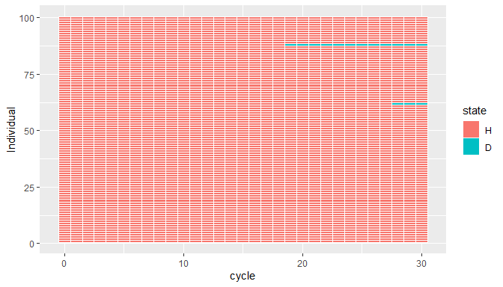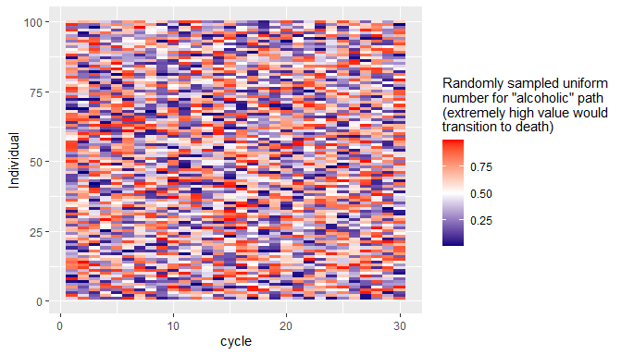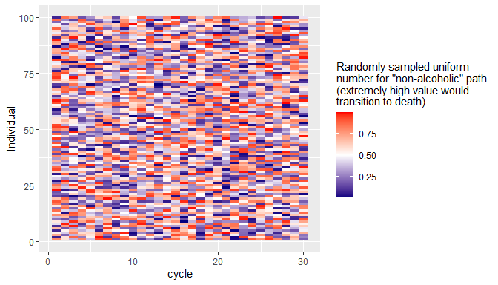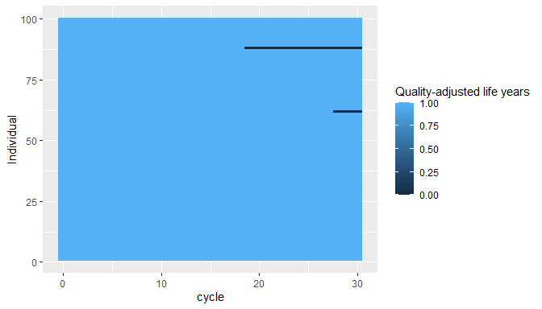

Table 5 shows the attributable cause of death among the selected individuals who died:

**Table** **5**: Microsimulation results: selected deaths attributable to alcoholic or non-alcoholic causes

| **Individual** | **Cycle** | **State for alcoholic path** | **State for non-alcoholic path** | **Cause of death** | **Combined state** |
| --- | --- | --- | --- | --- | --- |
| 684132 | 19 | H | D | Non-alcoholic | D |
| 774366 | 28 | H | D | Non-alcoholic | D |

# Questions for Michael Wolfson

1. Is it reasonable to combine alcoholic and non-alcoholic transition probabilities in this “parallel” method?
2. Since our interest is in age- and sex-specific deaths, is there any benefit in running microsimulation models for both sexes or all ages? Can we sum up the age- and sex-specific results to obtain the total deaths for both sexes or all ages?
3. Ideally, we should perform three-state model with an intermediate state for morbidity or hospitalization. However, given the difficulty in finding the morbidity to mortality transition probabilities from the literature, we only performed the two-state model. What are your advice on this?

# References

Holmes, John, Colin Angus, Penny Buykx, Abdallah Ally, Tony Stone, Petra Meier, and Alan Brennan. 2016. “Mortality and Morbidity Risks from Alcohol Consumption in the UK: Analyses Using the Sheffield Alcohol Policy Model (v. 2.7) to Inform the UK Chief Medical Officers’ Review of the UK Lower Risk Drinking Guidelines.” *Sheffield: ScHARR, University of Sheffield*.

Krijkamp, Eline M, Fernando Alarid-Escudero, Eva A Enns, Hawre J Jalal, MG Myriam Hunink, and Petros Pechlivanoglou. 2018. “Microsimulation Modeling for Health Decision Sciences Using r: A Tutorial.” *Medical Decision Making* 38 (3): 400–422.