Fusepool P3 demo apps

# Deliverable D4.2



Table of Contents

1. Deliverable D4.2 1

2. Document History 2

3. Document Information 2

4. Document Context Information 2

5. Quality Assurance / Review 2

6. Official Citations 3

7. Copyright 3

8. Acronyms and Abbreviations 3

9. Links in this deliverable 3

10. Executive Summary 4

11. Introduction 4

12. Hackathon 4

13. Demo applications 6

a) Demo App: “LOD events eXplorer” 6

b) Demo App: “In the Footsteps: Trentino's Famous People” 11

# Document History

|  |  |  |  |
| --- | --- | --- | --- |
| Ver. | Name | Date | Remark |
| v0.0 | Danilo Giacomi | 08.06.2015 | Initial draft |
| v0.1 | Danilo Giacomi | 26.06.2015 | General structure and  information |
| v0.2 | Danilo Giacomi, Giuliano Mega | 15.07.2015 | First app description |
| v0.3 | Danilo Giacomi, Giuliano Mega | 16.07.2015 | Second app description |
|  |  |  |  |
|  |  |  |  |

# Document Information

* Deliverable Nr Title: D4.2 Fusepool P3 demo apps
* Lead: Danilo Giacomi (NET7)
* Authors: Danilo Giacomi (NET7), Giuliano Mega (SPAZIO)
* Publication Level: Public

# Document Context Information

* Project (Title/Number): Fusepool P3 (609696)
* Work Package / Task: WP4 / T4.2
* Responsible person and project partner: Danilo Giacomi (NET7)

# Quality Assurance / Review

* 1st reviewer: Marco Combetto (PAT)
* 2nd reviewer: Davide Bruno (RET)

# Official Citations

Description of Work (DoW)

# Copyright

This document contains material, which is the copyright of certain Fusepool P3 consortium parties. This work is licensed under the Creative Commons Attribution 4.0 International License. To view a copy of this license, visit http://creativecommons.org/licenses/by/4.0/.

# Acronyms and Abbreviations

|  |  |
| --- | --- |
| Acronym | Description |
| DoW | Description of Work |
| PAT | Provincia autonoma di Trento |
| RET | Regione Toscana |

# Links in this deliverable

|  |  |
| --- | --- |
| Title | URL |
| FP3 Community website | http://getfp3.com |
| SOD 2015 | http://www.spaghettiopendata.org/page/benvenut-sod15 |
| SOD people | http://www.spaghettiopendata.org/conf/iscritti |
| SOD FP3 track | http://www.spaghettiopendata.org/content/riuso-di-dati-lod-ovvero-linked-open-data-fusepool-p3-project |
| LOD events eXplorer | http://explorer.nexacenter.org/ |
| LOD events eXplorer GitHub | https://github.com/giuseppefutia/sod2015 |
| In The Footsteps: Trentino's Famous People - Video | https://docs.google.com/file/d/0B_uwBrg856HvZjU2T0FXUWZ4WGM/edit |
| In The Footsteps: Trentino's Famous People - Github | https://github.com/marcyborg/In-The-Footsteps-Trentino-s-Famous-People |
| Uduvudu | https://github.com/uduvudu/uduvudu |
| Yelp | http://www.yelp.it/ |
| DBpedia | http://wiki.dbpedia.org/ |

# Executive Summary

This document details the work performed and planned as part of Deliverable D4.2 / Task 4.4 "Fusepool P3 demo apps".

We decided to hold a contest within the Spaghetti Open Data 2015 which was held in Bologna in March 2015.

The contest’s first aim was to share the knowledge about the Fusepool P3 project by letting external developers use our platform and its components for developing either web or mobile applications.

The two winning applications ideas have been rewarded with a money prize, to subsidize their development and to make the contest more appealing for the candidates.

The two applications, one web-based and one mobile, rewarded with prizes, and have been further developed in the following months. The two resulting applications not only make use of the platform’s data, but also interlink them with other sources and, by the use of the Uduvudu library, display the content in a nice visual manner.

# Introduction

The DoW for the Fusepool P3 project describes the main task of this deliverable as:

"T4.4 – Fusepool P3 demo apps: development of at least two demo apps related to the tourism sector for integration in web sites as widgets and as mobile, location-aware apps based on a rich set of open data provided by the public bodies combined with data from the LOD cloud (e.g. Wikipedia/DBpedia)."

Due to some technical and bureaucratic issues, this deliverable is being sent with some delay. At the time of the applications development, the Fusepool P3 Platform was available in the form of a sandbox, which was used by the app developers to retrieve the data for the applications. The sandbox, for its nature, is not a stable environment and when it was time to write the deliverable we needed a stable environment and for that a new server has been set up. Unluckily this took more time than anticipated as we’ve faced bureaucratic issues, problems with the data recovery from the sandbox and other minor technical issues which summed together shifted the day the server was ready further on.

Without access to the server and its data, of course, the applications couldn’t show their contents and we were not able to provide for the present deliverable a detailed description of the two applications until all was sorted out on the server side.

# Hackathon

At an early stage of the project it has been proposed to run a challenge within an hackathon where people from outside the project would be involved and instructed on the platform and the data it gathers, as well as requested to provide ideas for applications based on the usage of the platform and its data. To the winners of such a challenge some prizes would have been given, to make it more interesting and to add some motivation. The project consortium agreed that this way we would either involve the external community, thus disseminate about the project, and have fresher views on the possibility our platform and its data could offer.

At the end of the first year of the project, we reached a state where the platform could actually be run, processing and transforming the data as well as serving them to third-party applications. We, then, started scouting for possible events where the challenge could be run, and the Spaghetti Open Data SOD 2015 (http://www.spaghettiopendata.org/page/benvenut-sod15) seemed the best choice.

The focus of the Spaghetti Open Data community is, as the name says, the Open Data, so it's particularly fitting our project, the Hackathon position in time was also perfect, since it was to be held at the end of March, as we figured by that time we'd have a stable platform and some nice data to be offered to the community. Also, since our data-providing partner (PAT and RET) are both from Italy, running the challenge in Bologna would let Italian people working on them, which was a nice thing as most of the people attending the Hackathon would, of course, have the historical and cultural knowledge that would help them in focusing on re-use our data.

So on the 28th of March 2015 we went to Bologna to take part to the SOD 2015, where most of the project partners were represented, and we ran a track at the Hackathon. The two days in Bologna saw about 150 people (the list of people who signed up for those days can be found at http://www.spaghettiopendata.org/conf/iscritti), men and women from all over Italy and abroad, joining together for working on the several tracks set up. All the tracks were focused on the Open Data and their use.

The Fusepool P3 track, "Riuso di dati LOD ovvero Linked Open Data" (http://www.spaghettiopendata.org/content/riuso-di-dati-lod-ovvero-linked-open-data-fusepool-p3-project), saw several people involved and we started by showing the platform, some applications built upon it, some tools we have developed (e.g. Uduvudu) and their possible applications. The people involed, then, gathered in some groups and started sketching out some ideas. During this process we were often asked for information on the tools, the data, the platform, and by the end of the day some ideas was starting to take form.

We ran the challenge giving two days to people for producing applications ideas and sending them back to us for evaluation. At that stage we were only interested in receiving ideas to be further developed if they were evaluated positively by us. By the end of March Sunday 30th, we received the proposals from the groups formed at the Hackathon as well as from other participants which couldn't attend the hackathon, but were able to work remotely.

Of the proposed ideas, we chose the two that were better structured and seemed more interesting, also considering the goal of the Fusepool P3 project.

# Demo applications

Out of the proposed ideas from the SOD 2015 Hackathon, two were chosen and rewarded with a prize. The groups of people behind those ideas further developed the applications in the following months, and the results are show in this document.

The first application, a web-based one, is called "LOD events eXplorer" (found at http://explorer.nexacenter.org/) and by using some datasets about the events in the Italian Trentino region, provided by the Provincia Autonoma di Trento (PAT) partner, it shows the events in a timeline which can be browsed and scrolled via UI components.

By selecting an event, further details about that event are shown using the Uduvudu library, a product of the former Fusepool project which has been enhanced also in the context of the current Fusepool P3 Project.

The second one, a mobile application, is called "In The Footsteps: Trentino's Famous People" and it offers a view on the datasets about historical people from the Trentino area along with those about Architectural and Artistic Heritage, Restaurant and point of interest in general.

The mobile app, running on both Android and iOS, is focused on historical people, and guides the users through all the places linked in some way to the selected person. To reach its goal, the application mixes the data from the Fusepool P3 Platform with external datasets, like DBpedia (http://wiki.dbpedia.org/).

## Demo App: “LOD events eXplorer”

The “**LOD events eXplorer**” application, found at <http://explorer.nexacenter.org/>, is the development of one of the winning application ideas submitted as a result of the Spaghetti Open Data 2015 Hackathon. It is a web application using some datasets from the Provincia Autonoma di Trento partner.

The LOD events eXplorer web application makes use of the events dataset curated by the Provincia Autonoma di Trento to offer a timeline view of the events themselves. The events are spread all over the Trentino Region, and cover the whole year 2015. As the Provincia Autonoma di Trento updates their dataset, the application data will also grow and new events will be shown.

The application welcomes the user with a short explanation of what the application is about, a menu giving access to all the sections of the page, a calendar and a timeline widgets along with buttons to zoom and browse through them. The following image shows how the front page is presented

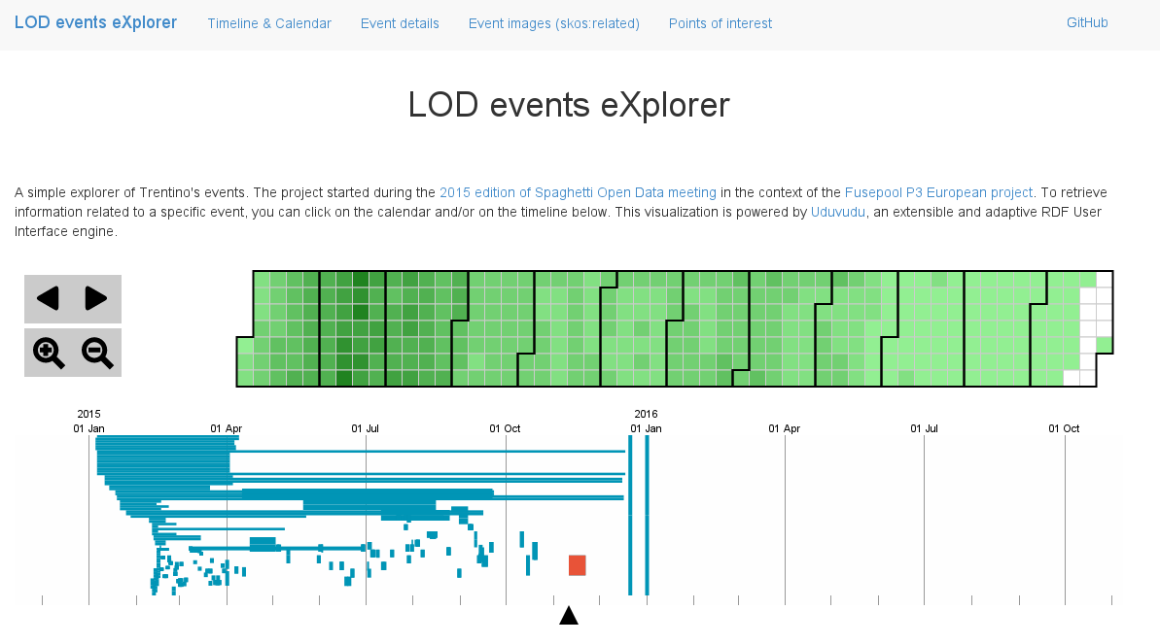

All the events are at first shown in the two graphical widgets showing them on a timeline and on a special calendar widget.

In the calendar widget every day of the year is represented by a square, whose colour identifies the number of event on that day. The darker the colour of the square, the higher the number of events on that day.

In the timeline widget the duration of each event is represented by the length of the related line, so that the user can see at first sight how long each event will last, and how many events in a day or a period are available.

By moving the mouse cursor above a square in the calendar widget, a tooltip appears showing the date and the number of the events on that date. By doing the same on a bar in the timeline widget, besides highlighting the bar itself, a tooltip will show the starting date and the ending date of that particular event. The following images show this behavior:

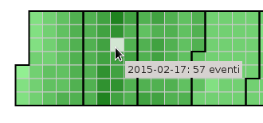 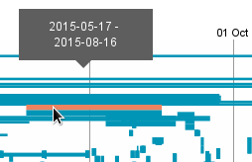

By clicking on the calendar widget, the timeline is updated by zooming on the period surrounding the chosen date. Clicking on an event in the timeline widget will show the details of the chosen event just below the first two widgets. Each event usually has several different information to be displayed, which are grouped in three sections. The same page sections are also linked in the top-most menu.

First there is the **Event Details** section, which takes the textual information of the event, usually including the title of the event, the dates, the category (e.g. Music, Art), a description of the event, which in most cases is quite long and accurate, and the contacts of the place or person responsible of the event itself.

Alongside this information, if geographical data are available, a map is also shown zoomed on the place where the event will be held. The interactive map used is an Uduvudu widget using the geographical and descriptive data of the place. Some events are held in or are linked to more than one place, and for those, multiple maps are shown.

The figure below shows an example of the Event Details section:

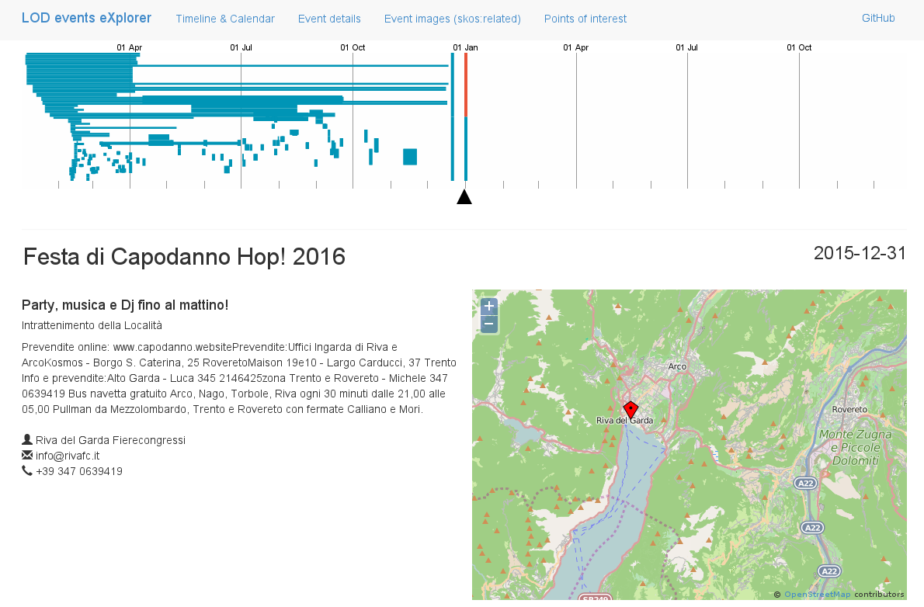

If an event has images related to it they are shown in the **Event Images** section, right below the Event Details one.

The visualization of the images also uses Uduvudu to create the widgets and to resize and organize the images themselves so that they are shown as a set of thumbnails. Clicking on an image will open it in a new tab of the browser where it’s shown in full size. Those are links to the original sources, most of which are taken from Wikipedia.

The image below shows an example of how the Event Images section appears for an event:

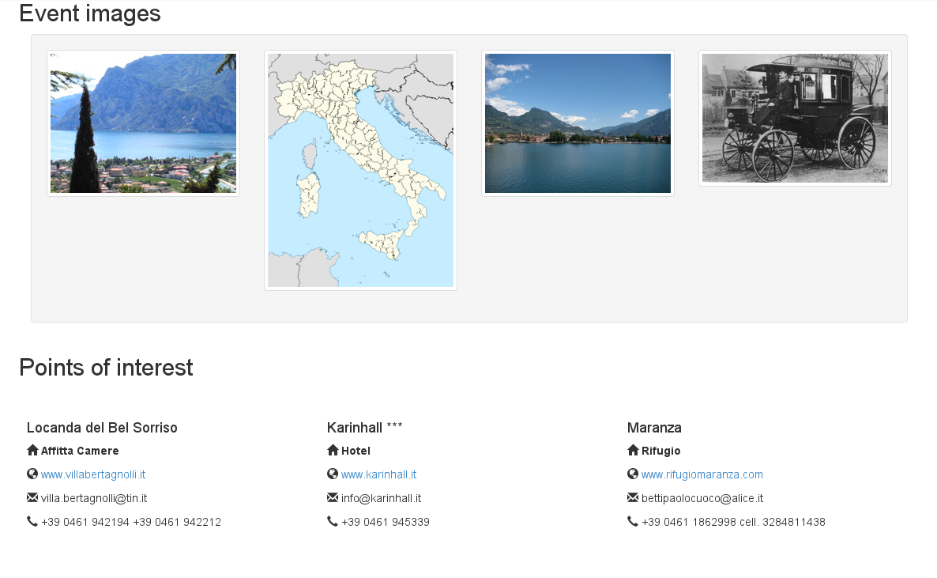

The last section of the page, the **Points of Interest** one, shows all the points of interest involved in the selected event. For each point of interest a set of information is shown, including typology, name and contacts.

The image below shows an example of the Points of Interest section for an event:

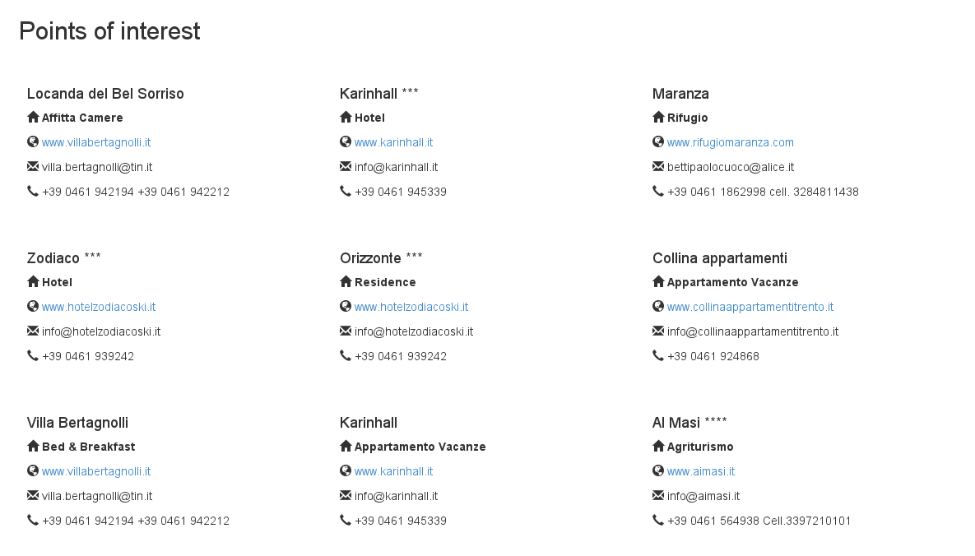

The data shown for each event and in the calendar and timeline widgets are kept in the Fusepool P3 Platform, collected from the datasets of the Provincia Autonoma di Trento, and transformed to be served to applications like the “LOD events eXplorer” one, which can offer articulated views on them.

This project was chosen as it mixes various aspects of the Fusepool P3 Project, by accessing the datasets, mixing the data found there and using the Fusepool’s Uduvudu library to offer a nice visualization of them.

Although based on the Trentino events, it’s clear that the application can be applied to datasets from other regions as well, like the Regione Toscana which is also a partner and a content provider of the Fusepool P3 Project.

The code base of the project is fully available on the GitHub page at the following URL: <https://github.com/giuseppefutia/sod2015> where further details and installation instructions of the project can also be found.

## Demo App: “In the Footsteps: Trentino's Famous People”

“**In the Footsteps: Trentino's Famous People**” is the other winning idea out of those proposed during the Spaghetti Open Data Hackathon which was rewarded with a prize and developed into a mobile application.

The “In the Footsteps: Trentino's Famous People” application is available for both Android and iOS devices, from the respective platforms market places.

The mobile app makes use of a server application, also developed within the project, which perform most of the job, by contacting the Fuspool P3 Platform and other data sources to provide the mobile apps running on either Android or iOS devices with the data to display.

The application welcomes the user with a list of persons names, taken from the Historical Characters dataset provided by the Provincia Autonoma di Trento and available in the Fusepool P3 Platform.

To collect all the people names, the application performs a SPARQL query against the Fusepool P3 Platform endpoint, which returns a list of entries like the following one:

|  |  |  |
| --- | --- | --- |
| ?person | ?name | ?job |
| http://www.trentinocultura.net/asp_cat/main.asp?IDProspettiva=19&TipoVista=Scheda&IdObj=50552&Pag=3&IdSel=1 | Abbondanzio | Vescovo di Trento |
| … | … | … |

By choosing a name from the list of people, in the mobile app, another request is performed to the Fusepool P3 Platform’s SPARQL endpoint to show a detailed description containing the name of the chosen person, his or her job, the place of birth and the place of death of the person, where available.

Such a request returns something similar to the following. In this case some of the information are not present, and the fields are just blank, in other examples those information are available and used in the visualization of the person description.

|  |  |  |  |  |  |
| --- | --- | --- | --- | --- | --- |
| **?name** | **?title** | **?birthPplace** | **?deathPlace** | **sameAs** | **?description** |
| Abbondanzio | Vescovo di Trento |  |  |  | Abbondanzio fu il secondo vescovo della Chiesa di Trento, successore di Giovino e diretto predecessore del più celebre San Vigilio |

The following images show the list of people you are presented with as the app starts up, and the detail page of one of the historical characters.

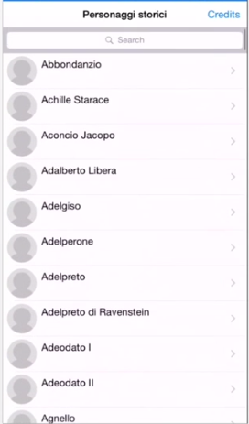 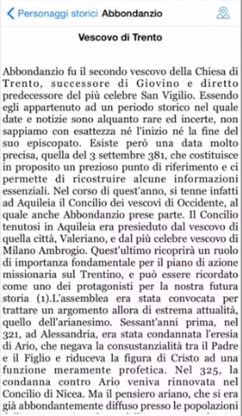

At this point, the application contacts other data sources, like DBpedia, the world largest collection of semantic data, extracted from Wikipedia and structured to be used with the semantic technologies.

The DBpedia dataset is queried searching for all the places related to the person in question that are within the Trentino region, as this is the focus of the application.

This data are, again, retrieved with a SPARQL query which asks for all the places which somewhat involve the chosen person. To render those places on a map, by using markers, another SPARQL query is performed for each resource.

This last query will return, for each place, precise geographical information which are then used to place the marker on a map and show it to the user, who now can browse it in search of “**Point of Interests**”, “**Ristoranti e osterie**” and “**Hotels**”, three of the datasets available in the Fusepool P3 Platform.

For each of these datasets, a new SPARQL query is performed against the Fusepool P3 Platform, the three queries are quite similar and are not shown in this document. However it’s worth noting that for the restaurants (the “Ristoranti e osterie” dataset), the application also makes use of the “Yelp” (<http://www.yelp.it/>) service which gather information about restaurants, pub, etc. which are then used by the demo application to further enrich its contents.

The Yelp system is queried using their APIs to retrieve a place rating, a description, an image and the owner contacts (usually the phone number).

The three types of places are shown on a map using three tabs, each of which activate the related type of places.

When opening up the map, a map crowded of markers is shown, as in the following figure:

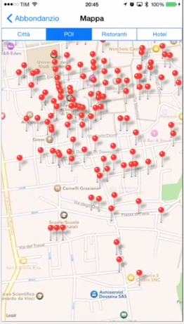

By zooming in, and selecting a marker, additional information about that place is shown in the form of a tooltip, as seen in the following image:

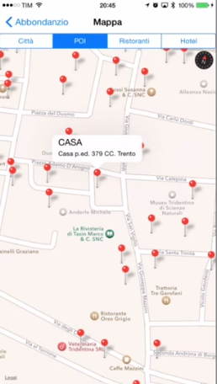

The restaurants (“Ristoranti” in the application) and hotels tabs look very similar, except that in those cases also information on how to contact the places are shown in the tooltips. As we’ve seen the hotels contacts are available in the datasets from the Provincia Autonoma di Trento, while the restaurants ones are fetched from an external service (Yelp). This is transparent to the user, as they are shown in very similar ways, as seen in the following images:

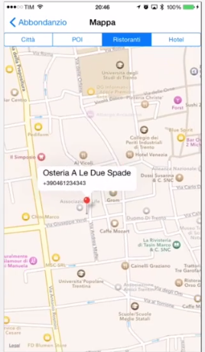 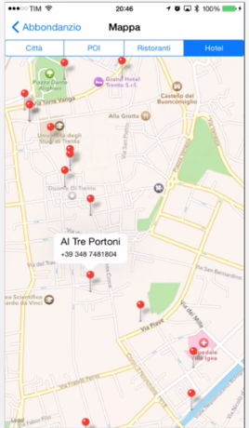

At the following URL:

<https://docs.google.com/file/d/0B_uwBrg856HvZjU2T0FXUWZ4WGM/edit>

a video showcases all the functionalities of the application described in this document. Also, on the project GitHub page, at <https://github.com/marcyborg/In-The-Footsteps-Trentino-s-Famous-People>, further technical details about the realization of the app can be found.

The app was chosen because of its idea to merge datasets taken from the Fusepool P3 Platform with external ones, namely the DBpedia ones, and show all the retrieved information on a mobile device, using a map. The developers went even further by accessing other services (Yelp) to further enrich the result.

The whole idea to visit the places where an historical character spent his or her days and study how it changed over time was also quite interesting, and summed to the technologies used made it a winning idea for us.