# Introduction to EJB3.0

When you define a session bean as a remote session bean, you should specify the remote interface class:

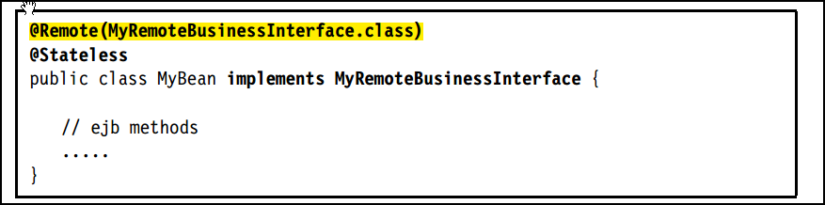

But if the session bean implements only one interface, you can also just code @Remote (without a class name)