# J2SE

## Issue from reference rt.jar

I was planning to make a tiny program to change the mp3 file properties like title. But I got bellow error when I want to run the codes googled

|  |
| --- |
| Description Resource Path Location TypeAccess restriction: The type AudioStream is not accessible due to restriction on required library |

Working solution from stackoverflow

|  |
| --- |
| There's another solution that also works. I found it on [this forum](http://forums.dzone.com/eclipse/384-access-restriction-problems.html):   1. Go to the Build Path settings in the project properties. 2. Remove the JRE System Library 3. Add it back; Select "Add Library" and select the JRE System Library. The default worked for me.   This works because you have multiple classes in different jar files. Removing and re-adding the jre lib will make the right classes be first. If you want a fundamental solution make sure you exclude the jar files with the same classes.  for me i have: javax.xml.soap.SOAPPart in 3 different jars: axis-saaj-1.4.jar saaj-api-1.3.jar and the rt.jar |

All the steps mentioned above can be finished in Eclipse.

<http://stackoverflow.com/questions/860187/access-restriction-on-class-due-to-restriction-on-required-library-rt-jar>

## Integer是不可变类，进入一个方法后，在里面的值的改变不会影响方法外的引用

先看一个小程序

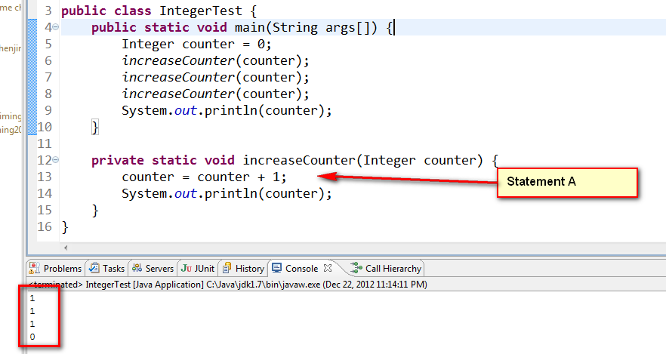

主函数的输出并没有像想像中一样会输出3，而是输出初始化的数值0

这是因为**与String类似，所有的包装类都是final类，即不可变类**。虽然在代码A处看起来是改变了counter的值，但实际上是创建了另一个对象，并将方法内的counter参数的引用指向了这个新创建的对象，由于是不同的引用，所以不会对方法外的引用有任何的影响。内存图如下所示：

在刚进入方法的时候：

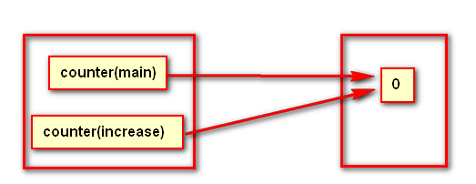

执行counter = counter + 1之后，由于Integer是不可变类，要改变它的值，其实是创建了一个新的对象，所以内存图如下：

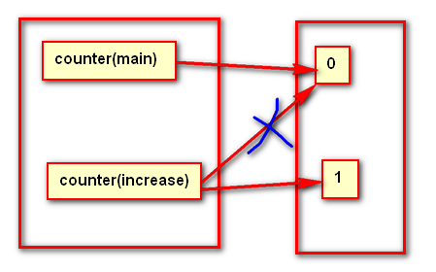

# Linux

## openSuse12.3无法安装vmtools

问题输出：

|  |
| --- |
| Searching for a valid kernel header path...  The path "" is not a valid path to the 3.7.10-1.1-desktop kernel headers.  Would you like to change it? [yes] |

Solution:

|  |
| --- |
| My settings are:   * $(uname -r)"=> **3.7.10-1.1-desktop** * $(uname -m)"=> **x86_64**     Anyway I assume you have the following packages (please adjust for your config):   * kernel-desktop-3.7.10-1.1.1.x86_64 * kernel-desktop-devel-3.7.10-1.1.1.x86_64     You don't need anything else.    And be sure you don't have installed: libvmtools0, open-vm-tools, open-vm-tools-gui.    So please do this:  $> mkdir -p /lib/modules/**3.7.10-1.1-desktop**/build/include/linux  $> cp /usr/src/linux-**3.7.10-1.1**-obj/**x86_64**/**desktop**/include/generated/uapi/linux/version.h \          /lib/modules/$(uname -r)/build/include/linux  $> ./vmware-install.pl  reboot and now you should be fine. |

出处：<https://communities.vmware.com/message/2287860>

# EJB

## Syntax error, insert "enum Identifier" to complete EnumHeaderName

在Servlet中声明要引用的EJB的时候，提示如下错误：

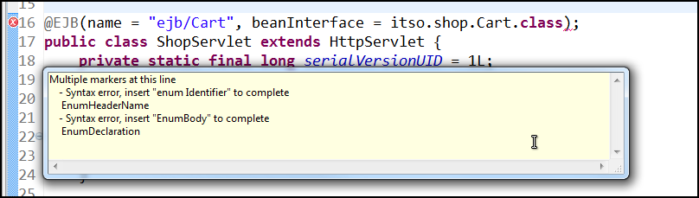

Solution:

格式错误。将annotation EJB的声明最后面的分号删除。Annoation的声明是不需要加分号的。

Syntax error, insert "enum Identifier" to complete EnumHeaderName这样的错误一般是语法上的错误。

一开始的时候以为是beanInterface的声明有问题，所以将这一部分删除发现问题依然存在，后来再试着删除分号，发现问题解决了

# Development Tools

## Version control

### SVN: out of the date

Problem:

When I delete the some package(folders) in a java project, I want to commit the deletion change, accur the error “out of the date” when I commit

Solution:

From: <http://hi.baidu.com/wicom/item/802f29dcf255f715e1f46fca>

|  |
| --- |
| **svn:** **Item is out of date**  **使用Svn提交时候遇到如下错误：**  **Deleting       E:/bdf-d7/bdf-dorado7/src/com/bstek/bdf/d7/cms/dir     Item is out of date svn: Commit failed (details follow): svn: Item '/trunk/bdf-dorado7/src/com/bstek/bdf/d7/cms/dir' is out of date**  **遇到这个错误原因是本地的资源文件版本不是服务器上面最新的版本，因此修改本地文件再提交时候，就会报Out of date错误。**  **解决办法，修改文件时候一定要首先保证和服务器一致，再做修改；而此时 需要先将本地文件还原（记着备份哦），再更新和服务器一致后再做修改。**  <http://stackoverflow.com/questions/2805546/svn-item-folder-is-out-of-date>  **Whenever you see "out of date" in an error message it means that the revision of the item in the repository is newer than the copy in your local working copy**. The **solution is always going to be to run an update**, so that your working copy is up to date with the repository, and then do the commit again (assuming that the update did not generate any conflicts).  For files, this is usually pretty easy to understand how and why this happens. However, Subversion also versions folders, and it is usually with folders that this problem most often happens. Subversion does not allow you to delete/rename a folder OR change its versioned properties, UNLESS the local copy of the folder is at the HEAD revision of the folder in the repository.  Your next question might be: "OK, I can maybe understand that, but **why is my folder out of date? I am the only person working in this repository.**"  That is a valid question, the answer lies in the way that Subversion works. When you commit a change to a file, the revision of the file in your working copy is updated to that new revision when the commit completes, however the version of the parent folder(s) of that file is not updated. This is because there may have been adds/deletes to other files in that folder and until you have run an update, the folder is not really at that new revision. This is called "**mixed revision working copies**".  In summary, the answer is always to do an update so that the folder or file is updated to its HEAD revision. |