# Chapter 1. System management: A technical overview

Notice that a server always belongs to a node, and the node always belongs to a cell. The purpose of the node and cell is to define the administrative domain. The node and cell are logical concepts used to group servers, and to define their scope. Every time a profile is created, a node is created. Therefore, there is a one to one relationship between a profile and a node

WebSphere scripting client (wsadmin)

The NONE connection type connects directly to the configuration files bypassing the application server. The NONE option allows the administrator to administer the application server even if the application server is not started, or if the embedded HTTP Server, or administrative service is not responding. When using the NONE option, the administrator must be on the same system as the application server.

Standalone application server system management environment

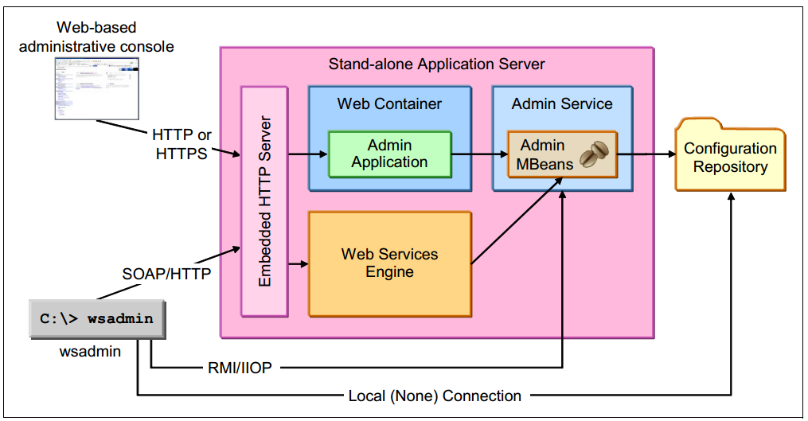

当我们有多台环境的时候，就会造成要进行多次的配置的问题，这个时候就需要用到Administrative Agent了。

The administrative agent is responsible for running the administrative application and administrative service to manage all of the servers on the registered node within the given system.

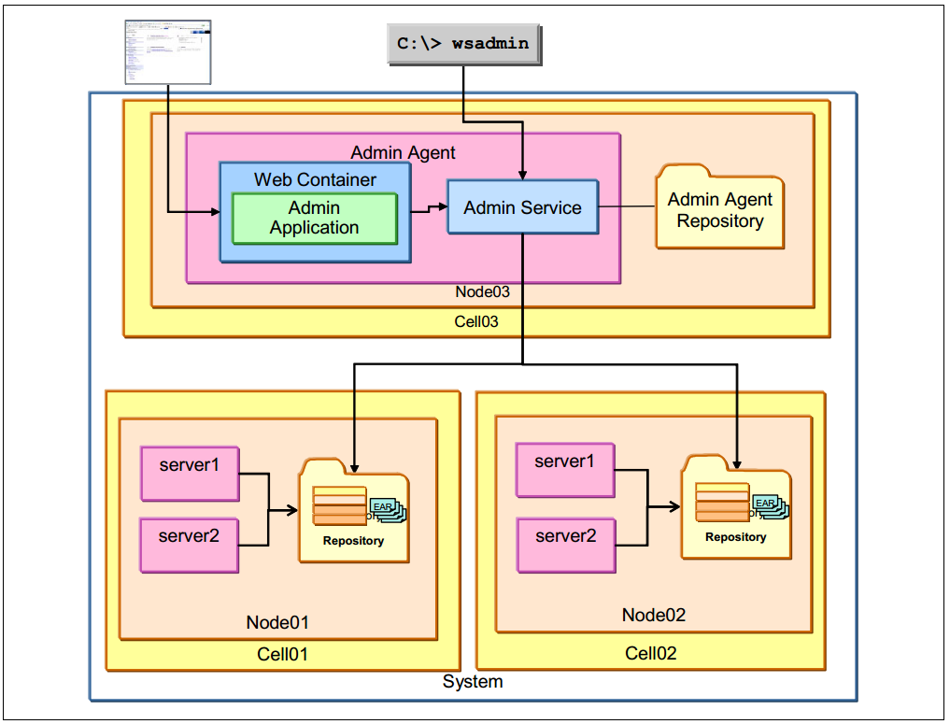

After a node containing a standalone server is registered with the administrative

agent, the administrative console application and administrative service are stopped on the application server. System resources are efficiently utilized because the administrative functionality is not enabled on multiple standalone servers. The standalone application server resources are dedicated to running applications.

Another key feature is the ability to administer an application server when it is not running. The administrative agent modifiesthe standalone servers configuration repository directly using the administrative service. The administrative agent can also start, stop, and create new servers within the managed node.

The administrative agent, along with multiple standalone servers, is a great starting point for simplifying administration. However, note that features such as failover, workload management, session data replication, and many other features cannot be configured without a distributed server environment.

The application servers are centrally managed using the deployment manager.

The deployment manager is responsible for administering the entire cell. The concept of cells and nodes become very important in a distributed server environment. A deployment manager administers one and only one cell.

After the deployment manager is created, the next step is to create a custom profile. This creates a second cell (defaultCell), a node, and a node agent. At this point, you do not have a functioning application server environment.

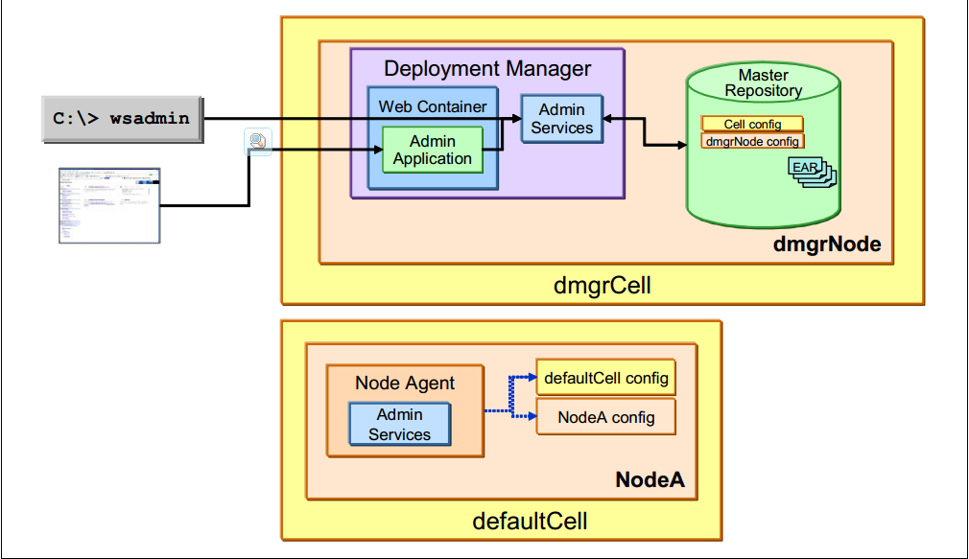

The next step is to federate the node (NodeA in Figure 1-6) to the deployment manager’s cell by using the addNodecommand. After being federated, NodeA is no longer part of the defaultCell, but rather it is part of the deployment manager’s cell (dmgrCell).

Now that NodeA has been federated, all administration of NodeA is delegated to the deployment manager and new application servers can be created on the node using the administrative tools for the deployment manager.

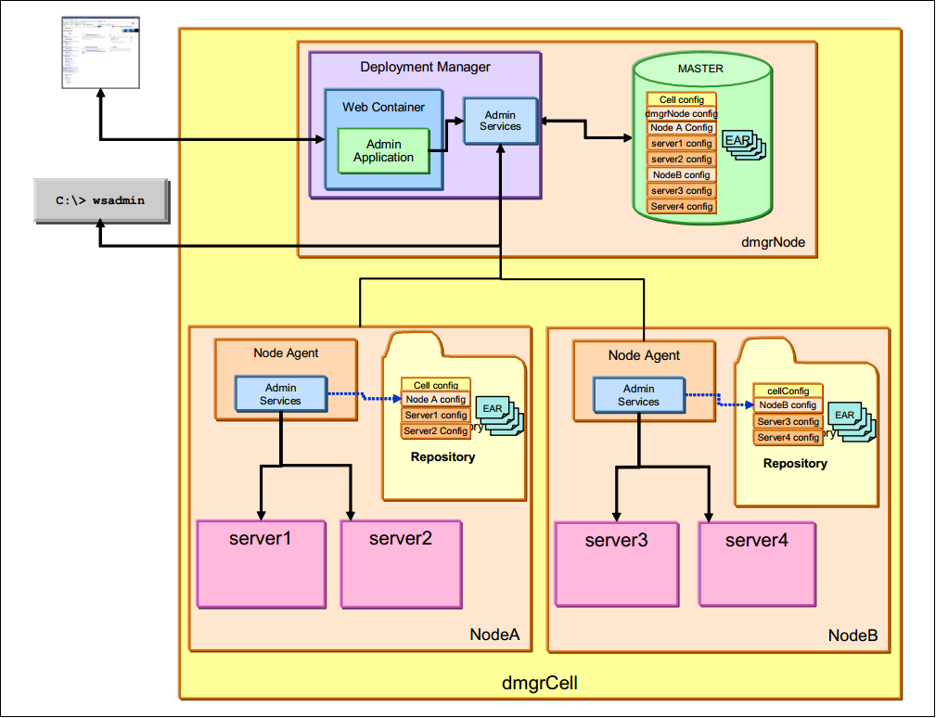

The deployment manager maintains a master repository of all the configuration files. When configuration changes are made at the deployment manager, the changes are first stored in the master repository. Automatic or manual synchronization pushes the changes down to the affected nodes.

## Rules for process startup

When a managed server begins its startup, it sends a discovery request message that allows other processes to discover its existence and establish communication channels with the process. This makes it possible to start the processes in a distributed server environment without following a strict order for startup

The only rule to remember is that the node agent should be started before any application servers on that node. The node agent contains the Location Service Daemon (LSD) in which each application server registers on startup. However, the node agent is purely an administrative agent and is not involved in application serving functions. Each managed server has the data necessary to start itself.