3G NETWORK
3G refers to the third generation of cellular technology that enables mobile telephony To connect to a 3G service, a user has to subscribe to a provider where typically you pay regularly for a set amount of data transfer allowance
Technology under 3G include UMTS which include W-CDMA and HSPA another is CDMA2000
3G ARCHITECTURE
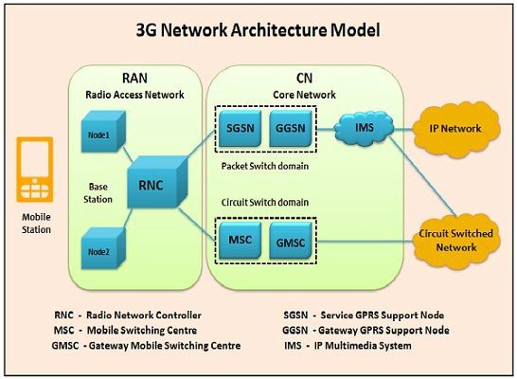
How 3G works
UMTS (Universal Mobile Telecommunications System) . UMTS, short for Universal Mobile Telecommunications System, is a 3G networking standard used throughout much of the world as an upgrade to existing GSM module.
UMTS makes use of WCDMA, a technology that shares much with CDMA networks used throughout the world, though it is not compatible with them. Base level UMTS networks are generally capable of downlink speeds as 384 kbps. The UMTS architecture takes advantage of the existing GSM and GPRS networks which serve as a core network in UMTS infrastructure.
The UMTS is made up of 3 main components:
a) User Equipment:
It is assigned to a single user and contains all the functions needed to access UMTS services. It contains Mobile Equipment (ME) With SIM card It is a radio terminal which is used to connect the UMTS subscriber with the fixed part of UMTS system via the radio interface. UMTS Subscriber Identity Module (USIM): A smartcard which contains the subscriber identity, authentication algorithms, encryption keys etc.
b) UMTS Terrestrial Radio Access Network (UTRAN):
It handles cell-level mobility. It is a system of base station and controller handling function related to mobility. It contains:
1. Nodes B (Base Stations): It converts the data between Uu radio interface and the Iub interface connecting a Node B with the RNC. • It performs physical level processing such as channel coding, data interleaving, rate matching, modulation etc.
2. Radio Network Controllers (RNC): RNC’s controls and manages radio resources to Node B. • RNC performs the data-link layer processing and participates in handover operations. • RNC is considered a single access point of UTRAN for the core network. • It’s connected to a single MSC/VLR to route circuit-switched traffic and to a single SGSN to route packet switched traffic.
c) Core Network (CN):
The core network is shared with GSM and GPRS. The CN contains functions for intersystem handover, gateways to other networks and performs location management. It contains:
- Home Location Register (HLR)
- Mobile Station Controller / Visitor Location Register (MSC/VLR).
- Gateway MSC: Connect UMTS to external circuit switch n/w (e.g. PSTN)
- Serving GPRS Support Node (SGSN): It serves the Packet-switched traffic.
- Gateway GPRS Support Node (GGSN): Connects UMTS to external packet switched. (e.g. Internet)
Application of 3G
- Mobile Multimedia Messaging Service MMS is a multimedia communication mode based on the store-and-forward mechanism. Different from SMS and EMS, MMS has no restriction on the amount and complexity of information contents. So MMS can be used to transmit short messages in texts, as well as pictures, videos and audios
- Streaming Media It support playing high-quality audio and video programs online at the speeds of from 28 kb/s to 1 200 kb/s. As a typical 3G service, streaming media represent animated images and information services.
- Open Service Architecture Provide open service platform for rapid service deployment. third party have a chance to provide services. It has advantages in network interworking and in the rapid deployment standard and uniform network Application Program Interface (API), which allows the third party to effectively upload services.

4G NETWORK
What done on 4G is a system architecture revolution, doesn’t mean the upgrading from 3G to 4G but means the design of new architecture for the purpose of high mobility of network, let’s look on the following important elements in 4G network
Control plane used to exchange signaling message in order to control UE
User plane used to exchange user data, these both processes are done on different elements in 4g network during data transmission let’s look on its architecture
4G NETWOR ARCHITECTURE
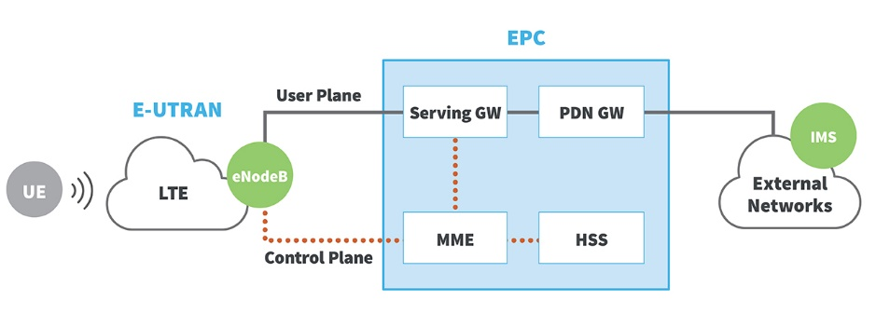
HOW IT WORKS
In E-UTRUN (Evolved UMTS Terrestrial Radio Access Network) it contains nodes which is basically transmitter and receiver which communicates with device through Radio waves in 4g network this work as independent element hence it doesn’t wait any permission from controller
During starting a session MME Make signaling communication with eNode and serving GW to control Data transmission from UE also MME deals with authorization and user authentication
While HSS store all information from the UE
Data are transferred from eNode to serving getaway SGW to eliminate any effect from user shifting from one node to another in E-UTRUN
Lastly PND GW is connected to the external network
APPLICATION OF 4G
4G Data intensive interactive user services - Services such as online satellite mapping will load instantly.
4G Multiple User Video conferencing - subscribers can see as well as talk to more than one person.
4G Location-based services - a provider sends wide spread, real time weather or traffic conditions to the computer or phone, or allows the subscriber to find and view nearby businesses or friends whilst communicating with them.
4G Tele-medicine - a medical provider monitors or provides advice to the potentially isolated subscriber whilst also streaming to them related videos and guides.
4G HDTV - a provider redirects a high definition TV channel directly to the subscriber where it can be watched.

5G NETWORK
Like other cellular networks, 5G networks use a system of cell sites that divide their territory into sectors and send encoded data through radio waves. Each cell site must be connected to a network backbone, whether through a wired or wireless backhaul connection. 5G networks use a type of encoding called OFDM, which is similar to the encoding that 4G LTE uses. The air interface is designed for much lower latency and greater flexibility than LTE, though.
5G ARCHITECTURE
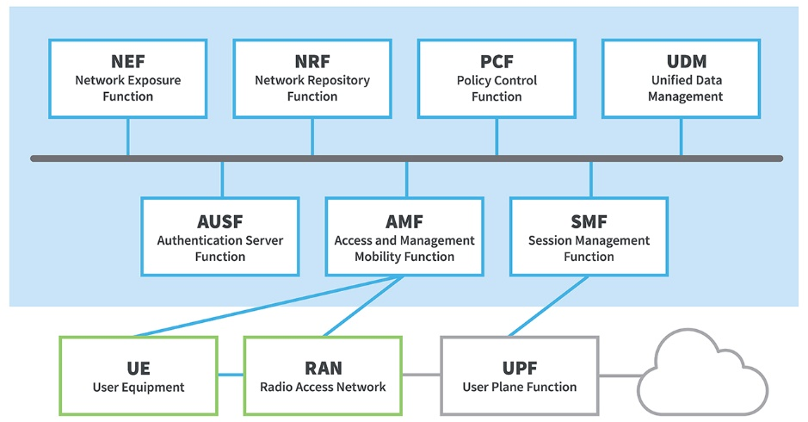
User Equipment (UE) like 5G smartphones or 5G cellular devices connect over the 5G New Radio Access Network to the 5G core and further to Data Networks (DN), like the Internet.
The Access and Mobility Management Function (AMF) acts as a single-entry point for the UE connection. Based on the service requested by the UE, the AMF selects the respective Session Management Function (SMF) for managing the user session.
The User Plane Function (UPF) transports the IP data traffic (user plane) between the User Equipment (UE) and the external networks.
The Authentication Server Function (AUSF) allows the AMF to authenticate the UE and access services of the 5G core.
Other functions like the Session Management Function (SMF), the Policy Control Function (PCF), the Application Function (AF) and the Unified Data Management (UDM) function provide the policy control framework, applying policy decisions and accessing subscription information, to govern the network behavior.5G network architecture is more complex behind the scenes, but this complexity is needed to provide better service that can be tailored to the broad range of 5G use cases
APPLICATION OF 5G

Autonomous Vehicles
Autonomous vehicles are one of the most anticipated 5G applications. Vehicle technology is advancing rapidly to support the autonomous vehicle future. Onboard computer systems are evolving with levels of compute power previously only seen in data centers.

5G IoT in Smart City Infrastructure and Traffic Management
Many cities around the world today are deploying intelligent transportation systems (ITS), and are planning to support connected vehicle technology. Aspects of these systems are relatively easy to install using current communications systems that support smart traffic management to handle vehicle congestion and route emergency vehicles

Applications in Industrial Automation
The key benefits of 5G in the industrial automation space are wireless flexibility, reduced costs and the viability of applications that are not possible with current wireless technology. Industrial automation is in use today, and most likely you have seen videos showing synchronized robotics at work in factories and supply chain applications

