COLLEGE BUSINESS EDUCATION
DAR ES SALAAM

GROUP ASSIGNMENT
COURSE: BACHELOR DEGREE IN INFORMATION TECHINOLOGY.
MODULE: DATA STRUCTURES AND ALGORITHMS
MODULE CODE: ITU07313
FACILITATOR: AHMED KIJAZI
YEAR OF STUDY: Second Year
SEMESTER : 1st
ACADEMIC YEAR: 2025/2026
STREAM: TNC
GROUP NUMBER THREE.
Deadline 15/01/2026

GROUP MEMBERS
S/N | FULL NAME | REGISTRATION NUMBER
1. | ADAM AJIDA ABDALLAH | 03.9711.01.01.2024
2. | FATMA MOHAMED MUSA | 03.9607.02.01.2024
3. | FRANCE GAUFRID FUSSY | 03.3154.01.01.2024
4. | GOODLUCK JULIUS ABRAHAM | 03.1535.02.01.2024
5. | JOSHUA M SAMWEL | 03.4813.02.01.2024
6. | REGINA CHARLES | 03.4512.02.01.2024
7. | TAITUS THOBIAS ELIAS | 03.3506.01.01.2024
8. | VICTORIA EMANUEL MBOKO | 03.3559.01.01.2022
9. | WILSON MAPE MAPANDE | 03.4228.02.01.2024

Question: With examples, explain different types of tree data structures

Answers
A Tree is a hierarchical data structure that consists of nodes connected by edges. It is used to represent relationships between elements, where each node holds data and is connected to other nodes with edges.
There are three Types of Tree data Structures
- Binary Tree
- Ternary Tree
- N-ary Tree
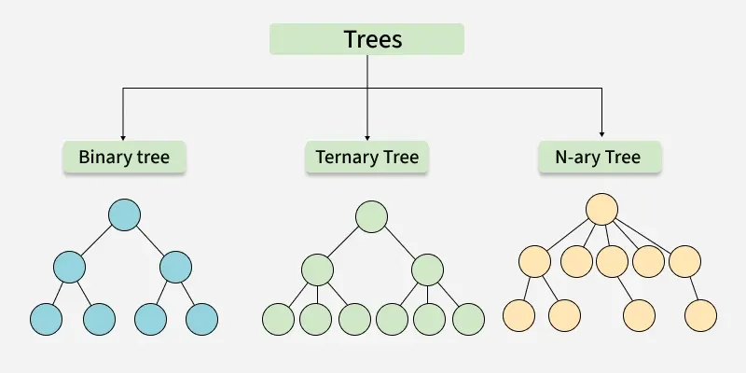

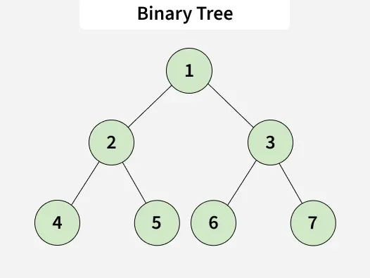
Binary Tree
A binary tree is a tree data structure where each node has at most two children. These two children are usually referred to as the left child and right child.
Binary Trees are simple but can become skewed (inefficient).
Example: Consider the tree below

Ternary Tree
A Ternary Tree is a tree data structure in which each node has at most three children. These two children are usually referred to as the left child, mid child and right child.
Example:

Ternary Search Tree: A ternary search tree is a special trie data structure where the child nodes of a standard trie are ordered as a binary search tree.

Ternary Heap: A type of heap where each node can have up to three children, though less common than binary heaps

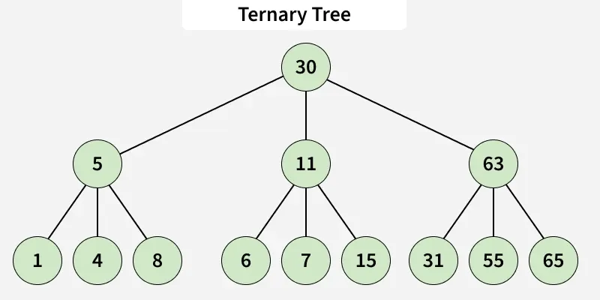
Consider the tree below.

N-ary Tree (Generic Tree)
An N-ary tree is a generalization of a binary tree, such that each node can have at most N children.
Examples of N-ary Trees:
- B-tree: A self-balancing search tree where nodes can have multiple children, usually used for indexing large databases.
- B+ Tree: A B+ treeis a variation of the B-tree that only stores data in the leaf nodes, making range queries more efficient.
- Trie (Prefix Tree): A tree where each node represents a character, and paths from the root to leaves represent strings. It can have a variable number of children for each node, making it an N-ary tree.

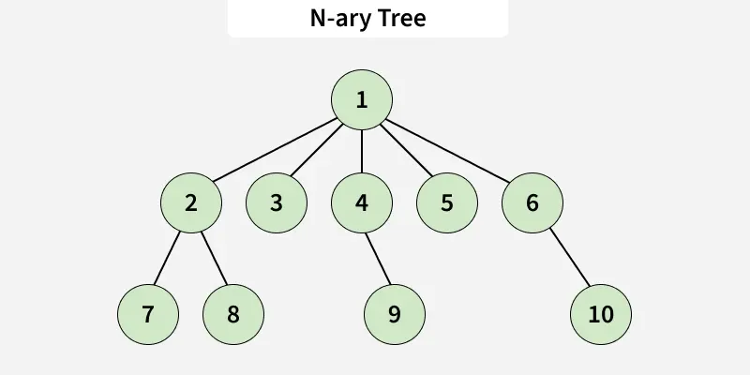
Consider the tree below

